

|  |  |  |
| --- | --- | --- |
| **Date:** |  | **February 18th, 2011** |
| **Authors:** |  | **Sela Davis** |
|  |  | **Chip Hilseberg** |
|  |  | **Jonathan Lobaugh** |
|  |  | **Eric Moreau** |
|  |  | **Nicholas Wilsey** |

Executive Summary

This document presents the game, *Trigger Happy*. *Trigger Happy* was designed and developed by a team of five graduate students over two courses with each course lasting 11 weeks. This document is broken up into a series of smaller documents that describes the game at various levels of design. At the high level there is the Elevator Pitch, High-Concept Document (One Sheet), and Game Treatment documents. The basic premise is found in the Elevator Pitch which also serves to spring interest in the game. The High-Concept and Game Treatment documents further flush out the game’s mechanics and introduce the story and critical path. The Gam Treatment document also provides a detailed competitive analysis of similar titles within *Trigger Happy’s* genre and a business case for why this game should be developed. These documents lead in to the Game Design Document, where all aspects of the game is explained in great detail. This includes all gameplay mechanics, game modes, and the specifications for each weapon and modifier. *Trigger Happy’s* primary level, the Academy, is detailed with concept art and renders in the Art Bible. This includes all assets that are inside the Academy level as well as the map’s geometry room by room. Also within the Art Bible are concepts and final renders for the player’s avatar, weapons, and modifiers. Alongside the Art Bible is the Audio bible which outlines similar specifications for audio assets that are to be in *Trigger Happy*. They are broken down into the relative areas they would appear in the game such as player or weapon audio triggers.

The Technical Design Document outlines the structure and implementation of the Singularity component engine that was developed for the *Trigger Happy*. It is broken down into each component system that the engine contains as well and documents their implementation and relation to the rest of the engine. Following the Technical design document is the Game Production Document and Development Timelines. These two pieces outline how the development cycle for the game will be structured and executed. The timelines themselves outline overall team goals as well as team member specific goals and deadlines that are to be met during the development cycle. As part of the development process, each team member has written an outline for their individual research topics. These topics reflect interests by the team members that they wish to tackle and implement alongside the development of *Trigger Happy*.

The final part of the document is the post mortem. The post mortem is broken up into two sections; the Development Document and the Appendages sections. The Development Document is an overall reflection of the entire design cycle of *Trigger Happy.* This includes features that were added and cut from the game along with the reasonings behind these design decisions. It also details development accomplishments and troubles that occurred along the way. The Appendages section houses the final presentation slides along with each team member’s individual research write-up.

## Table of Contents

Executive Summary ii

Elevator Pitch 14

High Concept Document (One-Sheet) 15

Game High Concept 15

Development Scope 16

Business Case 16

Bibliography 18

Game Treatment 19

Backstory 19

Game Concept 19

Critical Path 21

Story/Background 22

Features and Controls 22

Development Scope 23

Technology Features 24

Potential Technology Roadblocks 24

Platform 25

Business Case 25

Bibliography 26

Competitive Analysis 27

Doom 27

Quake 28

Unreal Tournament 2004 (UT2K4) 28

Team Fortress 2 (TF2) 29

Shadowrun 31

Halo 3 32

Call of Duty: Modern Warfare 2 33

Game Design Document 36

Executive Summary 36

Setting the Environment 38

Look and Feel 39

Visual 39

Camera 40

Audio 40

Game Modes 41

Assault 41

King of the Hill 42

Deathmatch 43

Game Mechanics 43

Equipping Weapons and Modifiers 44

Weapons 45

Modifiers 54

Player 66

Player Movement 66

Player Shields/Health 66

Player Death and Respawning 67

Input Controls 67

Menu Navigation 68

Weapon and Modifier Screens Navigation 68

In-Game Navigation 69

Game States and Screens 70

Logo Screens and Initialization 70

Main Menu Screen and Point-of-Entry 71

Match Lobby Screen and Choosing Teams 74

Game Loading Screen and Loading 75

In-Game 75

In-Game Graphical User Interface 79

World 83

Historical Overview 83

Life in the Modern Day 87

Organizations 89

The Industry 89

Future Proficient Soldier Academy 91

Characters 95

Appendage Conservation Front Staff 95

Impossible Possibilities Staff 96

Society for Historical Beatdowns Professors 96

Students (Player Avatars) 97

Academy Professors 98

The Academy 98

Art Bible 104

Theme and Style 104

Visual Style 104

Character Style 106

World Style 109

Map Styles 112

The Future Proficient Soldier Academy 112

The Appendage Conservation Front Wing 115

The Academy Wing 117

The Society for Historical Beatdowns Wing 119

The Impossible Possibilities Wing 121

Scenes 124

Test Render: The Sorting Room 124

Models and Textures 127

Player Avatar 127

Weapons 128

Animations 174

Character Animations 174

Audio Design Document 178

Overview: 178

Goal: 178

Music: 178

Sound Effects: 179

Voice: 179

Concepts: 180

Research: 180

Implementation: 181

Overall Development / Details: 182

Music: 182

Sound: 183

Voice: 183

Content List: 183

Sound effects: 183

Background Music: 213

Technical Design Document 217

Summary 217

Document Scope 217

Development Technology 218

Production Technology Requirements 218

Engine 219

System Architecture 219

Tasking System 224

Scene System 230

Components 237

Game 294

Components 294

Game Objects 294

References 295

Game Production Document 296

Summary 296

Document Scope 296

File Naming Convention 297

Document Structure 298

Coding Standards 299

Naming Conventions 299

Comments 300

Class Syntax 300

File format 301

Development Timelines 302

Overall Timeline 302

Game Engine Timeline 303

Game Components Timeline 303

Audio Assets Timeline 303

Art Assets Timeline 304

In-Game Objects Timeline 304

A Heuristic-Based Model for Adaptive, Non-Linear Music Generation in Games 306

Quick Bio 306

Short Summary 306

Further Detail 306

Problem and Solution 307

Overview 307

Relevance to Game 308

Literature Search and Previous Work 310

A Generative, Adaptive Music System for MMO games 310

Procedural Music in *Spore* 310

Dead Space Sound Design: In Space No One Can Hear Interns Scream. They Are Dead. 311

*Left 4 Dead* Audio Commentary 311

Computer models of musical creativity programs 312

Implementation and Deliverables 312

Plan of Action and Fallbacks 312

Deliverables 314

Requirements of Solution 315

Final Goals for Solution 317

Dynamic Difficulty Adjustment and Storytelling in Multiplayer Competitive Environments 319

The Problem 319

Why is this Problem Important? 322

Goals 323

The Approach 324

Research Literature 327

Deliverables and Integration 327

When is it Complete? 327

Design and Implementation of a Componentized Multi-Core Game Engine 329

The Problem 329

Why is this Problem Important? 331

Goals 332

The Approach 332

Research Literature 333

Deliverables and Integration 335

When is it Complete? 335

Variable Style Deferred Rendering 336

The Problem 336

Why is this Problem Important? 337

The Approach 338

Implement Basic Deferred Renderer 338

Compartmentalize the Renderer 339

Goals 341

Deliverables and Integration 341

When is it Complete? 342

Research Literature 342

Bibliography 342

Maya-based Creation and Assignment of Component Attributes for a Component-based Game Entity Architecture 345

Background 345

Problem 346

Claim 347

Goal 348

Method 348

Conclusion 349

Bibliography 350

Development Document 352

Lua-based System HLA Diagram and Discussion 352

Game Systems 352

SMURF Format Maya Exporter 368

Development Process 368

Engine Development 368

Engine Component Development 370

Asset Creation 371

Game Development 372

Implementation Choices 374

Lua 374

Serialized Networking 376

SMURF Format 376

Maya as Level Editor 377

Bullet Physics 378

Removal of Weapons 378

Game Walkthrough 380

Post Mortems 386

What Went Well 386

What Could Have Gone Better 387

Significant Setbacks 389

Future Work 391

Timeline Discussion 392

References 393

Appendix 395

Capstone Defense Slides 396

*This page intentionally left blank.*

Elevator Pitch

Imagine yourself in a world where you see a group of clones that look exactly like you. Also imagine that these clones are fighting tooth and nail with contraptions that harness the power of physics itself. You see some clones that are larger sloth-like versions of the other clones. You also see another group of clones up on the ceiling firing rockets down at these sloths. In the far corner you see what appears to be a series of barriers that appear out of nowhere and another clone with a pair of binoculars that fires some sort of projectile right over your shoulder only to hit another clone square in the forehead. You look around and see that you are in some sort of school environment that is attached to a museum and a warehouse.

Welcome to the world of *Trigger Happy*. In this world, players assume the character of clones being exploited in team based matches for the enjoyment of high paying spectators. The clients ordering these engagements can put the teams into a King of the Hill match where the goal is to capture more areas than the opponents, and Assault where one team is attacking and moving a flag across the map through a series of checkpoints while the other team defends. Players have at their disposal a series of weapons that they can take into battle and a combination of contraptions called Modifiers that bring the unpredictable nature of physics into the match. How will you fair? That depends on how well your survival skills are and ability to adapt to any situation that may present itself on the battlefield.

High Concept Document (One-Sheet)

"Kill him again...but this time with feeling."

**Short Description**: Fight alongside or against your friends in a multiplayer experience that pits one team against the other in dynamic battles. Use physics and science to your advantage to thwart your enemies and achieve victory.

**Tone Words:** *strategy, action, traps, comical, teamwork*

# Game High Concept

*Trigger Happy* is a 3D first-person shooter (FPS) game that utilizes modifiers to affect enemies’ perception of the world around them. The action will take place in a small series of self-contained areas designed to allow plenty of beneficial locations to lay down modifiers in order to both benefit the player and deter opponents. *Trigger Happy* is team-based, and players will find themselves combining their different abilities together in order to determine the best team makeup. Team sizes can vary depending on player activity at a given time. In addition, players will have the amount of control necessary to find and define their own play styles and play with the weapons they feel comfortable with.

The player's goal in *Trigger Happy* is to help his team win a multiplayer match. Objectives will change based upon which style of match the player chooses. If the match is a king of the hill style, the team's goal will be to enter a region and maintain it by killing all enemies who enter for a set period. If the match is an assault style, the assaulting team's goal is to bring a flag to a predefined set of checkpoints and the defending team's goal is to prevent them from bringing the flag to the final checkpoint for a certain amount of time.

# Development Scope

The development scope for *Trigger Happy* will directly reflect how our milestones will be laid out and it is because of this scope that our development process will use an iterative approach. With a development team of five persons and about six months of design/development time, the project will focus on the first-person shooter genre as well as the player's use of traps within the game world to alter the enemy's perception of the world around them. These two concepts will need to be combined together fluidly to create a dynamic game experience. The development scope and the timeline of milestones will need to reflect that integration of mechanics. The target platform for development will be Microsoft Windows on a PC rather than a console release.

A three-month design cycle with a three-month development cycle is planned. Engine and core systems will be developed in parallel with the design cycle due to their independence from the game idea.

# Business Case

*Trigger Happy* is targeted toward a casual first person shooter audience, which tends to be made up of males, aged 18-34. These players have typically played other first person shooters, and many of them are constantly looking around for a new first person shooter experience. *Trigger Happy* will suit their needs by adding unique modifiers, which are remotely triggered game objects a player can throw. The player is given a base set of different modifiers, which they can combine to create varying combinations that suit different play styles.

As the audience is likely familiar with FPSs, they already know what style of gameplay they are getting themselves into with this genre of game. *Trigger Happy* particularly appeals to players of games like Counter-Strike, who are looking for a change of pace, as the teamwork aspect will be similar and comfortable. While we are not looking to match Counter-Strike‘s sales numbers, it is important to note that the Counterstrike franchise has sold 9.2 million copies spread across three titles as of December 2008 (Cavalli).

Games in this genre tend to perform particularly well. However, numbers are often difficult to find, as players of these games tend to purchase on the PC rather than consoles, which are watched much more closely in sales. Games in the genre tend to perform better if they are part of a franchise or series, but original IP and unique ideas certainly can succeed. After all, Doom, a seminal game and the title that launched the series, was an original IP. On the other hand, Wolfenstein 3D, Doom's predecessor, was a spinoff of another genre but did not perform nearly as well.

Five graduate students in the Rochester Institute of Technology’s Game Design & Development program will develop *Trigger Happy*. Each has his or her own particular specialty, and each of these is uniquely suited toward the game. These specialties include important topics such as engine development, 3D modeling and texturing, audio content development, particle systems, and game world design and development. This will help to team to develop a compelling, rich game that will provide many hours of fun.

# Bibliography

Cavalli, Earnest. Valve Unveils Half Life, Counter-Strike Sales Figures. 3 December 2008. January 2010 <http://www.wired.com/gamelife/2008/12/valve-unveils-h>.

Game Treatment

# Backstory

What makes the Future Proficient Solider Academy such a unique place to learn? Is it our status as the first and only armed combat and entertainment school? Is it our groundbreaking work in the fields of Spawn Camping and Performing with Extreme Blood Loss? Or is it our close ties to bleeding edge R&D labs and hospitals? Perhaps it's our industry-trained faculty with real-world experience in a variety of forms, including real weapon historical reenactment, 1 vs. 1000 blood bowls, and customer-designed combat scenarios. All of these things make FPSA an excellent university; but what really makes it unique is its students and their dedication to each other spawn after spawn. As we say here at the academy, “It takes both 'u' and 'i' to spell ‘multi-kill.’”

Spots are filling fast for our third freshman class. Apply now and receive a free health pack (clones welcome).

**Tone Words:**strategy, action, traps, comical, teamwork

# Game Concept

*Trigger Happy* is a 3D first-person shooter (FPS) game that utilizes modifiers to affect the enemy's perception of the world around them. The action will take place in a small series of self-contained areas designed to allow plenty of beneficial locations to lay down modifiers in order to both benefit the player and deter opponents. *Trigger Happy* is team-based, and players will find themselves combining their different abilities together in order to determine the best team makeup. Team sizes can vary depending on player activity at a given time. In addition, players will have the amount of control necessary to find and define their own play styles and play with the weapons with which they feel comfortable.

A player will be able to pick a combination of weapons from a larger pool to use during gameplay, and they will use these weapons in attempts to defeat their opponents. Players will have a certain amount of health, which will allow them to survive one or more shots from weapons. Each weapon will have its own advantages and disadvantages (rate of fire, clip size, etc.). Upon defeating an opponent, the opponent will spawn again in a new location on the map. *Trigger Happy* will incorporate three game modes that focus on team play and strategy. These two game modes are King of the Hill, Assault, and Deathmatch. All three game modes have very different win conditions. Each of these game modes will emphasize team work for the players Once a team has met the win conditions of the round, players will be given the option to begin a new match.

Modifiers will also play a very important role in the player-on-player conflict. Players will have access to a subset of the modifier types and may swap them when they die. When a modifier is activated in a given area, affected players will receive a buff that changes the way they play. For example, placing an anti-gravity modifier will invert gravity for *all players* that are within its radius. Modifiers are not necessarily meant to punish players that enter them, only to change the nature of fighting in a way that can be exploited by the prepared. An anti-gravity modifier could function as an escape or a kill preventing distraction depending on how prepared a player is to use it. Modifiers fit into many different categories including, but not limited to, physical (anti-grav, slowing) and perceptual (barrier, decoy).

Particular locations will be designed into the levels to maximize the potential of certain modifiers, but players will not be limited to setting modifiers in these locations. The uniqueness of *Trigger Happy* gameplay comes from the fact that players can change the rules on the fly in local and strategic ways. While a typical FPS only offers one rule set and map over the duration of a fight, our gameplay supports dynamic shifts which means that gameplay is more frantic and player moldable producing a wider range of unique battle experiences.

# Critical Path

The flow of the game mainly takes place in a multiplayer arena. Once players boot up the game, they are immediately given the option to go to a game lobby. In the game lobby, a player can either create a new game or join a game in progress. Once in the game, a player is immediately asked to choose a set of weapons and modifiers and is then put on a team and spawns. At this point, the player's goal depends on the game type: either the player must attempt to help his team keep control over a set of points for a set period or the player must attack/defend a number of significant points in the map for a specified amount of time. If the player's health reaches zero, he will respawn again shortly. The player will have the option during this time to reselect weapons and modifiers, but is not required to.

There are two end states to the game for a player: either one team must meet a victory condition, which will end the game, or the player must disconnect from the game. This disconnect, of course, may be player-chosen or outside his realm of control. Either situation will bring the player back to the lobby, where he can create a new game, join another game in progress, or exit to the main menu.

# Story/Background

*Trigger Happy* takes place in a future based upon our world. In this future, reenactments (or "re-nacts") and personalized battles have become a popular form of entertainment as well as a lofty career goal. This has all become possible through the advent and spread of cloning, allowing people to fight, die, and live to fight another day. Leagues have begun to spring up to support this sport, and investors and sponsors constantly pay for biggest consumable required: clones. In response, many organizations have been founded. Some support these battles, while others fight to reduce clone waste. One of the most significant of these is the Future Proficient Soldier's Academy, where students learn about combat and weaponry. These students hope this education will help them get their "big break".

In *Trigger Happy*, players take control of one of the students of the Future Proficient Soldier's Academy. These students are then dropped into battle with one another and forced to fight in teams for the entertainment of others.

# Features and Controls

The unique selling points of *Trigger Happy* lie within the dual combination of allowing the player to choose their weapons to suit their personal play style and using modifiers that can be placed on the ground. Players will have the ability to spend a given amount of "points" on weapons and a separate amount of "points" on modifiers. Each weapon and modifier will have its own cost based upon its abilities and qualities. This will allow players to strategize effectively as teams while allowing them to enjoy the game in a play style they are comfortable with.

# Development Scope

Since all of us have had experience in development, the number of programmers seem inclusive to all members. However, each member has differing degrees of expertise in programming and the C++ language constructs. Design is handled by a talented designer: Chip is known for his thorough implementations of stories and game worlds. In addition, Nick will be another primary contact point regarding the design. By having two members, we create a game with better group unity without having the design being run by a single member.  In addition, the inclusion of two members allows designers to be available for questions at most times when members are working in the lab.  Other constructs (email, wiki, etc.) will be managed to help facilitate these collaborative behaviors as well.

Because an original engine will be developed for this game, the introduction of two members to manage and adjust the engine is quite valuable.  Again, much like the designers, having two engine designers means that work can be divided and the loss of one member does not put the group into instantaneous death spirals.  The job of these developers is to build and maintain an engine to fit the needs of the game play programmers.  Both developers have a single existing engine that will be utilized in the development of the game.

In the area of game assets, we have three members with skills in the artistic avenue.  Nick, Sela, and Eric have media backgrounds and are valuable in the development of game models, sound assets, and art assets.  Without such individuals, the game would have very little visual or audio presence.  The inclusion of these team members allows us to limit the need for outside sources that might become unreliable or costly.

Finally, since we have worked on projects with DirectX 10 and the use of such a core will be utilized in this project, the introduction of shader programmers helps to stream line the display process and allow basic drawing effects as well as complicated object and post-processing effects to be developed.

# Technology Features

There are a number of interesting technologies at play in the background of *Trigger Happy*. The core of the game utilizes a custom multithreaded game engine, giving the underlying architecture the flexibility it needs to run quickly and effectively. The background music of the game will be generated on the fly in order to help nudge the player's emotion and give them information about what is going on in the battlefield. Models will be brought into the game engine using a custom file format to speed up load times. Finally, a unique achievement system will be put in place to keep players engaged and give them goals that offer rewards usable within a match.

# Potential Technology Roadblocks

These neat technology features all have a show-stopping potential. As each is pushing the bounds of current research and technology, there is a fallback in place in case a system cannot be successfully implemented -- with the exception of the multithreaded game engine. This engine is a significant risk, but provides massive potential benefit to the users of the software.

# Platform

*Trigger Happy* is targeted at PCs running Microsoft Windows Vista or Microsoft Windows 7. In order to run the game, a DirectX 10 compatible graphics card will be required. The game will be controlled with a keyboard and mouse, and will not require the number pad on the right side of the keyboard in order to support laptop and small-form keyboards. This release will be targeted at an English-speaking American audience.

# Business Case

*Trigger Happy* is targeted toward a casual first person shooter audience, which tends to be made up of males, aged 18-34. These players have typically played other first person shooters, and many of them are constantly looking around for a new first person shooter experience. *Trigger Happy* will suit their needs by adding unique modifiers, which are remotely triggered game objects a player can throw. The player is given a base set of different modifiers, which they can upgrade to create varying combinations that suit different play styles.

As the audience is likely familiar with FPSs, they already know what style of gameplay they are getting themselves into with this genre of game. *Trigger Happy* particularly appeals to players of games like *Counter-Strike,* who are looking for a change of pace, as the teamwork aspect will be similar and comfortable. While we are not looking to match *Counter-Strike*‘s sales numbers, it is important to note that the *Counterstrike* franchise has sold 9.2 million copies spread across three titles as of December 2008 (Cavalli).

Games in this genre tend to perform particularly well despite the lack of public sales figures. Titles such as *Call of Duty: Modern Warfare* has sold millions. The latest installment, *Modern Warfare* 2 sold roughly 4.7 million in its first 24 hours in the United States and United Kingdom alone (Silverman). The *Call of Duty* franchise boasts a dedicated fan base on the PC platform that tends to buy most multiplayer FPSs upon release. While *Trigger Happy* will not be as highly publicized as *Battlefield: Bad Company 2*, it will still have the potential to become a sleeper hit. New IP can perform well in this genre, though the biggest hits are nearly always franchise titles. Many FPSs are released every year, but most of them are designed for a single-player experience rather than a multiplayer experience, which is what *Trigger Happy* will provide.

*Trigger Happy* will be developed by five graduate students in the Rochester Institute of Technology's Game Design & Development program. Each has his or her own particular specialty, and each of these is uniquely suited toward the game. These specialties include important topics such as engine development, 3D modeling and texturing, audio content development, particle systems, and game world design and development. This will help to team to develop a compelling, rich game that will provide many hours of fun. In addition, each has a research project that will provide a solution to a significant challenge, improving the *Trigger Happy* experience and making the game more appealing.

# Bibliography

Cavalli, Earnest. Valve Unveils Half Life, Counter-Strike Sales Figures. 3 December 2008. January 2010 <http://www.wired.com/gamelife/2008/12/valve-unveils-h>.

Silverman, Ben. 'Modern Warfare 2' Breaks Day One Entertainment Sales Record. n.d. January 2010 <http://videogames.yahoo.com/events/plugged-in/-modern-warfare-2-breaks-day-one-entertainment-sales-record/1372471>.

# Competitive Analysis

## Doom

Doom is considered the seminal FPS, and launched the entire genre into the spotlight. While many of its mechanics feel clunky now, it was a marvel of modern technology back in 1993. It is suspected that over 10 million shareware copies of Doom were installed on computers at the height of its popularity, and it proved to be possibly the most influential game to many current developers. Its most significant advantage was the fact that it featured a 3D graphics engine and looked much more visually appealing than everything else. On the other hand, it did not feature such modern improvements as a physics engine, jumping, looking around, etc.

Doom, much like its predecessors, featured the basic FPS mechanics found in *Trigger Happy*: running and shooting. This quickly brought the concept of FPSs to homes and workplaces everywhere, and spawned the creation of many similar games. It is impossible to build an FPS without looking back to Doom as a resource and guide, even though most of the mechanics and gameplay features have been significantly improved.

## Quake

*Quake* was the first major FPS playable over the internet (as opposed to over a local area network). *Quake* sales on the PC are unavailable, but the game spawned three sequels in the main franchise and a spinoff titled *Enemy Territory: Quake Wars*. It helped to popularize online play, a significant feature of *Trigger Happy* and most modern FPSs, and was one of the first games to have a series of officially sanctioned tournaments. The *Quake* series is still celebrated today at QuakeCon, which was originally created to bring pros together for these tournaments.

While FPSs have evolved significantly in the past fourteen years, *Quake* is still a seminal game when it comes to multiplayer in the genre. It featured now-standard features such as looking around with the mouse (though it was not standard), jumping, and a client-server model for multiplayer. These were all significant improvements over *Doom*, which used a prior version of the engine and was developed by the same company. *Trigger Happy* uses *Quake* as a respectable source for how to do multiplayer well, but also contains many of these now-standard FPS features as well as a unique "modifier" mechanic.

## Unreal Tournament 2004 (UT2K4)

*UT2K4* is an excellent first example to look at for its FPS elements. While sales data are unavailable online, *UT2K4* is considered one of the best in the Unreal Tournament franchise and performed remarkably in most reviews, giving it an average of 93 on Metacritic[[1]](#footnote-2). In addition, it was awarded titles such as "Best Multiplayer Game of the Year" in multiple print magazines.

*UT2K4* features a fast-paced, frenetic multiplayer death match system that is practically unrivalled (depending on the person you talk to) among PC FPS games. It will act as excellent inspiration and ideally help to guide the design phase. It is considered one of Epic's crowning achievements, and there is little to research in terms of "what went wrong" and more to study regarding "*why* things went well". Even though it is considered one of the best FPS games out there, there is still room in gamers' hearts for *Trigger Happy* -- FPS players are historically interested in exploring a number of FPS games with varying mechanics. *Trigger Happy*'s modifier mechanics should very easily help to differentiate it from the crowd, and will likely draw in players of *UT2K4* and other games who are looking to experience something different. By appealing to them quickly and showing the strengths of the product, they are more likely to return to play often.

## Team Fortress 2 (TF2)

*Team Fortress 2* is another well-known FPS released by Valve. While sales data are unavailable, *TF2* is one of the most popular games in the genre now -- and for good reason. It too has won awards from sites such as IGN and 1UP, all of which cite its mechanics, visual style, and comedic elements. *TF2* is proof that the typically serious FPS crowd does indeed have an appetite for comedy, which can easily become a drawing point for *Trigger Happy* as well.

While its predecessors and the name of its developer helped get it out to the public in the first place, it truly shines in the mechanics. *TF2* features two teams that compete across a variety of different maps for goals such as pushing a cart from one end of the map to another, capturing the opponent's flag, or maintaining control over certain points on the map. Each player has the option to choose from one of nine classes, allowing players to experience a variety of different options and adapt themselves based off the team's needs -- something that *Trigger Happy* allows for with its modifiers as well.

There are two specific classes that are applicable in this instance: the Engineer and the Demoman. Each provides the player with the ability to lay something unexpected in the terrain of the world, much like the modifiers in *Trigger Happy*. The Engineer has the ability to place down four different types of machines in the world: a Sentry Gun, which automatically fires at any opposing players in range; a Dispenser, which heals and refills the ammunition of any friendly player that comes near it; and a Teleporter Entrance and Exit, which allows players to unexpectedly (to the other team, at least!) move from one point to another. Each Engineer may only place one of each at a time. The Demoman, on the other hand, has the ability to lay down sticky bombs on the ground. They may then detonate them at any given point in time with a single click of a button, surprising players who do not see them or pay attention to their surroundings. These two classes make playing various maps in Team Fortress interesting, as players must always pay attention to the environment around them. Valve takes this one step further by creating maps with areas that would benefit from a sentry gun or sticky bombs. Player behavior has emerged from this, and players tend to specifically scout out certain areas of the level to check for these unexpected elements or attempt to take different paths all together. Valve has shown that specific level design can make this a positive effect rather than a negative effect.

## Shadowrun

*Shadowrun* is another FPS based off a pen-and-paper RPG intellectual property.  It was released for both Windows and the Xbox 360 and includes some interesting mechanics that are worth looking at. Reviews for the game were mixed, and the game received a 66 (Xbox 360)/67 (Windows) on Metacritic. Major criticisms of the title included its high price ($60 on release for the Xbox 360) and its limited number of maps and game modes. In addition, many people were disappointed with the direction the IP was taken in; many players were disappointed to find a FPS rather than an RPG. Despite this, *Shadowrun* sold 400,000 copies on the Xbox 360 and an unreleased number of copies on Windows.

*Shadowrun* allowed players to purchase abilities at the beginning of a round with money earned through teamwork and kills. These abilities were broken up into two categories: magic and technology. These could each be used by spending a certain amount of "essence", which varied per technique. Players had a maximum amount of essence determined by the race chosen before the match started. This added a unique strategic element to the game and was hailed as one of the most innovative points of *Shadowrun*. Moreover, players had a tendency to strategize ahead of time in order to create a team with a variety of abilities. This is something that *Trigger Happy* should succeed at as well, and this system will be very important for further analysis during the design phase.

## Halo 3

*Halo: Combat Evolved* was the Next Big Thing on the original Xbox, and *Halo3* was the first game in the franchise to hit the Xbox 360. It has sold over 10,000,000 copies during its lifetime, nearly 3,000,000 of which were first week sales in the Americas. It falls into the same genre of FPS with *Trigger Happy*, and focuses on providing a strong, cohesive experience in a unique world. Most importantly, *Halo 3* focuses on a polished multiplayer experience, and there is a significant amount that can be studied in the game. Level design is one of the most important things that Bungie and Microsoft focused on during the development of *Halo 3*’s multiplayer, and it shows. Moreover, they also spent a significant amount of time balancing and tweaking their melee, guns, and grenades. Similarly, *Trigger Happy* will require a lot of time in balancing and tweaking.

Unfortunately, there is very little mechanically that makes *Halo* 3 stand out. Instead, the game has become known for its polish and for being one of the first franchises after *Goldeneye* 007 and *Perfect Dark* to be successful in a console. The modifiers in *Trigger Happy* will help the game stand out from this blockbuster megahit, and will provide it its own place in the world of FPSs.

## Call of Duty: Modern Warfare 2

Call of Duty: Modern Warfare 2 is the newest game in the Call of Duty franchise and the sixth in the series. It managed to sell 6.97 million copies on the PS3 and 9.71 million copies on the Xbox 360. Sales figures are unavailable on the PC, but the market for the game is still there and there is a dedicated community on the platform. Modern Warfare 2 is a much more realistic game than *Trigger Happy*, and it shows in all of its elements, including its visual style.

More importantly, it focuses on realism in its gameplay and focuses toward a very hardcore player. Moreover, it features a leveling system that mostly appeals to players who want to put in many hours a day rather than an hour every once in a while. *Trigger Happy*, on the other hand, focuses on an audience who has less desire to spend their entire life in the game. Ultimately, *Trigger Happy* only competes with Modern Warfare 2 due to the genre rather than the target market. The FPS market is large enough that it has split, and *Trigger Happy* and Modern Warfare 2 are on different sides of the chasm.

Table : Summary of Competitive Analysis sales figures and ratings

|  |  |  |
| --- | --- | --- |
| Game Title | Sales Numbers | Metacritic Rating |
| Doom | ~10,000,000 (PC) | Not available |
| Quake | Not available | 94 |
| Unreal Tournament 2004 | Not available | 93 |
| Team Fortress 2 | Not available | 92 |
| Shadowrun | 400,000 (Xbox 360) | 66 (Xbox 360) 67 (PC) |
| Halo 3 | 10,000,000 (Xbox 360) | 94 |
| Call of Duty: Modern Warfare 2 | 6,970,000 (Xbox 360)  9,710,000 (PS3) | 86 (PC) 94 (Xbox 360) 94 (PS3) |

Ratings provided by Metacritic.com <http://www.metacritic.com/>

*This page intentionally left blank.*

Game Design Document

# Executive Summary

This document (*Trigger Happy* Game Design Document) describes the gameplay elements of *Trigger Happy*, including all specifications, details, and story elements. Other documents for *Trigger Happy* include the Art Bible, Audio Design Document, Technical Design Document, Development Document, and Development Timeline. This executive summary focuses on the gameplay and story, but touches upon other elements as well.

*Trigger Happy* is a 3D first-person shooter (FPS) game where players utilize modifiers to affect the enemy's perception of the world around them. The action takes place in a small series of self-contained areas designed to allow plenty of beneficial locations to lay modifiers that both benefit the player and deter opponents. *Trigger Happy* is team-based, and players often choose abilities that complement their teammates. Team sizes may not exceed eight players, but their actual size may vary at any particular time based upon player activity. In addition, players have the control necessary to find and define their own play styles and play with the weapons and techniques with which they feel comfortable.

Players are able to pick and use a combination of weapons from a larger pool during gameplay and use those weapons in attempts to defeat their opponents. Each weapon has advantages and disadvantages (rate of fire, clip size, etc.) over others, and they are the primary means through which players defeat their opponents. Players have a certain amount of health that, depending upon the damage taken, may allow them to survive one or more shots from

weapons and, when defeated they eventually respawns at a new location in the map with full health.

Modifiers also play a very important role in the player-on-player conflict. Initially, players assign to themselves a subset of modifiers, and may change them upon death (in much the same way they may with weapons). When a player deploys and triggers a modifier, players within their effect radius experience their unique effects. For example, triggering an Inverse Gravity modifier will invert gravity for *all players* within its effect radius. Modifiers are not necessarily meant to punish players affected by them, but change the nature of fighting in a way that can be exploited by the prepared. An Inverse Gravity modifier could function as an escape or a kill preventing distraction, depending upon how prepared a player is to use it. Modifiers fit into many different categories including, but not limited to, physical (anti-grav, slowing) and perceptual (barrier, decoy).

One may play *Trigger Happy* through any of three game modes, each of which focuses on team play and strategy. Those modes include King of the Hill, Assault, and Deathmatch. Each mode has a unique set of win-conditions, and once a team has met a currently played mode’s conditions, that “round” is over.

The play area was designed to maximize the potential of certain modifier effects. However, players are not limited to setting modifiers in particular locations. The uniqueness of *Trigger Happy* gameplay comes from the fact that players can change the rules on the fly in local and strategic ways. While a typical FPS only offers one rule set and map over the duration of a fight, our gameplay supports dynamic shifts, which means that gameplay is more frantic and player moldable – producing a wider range of unique battle experiences.

# Setting the Environment

*Trigger Happy* takes place in a time period where war has become obsolete due to vast military expenditures on cloning. However, the resulting improvement in clone production has also given birth to a new form of entertainment based on reckless behavior. This branch of the future TV industry, called Clone Programs, features cloned actors starring in dangerous analogs of everything from game shows, to dramas, to horribly mislead historical re-enactments. The actors in these productions are “soldiers” that are trained for both the performing arts and savage bloodshed. In each filming, they play out predefined roles using the weapons and world modifying technology provided by the sponsor of the program. However, when it is all about ratings, the brightest stars bring a style of their own.

Unfortunately, breaking in to the industry is not the easiest thing in the world. Between the expensive clones, the limited opportunities, and the fierce competition, one can quickly find themselves in the unregulated Last-Chance Leagues. Luckily, in recent years, a number of ex-industry professionals and academics founded the Future Proficient Soldier Academy to make the journey a bit easier. At their under-funded relic of an institution (housed in a condemned old fort in the middle of a bustling future city), professors teach all of the Clone Program arts from combat, to tech crafting, to camera work. Their instruction is supported by the healing arts of the militant, environmentalist-lead Appendage Conservation Front and the threadbare funding of the Impossible Possibilities research firm. And with its relentless grit and reckless disregard for safety, the Future Proficient Soldier Academy may one day be the best chance for industry hopefuls across the galaxy.

# Look and Feel

## Visual

*Trigger Happy* takes place in an absurd, bizarre, and comical universe. The visual styling is meant to enable, encourage, and amplify these choices. Its color palette focuses on bright, primary colors that capture the viewer’s attention. They also create a positive, happy feeling that matches the world. The rendering style is simple and iconic, focusing on recognizability over realism. Instead of wowing the player with ultra-high quality representations of boring environments, *Trigger Happy* attempts to convey interesting, meaningful environments that capture the players’ imagination.

In terms of technology, the environment is shaded with a flat shader to achieve our simplified look. However, it was not enough to just flat shade normal models and call it a day. The model designs mean to amplify themselves, so to communicate their points quickly and distinctively. Not only is this important for creating a unique look, it is critical in styling something as fast paced as an FPS. Emphasizing the key parts of the environment through use of distinctive size, shapes, textures and colors is critical to our look.

*\*Consult the Art Bible for specific environment and game object details.*

## Camera

The camera linked to players is a traditional first-person camera. Its view is from the character’s eye level, and its movement is very rigid and mirrors the character’s movement within the environment. And while players cannot see the model of the character they are controlling, they can see the weapon they are currently firing and various heads-up-display elements.

## Audio

To help maintain the feel of the game, the audio maintains the concept of an absurd, bizarre, and comical universe. Sound effects use 3D positional audio, as that allows players to recognize and remain aware of objects and situations outside of their field of view. Players have the option to scale the volume level individually for sound effects (including voiceovers) and music.

The background music utilizes a selection of electronic instruments and the occasional electric guitar. Music has been composed with the concept of battle in mind, with the hopeful effect of helping players stay "in the zone" during the heat of battle. The music is dynamic and individualized; changing for each player based upon the situation she or he is in, such as whether or not she or he has a low amount of health or a battle is underway nearby.

Sound effects have been developed with the juxtaposition of this world and the killing within, and have been processed to remove some realism and amplify certain parts of the sound. For easy identification, each weapon and modifier has its own unique sound, and they play their sounds when players switch to them, fire them, and place them. Modifiers also play a warning sound when a player is within a close proximity, as well as a different sound when the modifier goes off. In addition, sound effects play when players land on the ground from the air, are injured or fall from a great distance, or an explosion occurs. Finally, voiceovers are those of real voice actors and there is a collection of phrases.

\*Consult Audio Design Document for specific details on audio assets and implementation details.

# Game Modes

*Trigger Happy* is an online, team-based game, with these three modes of play: *Assault*, *King of the Hill*,and *Deathmatch.* Players choose a game mode from the game menu and once a match has started, the mode does not change.

## Assault

Assault is an attack / defend style game mode, where one team (the attacking team) tries to move its flag into the other's base, while the other (the defending team) tries to stop it from doing so. The game is timed, and if the attacking team successfully moves its flag into the opposing team's base before the time runs out, it wins the game. However, if it fails to do so, the defending team wins.

To move the flag through the map, a player from the attacking team must be carrying it. If the player with the flag dies, the flag falls to the ground where that player died. The flag remains at that spot until a player from the attacking team picks it up or a player from the defending team interacts with it. If a player from the defending team interacts with it, it is teleported back to the attacking team's last claimed control point or the attacking team's home base, depending upon the attacking team's progress.

So what is all of this control point talk? Well, the map has a series of designated “control points” between the attacker’s base and the enemy’s. To claim victory, attacking players must pass through each one in turn, and before the game time runs out. Successful passage through each adds additional time to the game time, but typically only enough for the attacking team to reasonably reach the next. And one final note, if a player dies anywhere in the map, they respawn at their team’s *base point*.

## King of the Hill

Kind of the Hill is a capture and hold style game mode, where one team must enter a defined region and defend it for a specified amount of time. Defending a region for the required time is considered “capturing” it, and each capture adds a point to the team’s total. The game is played until a team reaches a defined point total, and the first team to reach that total, wins. When players die in King of the Hill, they respawn in a semi-random location on the map, somewhere away from the region to defend.

The region to defend automatically changes when a team captures one. There is only one such region active and visible at a time, and the first team to have any player in such a region is charged with defending it. Defending a region involves routing out all enemies, and if the defending team denies haven for any enemy player for the specified amount of time, it will capture the region.

However, when any member of an attacking team enters a region before it is captured, the timer pauses, and the defending team must eradicate the intruders before it will resume. If the intruders are able to remove all members of the defending team from the region, their team will then become the defenders. Any time a region has a new defender, the timer resets.

## Deathmatch

Deathmatch is a kill or be killed game mode, and the simplest and most traditional of them all. There are two teams in Deathmatch, and the only goal is to kill the enemy. Any kills a player racks up adds to their team’s total, and the first team to kill a specific number of enemies wins the game.

# Game Mechanics

Like many first-person shooters, *Trigger Happy’s* primary game mechanic is running and gunning. Precision aiming is more important that it is in games like *Doom* (where just about every shot lands), but one does not have to be a sharpshooters to succeed here. In addition to firing weapons, players also deploy and trigger things called Modifiers (see below), which do require some strategic engagement. And while their use may certainly change the balance of local battles, more important is that they are strategically placed within the environment and triggered at the most opportune time. The game modes also require some strategic teamwork and coordinated play is particularly important.

## Equipping Weapons and Modifiers

Before a game begins, players have the opportunity to equip themselves with a number of unique weapons and modifiers. There are five weapons and eight modifiers to choose from, and players may enter the battlefield with three of each (potentially). There are no rules governing which three modifiers one selects, but weapons do have some restrictions.

When choosing weapon combinations, players have three “weapon points” to spend on a maximum of three weapons. Each weapon has a “Resource Point Allocation” value, which we have thoughtfully assigned to ensure that no weapon combination may overpower another, simply due to its aggregate damage potential. Taking into account damage potential and other attributes, weapons’ Resource Point Allocation values are as follows:

Table : Summary of Weapon resource point allocations

|  |  |
| --- | --- |
| Weapon Type | Resource Point Allocation Value |
| Pistol | 1 |
| Shotgun | 1 |
| Assault Rifle | 1 |
| Cannon Gun | 2 |
| Sniper Rifle | 2 |

Players have the opportunity to *select* a combination of weapons and modifiers at almost any time during a match, but they may only *equip* themselves with those items during two specific periods. The first being the period before the match begins; the second being after they have died and before they respawn. Players select weapon and modifiers combinations from specific screens, and this document covers those in more detail in Weapon and Modifier Selection Screens.

## Weapons

The use of weapons is the primary means through which players defeat their opponents. Every weapon is projectile-based, and its bullets are its only damage-causing attribute[[2]](#footnote-3). Moreover, all weapons share a set of common attributes; however, depending upon the situation, one would not consider all weapons equal. Each weapon’s particular attribute value define its potential advantages and disadvantages over the use of others, and no weapon’s attribute values combine to create a weapon that necessarily overpowers any other in all situations.

Moreover, there is no need for players to search the environment for additional ammunition for a specific weapon, because ammunition automatically regenerates at a fixed rate, for whichever weapon a player is currently using. More specifically, as time progresses, the number of bullets a player is holding for the weapon *they are currently using* will automatically increase (up to the Maximum Ammunition value minus Rounds per Clip value for that particular weapon – see Weapon Attributes). However, the bullet count in the current weapon’s clip will not automatically increase. The only way to increase that count is to reload the weapon.

### Weapon Attributes

Common weapon attributes include *Maximum Ammunition*, *Rounds per Clip*, *Delay between Fired Shots*, *Damage per Round*, *Bullets Fired per Shot*, *Reload Time*, *Range*, and *Resource Point Allocation*. We define these attributes as follows:

Maximum Ammunition – The maximum number of bullets one may hold for a particular weapon.

Rounds per Clip – The maximum number of bullets one may fire from a weapon before they must reload.

Delay Between Fired Shots – The minimum time one must wait before firing a subsequent round from a weapon.\*

Damage per Round – The damage to one’s health that a player would suffer if hit by a weapon’s bullet.[[3]](#footnote-4)

Bullets Fired per Shot – The number of bullets expelled from the weapon on each shot.

Reload Time – The time necessary to reload a weapon.\*

Range – The maximum distance a weapon’s bullet will fly (without encountering any object), before it no longer has any effect on players’ health (when it encounters them).

Resource Point Allocation – A strategically assigned value that helps to ensure that no player may select a “dominating” combination of weapons. (See Like many first-person shooters, *Trigger Happy’s* primary game mechanic is running and gunning. Precision aiming is more important that it is in games like *Doom* (where just about every shot lands), but one does not have to be a sharpshooters to succeed here. In addition to firing weapons, players also deploy and trigger things called Modifiers (see below), which do require some strategic engagement. And while their use may certainly change the balance of local battles, more important is that they are strategically placed within the environment and triggered at the most opportune time. The game modes also require some strategic teamwork and coordinated play is particularly important.

Equipping Weapons above for more details.)

\* This is programmatically enforced; thus, holding this action’s button will automatically enforce this delay between actions.

### Weapon Types

There are five weapon types in *Trigger Happy*, including a Pistol, Shotgun, Assault Rifle, Cannon Gun, and Sniper Rifle.

#### Pistol

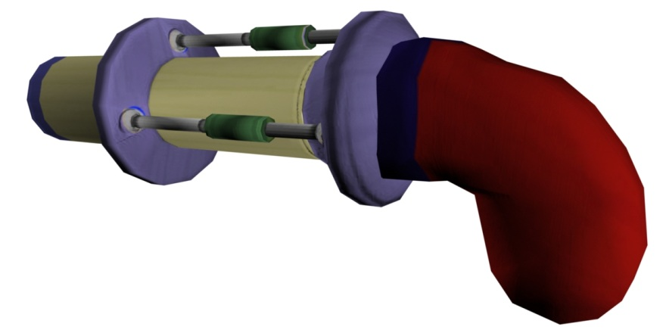

Figure : Pistol final rendering

The Pistol is the reliable fallback weapon for most players. It is a relatively compact and accurate, single-shot firing weapon that delivers a range of payloads (unlike all other weapons). By “charging” this weapon before firing, players may increase its potential Damage per Round. As outlined in the attribute table below, uncharged rounds deliver a relative low amount of damage, and a fully charged round delivers a much greater amount of damage. Damage caused by partially charged rounds deliver a relative (to the charge amount) amount of damage.

In addition to the common weapon attributes, the Pistol contains a *Charge Time* attribute, defined as:

Charge Time – The minimum amount of time needed to charge the weapon from uncharged (a charge of zero) to fully charged.

Table : Pistol attribute table

|  |  |
| --- | --- |
| Attributes | Values |
| Maximum Ammunition | 48 |
| Rounds per Clip | 6 |
| Delay between Fired Shots | 0.3 seconds |
| Damage per Round | 5 (uncharged), 40 (fully charged) health units |
| Bullets Fired per Shot | 1 |
| Charge Time | 2.5 seconds |
| Reload Time | 1 seconds |
| Range | 20 meters |
| Resource Point Allocation | 1 |

#### Shotgun

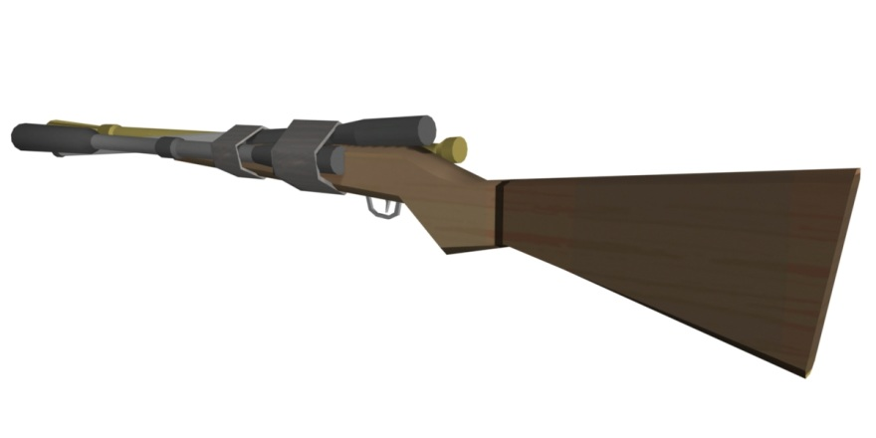

Figure : Shotgun final render

Considered the ideal weapon for close combat, fast reaction players, the Shotgun delivers a relatively high amount of damage when shot from the “ideal” range and dead on target. It expels multiple bullets (in a spray-like fashion) when fired, but one may hardly predict their trajectory with an always-confident level of accuracy.

The damage dealt by a Shotgun blast is directly proportional to the number of bullets that encounter an object. The fired bullet’s spread range is directly proportional to the distance between the end of the barrels (when the gun is fired) and the object they encounter.

In addition to the common weapon attributes, the Shotgun contains a *Spray Radius* attribute, defined as:

Spray Radius – The maximum radius from the end of the gun’s barrel, on the plane perpendicular to the barrel, in which bullets’ trajectory vectors will fall.

Table : Shotgun attribute table

|  |  |
| --- | --- |
| Attributes | Values |
| Maximum Ammunition | 35 |
| Rounds per Clip | 8 |
| Delay between Fired Shots | 0.75 seconds |
| Damage per Round | 5 health units |
| Bullets Fired per Shot | 5 |
| Spray Radius | 0.5 meters |
| Reload Time | 0.75 seconds |
| Range | 8 meters |
| Resource Point Allocation | 1 |

#### Assault Rifle

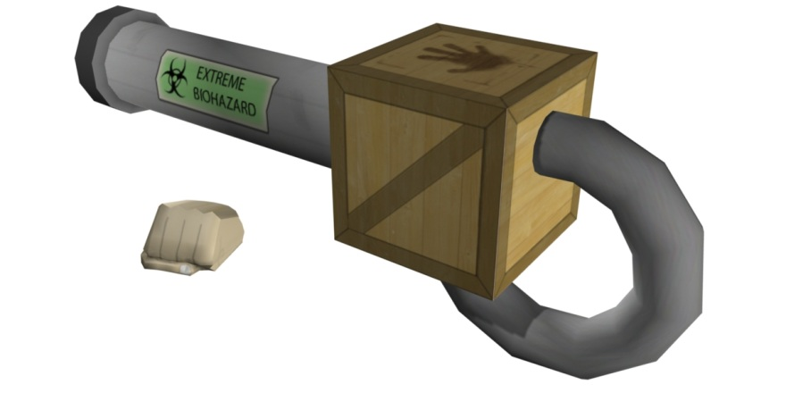

Figure : Assault Rifle final render

The Assault Rifle is a close encounter of the painful kind. This weapon fires off rounds faster than any other weapon at the player's disposal and excels at rapid-fire bursts. Each bullet has a relatively low damage value and loses any punch it has quickly, but with the highest number of rounds per clip of any weapon, it easily earns its name as the *Assault* Rifle.

This weapon contains only the common weapon attributes.

Table : Assault Rifle attribute table

|  |  |
| --- | --- |
| Attributes | Values |
| Maximum Ammunition | 200 |
| Rounds per Clip | 30 |
| Delay between Fired Shots | 0.1 seconds |
| Damage per Round | 4 health units |
| Bullets Fired per Shot | 1 |
| Reload Time | 1 seconds |
| Range | 15 meters |
| Resource Point Allocation | 1 |

#### Cannon Gun

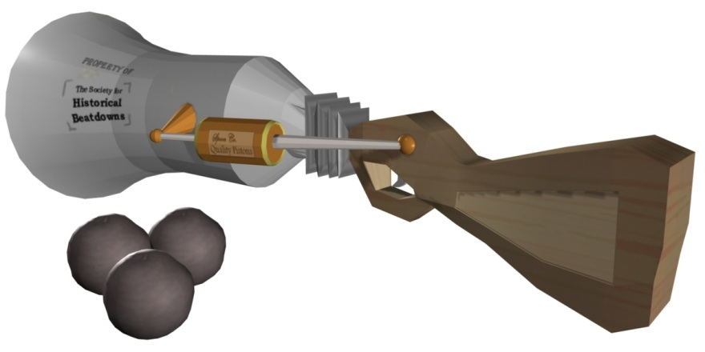

Figure : Cannon Gun final render

The Cannon Gun is a cannon with a chip on its shoulder; it is a weapon for players that like to see things go boom in a hurry. It fires cannonballs with a relatively fair amount of accuracy, and upon their contact with a player or surface, they explode in flaming glory, inflicting instantaneous damage to any enemy within their blast radius, and throwing them with a force relative to their distance from impact.

In addition to the common weapon attributes, the Cannon Gun contains a *Blast Radius* attribute, defined as:

Blast Radius – The maximum radius from cannonball impact with any surface, in which enemy players may feel any impact from the impact blast.

Table : Cannon Gun attribute table

|  |  |
| --- | --- |
| Attributes | Values |
| Maximum Ammunition | 8 |
| Rounds per Clip | 1 |
| Delay between Fired Shots | 1.5 seconds |
| Damage per Round | 80 health units |
| Bullets Fired per Shot | 1 |
| Blast Radius | 0.5 meters |
| Reload Time | 1 seconds |
| Range | 45 meters |
| Resource Point Allocation | 2 |

#### Sniper Rifle

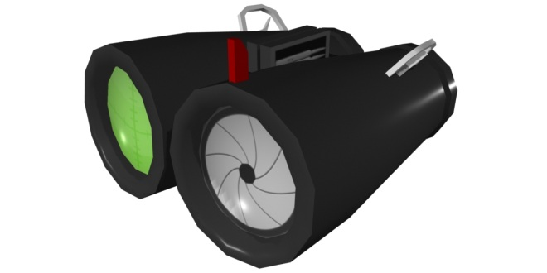

Figure : Sniper Rifle final render

The Sniper Rifle is for long-range, single fire precision and pain. It is a relatively high-impact and long recharge weapon, with a zooming scope (the only weapon to have such) that allows for precision marksmanship. Players utilizing this weapon will not generally do so in close quarters with their enemy but instead, from far behind the front lines, with an eye for picking enemies off one-by-one. Key to using this weapon effectively is a steady hand and an accurate mental stopwatch for its relatively long reload time.

This weapon contains only the common weapon attributes.

Table : Sniper Rifle attribute table

|  |  |
| --- | --- |
| Attributes | Values |
| Maximum Ammunition | 12 |
| Rounds per Clip | 1 |
| Delay between Fired Shots | 1.5 seconds |
| Damage per Round | 70 health units |
| Bullets Fired per Shot | 1 |
| Reload Time | 3 seconds |
| Range | 50 meters |
| Resource Point Allocation | 2 |

## Modifiers

Modifiers are deployable, energy consuming, triggered, affecting, and destructible objects. Their primary function is to create a tactical advantage for those who use them, and unlike weapons, they cannot weaken enemy players. They are defenseless, mostly passive objects that only cause an effect on players (including friendly players) who come within their Effect Radii. Their effects are temporary, however, but do compound on effects currently on players, and even last on affected players who leave their Effect Radii.

### Modifier Deployment and Identification

Players deploy modifiers from the Modifier Launcher object, and if they have any modifiers equipped, they will automatically have a Modifier Launcher at their disposal. This is the Modifier Launcher:

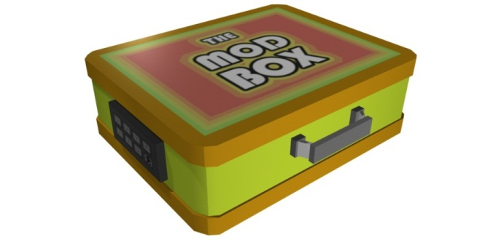

Figure : Modifier Launcher final render

When players deploy modifiers, they exit the Launcher in a straight line and attach themselves to the first object they encounter (including players). Depending upon whose team deployed a modifier, its presence in the world is identifiable by either the generic Modifier Icon object, or a more specific version.

If an enemy player deployed a modifier, it would look like the generic Modifier Icon, pictured below. If a teammate deployed a modifier, it would look like some semblance of the effect it would cause (see the icons in Modifier Types). And if a player deployed a modifier, it would not only look to her or him like the effect it would cause, but would be highlighted in such a way that it stands out from the others.



Figure : Modifier target final render

When players launch modifiers, there is always some indication on the screen of the relative direction to those modifiers. This is not the case for modifiers deployed by others (including teammates). To see those modifiers, players must be within an unobstructed, visual range of them.

### Modifier Energy

Modifiers consume energy when deployed. Each may consume a unique amount (see Modifier Types below), but they all draw from the same energy pool. This energy pool is associated with the player and is only available when one has at least one modifier equipped.

If a player tries to deploy a modifier that requires more energy than she or he currently has, the modifier will not deploy. Moreover, the only way to recollect used energy is to destroy (or have destroyed) the deployed modifier (see Modifier Destruction). Once a player destroys a modifier, its Modifier Energy immediately returns to its deployed player.

### Modifier Triggering

Although players may have deployed modifiers, they do not become agitated by nearby players (players within their Effect Radii) unless the player who deployed them simultaneously triggers them. Players may trigger deployed modifier indefinitely, and they do so with any weapon in hand and right clicking on their Modifier Icons (see Weapon and Modifier Mechanics). When agitated, modifiers deploy their effects instantaneously, affecting any players (including teammates) within their Effect Radii. These effects compound any other effects players are experiencing at the time, and remain with the affected players until the effect’s Effect Duration has expired.

### Modifier Destruction

Modifiers do not have to exist in the game world forever, and both enemies and those who deployed them may destroy them. One common attribute amongst all modifiers is Modifier Health, and its value is the damage required by any player to destroy it (see Modifier Attributes). To destroy an enemy’s modifier, players must equip themselves with any weapon and right click on the modifier icon. Doing this causes damage to the modifier, but only destroys it if the damage caused depletes the modifier of all of its Modifier Health.

Players may also destroy modifiers that they deployed, but only with the Modifier Launcher in hand. As with destroying enemy modifiers, players right click on the modifier icon to deal it damage, and once they have depleted its Modifier Health, they will have destroyed it.

All destroyed modifiers, regardless of whom by, immediately return their energy to the player who deployed them. Moreover, if a player has deployed modifiers in the world and then respawns with no modifiers equipped, their modifiers will remain in place. However, they will not be able to destroy their own modifiers. all of their deployed modifiers will immediately self-destruct – causing no effect on any players.

### Modifier Attributes

All modifiers share a common set of attributes, including *Modifier Health*, *Effect Radius*, *Effect Duration*, and *Energy Use*. Few have additional attributes and we define the common attributes as follows:

Modifier Health – The damage required to destroy a modifier.

Effect Radius – The radius in which players must be to be affected by a subsequently triggered modifier’s effect.

Effect Duration – The time a modifier’s effect affects a player.

Energy Use – The energy required from the player’s energy pool to deploy the modifier.

### Modifier Types

#### Inverse Gravity



Figure : Inverse Gravity icon final render

Inverse Gravity is the modifier of choice for players looking to really throw their enemies for a loop – and it acts exactly as its name implies. When triggered, any enemies caught within its Effect Radius have their field of gravity instantly reversed.

In addition to the common modifier attributes, Inverse Gravity contains an *Extra Force* attribute, defined as:

Extra Force – An instantaneous force applied to affected players. Its direction is opposite of the players new gravitational force

Table : Inverse Gravity attribute table

|  |  |
| --- | --- |
| Attributes | Values |
| Modifier Health | 5 health units |
| Effect Radius | 0.23 meters |
| Effect Duration | 13 seconds |
| Energy Use | 22 energy units |
| Extra Force | 10 newtons |

#### Knockback

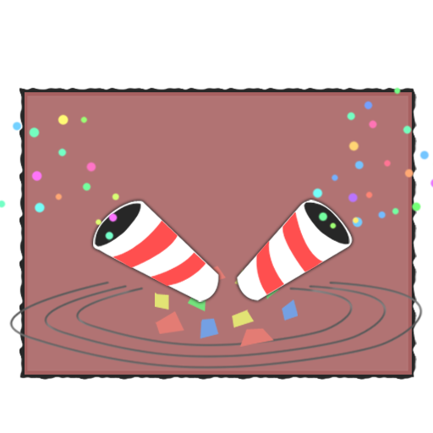

Figure : Knockback icon final render

The Knockback Modifier is perfect for players looking to clear a path through their enemies. When triggered, any players caught within its Effect Radius experience an instant, spherical force. This force is in the direction opposite the modifier’s position minus the affected player’s position

In addition to the common modifier attributes, Knockback contains an *Extra Force* attribute, defined as:

Extra Force – An instantaneous force applied to affected players.

Table : Knockback attribute table

|  |  |
| --- | --- |
| Attributes | Values |
| Modifier Health | 5 health units |
| Effect Radius | 0.23 meters |
| Effect Duration | Instant |
| Energy Use | 19 energy units |
| Extra Force | 10 newtons |

#### Featherlight



Figure : Featherlight icon final render

When triggered, any players caught within the Featherlight modifier’s Effect Radius experience an instant reduction in weight. With a lower weight, players are less affected by outside forces (relative to players with “normal” weight), including gravitational and those exerted from other modifiers.

In addition to the common modifier attributes, Featherlight contains a *Weight Reduction* attribute, defined as:

Weight Reduction – The percentage by which affected players’ weight is reduced.

Table : Featherlight attribute table

|  |  |
| --- | --- |
| Attributes | Values |
| Modifier Health | 5 health units |
| Effect Radius | 0.23 meters |
| Effect Duration | 10 seconds |
| Energy Use | 25 energy units |
| Weight Reduction | 75.0% |

#### Frictionless

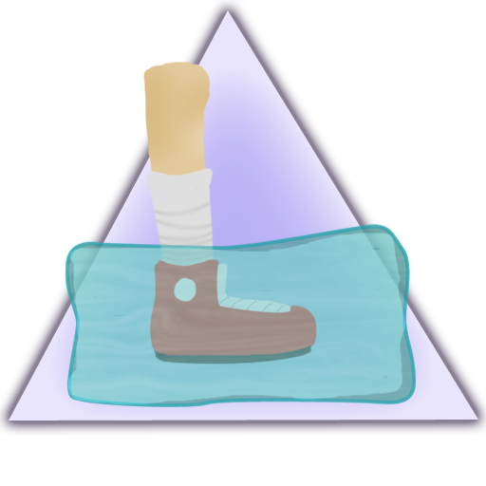

Figure : Frictionless icon final render

The Frictionless modifier is an invisible ice rink disaster waiting to happen. With this modifier, players give the gift of high speed and low friction to their affected brethren. When triggered, any players caught within its Effect Radius immediately experience an increase in speed, and a drastic reduction in friction.

In addition to the common modifier attributes, Frictionless contains an *Acceleration Factor* attribute, defined as:

Acceleration Factor – The percentage by which affected player’s current acceleration changes.

Table : Frictionless icon final render

|  |  |
| --- | --- |
| Attributes | Values |
| Modifier Health | 5 health units |
| Effect Radius | 0.23 meters |
| Effect Duration | 5 seconds |
| Energy Use | 19 energy units |
| Acceleration Factor | 200.0% |

#### Barrier

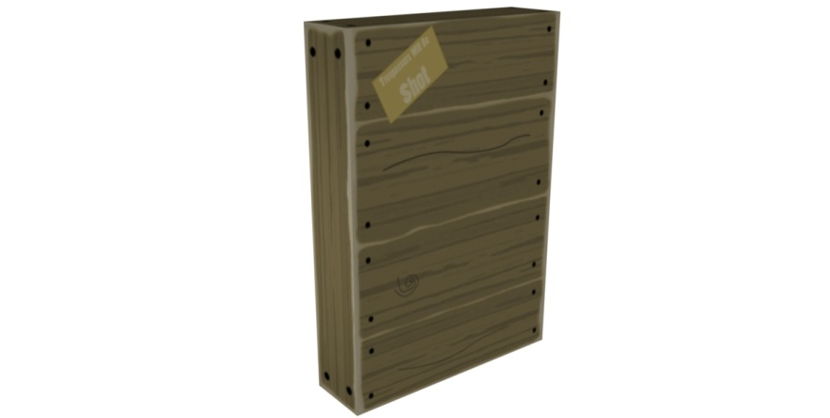

Figure : Barrier object final render

Barrier is the multi-purpose modifier used for both beneficial and detrimental effects. When triggered, this modifier instantly builds an impenetrable and slightly transparent wall, perpendicular to its modifier icon.

This modifier contains only the common modifier attributes, but does not contain an Effect Radius.

Table : Barrier attribute table

|  |  |
| --- | --- |
| Attributes | Values |
| Modifier Health | 100 health units |
| Effect Radius | not applicable |
| Effect Duration | 13 seconds |
| Energy Use | 24 energy units |

#### Grow

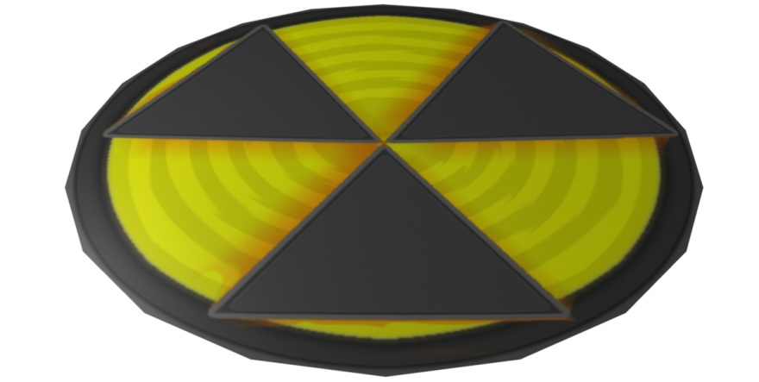

Figure : Grow effect final render

When triggered, any players caught within the Grow modifier’s Effect Radius experience an instant growth spurt. While new giant proportions may hamper ones’ ability to fit through doorways, it does offer an extra layer of protection from enemy bullets. This effect also reduces affected player’s speed.

In addition to the common modifier attributes, Grow contains a *Size Multiplier*, *Damage Bonus*, and *Speed Reduction* attribute, defined as:

Size Multiplier – The percentage by which affected player’s size changes.

Damage Bonus – The percentage by which affected player’s health is affected by enemy fire.

Speed Reduction – The percentage by which affected player’s maximum speed reduces.

Table : Grow attribute table

|  |  |
| --- | --- |
| Attributes | Values |
| Modifier Health | 5 health units |
| Effect Radius | 0.23 meters |
| Effect Duration | 5 seconds |
| Energy Use | 15 energy units |
| Size Multiplier | 150.0% |
| Damage Bonus | 80.0% |
| Speed Reduction | 85.0% |

#### Shrink

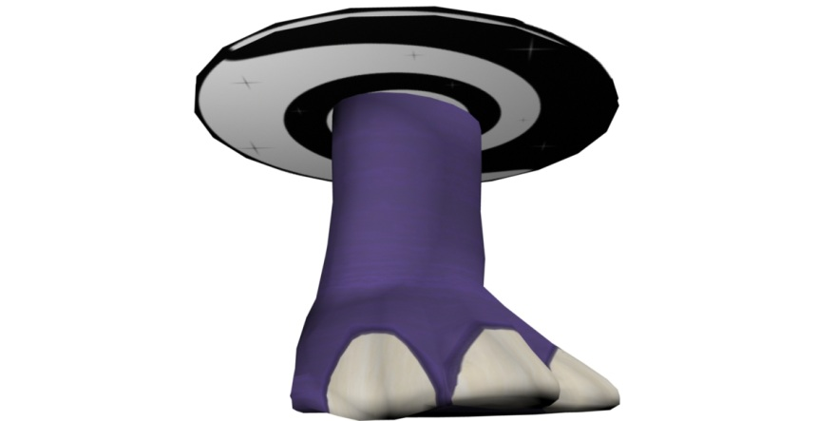

Figure : Shrink effect final render

Almost completely opposite to the Grow Modifier, the Shrink Modifier’s effect causes an instant reduction in size to those players caught within its Effect Radius. It also makes those players more vulnerable to enemy fire, but does not decrease their speed.

In addition to the common modifier attributes, Shrink contains a *Size Multiplier* and *Damage Reduction*, defined as:

Size Multiplier – The percentage by which affected player’s size changes.

Damage Bonus – The percentage by which affected player’s health is affected by enemy fire.

Table : Shrink attribute table

|  |  |
| --- | --- |
| Attributes | Values |
| Modifier Health | 90 health units |
| Effect Radius | 0.23 meters |
| Effect Duration | 5 seconds |
| Energy Use | 15 energy units |
| Size Multiplier | 75.0% |
| Damage Bonus | 115.0% |

#### Illusion



Figure : Illusion icon final render

When desperate times call for a distraction, the Illusion Modifier is typically the answer. Regardless of one’s distance to these modifiers, when triggered, they release an indestructible clone of an enemy player. They run, jump, and fire just like the player who deployed them, but their bullets never harm anything, their modifiers never really deploy, and enemy bullets pass right through them. They are a decoy, but only temporarily.

This modifier contains only the common modifier attributes, but does not contain an Effect Radius.

Table : Shrink attribute table

|  |  |
| --- | --- |
| Attributes | Values |
| Modifier Health | 5 health units |
| Effect Radius | not applicable |
| Effect Duration | 14 seconds |
| Energy Use | 14 energy units |

# Player

## Player Movement

Player representations in the *Trigger Happy* environment exhibit a bipedal human movement model. This model allows players to move forward and backward, turn side-to-side, jump, and strafe.

## Player Shields/Health

In *Trigger Happy*, players live and die by the shield (or health) protection they maintain. As players take damage from enemy weapon fire, they lose shield protection. And when they lose all shield protection, the weakest shot, explosion, or other physical attack will kill them. Shields are self-healing, however, and time free of damage will repair players’ shields and will eventually return them to their full protective nature.

## Player Death and Respawning

When players die, they must wait 10 seconds (at least) before reentering the game (respawning). During this period, they have the opportunity to alter their weapon and/or modifier load-outs, and equip themselves with that gear. They also regain full shields and, if they are re-equipping themselves with modifiers (i.e., they had no modifiers equipped when they last died) they will regain full Modifier Energy.

Where players respawn in the Trigger Happy world is game mode specific (see Game Modes), but players do reenter the world invulnerable to weapon fire and modifier effects (for some relatively small period). They may neither fire their weapons during this period, nor affect any modifiers (on either team). However, they are free to move about and interact with the world during this time.

# Input Controls

*Trigger Happy’s* physical control schemes were designed to be intuitive and direct. Three, slightly different schemes allow players to navigate through and control the game, including navigation and control through all menu and gameplay states. Moreover, mouse and keyboard are the only supported input devices.

## Menu Navigation

All menu navigation is simple and intuitive. One may use either the mouse pointer or keyboard arrow keys to highlight menu items, and select them with the click of the left mouse button or by pressing the keyboard’s carriage return key.

## Weapon and Modifier Screens Navigation

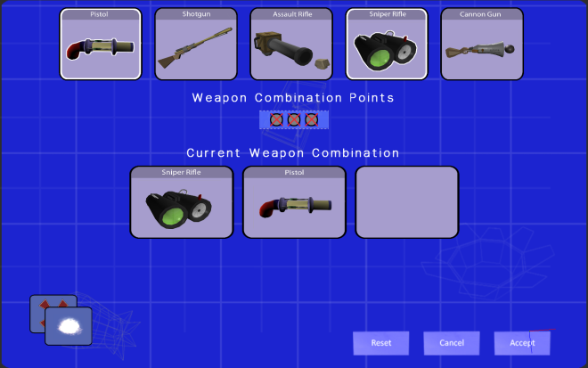 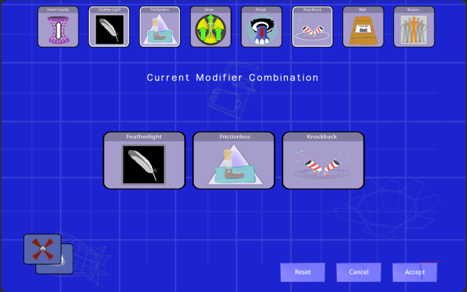

Figure : Weapon and Modifier selection screen final renders

As menus, the weapon and modifier selection screens share the general menu-navigation control scheme. However, they also include additional controls; namely, numeric hotkeys. As depicted in the image below, number keys 1-8 correspond to the selectable weapons and modifiers on their respective screens. Pushing any of these keys will select the matching weapon or modifier. For instance, pushing key 1 when on the Weapon Selection screen will select the weapon on the far left. Pushing key 8 on the Modifier Selection screen will select the modifier on the far right.

Other keyboard keys have a role as well. Key 9, for instance, resets selections made since entering the screen state, and key 0 cancels the selections made in the same period. The CTRL key toggles between the Weapon Selection and Modifier Selection screens and the carriage return key accepts the selection (and initiates a transition to the next game state).

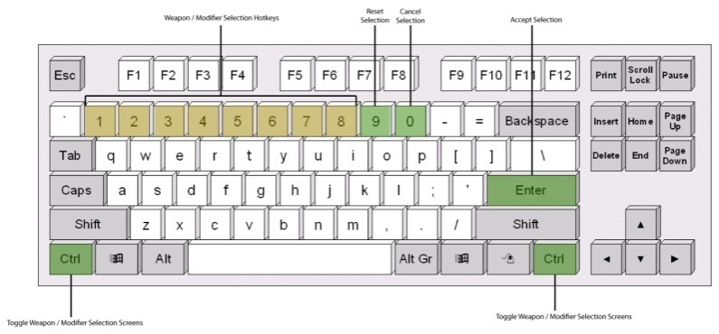 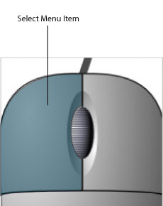

Figure : Weapon and Modifier selection keyboard and mouse button layout

## In-Game Navigation

The in-game input-control scheme closes matches that of a typical first-person shooter game. Players must use both the mouse and keyboard to navigate the environment and, unlike menu navigation, each input device (for the most part) plays a unique role. More specifically, players use the mouse to control their character’s look orientation, to fire their weapon, trigger their modifiers, and scroll through their equipment. They use the keyboard to translate their character, jump and crouch, select their weapons and modifiers, and call up in-game menus. The images below depict the exact details.

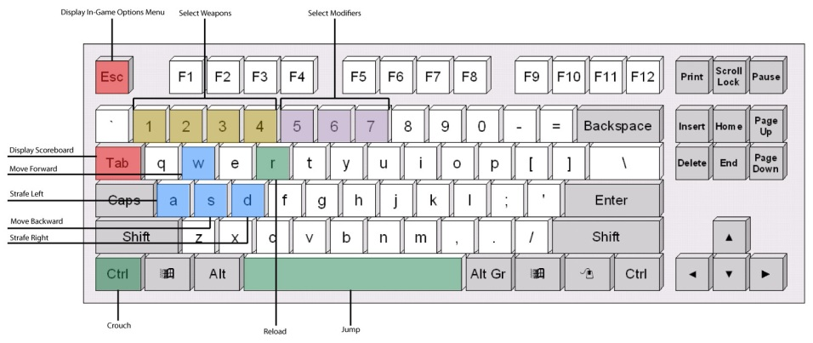 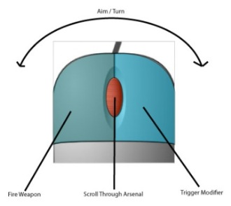

Figure : In-game keyboard and mouse button layout

# Game States and Screens

The following section describes the game states and screens one would enter and see when they start *Trigger Happy*, as well as the graphical user interface the in-game environment provides.

## Logo Screens and Initialization

  

Figure : Intro logo screen final renders

The *Logo* screens are the first players see when they start *Trigger Happy*. They are a series of screens that fade in and out, showing the development team's logo, the Singularity engine's logo, copyright details, and a brief mention of RIT's Game Design and Development graduate program.

The purpose of these screens is to give the player something to look at while the game initializes itself in the background. Once *Trigger Happy* has initialized, the final *Logo* screen fades into the *Main Menu* screen.

## Main Menu Screen and Point-of-Entry

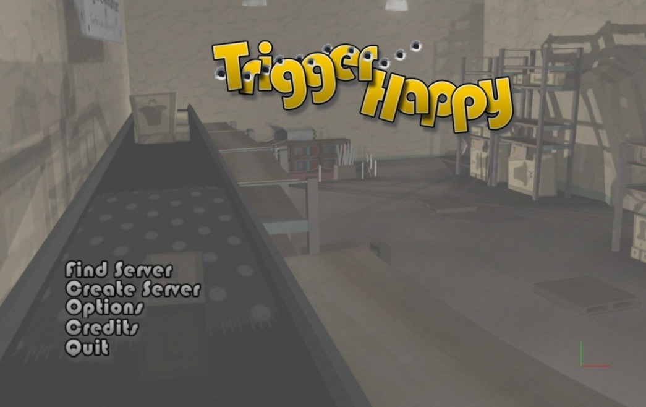

Figure : Main menu final render

The *Main Menu* screen is the first with which players may interact. It is from here that they initiate all game play, and it shows *Trigger Happy’s* title image and a menu of first-level options. The menu options highlight when the mouse pointer is over them, and include these options: *Find Server*, *Create Server*, *Options*, *Credits*, and *Quit*. When players select any option, its respective screen displays over the *Main Menu’s*.

### Find Server

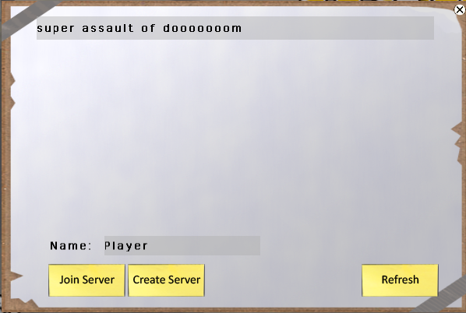

Figure : Find Server screen final render

From the *Main Menu* screen, players may enter the *Find Server* screen. This screen shows the name of all servers running the *Trigger Happy* game, and allows players to select and join one. Players may also change the default *Name* (representing their character’s name in the forthcoming game) from “Player”. If there are no server names displayed, players may *Refresh* the displayed name list until one appears, or go to the *Create Server* screen and create their own (as they may from the *Main Menu* screen).

### Create Server

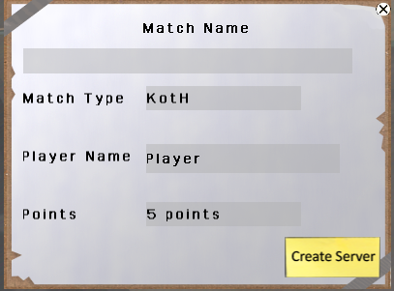

Figure : Create Server screen final render

From both the *Main Menu* and the *Find Server* screens, players may enter the *Create Server* screen. This screen allows one to host a *Trigger Happy* match, and set the *Match Name*, *Match Type*, their character’s name (*Player Name*), and any parameters pertinent to the Match Type set (see Game Modes for relevant parameters). And assuming players correctly enter all information, clicking this screen’s *Create Server* button will add the Match Name to the *Find Server* screen’s list of server names (for other players to see) and transition into the *Match Lobby* screen.

### Options

From the *Main Menu* screen, players may enter the *Options* screen. This screen is supposed to allow players to adjust various visual, audial, and performance settings for their personal game-playing experience.

### Credits

From the *Main Menu* screen (by selecting the *Credits* or *Quit* option), players may enter the Credits screen. This screen displays information pertaining to those who developed *Trigger Happy*, including students and third party sources, the RIT faculty, who the students would like to thank for their contributions, and the third party tools used by the students during development of *Trigger Happy*.

### Quit

From the Main Menu screen, players may quit the game. Selecting the *Quit* option first displays the Credits screen then, after some delay, kills the *Trigger Happy* process.

## Match Lobby Screen and Choosing Teams

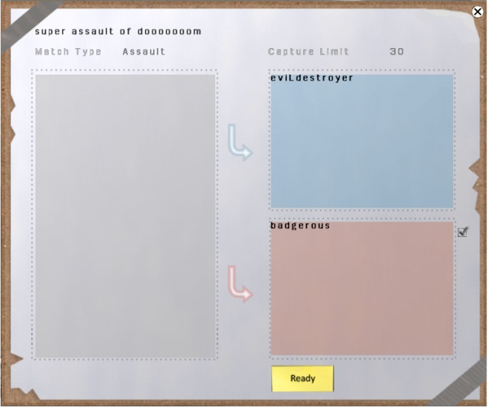

Figure : Match Lobby screen final render

Once players have either joined a server from the *Find Server* screen, or created a server from the *Create Server* screen, the *Match Lobby* screen appears. Here, they see relevant match information (as set the server creator in the *Create Server* screen), the name of players who have joined (and are waiting to join) one of the forthcoming match’s teams, and an option to joint one themselves. There is often a player size limit for each team, and players may only join a team if there is room available on it.

When all of the players have joined a team and are ready to proceed, they toggle the *Ready* button and wait for all others to do the same. Once everyone is “ready,” the game begins loading and this screen transitions to the *Game Loading* screen.

## Game Loading Screen and Loading

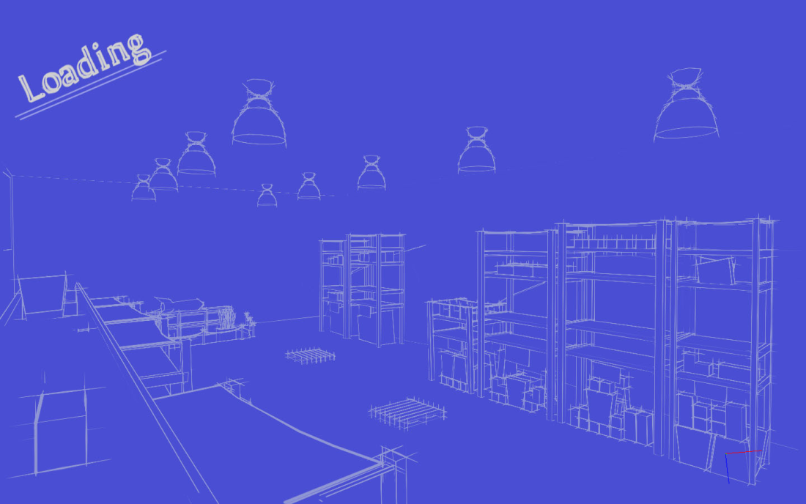

Figure : Game Loading screen final render

After players have chosen teams and before a match begins, the initial game state and environment assets must load into memory. Players see the *Game Loading* screen while this takes place, and are automatically transitioned to the in-game state (starting with the Weapon and *Modifier Selection* screen) once the initial game state and all assets have been loaded.

## In-Game

### Weapon and Modifier Selection Screens

Before a match begins and after players die, each has the opportunity to equip her or himself with a number of unique weapons and modifiers. There are five weapons and eight modifiers to choose from, and players may enter the battlefield with three of each (potentially). There are no rules governing which three modifiers one selects, but weapons do have some restrictions (see Equipping Weapons and Modifiers for restriction details).

 

Figure : Weapon and Modifier selection screen final renders

As depicted in the above images, both screens are visually similar, and players may switch between the two by selecting the respective screen icon (found in both screen’s bottom left corner). In the *Weapons Selection* screen, all available weapons, represented by their respective icons, appear in a row along the top. Similarly, all available modifiers, represented by their respective icons, appear in a row along the top of the *Modifier Selection* screen. Player selected weapons and modifiers appear in a central row of icons (on their respective screens), and players may *Accept*, *Cancel*, or *Reset* their selections by selecting the respective buttons (along the bottom right of each screen). The only addition to either screen is the Weapon Selection screen’s *Weapon Combination Points*, and as outlined in Equipping Weapons and Modifiers, this area displays the number of “Resource Point Allocation” values remaining in the player’s weapon selection. Selected weapons and modifiers show an outlined icon, and weapons that players may not select (because of restrictions) show an icon with a red X across them.

Selecting the *Accept* button *equips* players with their selected Weapons and Modifiers, and transitions them to the *Spawn* screen. If players select the Accept button before selecting any weapons, they are automatically *equipped* with the Pistol and then transitioned to the Spawn screen.

The Cancel button is only effective after players die (as opposed to the first time they select weapons and modifiers for the current match). It allows them to enter the Spawn screen equipped with the weapons and modifiers they had when they died, and ignore any selections they had made since then.

The Reset button clears player’s current Weapon or Modifier selection depending on which selection screen they are on. If they are on the *Weapon Selection* screen, all “Weapon Combination Point” indicators. When selected, players essentially un-equip themselves of all weapons and modifiers and upon then selecting the *Accept* button, will transition to the *Spawn* screen equipped with either the default Weapon or the Weapons and Modifiers selected since then.

### Spawn Screen and State

Players reach the Spawn screen and state from one of two ways – they select the *Accept* button in either the *Weapon* or *Modifier* selection screens for the first time in a match or “die” during one. The *Spawn* state is timed, and players must remain within it for that period. In other words, they may not enter (or reenter) the *Trigger Happy* environment until the “spawn time” has expired.

No matter how players enter the Spawn state, the screen shown allows them to transition into the *Weapon* and *Modifier* *Selection* screens, or spawn into the *Trigger Happy* environment. To transition to the *Weapon* and *Modifier* Selection screens, players select the *Arsenal Select* button, found at the bottom right of the screen. To spawn into the *Trigger Happy* environment, players select the *Spawn* button from the bottom right of the screen, which becomes available once the “spawn time” has expired.

In addition to navigation buttons, the *Spawn* screen shows the real-time progress of the current match. When the match is Assault, for instance, it shows a linear graph of the flag’s progress with respect to the “capture points”, as well as the time remaining for the assaulting team to claim a point captured. Before the assaulting team captures a point, its graphical representation on the graph is the defending team’s color. Once the assaulting team captures a point, the image changes to the assaulting team’s color.

When the match is King of the Hill, the screen shows the number of captured control points by each team. And when it is Deathmatch, it shows the total number of kills by each team, as well as the total needed to claim victory. (See Game Modes for a complete description of each game mode.)

## In-Game Graphical User Interface

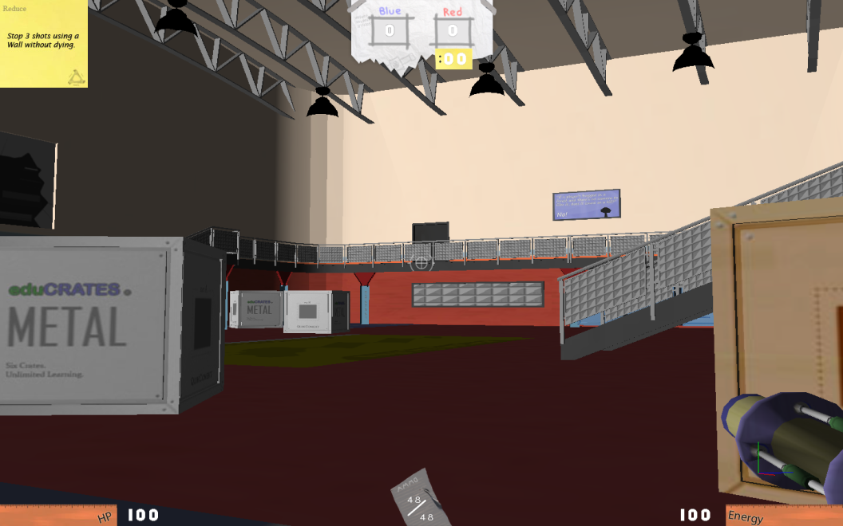

Figure : In-game screen plus HUD placements

The in-game user interface displays everything players need, to know about both their character’s state and the current match’s. Informative graphics surround the player’s view and include a *Shield Meter*, *Modifier Energy Meter*, *Weapon Ammo Meter*, *Target Reticle*, and *Game Mode Interface*.

### Shield Meter

The Shield Meter represents the level of shield protection a player currently maintains (see Player Shields/Health). It resides in the bottom left region of the in-game screen and reflects a player’s level of shield protection in real time. That is, as the player loses shield protection, the graphic slides off the left of the screen to reflect such. And when a player no longer has shield protection, the graphic is no longer visible.

A visible percentage of full shield protection accompanies the graphic and moves along with it, both physically and numerically, to reflect the player’s current percent of shield protection. At 100%, the player has full shield protection. At 0%, the player has no shield protection.

### Modifier Energy Meter

The Modifier Energy Meter represents the level of Modifier Energy a player currently maintains (see Modifier Energy). It resides in the bottom right region of the in-game screen and reflects a player’s level of Modifier Energy in real time. That is, as the player uses Modifier Energy, the graphic slides off the right of the screen to reflect such. And when a player no longer has Modifier Energy, the graphic is no longer visible.

A visible percentage of full Modifier Energy accompanies the graphic and moves along with it, both physically and numerically, to reflect the percentage of available Modifier Energy to the player. At 100%, the player has available a full amount of Modifier Energy. At 0%, the player has no Modifier Energy available.

### Weapon Ammo Meter

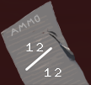

Figure : Ammo Meter final render

The Weapon Ammo Meter represents the number of bullets remaining in the player’s current weapon clip. It resides in the bottom center region of the in-game screen and reflects the bullet count in real time. The bottom number represents the total number of bullets that fit in the clip and the top number represents the number of bullets left in the clip. Moreover, as the player fires bullets, reloads their weapon, and/or changes weapon, both values update to reflect these changes.

### Target Reticle

While in a match, players always have a reticle in the middle of their screen. This reticle represents where the player is aiming at any given time with their currently selected Weapon or Modifier.

### Game-Mode Interface

Along the top center of the in-game screen is a graphical representation of the current match’s gameplay statistics. It updates in real time to reflect important match details, and serves as the sole in-game means through which players may see, in a definitive way, the tide of match. Each game mode (see Game Modes) has its own graphic and each presents information only relevant to that game mode.

#### Assault Interface



Figure : In-game Assault interface final render

The Assault interface presents a linear graph of the flag’s progress with respect to the “capture points,” as well as the time remaining for the assaulting team to claim a point captured. Before the assaulting team captures a point, its graphical representation on the graph is the defending team’s color. Once the assaulting team captures a point, the image changes to the assaulting team’s color.

#### King of the Hill Interface

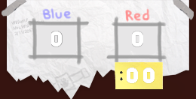

Figure : In-game King of the HIll final render

The King of the Hill interface presents a scoreboard of both teams captured control points. A numeric value reflects the number of control points each team has captured, and the time remaining to capture the current control point is visible beneath the score of the team that has control of the current control point (see King of the Hill).

#### Deathmatch Interface

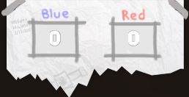

Figure : In-game Deathmatch final render

The Deathmatch interface presents a scoreboard of both teams’ accumulated kills (see Deathmatch).

# World

## Historical Overview

The world of *Trigger Happy* is positioned some centuries into our future. The time leading from our present day to the game's present day breaks down into four major periods: expansion, the birth of cloning, the death of cloning, and the proliferation of cloning.

### Expansion

One century beyond our present day, Mankind was forced to expand into the solar system due to the increasing overpopulation of Earth. After some fits and starts, man succeeded in inhabiting a few nearby planets, which relieved a lot of the strain on Earth's resources and improved life for settlers and home worlders alike. In fact, it was so successful that it set off a rush to capture the often scanty (though sometimes vast) resources of other nearby planets. This expansion initiated a boom in the (now inter-planetary) economy that led to the creation of a number of harvesting companies. However, within a century of exploration, many companies had proceeded so far outside of the solar system that the only nearby colonies were extremely under populated and unable to support further progress (it was hard just finding a place to eat). Of course, the reasonable answer to this problem would have been to wait for populations to increase and to enjoy the abundance of natural resources in the meantime. However, in the calculus of business, the infinite expanse of the Universe, plus a burgeoning market for luxury items, equaled "find any way to keep going."

For some companies, this meant conducting subtle warfare to capture competitors' resources. However, other companies decided to dump vast amounts of money into R&D to solve the supply chain and worker supply problems. Ironically, the solution was to increase the human population, which had triggered Mankind's problems in the first place. With a combination of industry pressure, vast amounts of money, and virtually no ethical oversight, the first cloning technology was born.

### The Birth of Cloning

No one is sure of the exact circumstances, but many believe that the first full-grown human cloning technology was probably created in a dark, dungeon-like lab under the cover of storm clouds. The only thing they do know is that some companies were pressured to put up a memorial to the "courageous" test subjects lost in the process of "discovery.” While at first a trade secret, the extremely expensive cloning process soon spread around the galaxy because of corporate espionage. Corporations with the banked money to make the bottom-line work out in their favor, spawned outposts composed of singled-minded workers that enabled them to press farther on. Unfortunately, expansion only lasted a few decades more, at which point the long expected (and denied) edge of the galaxy was discovered. At this point, the shaky peace between corporations began to breakdown, as the full resource map was now known and it was finally possible to know who was ahead. War became the only method of increasing market share. The situation appeared to revert to the same as the initial boom, but many forgot that clones could be used for more than mining and shipping.

### The Death of Cloning

As corporations declared war on each other, it shortly became clear that the battles were not going to end soon, if ever. Based on the requirements of the cloning process, existing resources, and the attrition rate of combat, it was calculated that war between the two largest corporations would conclude in roughly 3.1x10^7 years. Recognizing the futility of their conflict (but only after harvesting at least 50% of all the galaxy's resources), the various large companies declared peace and set out to undermine each other in different ways. Within a century, the market had become saturated with goods, and the only people that could afford large scale cloning began to fade away.

### The Proliferation of Cloning

As science caught up to greed, the cloning process was refined and cheapened. Alternate methods were also developed, and the price eventually dropped to the point that a normal person could afford one or two backups if they saved for them. Shortly after, employers began to demand that potential employees provide proof of clone to offset any potential losses resulting from death. This, more than anything else, spread clones to the various different pockets on humanity (some of which were originally clone colonies themselves). It became commonplace to know at least one person than had been "swapped" (replaced with a clone) over the course of their life (though fidelity in cloning methods varies and some had woken up one day to find that their swapped significant other was borderline unrecognizable).

In the present day, clone prices have declined enough for most people to support a small group of high fidelity clones. For those with fortune or sponsorship, a vast supply is not beyond reach. More commonly, people buy "upgrades" to their current bodies in the form of trendy new parts. Everything from pragmatic benefit (more strength, dexterity, damage resistance) to innovative fashion (glowing, patterned) is available. Unfortunately, after centuries of wide spread cloning, the corpse waste from the past wars and clone consumerism has started causing environmental issues.

## Life in the Modern Day

### Habitation

Modern life is largely terrestrial in nature. Even though technology has advanced far enough for humans to live in space, the large majority prefer to live on some planet or other. Travel in space remains expensive and/or dangerous at a personal level, so trips are scheduled in way akin to our current airlines. For this reason, most work within their planetary ecosystem unless they happen to be involved in some form of intergalactic business. The exact living conditions vary from planet to planet, but most have a number of terrestrial cities in the most habitable areas. Particularly rich or advantageously located planets can be very populous, but most are less dense than the Earth today. Planets nearer to the Earth are more likely to be populated, but are also more likely to host ruins from our near future (ghost planets).

### Modern Cloning Technologies

A number of cloning methods exist in the modern era. Some are refinements of the original method, while others are new. They each have their own strengths and weaknesses. For example,

Build-a-Body – The most popular cloning method employing standardized, interchangeable appendages to reduce clone construction cost. Customers are measured to determine which parts best match their own natural form and are given a full specification that they can later use to order a supply of clones. Alternately, customers can choose "designer" parts to replace their natural ones (save the face, which is illegal to modify for reasons of identification). Build-a-Body suppliers frequently run promotions featuring new parts, which creates a consumer culture of constant upgrades and outdated models. Customers can switch between their purchased bodies using locally available brain transplant centers (thanks to the ISO-9000 Brain-Body Interface standard and frequent brain backups).

Authentic Cloning – A more expensive cloning method based the original process. It works at the genetic level, allowing the maximum customization possible, but requires a longer, more resource intensive gestation period. Only the rich, vain, or people that must be different need apply.

Multi-Cloning – The most expensive method of cloning by far. It involves the upkeep of a full set of clones from the customer's birth. Usually, an allotment of 10-20 clones will be purchased and then raised in various different locations and living conditions. This scheme has the advantage of allowing the customer to explore many life paths simultaneously and to choose the most pleasing one. Clones following rejected paths are either allowed to live free or terminated.

Ancestral – Often used in situations where cloning technology is shared amongst a village or a particularly important body is vacated. It involves a one-time fee paid to transfer a (usually natural born) person into the body of a recently deceased one. It is so named because it is mainly used by tribal cultures to place the mind of a new leader into the inherited body of the old one. Why they choose to keep these bodies around for generations is unknown, but most think that it is for symbolic, religious, or nostalgic reasons.

# Organizations

There are two main groups in the FPSA: the Appendage Conservation Front (ACF) and the Impossible Possibilities (IP). The ACF is an environmental conservation group formed in response to the resources wasted by clones. The ACF pushes recycling of clones and condemns the waste of clone resources, and are very similar to our world's recycling advocates. They push the FPSA to allow students access to recycled or refurbished body parts in the event of an injury, rather than a full-on clone replacement. The IP, on the other hand, is a group that pioneers new technology in the world of *Trigger Happy*. While maintaining a peaceful front, this group secretly trades the forefront of technology to the FPSA for the ability to use students as test subjects for new experience.

## The Industry

Ever since the advent of reasonably priced clones, there have been jokers and daredevils that have exploited the entertainment opportunities inherent. It is from these brave pioneers (mostly using viral media to distribute their work) that the "industry" as we know it was born. Hits like *Last Safari*, *Candid Catastrophe[[4]](#footnote-5)*, and *Real World Asteroids* propelled them into the public eye and earned them the first network contracts for this type of entertainment. As clone programs (which they came be to known as) began to multiply, genres were identified and explored. The genre that was most important for our industry was originally called "historical reenactment.” This class of programs (and eventually, events) took their inspiration from past battles and utilized the talents of the few warriors that still studied combat.  A single "re-nact" pitted teams representing each of side of a historical conflict against each other in "realistic" locations. No one is sure if the original re-enactments were ever truly accurate in a historical sense, but as their audience exploded, rules were bent more and more (see the "telephone theory of history"). For example, *Spartans XVII: Xerxes Space Giant* was not much like the battle as scholars know it, but it did set a record for simultaneous viewers.

A natural result of the continued rule bending was the expansion of re-enactment programming to include many non-historical combat scenarios. The first example of this type of program was *Rockets vs. 100,* a game show where 100 randomly chosen participants were provided with clones and tasked with taking down a single contestant with a rocket launcher. Needless to say, it was both pioneering and a breakthrough hit. Running simultaneously with the diversification trend was its emergence from the video programming studios. Real world competitions began to draw as well as their video counterparts (even in 3D segments). However, the real breakthrough was the personalization of combat.

The joint forces of cheapening clones and audience expansion meant that investors could afford to sponsor the cloning requirements for a small team or single participant. Unlike the industry stars, these teams could cater to smaller clients and even personal requests. It is at this time that we witnessed the birth of personalized performances for large parties, conflict resolution, commercials and even pranks.

The remaining time between then and the present was largely dominated by the standardization of the industry. Leagues sprung up for hopefuls looking to secure a rare job; they usually stuck around until their supplies of clones ran out (and sometimes, tragically, even afterwards). However, making it big is still nothing but a dream for most. However, if one is willing scrap, there is an alternate path to stardom that involves using low paying, oddball performances to jump-start a team. It is this path that the Future Proficient Soldier Academy initially takes.

## Future Proficient Soldier Academy

The FPSA was founded three years before the present day. It is the first school to offer instruction in the various fields associated with clone-based combat. It runs its own school ("The Academy"), and maintains partnerships with two other organizations that offer their own services.

### The Academy a.k.a. "*Trigger Happy* High"

The Academy teaches courses in two main areas. The first covers combat skills and the performing arts required for being a professional combatant. After a baseline of entertainment prowess is established, students are taught a variety of weapon and tactical skills. Finally, they are given the opportunity to develop a specialty and a persona to sell themselves. It also features minors in various types of historical warfare.

The second area is an art program focused on weapon and modification crafting. Students select a specific class of weapon or modification as their focus and produce a working example as a final project. Admission to the academy is based on a portfolio for craft students and a skills assessment for combat students.

### Appendage Conservation Front a.k.a. "Spleen Peace"

The ACF is an environmental conservation group that is part of a larger network of volunteer environmental organizations[[5]](#footnote-6). It plays a role in several areas, but its association with FPSA is through its part recycling services. The ACF was formed in the past as a reaction to the corporate wars. They objected not so much to the violence as to the massive waste of resources that it caused. In their eyes, perfectly good body parts were being discarded and replaced with full clones for no good reason. In response, they pioneered the first clone recycling methods, which both created a low cost, clean market for appendages and began to deal with the pollution.

Centuries after their creation, environmental damage from the past wars still exists along with the new scourge of clone consumerism (resulting from cheaper prices). Their current mission is to advocate for restraint in purchasing new clones and encourage recycling of parts. This mission has a few parts. One is their hospital wing, which deals with the emergency care -- refurbishing discarded limbs for use in repairing bodies instead of replacing them (how quaint). FPSA began working with ACF as a way to cut costs on clones for their demonstrations (read: make it possible to operate at all). They tolerate the ACF's "enthusiasm" for their cause because they have no other choice. This sometimes even means participating in ACF "diplomatic missions" as support crew. However, the students are given access to cheap body part replacement (a painless procedure, but resulting in some mismatches because this ACF branch gets most of the poor condition models) if they cannot afford their own clones. The other half of this branch's mission is to popularize re-purposed parts among the general populace. Their plan involves jump-starting an underground fashion movement centering on matching up fashions from the past. The Anti-Common Fashion (ACF) line is the heart of this movement and draws on the best of their recycled parts.

### Impossible Possibilities

Impossible Possibilities is a research and development lab that maintains a branch in the FPSA building. They specialize in developing technology for the clone combat industry and operate as part of a powerful media corporation. Their official agreement with FPSA is that they provide some materials and weapons to students and in exchange get first shot at to recruiting. What is actually happening is a different story. The Impossible Possibilities corporate headquarters has little respect for FPSA programs and mostly maintains a presence there to use students as cheap test subjects.  They also use it as an easy way to paint their monolithic corporation as a community player. As such, they do not commit a whole lot of resources to the operation and only check up on a quarterly basis. Despite what HQ intends, the lab is run as a shell that lies to corporate while screwing around with the provided or found materials. It is largely staffed by Impossible Possibilities employees that are being punished for some meaningless transgression and therefore are not too keen on following the company "vision.” Whenever it comes time for a review, they clean up the random experiments and invent a new set of fabricated claims to prove that they are making progress. The best of the crafting students can often be found in the lab working on something dangerous or recruiting their combat friends to test it out.

### The Society for Historical Beatdowns

The Society for Historical Beatdowns (SfHB) is an academic institute within the Academy. Its students and professors do not practice combat professionally, instead opting to study its history. Graduates go on to become event planners (especially in re-enactments), consultants to tech designers, and occasionally historians. The range of their study extends back to ancient times, though a lot of the evidence from even recently is lost (due to overpopulation and loss of knowledge). Consequently, they have to fill in gaps with video, books, and sources of uncertain merit that happened to survive. A lot more imagination is used in their exploration of history than was previously the case. The department has recently embarked upon a project to produce semester war memorials that recreate an event in exacting detail (from their point of view anyway). Their base of operations is a museum displaying the various historical pieces that they have bought or found. The museum tries very hard to look professional, but the SfHB does not have an unlimited amount of money so there is some trickery involved (they do have more money than the other three departments, but a lot is spent on the historical expeditions and maintaining their expansive collection). They frequently bring people from the industry though their museum because in addition to research, they act as consultants for big name productions.

# Characters

## Appendage Conservation Front Staff

The ACF staff is composed partly of volunteers and partly of full time staff. They vary in their levels of zeal for the environment, but given the sometimes grisly nature of their work, most are on the dedicated side (though some of them are in it for that part). They have varying opinions about their assignment to FPSA. Some believe that supporting an industry that uses a tremendous amount of clones only for entertainment is not worthwhile. Others take the more practical approach that they get to make the most impact here while popularizing their program and also getting free rent. For the former group, the FPSA hospital also acts as part of a larger distribution network that provides parts to the disadvantaged, which satisfies their world saving desires.

Personality wise, the group tends toward the eccentric side. They approach their job with a cheeriness that some might find to be a bit creepy. At the same time, they have a nurturing instinct that can surprise you. Some are more interested in the helping side than the processing side (and have been known to get sick when walking in the wrong door). Others are more determined in their approach, hoping to use volunteer work to propel them into a good med school. If you get on the wrong side of the ACF, though, you can expect a harsh but creative condemnation of your position.[[6]](#footnote-7)

## Impossible Possibilities Staff

The IP staff is composed of scientists that have become disfavored in their corporation for various reasons and "promoted" to the FPSA lab. Some of them were too interested in a topic of no commercial value, some had a disagreement with management, and some were a bit unstable. All of them are now less than interested in conforming to their corporate headquarters (except for during quarterly checkups). Initially, they were discouraged about being assigned to an underfunded lab, but they have come to love the students, the freedom, and their newfound "rebellious" side. Some maintain big dreams about pioneering new fields, while others just want to blow stuff up.

## Society for Historical Beatdowns Professors

These professors are more academic than their counterparts. They focus on education as an end instead of as a tool to become better at a trade or craft. Their particular interest is the study of war history and they are recognized experts in the field. They know this, and consequently affect a pomposity that can make them hard to deal with. This arrogance is compounded by the fact that the industry frequently consults their experience and compensates them well. Of course, they are completely unaware that their interpretation of history is wildly inaccurate, but no one else knows enough to challenge them. Many of them were relatively unknown professors before, and some prefer a more academic/conservative style. Others, however, have been struck by the fame and fortune, which creates some tension with their colleagues.

## Students (Player Avatars)

The player takes on the role of an FPSA student. The students are humanoid and come from various backgrounds. Some prominent groups include:

People on scholarship that could not afford to are discovered in the amateur leagues.

Fans of the industry that show some glimmer of promise.

Rich students whose parents forced them to attend college but did not bother to examine what the Academy teaches.

People who will argue to the death that combat is an under-valued but extremely "meaningful" art form.

Middle aged people on their mid-life crisis.

The occasional prodigy with a requisite devoted following.

## Academy Professors

The Academy professors come from a multitude of different backgrounds. Most of them have industry experience of one type of another.

# The Academy

### Blueprint and Connections

The layout of the Academy can be broken down into various wings. Below is the overall layout of the Academy level. The first image shows the blueprint of the level, which gives the overall shape. The second image is a map of the connections of each of the rooms. The connections map makes it easy to see how each room is laid out. The Academy level on the whole is comprised of 13 rooms. These rooms have multiple connections that allow for a number of paths player can take during the match.

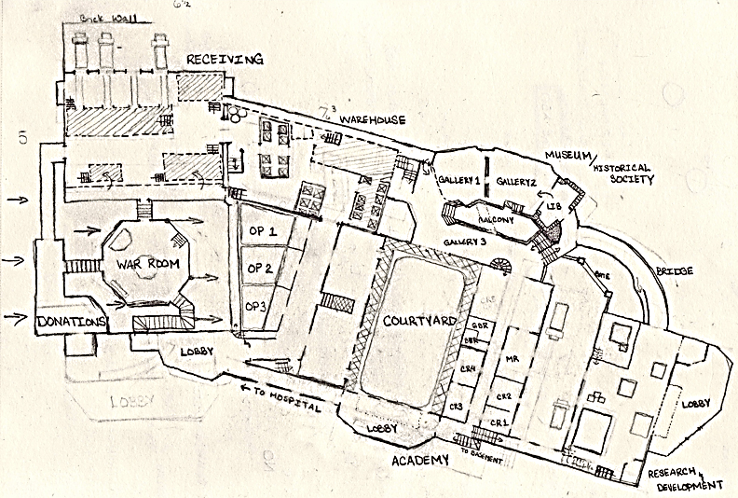

Figure : Academy level blueprint map

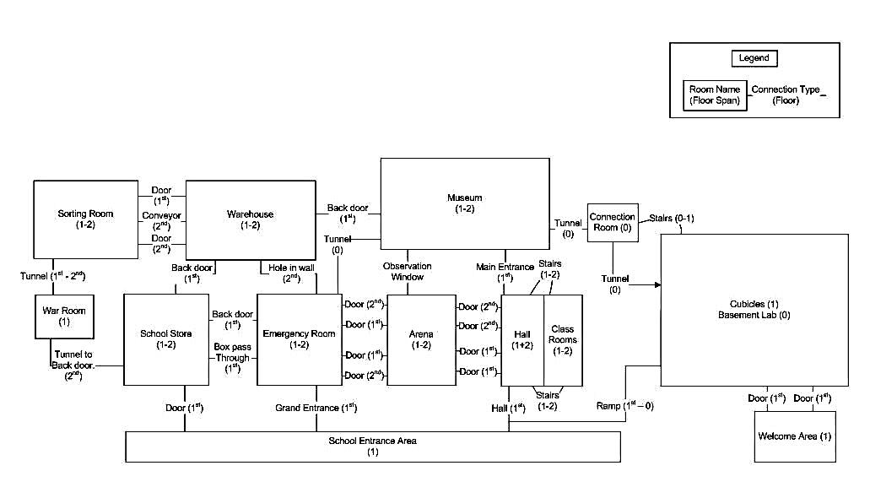

Figure : Academy level room connection map

### Scenario

At the end of every school year, the ACF and the Impossible Possibilities staff host a competition taking up the whole FPSA building. This competition serves three main purposes. First, it celebrates the graduation of students into the next grade. IP releases its best inventions for one-day use while ACF breaks out the best parts it has managed to collect over the year. Second, it gives the students a chance to showcase their skills and projects before their peers. Parents, friends, and non-combat students gather outside the building to cheer the teams on while watching video feeds. Third, and most importantly, it decides which group will command power in the following year. If ACF wins, they get full access to IP's technology for a week (the last time this happened, they modified a pallet of expensive arm upgrades to make them randomly brandish their middle finger), while if IP wins, they get a couple bins of mannequin parts to test on and amnesty for all of the parts they've stolen over the year.

#### The FPSA Building

The FPSA is housed in a large, solid building that was converted from an old military fortification. It was left over from the wars a thousand years ago like medieval castles in our present day. It was chosen for its space and sturdiness (it has to resist bullets and explosions), but mainly because it was the cheapest rent that they could find. The building is stone on the outside, but has crumbled in some places. The broken down parts as well as sections of the interior have been refurnished with wooden or plaster walls on the inside. Some of the rooms even have modern systems for providing heating and other services. Compare this to the surrounding city, which is built from new-age materials that enable artistic, gravity defying architecture.

The FPSA building is two-stories tall, with a bunker/basement. Its rooms are arranged in a number of different configurations due to its military use. Some of them have recently been connected (though intentional or unintentional demolition) to enable certain layouts for teaching. The building is composed of four main wings: the Appendage Conservation Front wing, the Impossible Possibilities wing, the Academy wing, and the Society for Historical Beatdowns wing.

#### The Appendage Conservation Front Wing

This wing houses the ACF. It is a combination of a hospital, school store, and distribution center.

Sorting Room – Where the ACF receives parts donations and sorts them. It has a number of bays to accept trucks full of wooden boxes with parts. These bays are connected to conveyor belts that sort the parts into upper body and lower body categories. The sorting conveyors span two vertical levels.

Warehouse – The warehouse stores boxes of parts according to various criteria including gender, size, etc. They are kept in large racks that have been re-purposed from holding weapons to hold various boxes. Above the doors are signs that warn players to avoid creating sparks of fire in the Armory (which was the original function of this room).

War Room – A hidden room where the ACF plans their "missions to promote awareness.” It contains maps marked with objectives, ammunition, and a central discussion table.

School Store – Where students come to buy nicer refurbished parts and school supplies. It is broken into sections by school function, with each section having a number of "dressing rooms", boxes of parts, and clothing to match the parts. Ads cover the walls promoting the different styles (most of them "retro"), the school, and the environmental benefits of buying used.

Emergency Room – A room designed to repair students in the fastest manner possible. It has gurneys on rails that convey injured students through a large machine that pulls random parts from a hopper and heals them. It is located below the school store.

#### The Academy Wing

This wing contains the classrooms and training areas used primarily by combat students (and sometimes crafting students).

The Higher Learning Arena – A three-level arena constructed to simulate a variety of combat situations. It is marked up with large decals that identify important spots (learning opportunities) including sniping spots, beneficial mod locations, and spawns to camp.

#### The Society for Historical Beatdowns Wing

This wing is dominated by a large, museum-like set of displays that chronicle the history of warfare.

The Museum – A large area with a number of displays positioned around it. It is better decorated than the rest of the school because industry representatives frequently drop by to consult with the professors on new programs. Example displays include:

Castle Scene – A depiction of warfare in the middle ages complete with a castle, wizard, and catapults flinging nuclear bombs.

Art Bible

# Theme and Style

**[Note: All sketches detail shapes and colors, not rendering style. See descriptions and references in Character and World Style sections for that information.]**

## Visual Style

*Trigger Happy* takes place in an absurd, whimsical, and comical Universe. The visual styling is meant to enable and amplify these feelings. The game's color palette is diverse, featuring distinctive colors that uniquely mark areas and characters.



Figure : Color palette templates

The rendering style is simple and iconic, focusing on recognizability over realism. Instead of wowing the player with ultra-high quality representations of boring environments, we will devote our time to interesting, meaningful environments that capture the player's imagination. The model design will be focused on communicating its point quickly and distinctively. Not only is this important for creating a unique look, it is critical in styling something as fast paced as an FPS. To do this, we will be emphasizing the key parts of the environment through use of distinctive sizes, shapes, and colors. We will also simplify the texturing and geometry to move the player's focus from the rendering to the objects. Simplification should not be confused with low quality, however. It is a high quality style that uses a small number of colors and details to nonetheless capture the meaning of a texture or form (and even amplify its meaning through amplification by simplification).

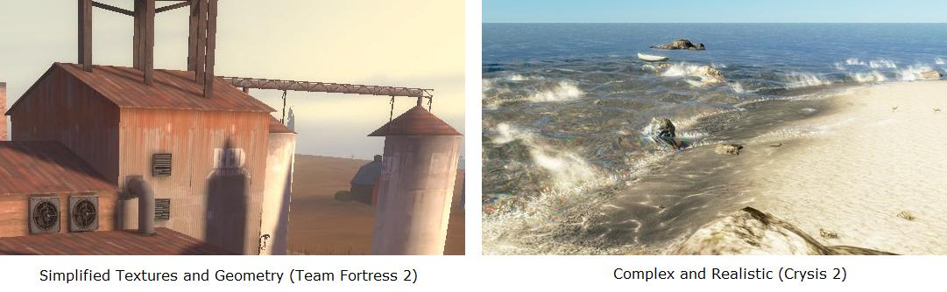

Figure : Color palette reference images

Another reason for choosing a more iconic, cartoonish style is the subject matter and tone of our game. *Trigger Happy* is designed to create comical and fun interactions. However, it is also a first person shooter featuring body part swapping. A realistic look would create mixed feelings because of these off putting topics. For some games, fully representing the gore adds to the design (such as a gritty war game), but for our fun and light feel it only detracts. Cartoon violence is appropriate because it sidesteps most of the real world consequences and shifts focus back on the inventions that we create for the game.

## Character Style

The player avatars in *Trigger Happy* are first and foremost normal, humanoid students. Second, they are FPS combatants that have little money. Their shape and clothing is a result of these two forces combined. Each team member wears a simple set of armor composed of scrounged parts such as pillows, sports pads, and cooking ware.

The characters' bodies are stylized instead of being anatomically correct. They are closer to cartoon characters than the ultra-realistic style of Call of Duty or Gears of War. Their forms are abstracted to smooth over the details of body hair, subtle musculature changes, wrinkles, and small joints. Parts such as hands, feet, and head are over-sized for comic effect. The textures are low frequency, simply detailed, and realistic in color. The animations are exaggerated and dynamic.

### References

|  |  |
| --- | --- |
| Figure : Sniper character - Team Fortress 2 | **Relevant Parts:** Distinct border; simple textures; abstracted body shape; slight cartoonish feel. |
| Figure : Human female - World of Warcraft | **Relevant Parts:** Abstracted, idealized body shape. Realistic, but also lower detail, simplified textures. |

### Concept Sketches of Player Character

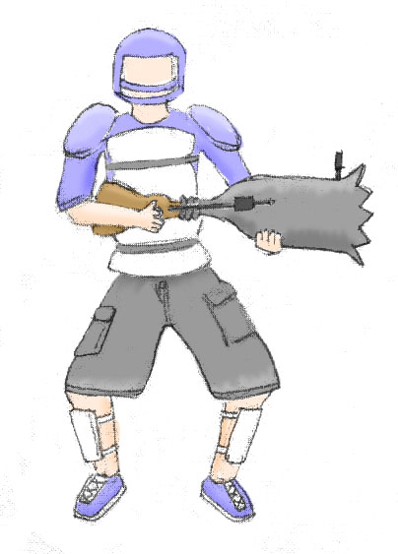

Figure : Player avatar idle concept sketch

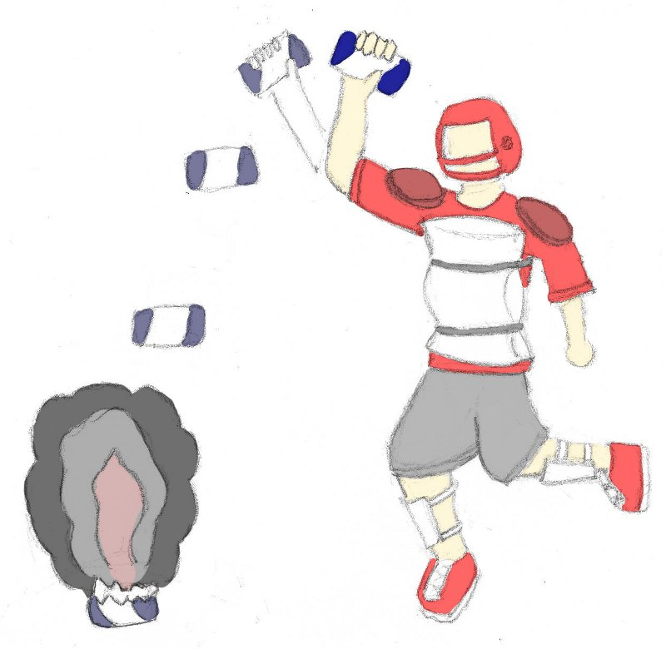

Figure : Player avatar throwing grenade concept sketch

## World Style

The world of *Trigger Happy* is designed to mesh with the appearance of the characters and the comical feel of the game. It is represented in a naturalistic style but with much of the detail abstracted away. Textures are simplified, low-noise, featuring broad strokes of color derived from more detailed base textures. Only as much detail as is needed to communicate the object's material is provided. The color choices will reflect the palettes of the areas that the objects reside in. Objects are modeled with low complexity. They are never shiny or reflective, instead using diffuse lighting. They are meant to communicate their purpose quickly and effectively. The general feeling is simple and clean from a visual perspective. Interest is generated though the content of the objects instead of the rendering.

Below is the result of transforming a source texture into a texture matching our style. It involves abstraction, smoothing, and then flattening and desaturating the colors without losing the significant details that define the texture.

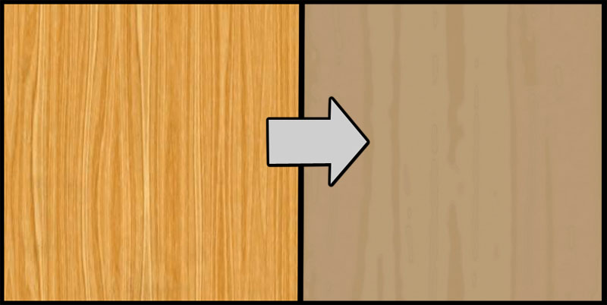

Figure : Example of texture saturation

### References

Warsow

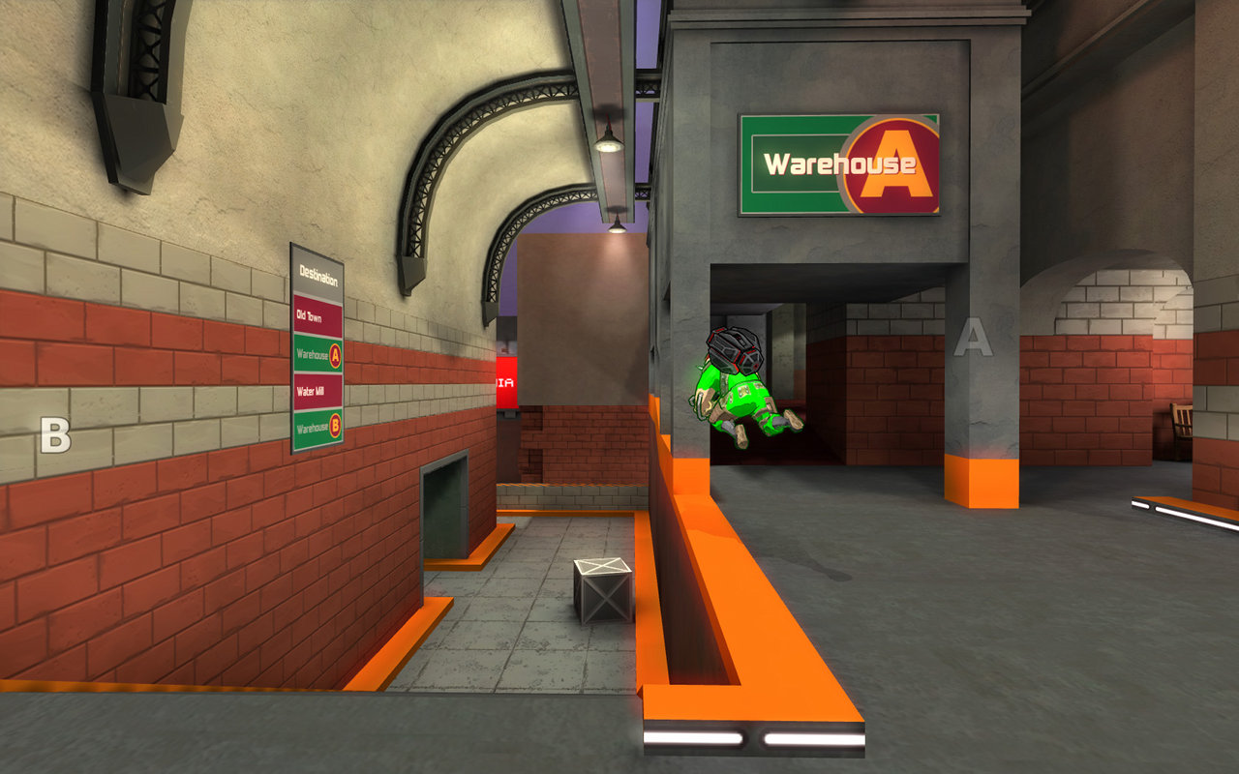

Figure : Color style reference image from Warsaw

**Relevant Parts**: Textures that prioritize shape and color over high frequency detail. Simple geometry.

<http://www.warsow.net/media/0.5/1280px/01.jpg>

Team Fortress 2

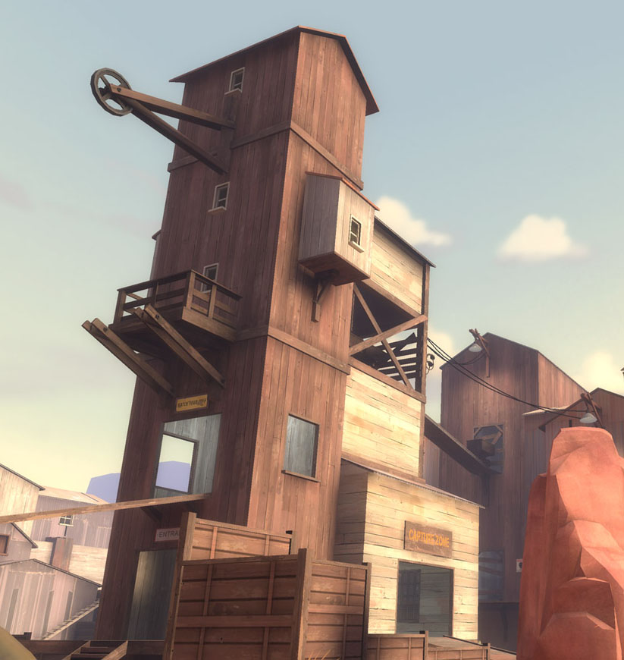

Figure : Geometry and color reference image from Team Fortress 2

**Relevant Parts**: The painterly quality of the textures. The angular and orthogonal lines. The eye-catching layout of the geometry.

<http://evilwombat.files.wordpress.com/2008/08/05_ravine_2.jpg>

# Map Styles

## The Future Proficient Soldier Academy

The Academy is built into an old, stone fort that has been decaying for several hundred years. It is two stories tall with additional space in a spooky, catacomb-like basement area. Its rooms and corridors are in various states of disrepair, ranging from surface damage, to structural damage, to complete collapse. Some parts have been patched up with new or found materials, but most have not. The original rooms of the fort have mostly been converted over to new purposes for use in the school. For example, the armory now stores spare part boxes as a warehouse, while the dungeons have been re-purposed as a hidden experimentation area.

Attached to the fort is a new research lab built by the fabulously rich Impossible Possibilities Corporation. Unlike the rest of the school, it is built from high quality futuristic materials. In fact, the entire city surrounding the Academy is more like the research lab than the fort. The only reason that the fort and its grassy grounds exist in the modern architectural age is that universal historical preservation laws prevent its outright destruction.

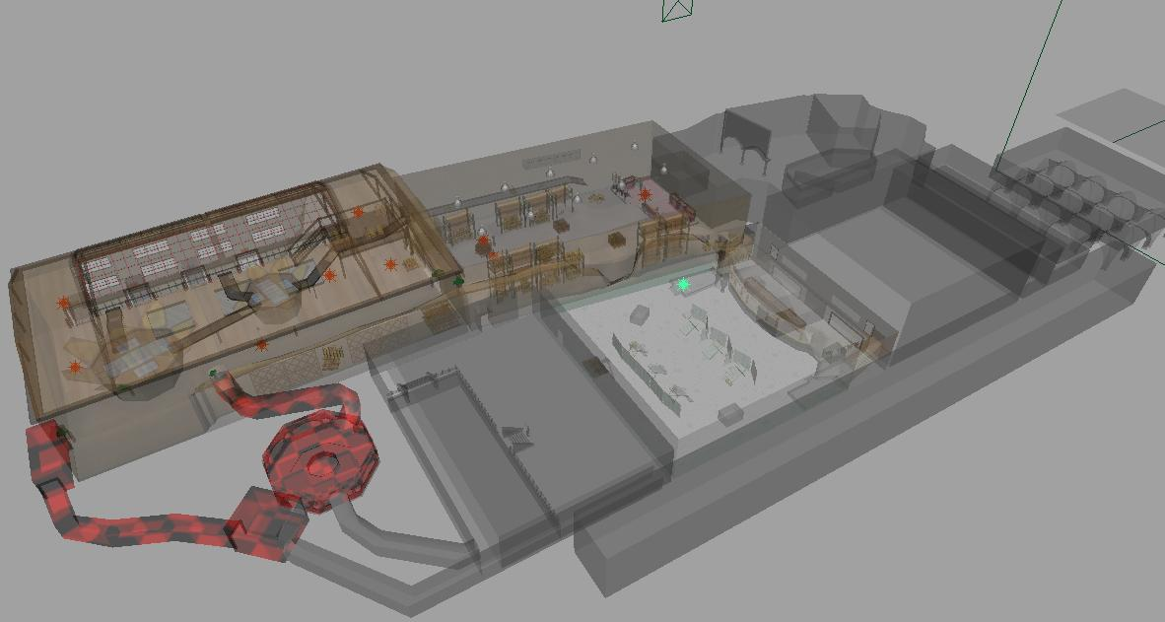

Figure : Academy level final render

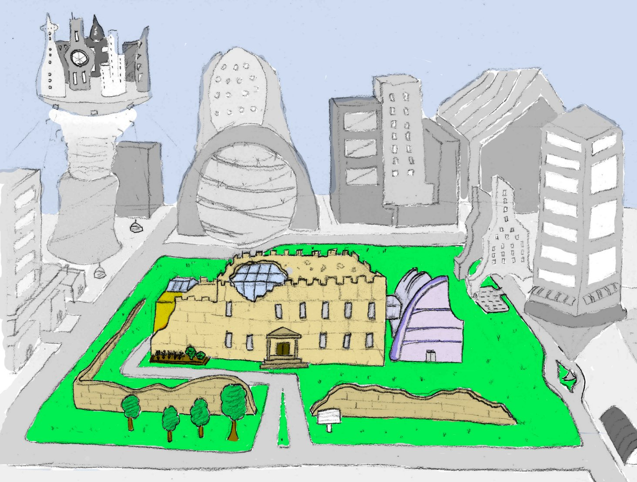

Figure : World surrounding academy level concept sketch

### References



Figure : Architecture reference image

## The Appendage Conservation Front Wing

The Appendage Conservation Front Wing is half dedicated to ACF work and half dedicated to their school support activities. It is styled in a bright and cheery way, which is meant to be juxtaposed with its morbid work. It is the wing with the most windows, light, and airy space. The decorations placed throughout the wing are mostly natural or do-it-yourself kind of objects though there is machinery when it cannot be helped. For example, their conveyor belts are mostly metal and rubber, but the holes in them have been repaired with cloth patches that betray hand stitching. The walls are partially fort stone, but it is vine covered in places. There is a prodigious amount of signage advertising environmentally friendly practices. Any repair work done here is done using sustainable materials like wood or clay.

|  |  |
| --- | --- |
| Figure : Sorting Room concept sketch | Figure : Sorting Room concept sketch |

### References

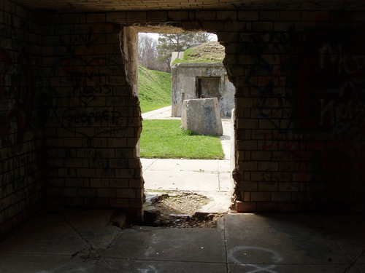

Figure : Sorting Room reference imagery

## The Academy Wing

The Academy Wing is housed in the fort training area. This area is composed of a number of training rooms and a large courtyard that was used for doing military exercises. It is styled in a semi-scholastic fashion, with notable differences that separate it from a standard school look. These differences are largely drawn from a vast store of first-person shooter objects and training items. The point is not so much to mock a FPS, as it is to create an environment where students can learn about this type of combat. As such, every cover spot, spawn location, and capture point is a labeled learning opportunity. The materials here are rubber for the training arena, and stone for the classrooms. The classrooms contain a mix of rugged training gear and standard school gear like chalkboards and class rules.

|  |  |
| --- | --- |
| Figure : Arena concept sketch | Figure : Arena color palette template |

### References



Figure : Arena reference imagery

<http://www.jewell.edu/william_jewell/gen/william_and_jewell_generated_bin/images/basic_module/track.jpg>



Figure : Arena reference imagery

<http://www.paranormalknowledge.com/wp-content/uploads/2009/07/high-school-hallway-300x224.jpg>

## The Society for Historical Beatdowns Wing

This wing is located behind the Academy wing inside of a large, two-story tall room. It constructed as a museum, and is filled with relics of our military history; however, their purposes of are grossly misinterpreted. The general look of this wing is one of cheaply purchased luxury obscuring serious faults in the building. Columns hide crumbling supports. Velvet curtains hide destroyed sections of wall. The only windows in the wing are covered in heavy, protective steel bars. However, despite all of this, the professors are immensely proud of their creation.

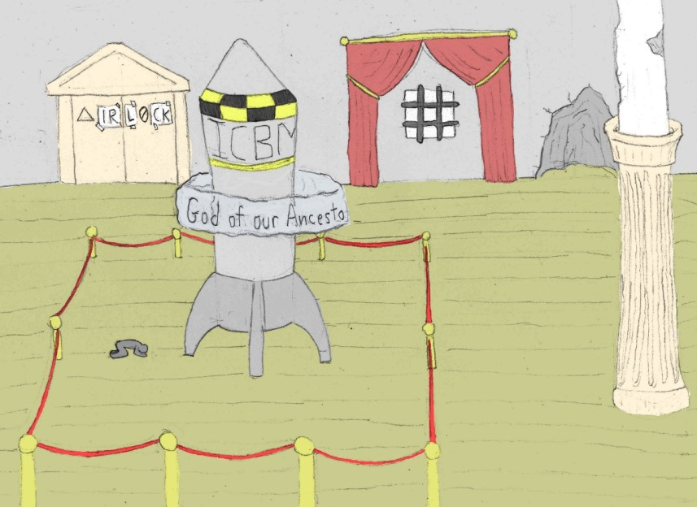

Figure : Museum concept sketch



Figure : Museum color palette template

### References

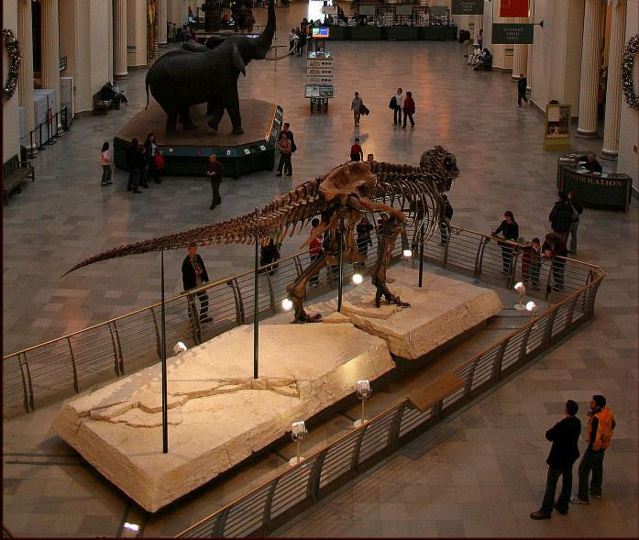

Figure : Museum reference imagery

<http://www.lensimpressions.net/index.php?showimage=515>

## The Impossible Possibilities Wing

The Impossible Possibilities Wing has a split personality. Upstairs it is the only futuristic looking location in the entire academy. Materials like glass and stainless steel dominate. Object float, hang, and sparkle in the sun. Even the cubicles are built from transparent displays. However, this luxury comes at a price. The entire floor is under heavy, automated observation by the parent corporation. Big brother is present in all of the hidden and not so hidden niches. Luckily, the lab staff and students have a place where they can work unobstructed. The basement of this wing taps into the dungeons of the fort. In this spooky environment, modern technology mixes with ancient stockades. The combined look is an accidental mad scientist’s lab set in a dimly lit underground cavity.

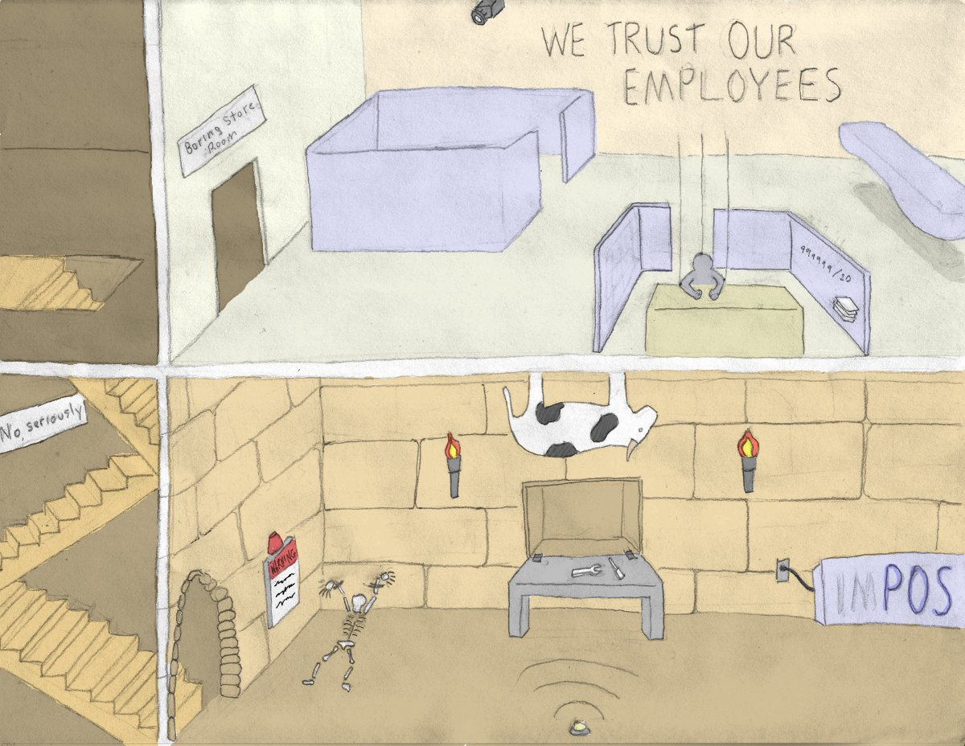

Figure : Hospital concept sketch



Figure : Hospital color palette templates

### References

Ground Level Cubicles



<http://www.peterallenco.com/DSCN0095.JPG>

Basement Lab

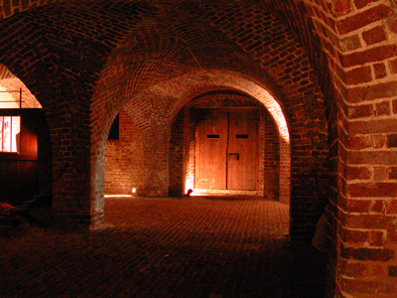

<http://dolinsky.fa.indiana.edu/caveart/spr09/jcterzin/jct_dungeon1.jpg>

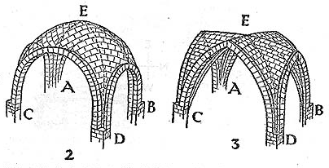

Figure : Hospital reference imagery

# Scenes

## Test Render: The Sorting Room

*For details on the layout, see the Models and Textures section.*

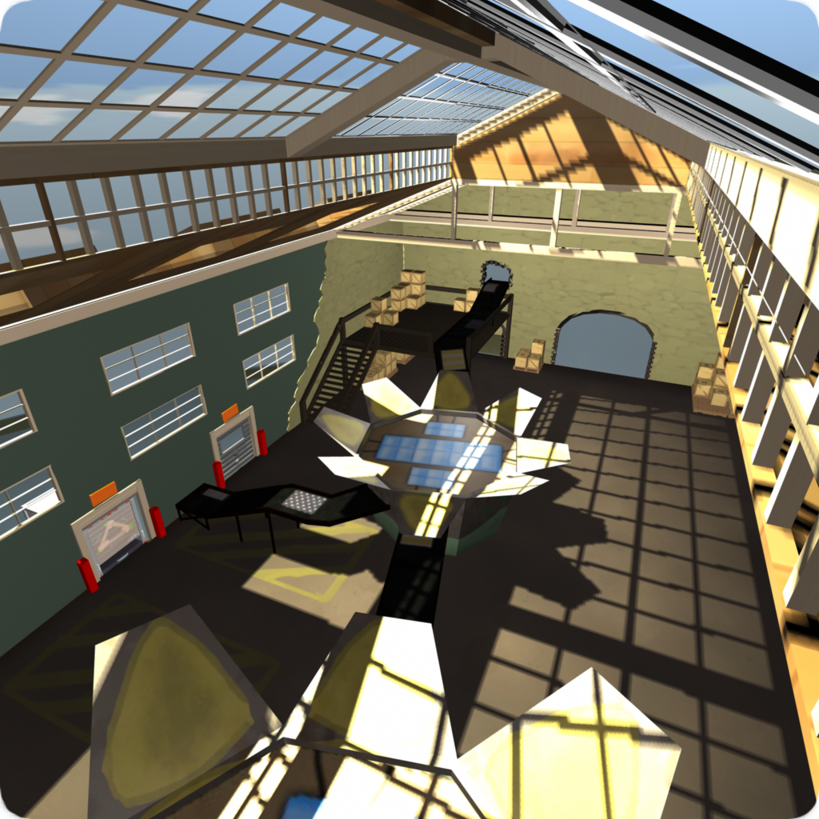

Figure : Test render: Sorting Room - High ceiling shot

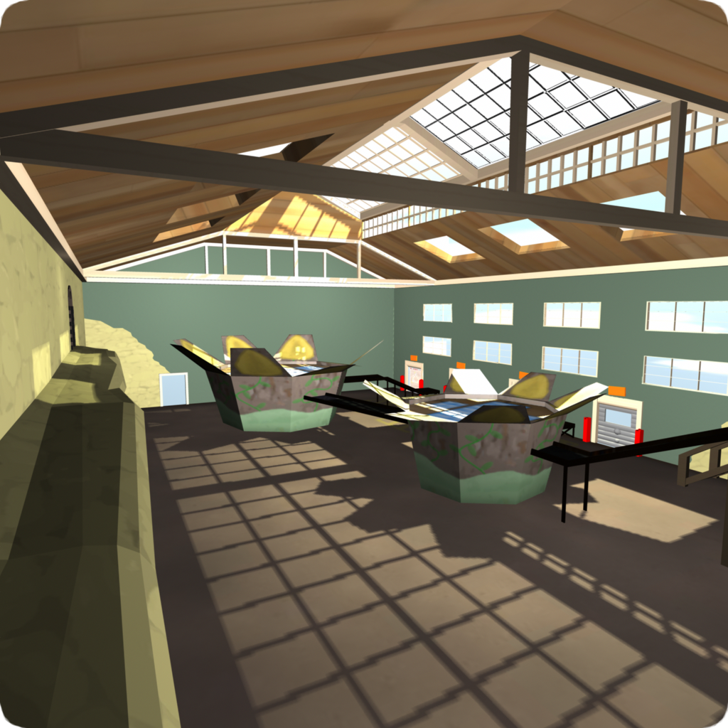

Figure : Test render: Sorting Room - From the ledge

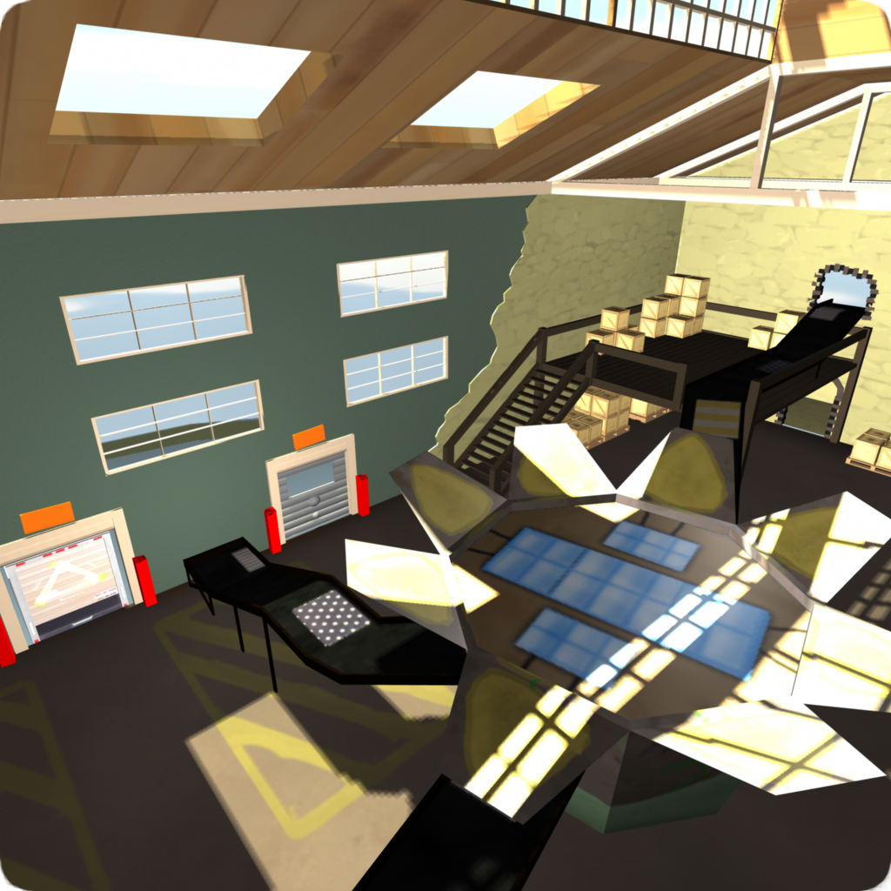

Figure : Test render: Sorting Room - Above the conveyor belts

# Models and Textures

Each asset is rated according to three criteria:

* Gameplay Importance [5 most – 1 least] – How much losing this asset would affect the gameplay (level flow, not having a weapon to fire, etc.).
* Art Importance [5 most – 1 least] – How much losing this asset would affect the ability of the game to convey story and style.
* Simplifiable? - Can the geometry and textures be simplified or is it critical that this asset appear exactly as stated.

## Player Avatar

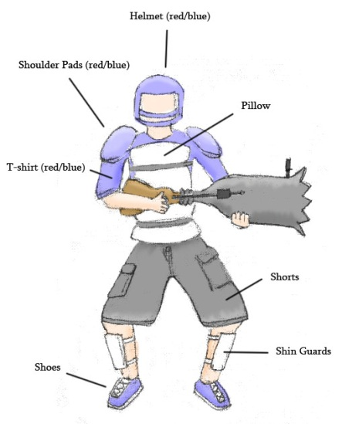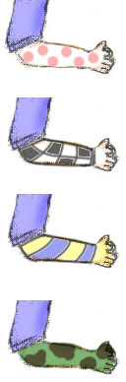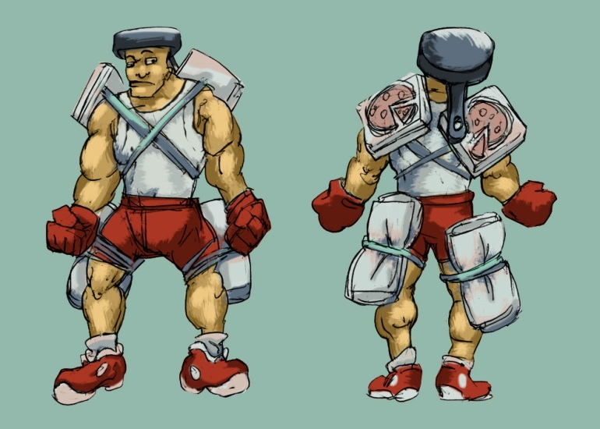

Figure : Player avatar concept sketches

Meshes: Body, Pillows, Pizza Boxes, Textures

## Weapons

#### Modifier Launcher

*Description:* A metal lunch box like container that holds the modifiers. Decorated with the "Mod Crew" logo (70s theme) and various technical components (radar dish, etc.).

*Quality*: High.

*Use*: Fires the modifiers.

*Importance:* Gameplay (5). Art (3). Can be simplified.

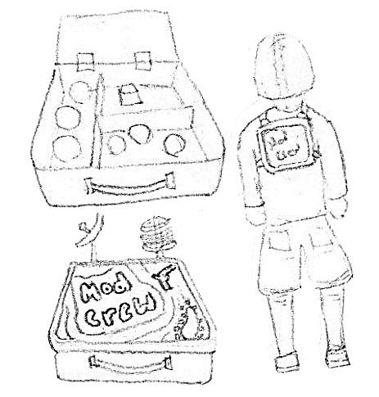

Figure : Modifier Launcher concept sketch

#### Modifier_Launcher

Figure : Modifier Launcher final render

#### Nullifier Weapon

*Description:* A remote control-like device made from a pocket calculator and an antenna. The button is large and red.

*Quality*: High.

*Use*: Held in one hand by the player.

*Importance:* Gameplay (5). Art (3). Can be simplified to a remote with only a single button.

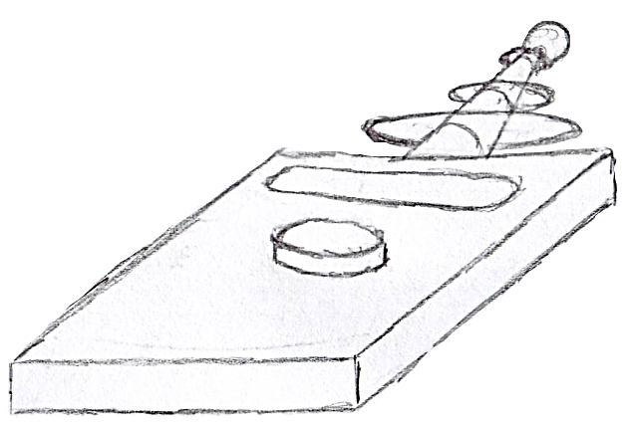

Figure : Nullifier Gun concept sketch

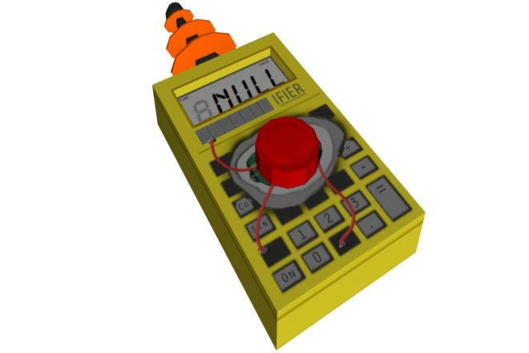

Figure : Nullifier Gun final render

**Note: This feature was cut from the final implementation**

**(See Development Document pp. 336)**

#### Pistol "The Small Bang"

Description: A modified pop gun. Augmented with small pistons to work the pumping motion. Constructed from a fine grained wood material.

*Quality*: High.

Use: Shoots normal and flaming ping pong balls.

Importance: Gameplay (5). Art (4). Can be simplified to a basic pop gun.

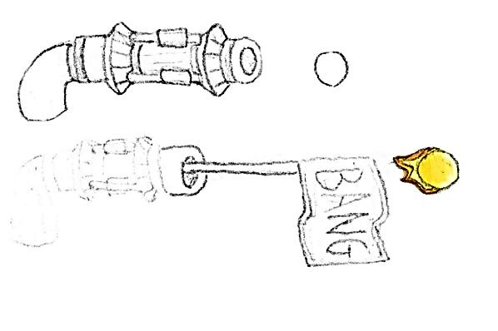

Figure : Pistol concept sketch

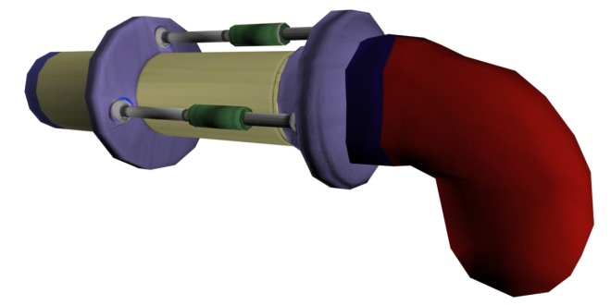

Figure : Pistol final render

#### 

#### Sniper Rifle "Binocular Sniper Rifle"

*Description:* A compact sniper rifle mounted inside a pair of binoculars. The left ocular contains the barrel while the right ocular contains the scope. There are two triggers, one on each ocular where the hands hold.

*Quality*: High.

*Use*: Held with two hands. Each on the triggers of the binocular scopes.

*Importance*: Gameplay (5). Art (3). Can be simplified a small amount, but the scope and barrel much remain.

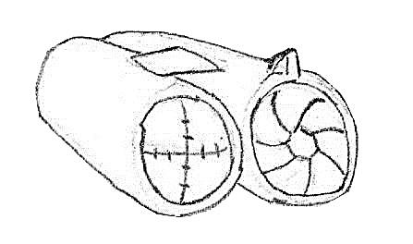

Figure : Sniper Rifle concept sketch



Figure : Sniper Rifle final render

#### Explosive Projectile Weapon "Cannon Gun"

*Description:* A blunderbuss widened at the end to fire explosive cannon balls. Augmented with shock absorbers, one on each side and a joint spring in the middle. Features a large crosshair sight on the end of the barrel.

*Quality*: High.

*Use*: Held with two hands. One on the trigger, one on the stock.

*Importance*: Gameplay (5). Art (3). Can be simplified as long as it maintains its shape and joint spring.

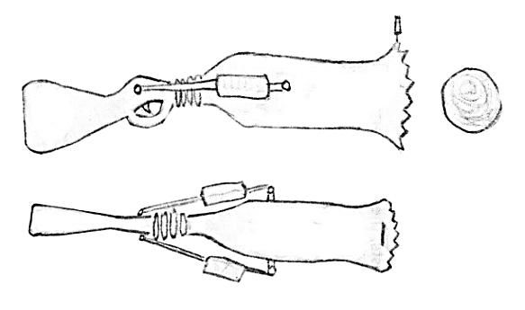

Figure : Cannon Gun concept sketch

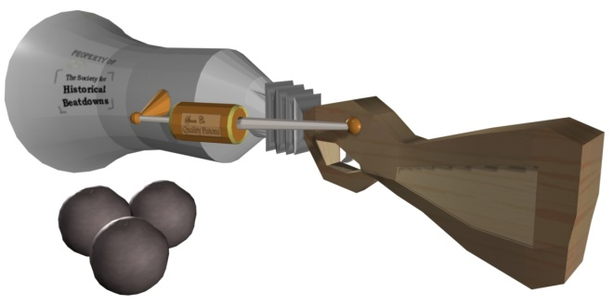

Figure : Cannon Gun final render

#### Assault Rifle "Fists of Fury"

*Description:* A gun that fires unusable hands in the form of fists. It feeds from a parts box and projects them from a steel tube.

*Quality*: High.

*Use*: Held with two hands. One on the stock, one on the trigger.

*Importance*: Gameplay (5). Art (4). Cannot be simplified.

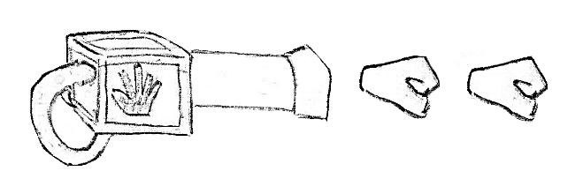

Figure : Assault Rifle concept sketch

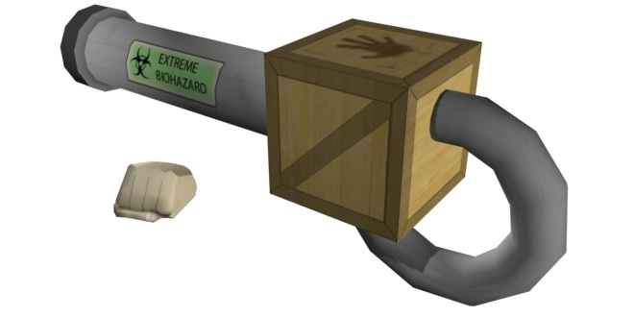

Figure : Assault Rifle final render

#### Shotgun "Multi-Shot"

*Description:* Many single shot guns taped together. They reload at different frequencies.

*Quality*: High.

*Use*: Held with two hands. One on the stock, one on the trigger.

*Importance*: Gameplay (5). Art (2). Can be simplified or outright changed.

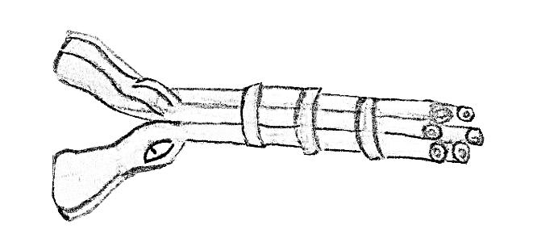

Figure : Shotgun concept sketch

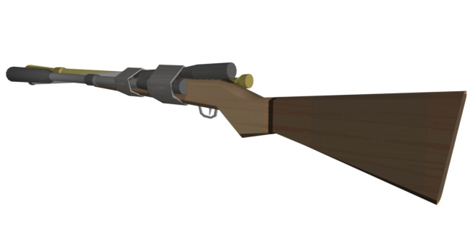

Figure : Shotgun final render

#### Damage over Time Weapon "The Composter"

*Description:* A solar powered heat ray gun, powered by an energy efficient CFL. Over-driven version of a tool used for composting and moving soil. A solar panel is mounted on its back; while an array of focusing lenses sit on the top.

*Quality*: High.

*Use*: Held with two hands. One on the stock, one on the trigger.

* *Importance*: Gameplay (5). Art (4). Can only be simplified very little without losing its meaning.

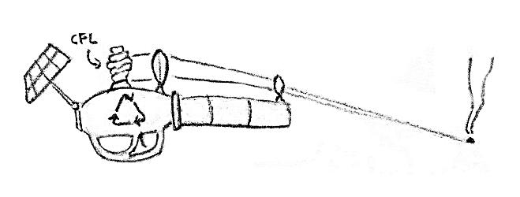

Figure : Damage Over TIme concept sketch

**Note: This feature was cut from the final implementation**

**(See Development Document pp. 336)**

#### Grenade "Pop Can"

*Description:* A soda can filled with explosives. Triggers shortly after the tab is popped. Explodes in a fireball.

*Quality*: High.

*Use*: Held with one hand.

*Importance*: Gameplay (5). Art (2). Cannot be simplified.

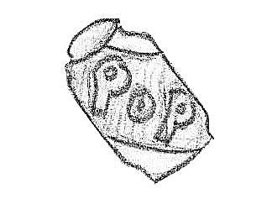

Figure : Grenade concept sketch



Figure : Grenade final render

**Note: This feature was cut from the final implementation**

**(See Development Document pp. 336)**

### Modifiers

#### Modifier Marker

*Description:* An X shaped decal marking where a modifier is. Colored to almost but not quite blend in with the environment. Appears to be made from tape.

Quality: High.

*Use*: Placed to mark where a modifier is deployed.

*Importance*: Gameplay (5). Art (2). Cannot be simplified.

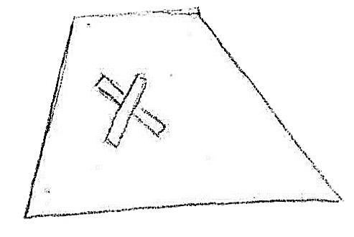

Figure : Modifier Marker concept sketch



Figure : Modifier Marker final render

#### Shrink Effect

*Description:* A portal appears 6 feet along the normal of the surface that the modifier is on. A large hand or dinosaur foot stomps downward crushing the player for the duration. The portal features a swirl distortion and is textured like a star field.

Quality: High.

*Use*: Triggered when a Shrink modifier goes off.

*Importance:* Gameplay (5). Art (4). Can be simplified as long as it intuitively represents crushing or shrinking.

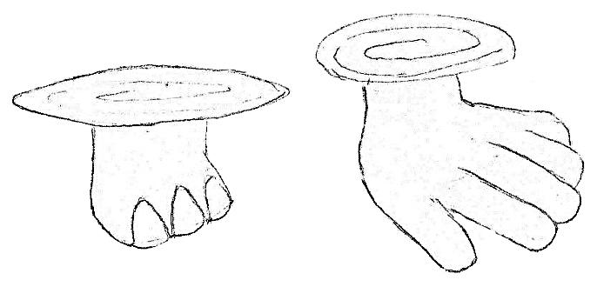

Figure : Shrink effect concept sketch

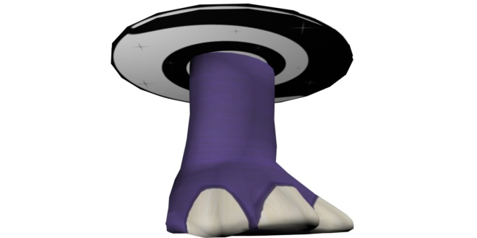

Figure : Shrink effect final render

#### Growth Effect

*Description:* A large radiation symbol glowing with unnatural orange light. Indicative of mutating radiation.

Quality: High.

*Use*: Appears when the Grow modification is triggered. Causes the player model to get bigger as described in the Grow animation.

*Importance:* Gameplay (3). Art (4). Can be simplified as long as it communicates the idea of growth.

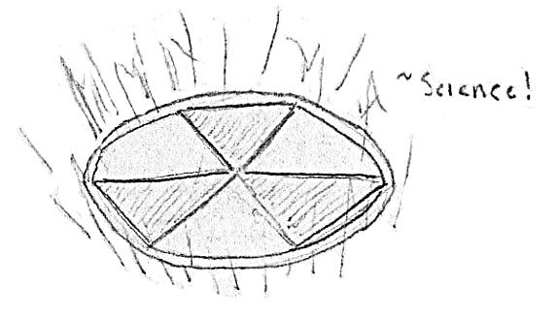

Figure : Grow effect concept sketch

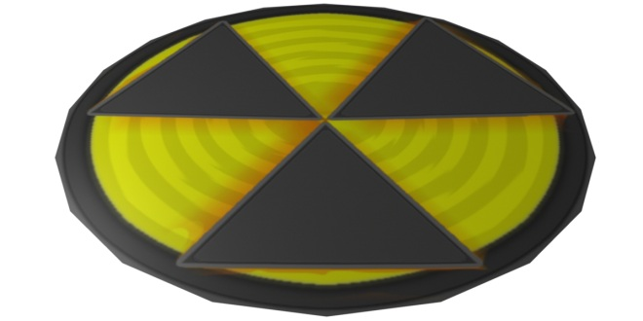

Figure : Grow effect final render

#### Barrier Effect

*Description:* A barrier made of semi-transparent wood planks. It is as tall as a player and twice as wide. Has depth equal to twice a player's depth. An opaque sign on the front says "Trespassers will be Shot." It pops up from the modifier’s surface along the surface normal.

Quality: High.

*Use*: Triggered when a barrier modifier is activated.

*Importance*: Gameplay (5). Art (3). Can be simplified as long as it blocks the player’s path but not its view.

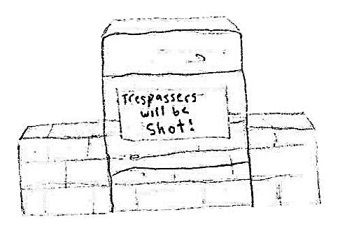

Figure : Barrier concept sketch

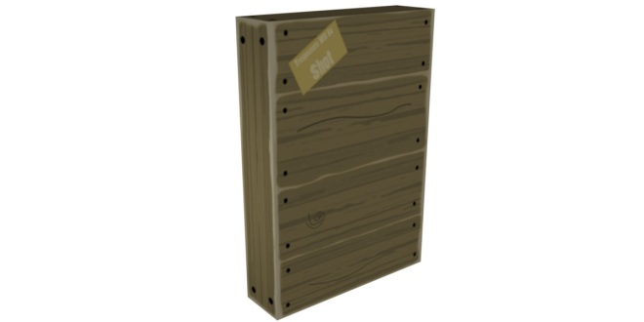

Figure : Barrier final render

#### Knockback Effect

*Description:* An explosion of confetti and streamers.

Quality: High.

*Use*: Triggered when the knockback modifier is activated.

*Importance*: Gameplay (3). Art (3). Can be simplified as long as it communicates the idea of an explosion.

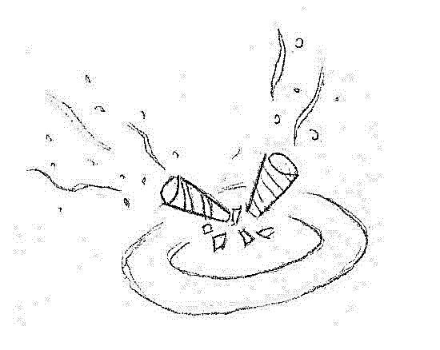

Figure : Knockback concept sketch



Figure : Knockback Icon final render

#### Inverse Gravity Effect

*Description:* A wormhole-like swirl extends from the modifier location upwards along the current gravity vector. Animates to show the swirl like a small, thin disk moving up a barbershop pole.

*Quality*: High.

*Use*: Triggered when a gravity inversion modifier is activated.

*Importance*: Gameplay (4). Art (3). Can be simplified as long as it points the direction of the player’s movement.

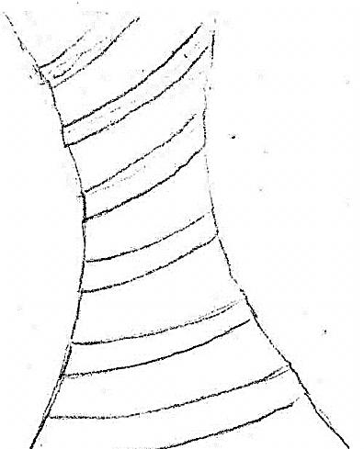

Figure : Inverse Gravity concept sketch



Figure : Inverse Gravity icon final render

#### Frictionless Effect

*Description:* Replace the player's lower body clothing with a pair of footie pajamas.

*Quality*: High.

*Use*: Swapped into the model texture when the player is under the effect of the Frictionless modifier. Does not interrupt the player's running leg animations.

*Importance:* Gameplay (5). Art (2). Cannot be simplified.



Figure : Frictionless icon final render

#### Featherlight Effect

*Description:* A poof of light-colored, low opacity particles.

*Quality*: High.

*Use*: Appear when the player is under the effect of the Featherlight effect.

*Importance:* Gameplay (5). Art (3). Can be simplified as long as it communicates reduced weight.



Figure : Featherlight icon final render

#### Illusion Effect

*Description:* Spawns several copies of the player's model to distract enemies. Appears just like a player avatar.

*Quality*: High.

*Use*: Appear when the Decoy modifier is activated.

*Importance*: Gameplay (5). Art (3). Cannot be simplified.



Figure : Illusion icon final render

***Consult the Player Avatar section for concept art pg. 104.***

### Map: The Academy

*Description:* The complete Academy level. Rooms are linked together with corridors

*Quality*: High.

*Use*: The map players will participate in matches

*Importance*: Gameplay (5). Art (5). Cannot be simplified.



Figure : Academy level blueprint map



Figure : Complete Academy level final render

#### The Appendage Conservation Front Wing

##### Sorting Room



Figure : Sorting Room - High ceiling render

###### Environment

This room is open, airy, and has a cheerful tenor. It is lit through its myriad windows and is painted in natural colors. The floor is dirty, but not damaged or neglected. The walls are half natural material, half old stone from the fort. Vines and moss cover parts of it.

###### Conveyor Belt

*Description:* Several belts at varying levels of inclination. Fairly worn down. Wide enough to support two players side by side. The belt has worn thin in places and been fixed up with cloth patches.

*Quality:* Medium, 250/piece.

*Use*: Proceed into and out of the sorting machine. Used as walkways.

*Importance:* Gameplay (4). Art (3). Can be simplified in texture.

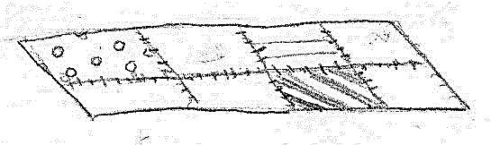

Figure : Conveyor belt concept sketch

###### Wooden Body Part Boxes

*Description:* Wooden boxes with depictions of appendages on them. At least one depiction for upper body and one for lower body.

*Quality:* Low, 12-50.

*Use*: Placed on conveyor belts and in stockpiles.

*Importance*: Gameplay (3). Art (5). Cannot be simplified.

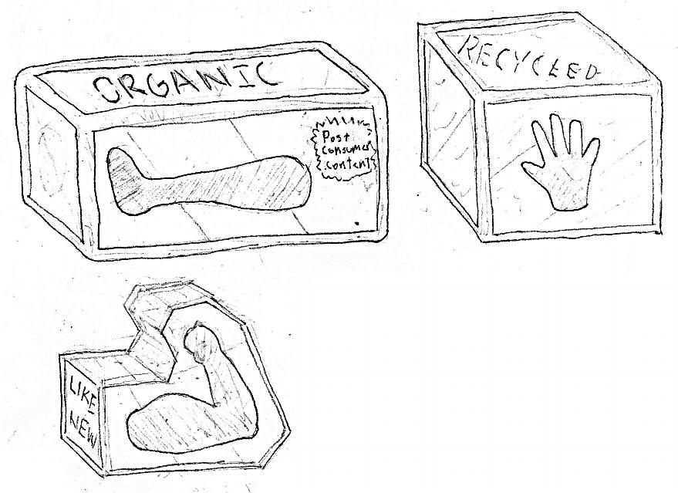

Figure : Warehouse crate concept sketches

###### Delivery Truck Rear

*Description:* The back of a delivery truck, partly open but not accessible. Decorated with the ACF logo.

*Quality:* Low-Medium, 35-50.

*Use*: Placed along the wall with only the rear two feet showing.

*Importance*: Gameplay (1). Art (3). Can be simplified in complexity or texture.

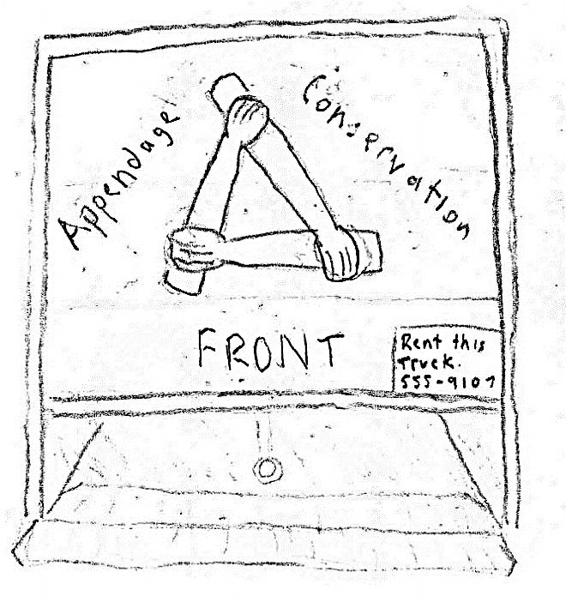

Figure : Delivery truck door concept sketch

###### Windows

*Description:* Large, greenhouse like window with multiple panes.

*Quality:* Low, 2-18.

*Use*: Allows light to enter through the backside and top of the sorting room.

*Importance*: Gameplay (1). Art (3). Cannot be simplified.

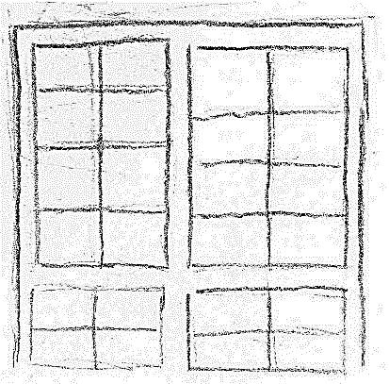

Figure : Window concept sketch

###### Sorting Machine

*Description:* Large octagonal machine for sorting parts. Flat on the top with solar panels arranged around the outside like flowers petals. Various openings for conveyors to enter or exit. Decorated with environmental graffiti.

*Quality:* Medium, 500-800.

*Use*: Used as a platform on which to fight.

*Importance*: Gameplay (5). Art (4). Textures can be simplified.

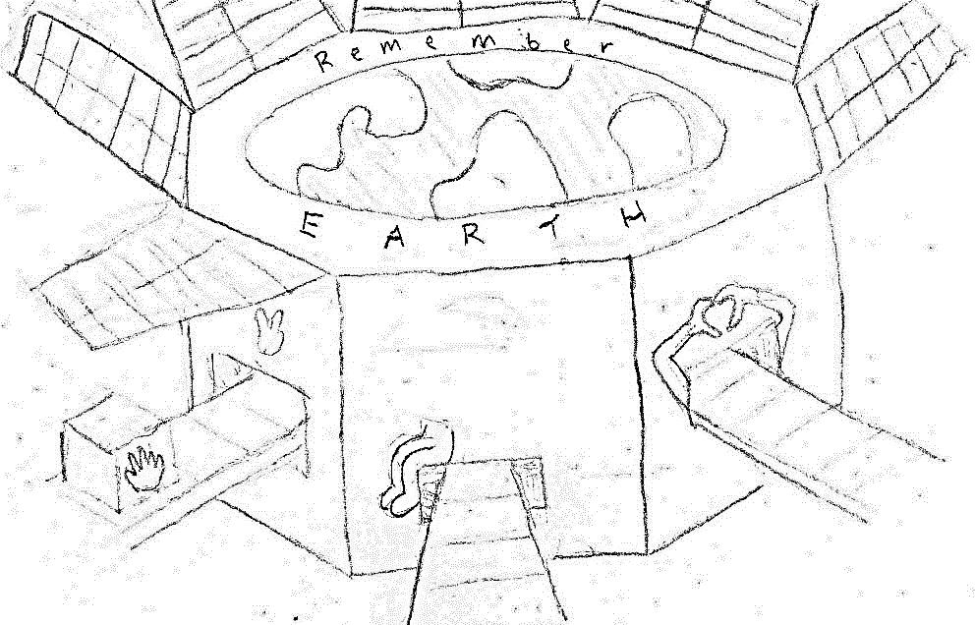

Figure : Sorting machine concept sketch

##### Warehouse

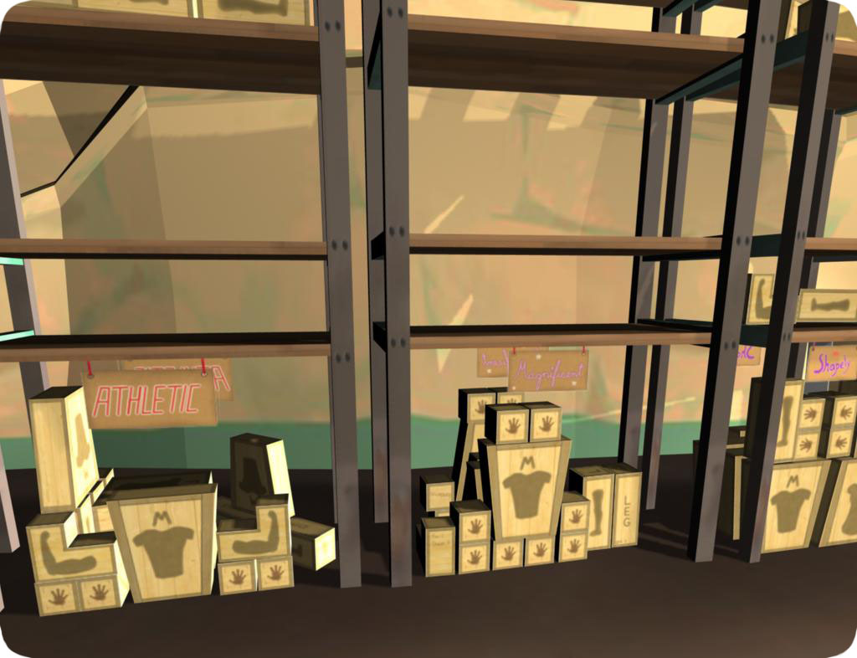

Figure : Warehouse shelf final render

###### Environment

Large, cavernous, stone room that used to function as the armory. Worn down feeling. Some of the walls have moss on them.

###### Wooden Body Part Boxes

Defined In: "Wooden Body Part Boxes" in Appendage Conservation Front - Sorting Room.

###### Categorization Signs

*Description:* Signs labeling the various stock piles in the warehouse. Cardboard, hand painted. Size Labels: "Scrappy," "Solid." Types: "Hairy", "Goofy", "Magnificent," "Whoa"

*Quality:* Low, 20-40/piece.

*Use*: Placed above the stock piles, either hung or on a pole projecting from a pile.

*Importance:* Gameplay (1). Art (4). Can be simplified a bit in texture.

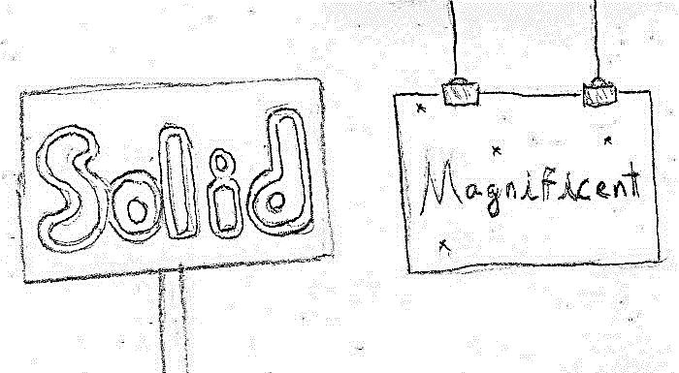

Figure : Wooden sign concept sketches

###### Armory Label

*Description:* An official, solid looking military sign saying "ARMORY" with quotes around "ARM" (the joke being that it houses arms...). Yellow and black warning stripes on the sides.

*Quality:* Low, 2-10.

*Use*: Large scale and place on the longest wall of the room at a height to allow viewing from all parts of the room.

*Importance*: Gameplay (1). Art (3). Cannot be simplified.

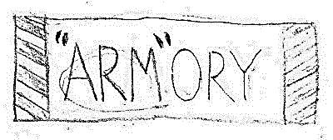

Figure : Armory label concept sketch

###### Warning Sign

*Description:* A conspicuous sign warning of the dangers of discharging live ammunition in the Armory. Official, standardized look. Full of bullet holes and dents.

*Quality:* Low, 2-10.

*Use*: Placed around doors and stockpiles.

*Importance*: Gameplay (1). Art (4). Cannot be simplified.

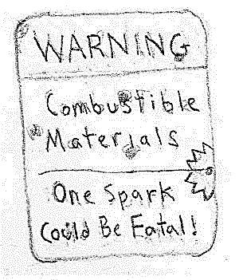

Figure : Warning sign concept sketch

###### Part Piles

*Description:* Messy collections of part boxes labeled with signs.

*Quality:* Medium, 100-200.

*Use*: Placed on the floor around the room.

*Importance*: Gameplay (4). Art (4). Cannot be simplified.

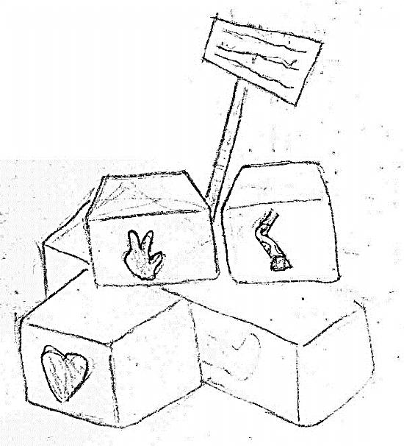

Figure : Part pile concept sketch

##### War Room

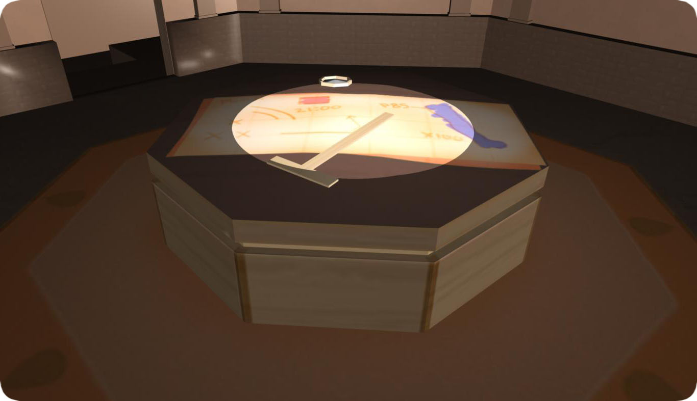

Figure : War Room final render

###### Environment

Octagonal shape; wood paneled walls; tile floor. Has a dim, smoky feel.

###### War Table

*Description:* An octagonal table covered with paperwork, a cigarette tray, a bottle of soy-milk, and scotch glasses.

*Quality:* Medium, 200-300.

*Use*: Placed in the middle of the war room.

*Importance*: Gameplay (3). Art (4). The items on top of the table can be simplified or removed.

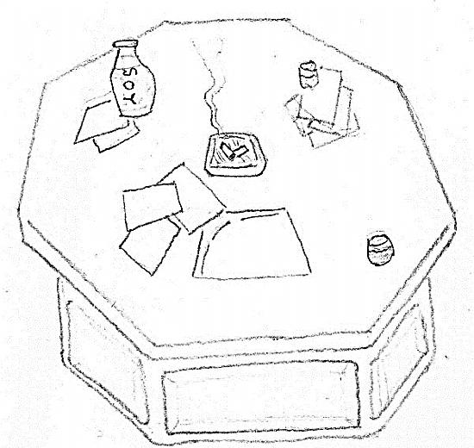

Figure : War Room table concept sketch

##### School Store

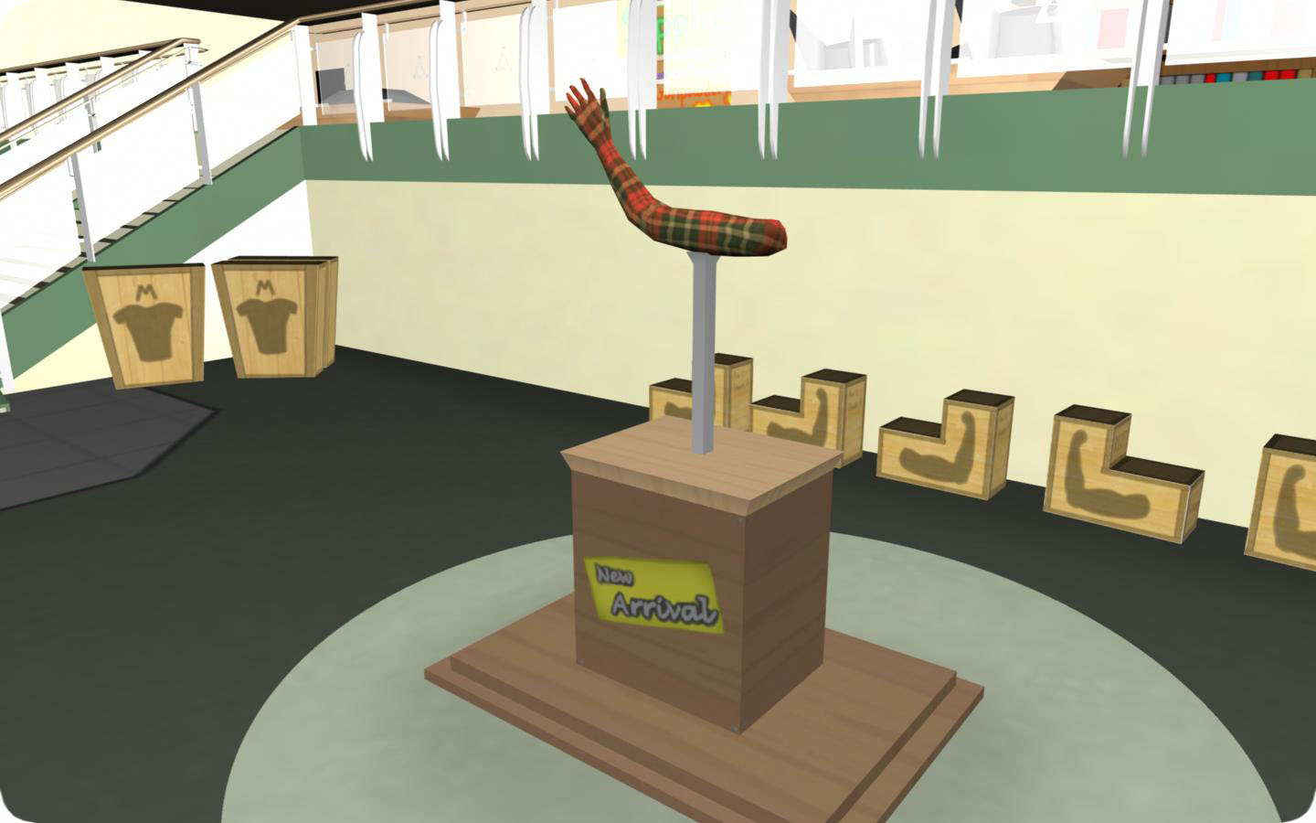

Figure : School Store final render

###### Environment

Carpeted floor; walls painted green on the bottom half. Parts of the walls are covered with banners for the school. It is split into two vertical levels, with the left side of the store raised higher than the right. The left side has school supplies while the right has parts.

###### Bargain Bin

*Description:* An 8' x 8', low-sitting bin with parts boxes piled in it. This bin connects through a chute horizontally to the emergency room.

*Quality:* Medium, 200-300.

*Use*: Placed near the center of the store.

*Importance*: Gameplay (4). Art (4). Cannot be simplified.

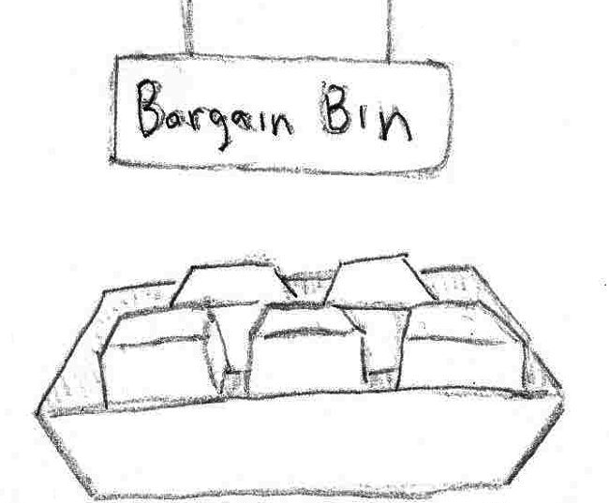

Figure : Bargain bin concept sketch

###### Reclaimed Crafting Supplies Bins

*Description:* Bins containing recycled materials including: gun powder, radioactive waste, wood, and assorted chemicals.

*Quality:* Low, 200-300.

*Use*: Placed near the entrance to the store (interspersed with school supplies).

*Importance:* Gameplay (2). Art (3). Can remove some of the supplies types.

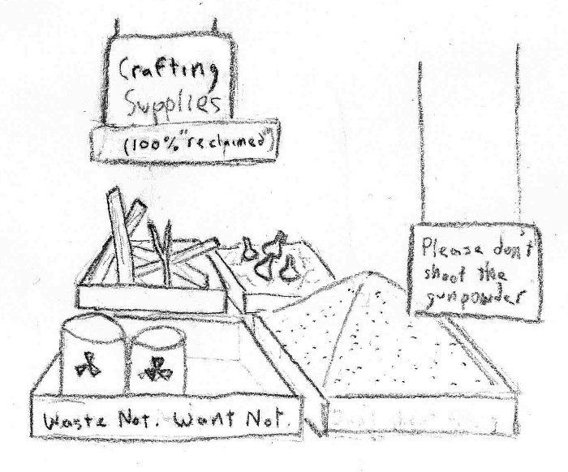

Figure : Crafting supply bin concept sketch

###### Categorization Signs

*Description:* Signs labeling the different part types being sold. Roles include: Strong arms for holding weapons, Heat resistant arms for crafting, glowing appendages for drawing attention, and Camouflaged parts for blending in.

*Quality:* Low, 2-10.

*Use*: Placed above the mannequin displays below.

*Importance:* Gameplay (1). Art (3). Cannot be simplified.

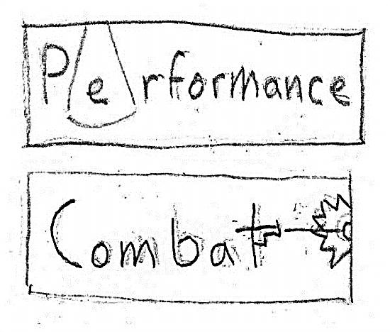

Figure : Category sign concept sketches

###### Mannequin Displays

*Description:* Mannequins on platforms showing off the looks specified in "Categorization Signs."

*Quality:* Medium.

*Use*: Spread about the room.

*Importance:* Gameplay (3). Art (4). Can reduce the number of displays or the scene complexity.

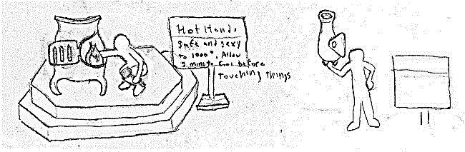

Figure : Mannequin display concept sketches

##### Emergency Room

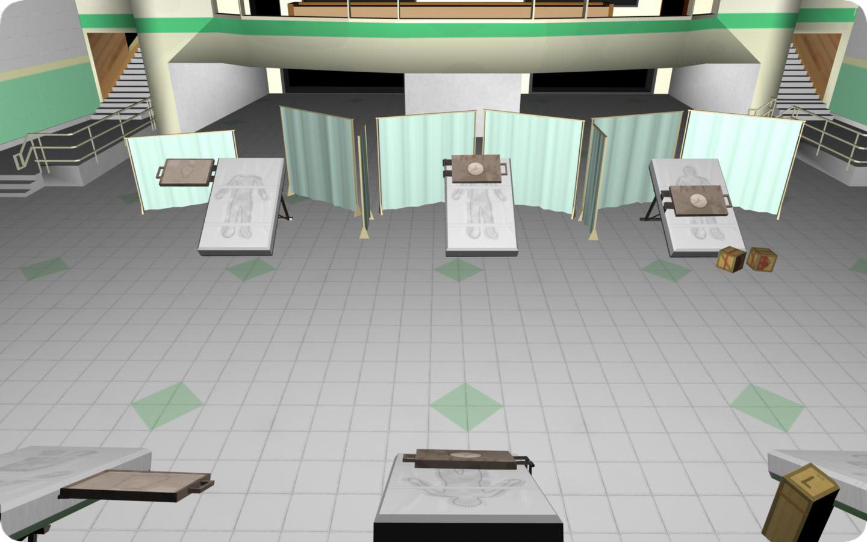

Figure : Emergency Room final render

###### Environment

Hospital white floors; well lit; sectioned off by curtains. Light green highlights on the walls.

###### Marked Down Parts Boxes

*Description:* A parts box covered with orange stickers that announce its low price or damage goods.

*Quality:* Medium, 400-500.

*Use*: Placed in the hopper holding boxes that came from the school store bargain bin.

Uses Content From: Parts Boxes - Appendage Conservation Front Wing - Sorting Room

*Importance:* Gameplay (3). Art (4). Cannot be simplified.

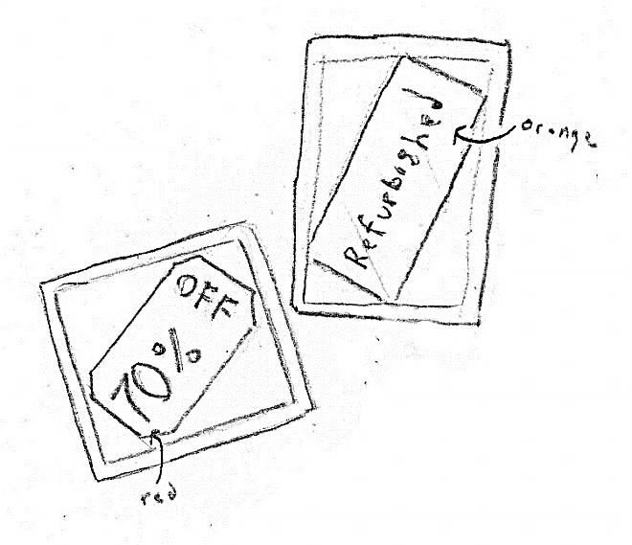

Figure : Marked down part concept sketch

###### Curtains

*Description:* Light blue curtains hung from rolling metal racks.

Quality: Medium

*Use*: Breaks the emergency room into different areas of specialty.

*Importance:* Gameplay (4). Art (4). Cannot be simplified.

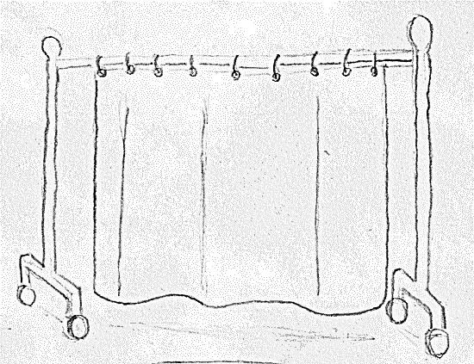

Figure : Curtain concept sketch

###### Respawners

*Description:* Specialized machinery for quickly repairing FPS victims ("Out in 5 seconds or less"). Shaped to represent the different injuries. A respawn timer is placed on the outside of the door.

Quality: High.

*Use*: Placed around the room within the curtains. They lay on the floor in the same orientation as an operating table.

*Importance*: Gameplay (2). Art (4). Number of types can be reduced.

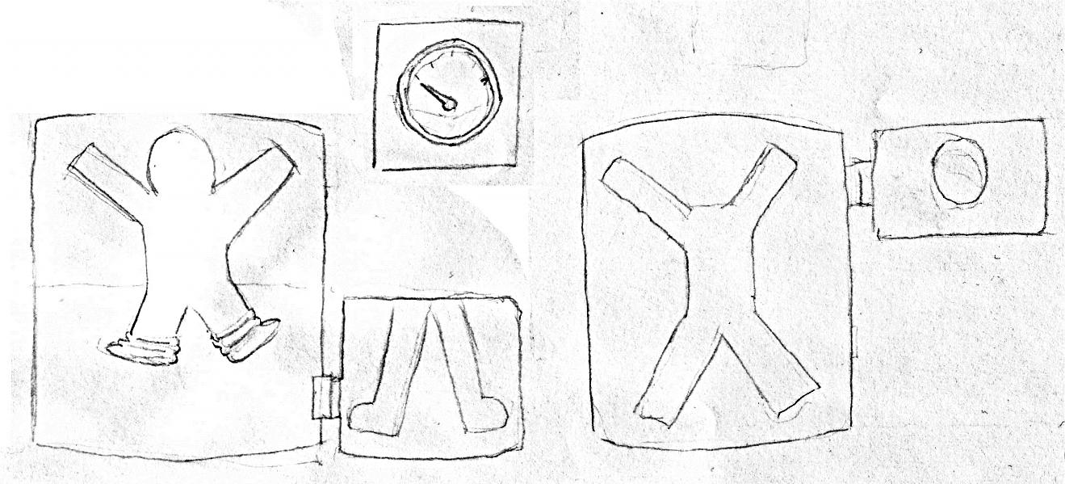

Figure : Respawner concept sketch

#### Academy Wing

##### The Higher Learning Arena

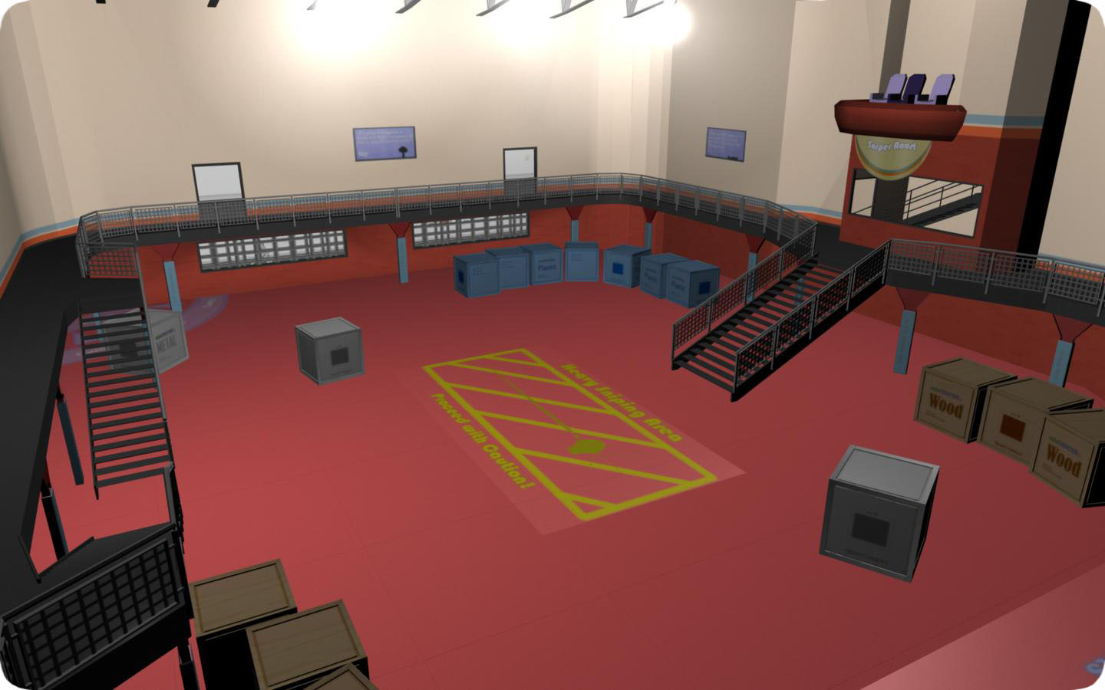

Figure : Arena final render

###### Environment

The floor in this room is covered in colorful, rubberized material that is high traction and easy to clean. The walls are constructed from stone with pads on their bottom sections. Various educational areas are arranged around it, including a target for practicing the knock back modifier and decoys. It has a variety of layouts emphasizing the different situations on an FPS (cover, high ground, spawn camping, etc.).

###### Learning Opportunity Decals

*Description:* Colorful decals that identify locations. Meant to teach students about combat. Examples include: "Spawn Camping Area, Sniper Spot, Run Away, Spawn Area, Taunt, Photo Op"

*Quality:* Low, 2-50/piece.

*Use*: Placed on the floors and walls around the arena.

*Importance*: Gameplay (1). Art (5). Can be simplified in number and ornateness.

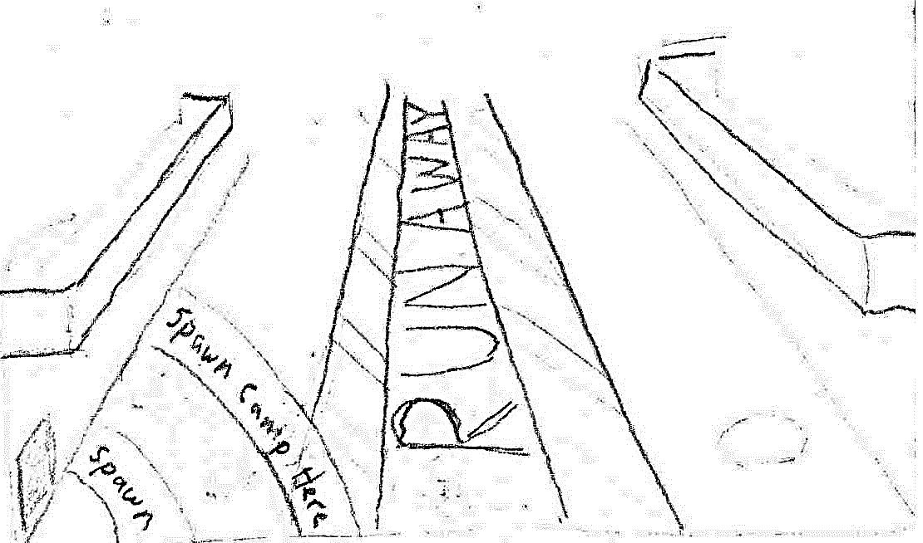

Figure : Arena floor concept sketch

###### Cat Walks

*Description:* Metal cat walks of about 8 feet in width. Secured to the wall on the bottom with bolted L-shaped pieces of metal. Colored dark grey.

*Quality:* Medium, 400/piece.

*Use*: Attached to the walls and between other cat walks. Two floors vertical.

*Importance*: Gameplay (5). Art (3). Can play with the railing details.

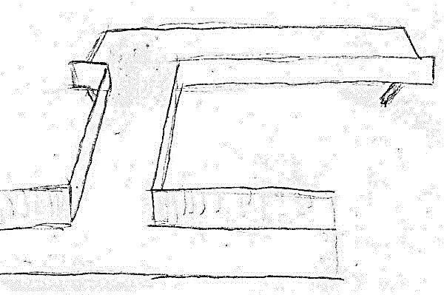

Figure : Cat walk concept sketch

#### The Society for Historical Beatdowns Wing

**[Note: This wing can optionally be closed off to reduce the size of the map / asset creation. Hidden / optional assets are labeled as (Optional) in their title.]**

##### The Museum

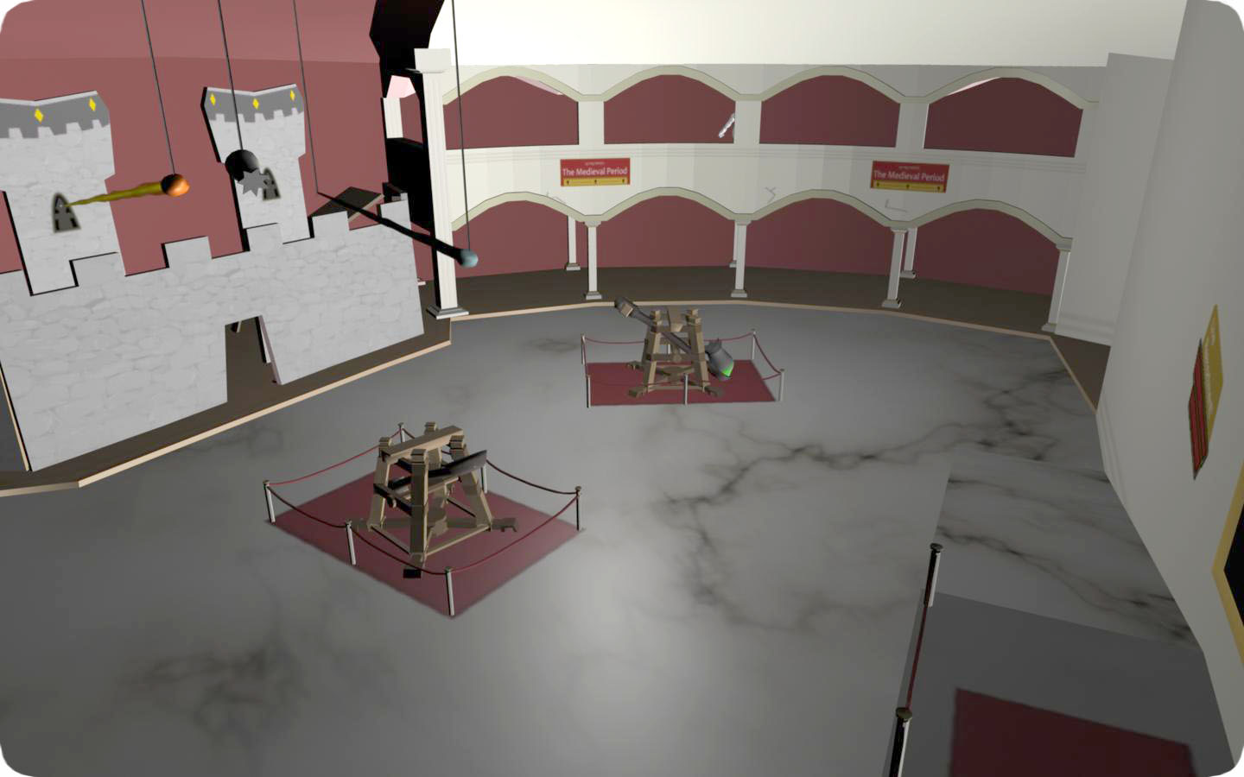

Figure : Museum final render

###### Environment

This large hall typifies the personalities of the professors. It is a worn and crumbling edifice that has been patched over to give the impression of grandeur. Holes in the walls have been covered over. The architectural style is classical, and focuses on white, red, and gold colors.

###### Columns (Optional)

*Description:* Plaster, Corinthian columns erected around the stone supports of the original fort. They only stretch up 2/3 of the original supports.

*Quality:* Medium, 700/piece.

*Use*: Supporting the ceiling.

*Importance:* Gameplay (5). Art (4). Fluting detail can be reduced.

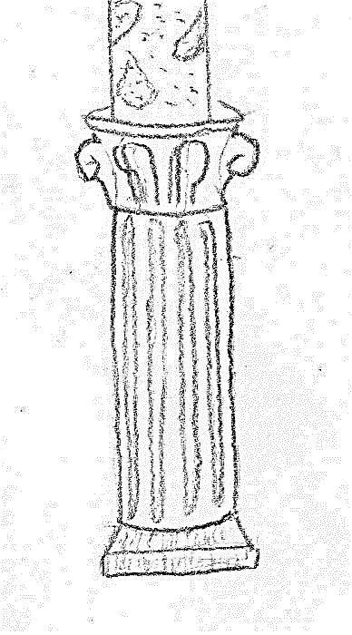

Figure : Museum column concept sketch

# Animations

## Character Animations

### Walk

**Action:** A medium speed jogging motion. As each foot prepares to strike the ground, the other foot has already left it.

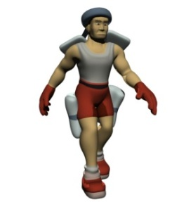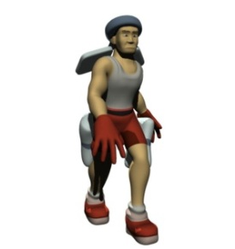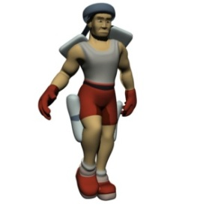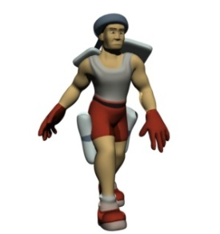

### Die

**Action:** The player collapses to the ground with arms splayed out and knees bent.

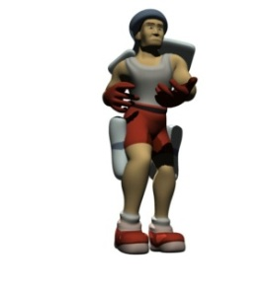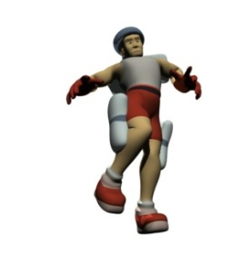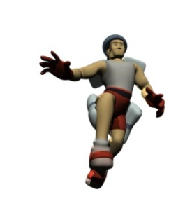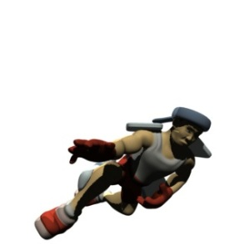

### Jump

**Action:** The player jumps upwards bending the knees and raising the upper legs.

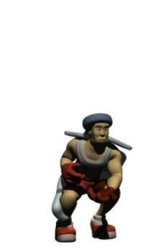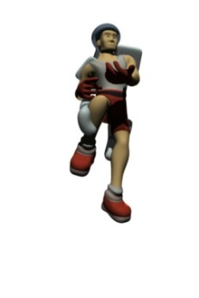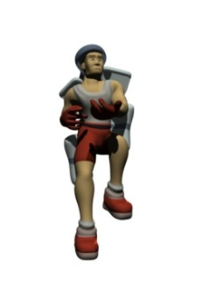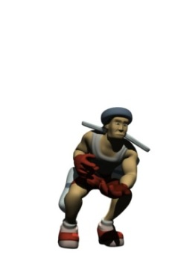

### Grow

**Action:** Scales the player model up and slows the walk cycle animation.

### Shrink

**Action:** Scales the player model down and speeds up the walk cycle animation.

### One Handed Weapon Idle

**Action**: The player stands while holding a one-handed weapon.

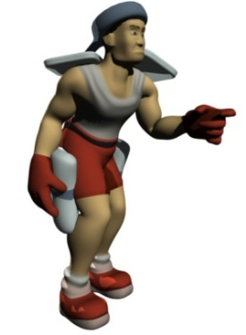

### One Handed Weapon Run

**Action**: The player runs while holding a one-handed weapon.

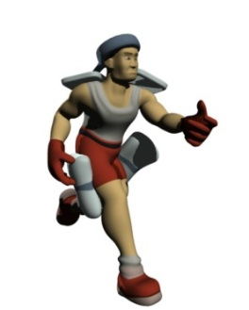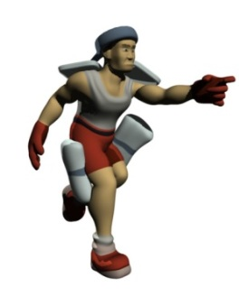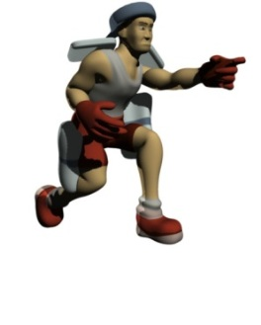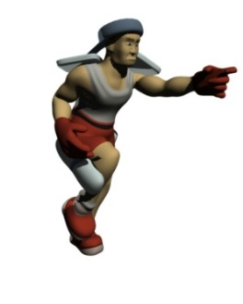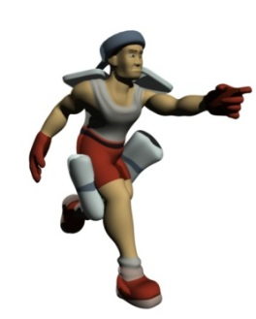

### Two Handed Weapon Idle

**Action**: The player stands while holding a two-handed weapon.

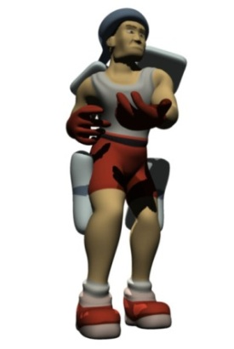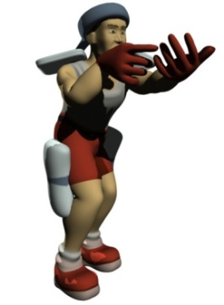

### Two Handed Weapon Run

**Action**: The player runs while holding a two-handed weapon.

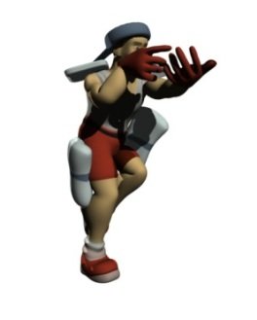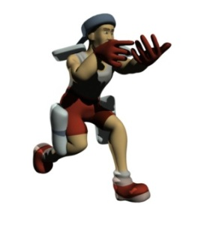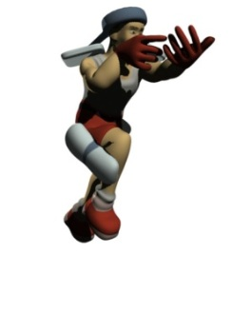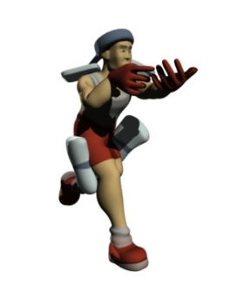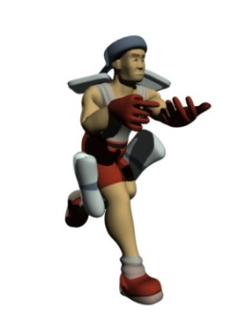

### Binocular Idle

**Action**: The player stands while holding his hands up to his head.

### Binocular Run

**Action**: The player runs while holding his hands up to his head.

### Taunt

**Action**: The player taunts an opponent.

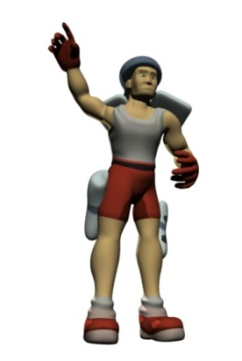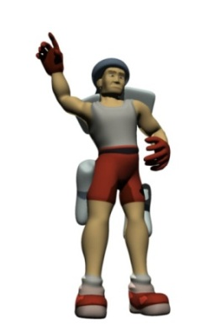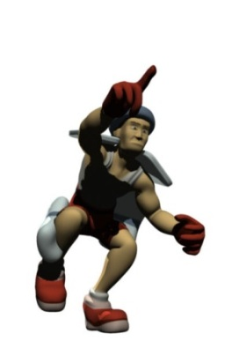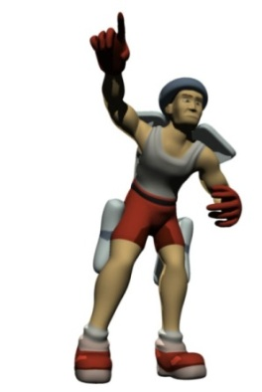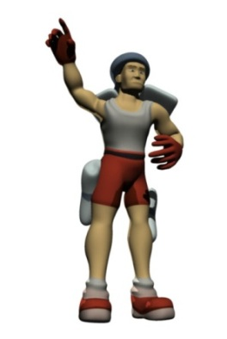

Audio Design Document

# Overview:

## Goal:

We design audio for one specific reason – to give players as much information about their surroundings as possible. Games often use sound effects to this end, but we also use music to set a mood or drape a setting. Because *Trigger Happy* is a frantic, first-person shooter, its music tries to convey as much information as possible. It also employs voiceovers to provide important gameplay information (rather than provide story information, as is typically the case).

## Music:

*Trigger Happy* generates its music on the fly (see the “Research Proposal” section below) based upon a number of in-game variables. This tries to subconsciously help players understand and react to the current game state, without the music becoming overdone or boring. By modifying the general feel of the music based upon game state, the player will hopefully prepare for battles and/or recognize that there is no danger nearby, without even realizing it. Music is based upon the metal genre and is specifically influenced by seminal band X-Japan, who has a remarkable talent of switching back and forth between power ballads and fast metal within the span of a song. A focus on a continual beat and a steady guitar line are very important, and songs like "Dahlia" and the 29-minute epic "Art of Life" are highlighted selections and influences from their discography.

## Sound Effects:

The sound effects also provide the players with information about the world, but with a more “recognize-and-respond” effect, rather than the subconscious response we expect from the background music. Sounds are not 100% realistic, and we overemphasize them so that the players understand what they are and what is going on. Ambient effects are also present in the game, but simply convey localized information rather than game state information. They help to add to the feel of the game.

## Voice:

*Trigger Happy* explicitly uses voiceovers to provide the players with information, such as how long until the round is over, as well as other bits of the game state. Players hear voiceovers through a loudspeaker sound system most of the time, so one may assume that all players can hear the conveyed information at the same time. These effects are very distinct, so that they do interfere with other player communication.

**Music tone words:** frenetic, metal, overemphasized, information-centric

## Concepts:

* The audio must give the player as much information about the game state as possible.
* The audio must not become so overwhelming that the player has the desire to turn it off.
* The audio must not “clash” with variable sound effects or music tracks.
* The music should provide the player with a unique soundscape that they would never hear twice.

# Research:

We must spend a significant amount of time conducting research for the music system of the game. XACT and the *Singularity* audio engine will manage the voice and sound effect implementations.

The music system will systematically piece together a number of non-linear tracks based, upon what is going on in the game world. There will be three main phases: “calm”, “danger”, and “heat-of-battle”. In addition, the game may modify certain elements based upon variables such as the player’s health, the proximity of the nearest enemy, and other factors.

We will develop a special audio system to consider this and implement it. This system will determine the phase based upon constantly updating information and then begin to build music from there. To ensure that the musical snippets piece together properly, we will build the music from the ground up, completing first a rhythm section (drums followed by bass) that will fit together. From there, we will only choose a certain number of melody tracks. We will add many melody lines to the game to ensure that players do not hear the music too often. Finally, we will add supporting strings and synthesizers to make the piece sound fuller and provide extra information (a specific instrument used as a drone, for instance, may tell the player that his health is low.)

We will implement numerous technology tests to determine the exact methods of building the audio piece. Ideally, we will use a combination of custom software and XACT to keep everything in beat and to blend the various tracks together. If necessary, we will use FMOD or Wwise to support virtual voices that expand upon the number of channels on the sound card. A final fallback method would utilize a custom MIDI interpreter and player. In this case, each MIDI cue would apply to a specific set of samples.

We may apply additional sounds to the music, including destructive interference of particular frequencies on particular tracks and other DSP effects. We will keep everything in a single key, but may also modulate each track up to another.

# Implementation:

We will record voiceovers – specific player-centric sound effects – in Digidesign Pro Tools with a single voice actor. We will clean these tracks and process them before bringing them into the game. We will use Microsoft XACT and *Singularity*’s audio engine to play them. We will export voiceovers as .wav files and may or may not compress them in XACT. We will base that decision on quality requirements.

Likewise, we will use XACT and *Singularity*’s audio engine to play sound effects. We will record them with Digidesign Pro Tools or acquire them from licensed sources. We will heavily modify them in Apple Logic, so that they appropriately match the game. We will export sound effects as .wav files and compress them using XACT.

Finally, we will play music through a custom music generator described in the Research section. We will generate non-linear music pieces in Apple Logic and output them as .wav files. We will compress these .wav files in XACT to save space, and blend them together in a virtual channel before outputting them to the sound card – as we will have made them from a number of unique tracks.

We will save each file as a standard LPCM 16-bit wav file at 44100 kHz. Then, we will bring the files into XACT and compress them into ADPCM to save space in memory (with the exception of voiceovers, which will remain uncompressed). We may reconsider techniques described here if the research phase shows a significant use of memory. We will begin filenames with a lowercase prefix followed by an underscore and a PascalCase descriptor.

We will utilize the following prefixes: menu, player, weapon, modifier, ambient, vo, music.

# Overall Development / Details:

## Music:

We will create music tracks in Apple Logic and rerecorded live if time allows. We will make each track from a number of individual pieces that we will have strung together live by the adaptive music engine used by the game. Should this adaptive music engine fail or show itself to be unsuccessful, we will write looping music tracks in Apple Logic and potentially rerecorded live.

## Sound:

We will take sound effects from a mix of original Foley sessions and modified, licensed sound effects. These tracks will be overemphasized and unrealistic compared to their real-world counterparts, but will still be recognizable to players. These high-power effects will make players’ adrenaline rush and allow them to consciously notice and acknowledge the information the game is conveying..

## Voice:

We will record voiceovers in Digidesign Pro Tools and pre-process them to save CPU time in the game. These voiceovers will all be linear and we will not piece them together like we will the music. We will use one voice actor, an adult male, for all of the player sounds

# Content List:

## Sound effects:

Sample Asset Name. If starred, the source file may be the same as another.

|  |  |
| --- | --- |
| Description | A description of how the asset sounds. |
| Play cue | The event that causes the asset to play. |
| Source | The source of the asset. Synthesizers, foley sessions, or licensed and modified sound effects. |
| Length | How long the asset plays. If starred, final length depends on animation lengths. |
| Loops | Does the asset loop? (Boolean) |
| 3D positional | Is the asset positioned in 3D space? (Boolean -- yes means 3D, no means 2D) |
| Others can hear | Will others hear this particular effect in the game world? (Boolean. Some assets will play on all machines regardless.) |
| Filename | The source filename for the asset; will not appear in the final game. |
| Wavebank | The wavebank the source file can be found within; will appear in the final game. |
| Soundbank | The soundbank the file can be accessed from. Will appear in the final game. |
| Cue name | The cue name used to call the sound. Will typically be the same as the Filename but without an extension. |

### Interface (menu\_)

***Menu Cursor Move***

|  |  |
| --- | --- |
| Description | The menu cursor movement sound is similar to the click of a small metal object (such as a bullet) hitting a solid object. |
| Play cue | The arrow keys are used on the main menu to change a selection. |
| Source | Licensed track or Foley |
| Length | 0.1 seconds |
| Loops | No |
| 3D positional | No |
| Others can hear | No |
| Filename | menu\_CursorMove.wav |
| Wavebank | MenuEffects.xwb |
| Soundbank | MenuEffects.xsb |
| Cue name | menu\_CursorMove |

***Menu Select***

|  |  |
| --- | --- |
| Description | The selection sound in *Trigger Happy* main menus is similar to the basic pistol’s firing sound. |
| Play cue | Something is selected in one of the menus. |
| Source | Licensed track or Foley |
| Length | 0.2 seconds |
| Loops | No |
| 3D positional | No |
| Others can hear | No |
| Filename | menu\_Select.wav |
| Wavebank | MenuEffects.xwb |
| Soundbank | MenuEffects.xsb |
| Cue name | menu\_Select |

***Menu Cancel***

|  |  |
| --- | --- |
| Description | The cancel sound is similar to the modifier destroyed sound. |
| Play cue | The player backs out of a menu or cancels a selection. |
| Source | Licensed track or Foley |
| Length | 0.2 seconds |
| Loops | No |
| 3D positional | No |
| Others can hear | No |
| Filename | menu\_Cancel.wav |
| Wavebank | MenuEffects.xwb |
| Soundbank | MenuEffects.xsb |
| Cue name | menu\_Cancel |

### 

### Player (player\_)

#### Player Effects

***Player-on-Player Collision***

|  |  |
| --- | --- |
| Description | Player-on-player collision is an organic sound that will be recorded directly from flesh-on-flesh. |
| Play cue | The player accidentally bumps into another player in the heat of battle. |
| Source | Flesh-on-flesh collision (Foley) |
| Length | 0.2 seconds |
| Loops | No |
| 3D positional | Yes |
| Others can hear | Yes |
| Filename | player\_PlayerCollision.wav |
| Wavebank | PlayerEffects.xwb |
| Soundbank | PlayerEffects.xsb |
| Cue name | player\_PlayerCollision |

***Player Hurt***

|  |  |
| --- | --- |
| Description | The player hurt sound is a male human sound of pain and grunting. |
| Play cue | The player takes damage and is not in a "danger" level of health. |
| Source | Human male grunt (Voice actor) |
| Length | 0.2 seconds |
| Loops | No |
| 3D positional | Yes |
| Others can hear | Yes |
| Filename | player\_Hurt.wav |
| Wavebank | PlayerEffects.xwb |
| Soundbank | PlayerEffects.xsb |
| Cue name | player\_Hurt |

***Player Hurt (Near-Dying)***

|  |  |
| --- | --- |
| Description | The near-dying player hurt sound is a human male groaning in agony. |
| Play cue | The player takes damage and is in a "danger" level of health. |
| Source | Human male grunt (Voice actor) |
| Length | 0.3 seconds |
| Loops | No |
| 3D positional | Yes |
| Others can hear | Yes |
| Filename | player\_NearDying.wav |
| Wavebank | PlayerEffects.xwb |
| Soundbank | PlayerEffects.xsb |
| Cue name | player\_NearDying |

***Player Respawn***

|  |  |
| --- | --- |
| Description | A whooshing sound generated by the release of a new clone. |
| Play cue | The player respawns on the level. |
| Source | Wind sounds (Foley) |
| Length | 1 second |
| Loops | No |
| 3D positional | No |
| Others can hear | No |
| Filename | player\_Respawn.wav |
| Wavebank | PlayerEffects.xwb |
| Soundbank | PlayerEffects.xsb |
| Cue name | player\_Respawn |

***Player Health Recharge***

|  |  |
| --- | --- |
| Description | The player health recharge is a quiet drone ascending in pitch until the player's health is fully charged. The pitch is based solely upon how much health has been charged rather than what percentage of health the charge has reached. |
| Play cue | The sound will play when the player's health begins to recharge. |
| Source | Synthesizer |
| Length | 3 seconds |
| Loops | Yes (until health is recharged) |
| 3D positional | No |
| Others can hear | No |
| Filename | player\_HealthRecharge.wav |
| Wavebank | PlayerEffects.xwb |
| Soundbank | PlayerEffects.xsb |
| Cue name | player\_HealthRecharge |

***Footsteps***

|  |  |
| --- | --- |
| Description | The footsteps are recordings of humans walking/running \*(on the following materials: stone, metal, carpet, wood, tile, rubber, and glass). |
| Play cue | These will play when the player walks on top of the respective in-game material. |
| Source | Shoes on materials (Foley) |
| Length | < 0.1 seconds |
| Loops | No |
| 3D positional | Yes |
| Others can hear | Yes |
| Filename | player\_Footsteps.wav |
| Wavebank | PlayerEffects.xwb |
| Soundbank | PlayerEffects.xsb |
| Cue name | player\_Footsteps |

***Player Lands on Ground***

|  |  |
| --- | --- |
| Description | This sound is a louder, multi-layered version of the material's footstep recording. \*(The materials are stone, metal, carpet, wood, tile, rubber, and glass). |
| Play cue | The player lands from a fall greater than N feet. |
| Source | Footsteps asset |
| Length | 0.2 seconds |
| Loops | No |
| 3D positional | Yes |
| Others can hear | Yes |
| Filename | player\_Landing.wav |
| Wavebank | PlayerEffects.xwb |
| Soundbank | PlayerEffects.xsb |
| Cue name | player\_Landing |

#### 

#### Assault and King of the Hill

***Flag Picked Up***

|  |  |
| --- | --- |
| Description | This is a celebratory signal to let the player know that he is doing the team a service. Similar to trumpet announcements in the courts of kings. |
| Play cue | The player picks up the flag to bring it to another checkpoint and is attacking. |
| Source | Synthesizer trumpets. |
| Length | 0.75 seconds |
| Loops | No |
| 3D positional | No |
| Others can hear | No |
| Filename | player\_FlagPickup |
| Wavebank | PlayerCTFEffects.xwb |
| Soundbank | PlayerEffects.xsb |
| Cue name | player\_FlagPickup |

***Flag Dropped***

|  |  |
| --- | --- |
| Description | This is a tragic signal to let the player know that he failed. This is a variation of the trumpet announcement. |
| Play cue | The player drops the flag for whatever reason (death). |
| Source | Synthesizer trumpets. |
| Length | 0.75 seconds |
| Loops | No |
| 3D positional | No |
| Others can hear | No |
| Filename | player\_FlagDrop.wav |
| Wavebank | PlayerCTFEffects.xwb |
| Soundbank | PlayerEffects.xsb |
| Cue name | player\_FlagDrop |

***Flag Brought to Checkpoint***

|  |  |
| --- | --- |
| Description | A variation on the flag picked up theme. This may become the same sound as the flag picked up. |
| Play cue | The player brings the flag to the checkpoint successfully. |
| Source | Synthesizer trumpets. |
| Length | 0.5 seconds |
| Loops | No |
| 3D positional | No |
| Others can hear | No |
| Filename | player\_FlagCheckpoint.wav |
| Wavebank | PlayerAssaultEffects.xwb |
| Soundbank | PlayerEffects.xsb |
| Cue name | player\_FlagCheckpoint |

***Player Defends KOTH Spot***

|  |  |
| --- | --- |
| Description | This is a soft hum that plays in the background as a notifier. |
| Play cue | The player is standing on the KOTH spot and is part of the team defending it. Stops playing when the player leaves the spot or the team loses control. |
| Source | Synthesizer or Foley |
| Length | 2 seconds |
| Loops | Yes (indefinitely) |
| 3D positional | No |
| Others can hear | No |
| Filename | player\_KOTHDefending.wav |
| Wavebank | PlayerKOTHEffects.xwb |
| Soundbank | PlayerEffects.xsb |
| Cue name | player\_KOTHDefending |

***Player Captures KOTH Spot***

|  |  |
| --- | --- |
| Description | This is the same success sound as the flag brought to the checkpoint. |
| Play cue | The player is on the KOTH spot when it is successfully captured. |
| Source | Synthesizer trumpets. |
| Length | 0.5 seconds |
| Loops | No |
| 3D positional | No |
| Others can hear | No |
| Filename | player\_KOTHCapture.wav |
| Wavebank | PlayerKOTHEffects.xwb |
| Soundbank | PlayerEffects.xsb |
| Cue name | player\_KOTHCapture |

### Weapons (weapon\_)

#### Projectiles

***Explosion***

|  |  |
| --- | --- |
| Description | A loud, high-impact explosion. |
| Play cue | An explosive item or projectile is set off. |
| Source | Fire and high impact (Licensed effects or Foley) |
| Length | 0.75 seconds |
| Loops | No |
| 3D positional | Yes |
| Others can hear | Yes |
| Filename | weapon\_Explosion.wav |
| Wavebank | WeaponEffects.xwb |
| Soundbank | WeaponEffects.xsb |
| Cue name | weapon\_Explosion |

***Bullet Collision (Soft Material)***

|  |  |
| --- | --- |
| Description | The collision sound of a hard object against a soft material. |
| Play cue | A projectile hits a soft material. |
| Source | Material collisions (Foley) |
| Length | 0.1 seconds |
| Loops | No |
| 3D positional | Yes |
| Others can hear | Yes |
| Filename | weapon\_SoftCollision.wav |
| Wavebank | WeaponEffects.xwb |
| Soundbank | WeaponEffects.xsb |
| Cue name | weapon\_SoftCollision |

***Bullet Collision (Hard Material)***

|  |  |
| --- | --- |
| Description | The collision sound of a hard object against a hard material. |
| Play cue | A projectile hits a hard material. |
| Source | Material collisions (Foley) |
| Length | 0.1 seconds |
| Loops | No |
| 3D positional | Yes |
| Others can hear | Yes |
| Filename | weapon\_HardCollision.wav |
| Wavebank | WeaponEffects.xwb |
| Soundbank | WeaponEffects.xsb |
| Cue name | weapon\_HardCollision |

#### Sniper Rifle

***Switch to Sniper Rifle***

|  |  |
| --- | --- |
| Description | A series of hard objects again flesh and cloth. |
| Play cue | The player switches to the Sniper Rifle. |
| Source | Misc. collisions (Foley) |
| Length | 0.3 seconds\* |
| Loops | No |
| 3D positional | No |
| Others can hear | No |
| Filename | weapon\_SniperSwitch.wav |
| Wavebank | WeaponEffects.xwb |
| Soundbank | WeaponEffects.xsb |
| Cue name | weapon\_SniperSwitch |

***Sniper Rifle Fire***

|  |  |
| --- | --- |
| Description | The Sniper Rifle makes a loud, booming explosive sound from its barrel when it fires. |
| Play cue | The player fires the Sniper Rifle. |
| Source | Explosion asset and pistol asset. |
| Length | 0.2 seconds |
| Loops | No |
| 3D positional | Yes |
| Others can hear | Yes |
| Filename | weapon\_SniperFire.wav |
| Wavebank | WeaponEffects.xwb |
| Soundbank | WeaponEffects.xsb |
| Cue name | weapon\_SniperFire |

***Sniper Rifle Reload***

|  |  |
| --- | --- |
| Description | The sound of the player pushing a new bullet into the Sniper Rifle. |
| Play cue | The player reloads the Sniper Rifle. |
| Source | Mechanical sounds (Foley) |
| Length | 1 second |
| Loops | No |
| 3D positional | No |
| Others can hear | No |
| Filename | weapon\_SniperReload.wav |
| Wavebank | WeaponEffects.xwb |
| Soundbank | WeaponEffects.xsb |
| Cue name | weapon\_SniperReload |

#### 

#### Rocket Launcher

***Switch to Rocket Launcher***

|  |  |
| --- | --- |
| Description | A series of hard objects again flesh and cloth. Possibly the same as the switch to the Sniper Rifle. |
| Play cue | The player switches to the Rocket Launcher. |
| Source | Misc. collisions (Foley) |
| Length | 0.3 seconds\* |
| Loops | No |
| 3D positional | No |
| Others can hear | No |
| Filename | weapon\_RocketSwitch.wav |
| Wavebank | WeaponEffects.xwb |
| Soundbank | WeaponEffects.xsb |
| Cue name | weapon\_RocketSwitch |

***Rocket Launcher Fire***

|  |  |
| --- | --- |
| Description | A loud impact from the recoil. |
| Play cue | The player fires the Rocket Launcher. |
| Source | Collision sounds (Foley) |
| Length | 0.2 seconds |
| Loops | No |
| 3D positional | Yes |
| Others can hear | Yes |
| Filename | weapon\_RocketFire.wav |
| Wavebank | WeaponEffects.xwb |
| Soundbank | WeaponEffects.xsb |
| Cue name | weapon\_RocketFire |

***Rocket Launcher Reload***

|  |  |
| --- | --- |
| Description | The sound of a player pulling a rocket out from a pouch and putting it into the machine. |
| Play cue | The player reloads the Rocket Launcher. |
| Source | A combination of the Sniper Rifle Reload and the Grenade Switch |
| Length | 1 second |
| Loops | No |
| 3D positional | No |
| Others can hear | No |
| Filename | weapon\_RocketReload.wav |
| Wavebank | WeaponEffects.xwb |
| Soundbank | WeaponEffects.xsb |
| Cue name | weapon\_RocketReload |

#### Assault Rifle

***Switch to Assault Rifle***

|  |  |
| --- | --- |
| Description | A series of hard objects again flesh and cloth. Possibly the same as the switch to the Sniper Rifle. |
| Play cue | The player switches to the Assault Rifle. |
| Source | Collision sounds (Foley) |
| Length | 0.3 seconds\* |
| Loops | No |
| 3D positional | No |
| Others can hear | No |
| Filename | weapon\_AssaultSwitch.wav |
| Wavebank | WeaponEffects.xwb |
| Soundbank | WeaponEffects.xsb |
| Cue name | weapon\_AssaultSwitch |

***Assault Rifle Fire***

|  |  |
| --- | --- |
| Description | A fast-paced firing sound with a slight bit of grinding. |
| Play cue | The player fires the Assault Rifle. |
| Source | Licensed tracks |
| Length | 0.2 seconds |
| Loops | No |
| 3D positional | No |
| Others can hear | No |
| Filename | weapon\_AssaultFire.wav |
| Wavebank | WeaponEffects.xwb |
| Soundbank | WeaponEffects.xsb |
| Cue name | weapon\_AssaultFire |

***Assault Rifle Reload***

|  |  |
| --- | --- |
| Description | Fleshy objects against metal. |
| Play cue | The player reloads the Assault Rifle. |
| Source | Misc. collisions (Foley) |
| Length | 1 second |
| Loops | No |
| 3D positional | No |
| Others can hear | No |
| Filename | weapon\_AssaultReload.wav |
| Wavebank | WeaponEffects.xwb |
| Soundbank | WeaponEffects.xsb |
| Cue name | weapon\_AssaultReload |

#### Shotgun

***Switch to Shotgun***

|  |  |
| --- | --- |
| Description | A series of hard objects again flesh and cloth. Possibly the same as the switch to the Sniper Rifle. |
| Play cue | The player switches to the Shotgun. |
| Source | Collision sounds (Foley) |
| Length | 0.3 seconds\* |
| Loops | No |
| 3D positional | No |
| Others can hear | No |
| Filename | weapon\_ShotgunSwitch.wav |
| Wavebank | WeaponEffects.xwb |
| Soundbank | WeaponEffects.xsb |
| Cue name | weapon\_ShotgunSwitch |

***Shotgun Fire***

|  |  |
| --- | --- |
| Description | The sound of many small explosions at once and a short clicking afterwards (as is typical for a shotgun). |
| Play cue | The player fires the Shotgun. |
| Source | Modified Explosion asset |
| Length | 0.5 seconds |
| Loops | No |
| 3D positional | Yes |
| Others can hear | Yes |
| Filename | weapon\_ShotgunFire.wav |
| Wavebank | WeaponEffects.xwb |
| Soundbank | WeaponEffects.xsb |
| Cue name | weapon\_ShotgunFire |

***Shotgun Reload***

|  |  |
| --- | --- |
| Description | The sound of three shotguns reloading at varying rates. |
| Play cue | The player reloads the Shotgun. |
| Source | Reloading (Licensed tracks) |
| Length | 0.5 seconds |
| Loops | No |
| 3D positional | No |
| Others can hear | No |
| Filename | weapon\_ShotgunReload.wav |
| Wavebank | WeaponEffects.xwb |
| Soundbank | WeaponEffects.xsb |
| Cue name | weapon\_ShotgunReload |

#### Pistol

***Switch to Pistol***

|  |  |
| --- | --- |
| Description | A series of hard objects again flesh and cloth. Possibly the same as the switch to the Sniper Rifle. |
| Play cue | The player switches to the Pistol. |
| Source | Collision sounds (Foley) |
| Length | 0.3 seconds\* |
| Loops | No |
| 3D positional | No |
| Others can hear | No |
| Filename | weapon\_PistolSwitch.wav |
| Wavebank | WeaponEffects.xwb |
| Soundbank | WeaponEffects.xsb |
| Cue name | weapon\_PistolReload |

***Pistol Fire***

|  |  |
| --- | --- |
| Description | A small, high-pitched pop. |
| Play cue | The player fires the Pistol. |
| Source | Balloon popping (Foley) |
| Length | 0.2 seconds |
| Loops | No |
| 3D positional | Yes |
| Others can hear | Yes |
| Filename | weapon\_PistolFire.wav |
| Wavebank | WeaponEffects.xwb |
| Soundbank | WeaponEffects.xsb |
| Cue name | weapon\_PistolFire |

***Pistol Charging***

|  |  |
| --- | --- |
| Description | A high-pitched whine from low to high. |
| Play cue | The player charges the Pistol. |
| Source | Modified flamethrower sound. |
| Length | 2.5 seconds\* |
| Loops | Yes (until the player releases the fire button) |
| 3D positional | Yes |
| Others can hear | Yes |
| Filename | weapon\_PistolCharge.wav |
| Wavebank | WeaponEffects.xwb |
| Soundbank | WeaponEffects.xsb |
| Cue name | weapon\_PistolCharge |

***Pistol Charged Fire***

|  |  |
| --- | --- |
| Description | A louder, mid-pitched pop. |
| Play cue | The player fires the charged Pistol. |
| Source | Balloon popping (Foley) |
| Length | 0.2 seconds |
| Loops | No |
| 3D positional | Yes |
| Others can hear | Yes |
| Filename | weapon\_PistolFireCharged.wav |
| Wavebank | WeaponEffects.xwb |
| Soundbank | WeaponEffects.xsb |
| Cue name | weapon\_PistolFireCharged |

***Pistol Reload***

|  |  |
| --- | --- |
| Description | The sound of ping-pong balls being pushed into a small container. |
| Play cue | The player reloads the Pistol. |
| Source | Balls into containers (Foley) |
| Length | 1 second |
| Loops | No |
| 3D positional | No |
| Others can hear | No |
| Filename | weapon\_PistolReload.wav |
| Wavebank | WeaponEffects.xwb |
| Soundbank | WeaponEffects.xsb |
| Cue name | weapon\_PistolReload.wav |

### 

### Modifiers (modifer\_)

#### General

***Modifier Deploy***

|  |  |
| --- | --- |
| Description | A mechanical movement sound as the modifier deploys. |
| Play cue | The sound played when a modifier becomes active. |
| Source | Mechanical objects (Foley) |
| Length | 0.2 seconds\* |
| Loops | No |
| 3D positional | Yes |
| Others can hear | Yes |
| Filename | modifier\_Deploy.wav |
| Wavebank | ModifierEffects.xwb |
| Soundbank | ModifierEffects.xsb |
| Cue name | modifier\_Deploy |

***Modifier Shot***

|  |  |
| --- | --- |
| Description | A bullet collision with an emphasized solid sound. |
| Play cue | The player damages a modifier. |
| Source | Modified bullet collision asset |
| Length | 0.2 seconds |
| Loops | No |
| 3D positional | Yes |
| Others can hear | Yes |
| Filename | modifier\_Shot.wav |
| Wavebank | ModifierEffects.xwb |
| Soundbank | ModifierEffects.xsb |
| Cue name | modifier\_Shot |

***Modifier Destroyed***

|  |  |
| --- | --- |
| Description | A small explosion. |
| Play cue | A modifier is destroyed. |
| Source | Modified explosion sound |
| Length | 0.5 seconds |
| Loops | No |
| 3D positional | Yes |
| Others can hear | Yes |
| Filename | modifier\_Destroy.wav |
| Wavebank | ModifierEffects.xwb |
| Soundbank | ModifierEffects.xsb |
| Cue name | modifier\_Destroy |

#### Inverse Gravity

***Inverse Gravity Select***

|  |  |
| --- | --- |
| Description | A short whoosh and metal against material as the player pulls out the modifier gun. A single note using a piano when the modifier cartridge is inserted. |
| Play cue | The Inverse Gravity modifier is selected. |
| Source | Synthesizer and Foley. |
| Length | 0.5 seconds |
| Loops | No |
| 3D positional | No |
| Others can hear | No |
| Filename | modifier\_InverseSelect.wav |
| Wavebank | ModifierEffects.xwb |
| Soundbank | ModifierEffects.xsb |
| Cue name | modifier\_InverseSelect |

***Inverse Gravity Proximity***

|  |  |
| --- | --- |
| Description | A quick ascending series of notes using a piano. Major key. |
| Play cue | The player walks within the proximity radius of an Inverse Gravity modifier. |
| Source | Synthesizer |
| Length | 0.2 seconds |
| Loops | No |
| 3D positional | Yes |
| Others can hear | Yes |
| Filename | modifier\_InverseProximity.wav |
| Wavebank | ModifierEffects.xwb |
| Soundbank | ModifierEffects.xsb |
| Cue name | modifier\_InverseProximity |

***Inverse Gravity Trigger***

|  |  |
| --- | --- |
| Description | A quick, loud ascending series of notes using a piano. Minor key. |
| Play cue | The Inverse Gravity modifier is triggered. |
| Source | Synthesizer |
| Length | 0.2 seconds |
| Loops | No |
| 3D positional | Yes |
| Others can hear | Yes |
| Filename | modifier\_InverseTrigger.wav |
| Wavebank | ModifierEffects.xwb |
| Soundbank | ModifierEffects.xsb |
| Cue name | modifier\_InverseTrigger |

#### Increase Gravity

***Featherlight Select***

|  |  |
| --- | --- |
| Description | A short whoosh and metal against material as the player pulls out the modifier gun. A single note using a harpsichord when the modifier cartridge is inserted. |
| Play cue | The Featherlight modifier is selected. |
| Source | Synthesizer and Foley |
| Length | 0.5 seconds |
| Loops | No |
| 3D positional | No |
| Others can hear | No |
| Filename | modifier\_IncreaseSelect.wav |
| Wavebank | ModifierEffects.xwb |
| Soundbank | ModifierEffects.xsb |
| Cue name | modifier\_IncreaseSelect |

***Featherlight Proximity***

|  |  |
| --- | --- |
| Description | A quick ascending series of notes using a harpsichord. Major key. |
| Play cue | The player walks within the proximity radius of a Featherlight modifier. |
| Source | Synthesizer |
| Length | 0.2 seconds |
| Loops | No |
| 3D positional | Yes |
| Others can hear | Yes |
| Filename | modifier\_IncreaseProximity |
| Wavebank | ModifierEffects.xwb |
| Soundbank | ModifierEffects.xsb |
| Cue name | modifier\_IncreaseProximity |

***Featherlight Trigger***

|  |  |
| --- | --- |
| Description | A quick, loud ascending series of notes using a harpsichord. Minor key. |
| Play cue | The Featherlight modifier is triggered. |
| Source | Synthesizer |
| Length | 0.2 seconds |
| Loops | No |
| 3D positional | Yes |
| Others can hear | Yes |
| Filename | modifier\_IncreaseTrigger.wav |
| Wavebank | ModifierEffects.xwb |
| Soundbank | ModifierEffects.xsb |
| Cue name | modifier\_IncreaseTrigger |

#### 

#### Knockback

***Knockback Select***

|  |  |
| --- | --- |
| Description | A short whoosh and metal against material as the player pulls out the modifier gun. A single note using a vibraphone when the modifier cartridge is inserted. |
| Play cue | The Knockback modifier is selected. |
| Source | Synthesizer and Foley |
| Length | 0.5 seconds |
| Loops | No |
| 3D positional | No |
| Others can hear | No |
| Filename | modifier\_KnockbackSelect.wav |
| Wavebank | ModifierEffects.xwb |
| Soundbank | ModifierEffects.xsb |
| Cue name | modifier\_KnockbackSelect |

***Knockback Proximity***

|  |  |
| --- | --- |
| Description | A quick ascending series of notes using a vibraphone. Major key. |
| Play cue | The player walks within the proximity radius of a Knockback modifier. |
| Source | Synthesizer |
| Length | 0.2 seconds |
| Loops | No |
| 3D positional | Yes |
| Others can hear | Yes |
| Filename | modifier\_KnockbackProximity.wav |
| Wavebank | ModifierEffects.xwb |
| Soundbank | ModifierEffects.xsb |
| Cue name | modifier\_KnockbackProximity |

***Knockback Trigger***

|  |  |
| --- | --- |
| Description | A quick, loud ascending series of notes using a vibraphone. Minor key. |
| Play cue | The Knockback modifier is triggered. |
| Source | Synthesizer |
| Length | 0.2 seconds |
| Loops | No |
| 3D positional | Yes |
| Others can hear | Yes |
| Filename | modifier\_KnockbackTrigger.wav |
| Wavebank | ModifierEffects.xwb |
| Soundbank | ModifierEffects.xsb |
| Cue name | modifier\_KnockbackTrigger |

#### Accelerator

***Frictionless Select***

|  |  |
| --- | --- |
| Description | A short whoosh and metal against material as the player pulls out the modifier gun. A single note using a piccolo when the modifier cartridge is inserted. |
| Play cue | The Frictionless modifier is selected. |
| Source | Synthesizer and Foley |
| Length | 0.5 seconds |
| Loops | No |
| 3D positional | No |
| Others can hear | No |
| Filename | modifier\_AcceleratorSelect.wav |
| Wavebank | ModifierEffects.xwb |
| Soundbank | ModifierEffects.xsb |
| Cue name | modifier\_AcceleratorSelect |

***Frictionless Proximity***

|  |  |
| --- | --- |
| Description | A quick ascending series of notes using a piccolo. Major key. |
| Play cue | The player walks within the proximity radius of a Frictionless modifier. |
| Source | Synthesizer |
| Length | 0.2 seconds |
| Loops | No |
| 3D positional | Yes |
| Others can hear | Yes |
| Filename | modifier\_AcceleratorProximity.wav |
| Wavebank | ModifierEffects.xwb |
| Soundbank | ModifierEffects.xsb |
| Cue name | modifier\_AcceleratorProximity |

***Frictionless Trigger***

|  |  |
| --- | --- |
| Description | A quick, loud ascending series of notes using a piccolo. Minor key. |
| Play cue | The Frictionless modifier is triggered. |
| Source | Synthesizer |
| Length | 0.2 seconds |
| Loops | No |
| 3D positional | Yes |
| Others can hear | Yes |
| Filename | modifier\_AcceleratorTrigger.wav |
| Wavebank | ModifierEffects.xwb |
| Soundbank | ModifierEffects.xsb |
| Cue name | modifier\_AcceleratorTrigger |

#### 

#### Barrier

***Barrier Select***

|  |  |
| --- | --- |
| Description | A short whoosh and metal against material as the player pulls out the modifier gun. A single note using a tuba when the modifier cartridge is inserted. |
| Play cue | The Barrier modifier is selected. |
| Source | Synthesizer |
| Length | 0.5 seconds |
| Loops | No |
| 3D positional | No |
| Others can hear | No |
| Filename | modifier\_BarrierSelect.wav |
| Wavebank | ModifierEffects.xwb |
| Soundbank | ModifierEffects.xsb |
| Cue name | modifier\_BarrierSelect |

***Barrier Proximity***

|  |  |
| --- | --- |
| Description | A quick ascending series of notes using a tuba. Major key. |
| Play cue | The player walks within the proximity radius of a Barrier modifier. |
| Source | Synthesizer |
| Length | 0.2 seconds |
| Loops | No |
| 3D positional | Yes |
| Others can hear | Yes |
| Filename | modifier\_BarrierProximity.wav |
| Wavebank | ModifierEffects.xwb |
| Soundbank | ModifierEffects.xsb |
| Cue name | modifier\_BarrierProximity |

***Barrier Trigger***

|  |  |
| --- | --- |
| Description | A quick, loud ascending series of notes using a tuba. Minor key. |
| Play cue | The Barrier modifier is triggered. |
| Source | Synthesizer |
| Length | 0.2 seconds |
| Loops | No |
| 3D positional | Yes |
| Others can hear | Yes |
| Filename | modifier\_BarrierTrigger.wav |
| Wavebank | ModifierEffects.xwb |
| Soundbank | ModifierEffects.xsb |
| Cue name | modifier\_BarrierTrigger |

#### Illusion

***Illusion Select***

|  |  |
| --- | --- |
| Description | A short whoosh and metal against material as the player pulls out the modifier gun. A single note using a string quartet when the modifier cartridge is inserted. |
| Play cue | The Illusion modifier is selected. |
| Source | Synthesizer and Foley |
| Length | 0.5 seconds |
| Loops | No |
| 3D positional | No |
| Others can hear | No |
| Filename | modifier\_IllusionSelect.wav |
| Wavebank | ModifierEffects.xwb |
| Soundbank | ModifierEffects.xsb |
| Cue name | modifier\_IllusionSelect |

***Illusion Proximity***

|  |  |
| --- | --- |
| Description | A quick ascending series of notes using a string quartet. Major key. |
| Play cue | The player walks within the proximity radius of an Illusion modifier. |
| Source | Synthesizer |
| Length | 0.2 seconds |
| Loops | No |
| 3D positional | Yes |
| Others can hear | Yes |
| Filename | modifier\_IllusionProximity.wav |
| Wavebank | ModifierEffects.xwb |
| Soundbank | ModifierEffects.xsb |
| Cue name | modifier\_IllusionProximity |

***Illusion Trigger***

|  |  |
| --- | --- |
| Description | A quick, loud ascending series of notes using a string quartet. Minor key. |
| Play cue | The Illusion modifier is triggered. |
| Source | Synthesizer |
| Length | 0.2 seconds |
| Loops | No |
| 3D positional | Yes |
| Others can hear | Yes |
| Filename | modifier\_IllusionTrigger.wav |
| Wavebank | ModifierEffects.xwb |
| Soundbank | ModifierEffects.xsb |
| Cue name | modifier\_IllusionTrigger |

#### 

#### Grow

***Grow Select***

|  |  |
| --- | --- |
| Description | A short whoosh and metal against material as the player pulls out the modifier gun. A single note using a male choir when the modifier cartridge is inserted. |
| Play cue | The Grow modifier is selected. |
| Source | Synthesizer and Foley |
| Length | 0.5 seconds |
| Loops | No |
| 3D positional | No |
| Others can hear | No |
| Filename | modifier\_GrowSelect.wav |
| Wavebank | ModifierEffects.xwb |
| Soundbank | ModifierEffects.xsb |
| Cue name | modifier\_GrowSelect |

***Grow Proximity***

|  |  |
| --- | --- |
| Description | A quick ascending series of notes using a male choir. Major key. |
| Play cue | The player walks within the proximity radius of a Grow modifier. |
| Source | Synthesizer |
| Length | 0.2 seconds |
| Loops | No |
| 3D positional | Yes |
| Others can hear | Yes |
| Filename | modifier\_GrowProximity.wav |
| Wavebank | ModifierEffects.xwb |
| Soundbank | ModifierEffects.xsb |
| Cue name | modifier\_GrowProximity |

***Grow Trigger***

|  |  |
| --- | --- |
| Description | A quick, loud ascending series of notes using a male choir. Minor key. |
| Play cue | The Grow modifier is triggered. |
| Source | Synthesizer |
| Length | 0.2 seconds |
| Loops | No |
| 3D positional | Yes |
| Others can hear | Yes |
| Filename | modifier\_GrowTrigger.wav |
| Wavebank | ModifierEffects.xwb |
| Soundbank | ModifierEffects.xsb |
| Cue name | modifier\_GrowTrigger |

#### Shrink

***Shrink Select***

|  |  |
| --- | --- |
| Description | A short whoosh and metal against material as the player pulls out the modifier gun. A single note using a female choir when the modifier cartridge is inserted. |
| Play cue | The Shrink modifier is selected. |
| Source | Synthesizer and Foley |
| Length | 0.5 seconds |
| Loops | No |
| 3D positional | No |
| Others can hear | No |
| Filename | modifier\_ShrinkSelect.wav |
| Wavebank | ModifierEffects.xwb |
| Soundbank | ModifierEffects.xsb |
| Cue name | modifier\_ShrinkSelect |

***Shrink Proximity***

|  |  |
| --- | --- |
| Description | A quick ascending series of notes using a female choir. Major key. |
| Play cue | The player walks within the proximity radius of a Shrink modifier. |
| Source | Synthesizer |
| Length | 0.2 seconds |
| Loops | No |
| 3D positional | Yes |
| Others can hear | Yes |
| Filename | modifier\_ShrinkProximity.wav |
| Wavebank | ModifierEffects.xwb |
| Soundbank | ModifierEffects.xsb |
| Cue name | modifier\_ShrinkProximity |

***Shrink Trigger***

|  |  |
| --- | --- |
| Description | A quick, loud ascending series of notes using a female choir. Minor key. |
| Play cue | The Shrink modifier is triggered. |
| Source | Synthesizer |
| Length | 0.2 seconds |
| Loops | No |
| 3D positional | Yes |
| Others can hear | Yes |
| Filename | modifier\_ShrinkTrigger.wav |
| Wavebank | ModifierEffects.xwb |
| Soundbank | ModifierEffects.xsb |
| Cue name | modifier\_ShrinkTrigger |

## Background Music:

The full extent of the construction and stitching of these pieces will depend on the research project and we will flesh them out further, later.

|  |  |
| --- | --- |
| Description | See each piece description |
| Play cue | When the MusicManager dictates |
| Source | Logic |
| Length | 1-4 measures |
| Loops | No (but seams connect) |
| Filename | music\_[Instrument].wav |
| Wavebank | NonLinearMusic.xwb |
| Soundbank | NonLinearMusic.xsb |
| Cue name | music\_Level |

**Drum Pieces**

These drum pieces will use a heavy rock kit. The drum pieces will set the rhythm and the tempo for the track, and we will choose other pieces based upon the drum.

**Bass Pieces**

We will base our bass piece decisions on the drum track, and will utilize a rhythm that blends intricately with the drum pieces. Bass lines will be relatively complex compared to the rhythm guitar lines. We consider the drum and the bass pieces as the tight rhythm section, though we may also consider the rhythm guitar as part of this section.

**Rhythm Guitar Pieces**

We will base our rhythm guitar lines on the drum rhythm and the bass rhythm/chord structure. Rhythm guitar lines will be relatively simple and typically utilize major chord structures.

**Lead Guitar Pieces**

We will choose the lead guitar lines solely upon the rhythm guitar section, and will include both melody lines and dual harmony solos.

**String Pieces**

String pieces will support the guitar pieces and help to soften the full piece of music. Strings, much like synths, will not always play and will often be whole notes in the background.

**Synth Pieces**

Synthesizer pieces will not always play, and will often act as drones. Occasionally, we may bring the synthesizer in to act as melody or as harmony to the lead guitar.

**Piano Pieces**

We use the piano pieces when a player dies. The music will begin to fade into a piano line similar to the current melody, and fade back into the full track when the player respawns.

**Misc. Pieces**

Miscellaneous instruments such as gongs fit in here.

NOTE: We will develop the background music in *Trigger Happy* as a series of smaller pieces, broken down by instrument and designed to piece together fluidly. We describe the pieces here. We describe the overall system in the “Research” section above. In addition, we describe “fallback” music tracks should the adaptive system fail.

***Trigger Happy Theme***

|  |  |
| --- | --- |
| Description | We play the *Trigger Happy* theme on the main menu screen when the game is loaded. It will be a lower-energy track utilizing the same instruments as the rest of the game’s soundtrack. There will be female lead singer and a fully developed set of lyrics. This track will have an especially catchy introduction to hook the player and make the game immediately more appealing upon load. The best-case scenario is a player who listens fully to the track each time. This track should be about three minutes long. |
| Play cue | When the player is on the main menu. |
| Source | Logic |
| Length | 180 seconds |
| Loops | No |
| Filename | music\_Theme.wav |
| Wavebank | LinearMusic.xwb |
| Soundbank | LinearMusic.xsb |
| Cue name | music\_Theme |

***Fallback Level Background***

|  |  |
| --- | --- |
| Description | This track is a high-energy masterwork of metal. A double-kick drum will become a prominent piece of the music, as will a technical guitar melody line. We double-up heavy rhythm guitars to thicken the sound, and the key of the music will be a minor key. This track will give players the sense of battle and adrenaline. |
| Play cue | When the player is in the level. |
| Source | Logic |
| Length | 300 seconds\* |
| Loops | Yes |
| Filename | music\_Level.wav |
| Wavebank | LinearMusic.xwb |
| Soundbank | LinearMusic.xsb |
| Cue name | music\_Level |

***Death Soundtrack***

|  |  |
| --- | --- |
| Description | As the respawn counter counts down, we play a short piano track. When the player respawns, the level background will begin to play again. |
| Play cue | When the player dies. |
| Source | Logic |
| Length | 15 seconds\* |
| Loops | No |
| Filename | music\_Death.wav |
| Wavebank | LinearMusic.xwb |
| Soundbank | LinearMusic.xsb |
| Cue name | music\_Death |

Technical Design Document

# Summary

This document provides a detailed view of the technical aspects of the development for *Trigger Happy,* the game. It details all aspects of both the design of the game objects, as well as the underlying game engine. Since the design choices made for the engine are tangential to the usual design choices for engines, some confusion might result if the reader does not start from the beginning with the system architecture description.

# Document Scope

This document was used in the development and implementation of the *Trigger Happy* game. It details the architecture of the multi-threaded engine, the core components, and gameplay elements used in the development cycle. It is useful background reading for anyone involved in management or oversight of the *Trigger Happy* game.

# Development Technology

|  |  |
| --- | --- |
| Graphical Platform | NVidia 9600 GT (x2) |
| System Hardware | Intel Core2 Quad 2.66GHz |
| Content Pipeline Tools | Autodesk Maya |
|  | Apple Logic |
|  | Adobe Photoshop CS4 |
| Development Tools | Visual Studio 2008 |
|  | SVN (gdd.unfuddle.com) |
|  | Trac |
| Operating System(s) | Windows Vista |
|  | Windows 7 |
| External Libraries | Lua v5.1 |
|  | XACT |
|  | DirectX v10 |
|  | DirectInput v8 |
|  | Bullet Physics Library 2.7 |

# Production Technology Requirements

|  |  |
| --- | --- |
| Hardware | NVidia 9 Series graphics card or greater.  Radeon HD2900 graphics card or greater. |
|  | Intel Pentium D 3GHz or Higher |
| Operating System(s) | Windows Vista |
|  | Windows 7 |
| External Libraries | DirectX v10 or greater |
|  | DirectInput v8 |
|  | Lua v5.1 |
|  | Bullet Physics Library |

# Engine

Details of the internal details of the *Singularity* engine, its architecture, and objects.

## System Architecture

At the core of *Trigger Happy’s* development is the design of a new engine known as *Singularity*. *Singularity* combines a task-based threading model, popularized by the Intel's Threaded Building Blocks (TBB) [1], and a component-based entity architecture. By combining these two techniques, *Singularity* is able to fully utilize multi-core processors while minimizing the usual overhead associated with multi-core development. In the context of multi-core processors, the combination of these two architectures is very powerful and offers a world of possibilities not available to most game engines.

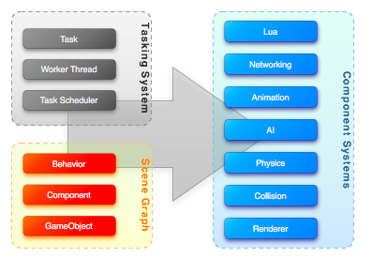

Figure : Singularity System Architecture Overview

The engine is split into multiple subsystems, each consisting of the tasking system, scene management, and the engine components. Both the tasking and scene management systems are core to the engine framework and provide the means of executing or managing the engine components. Components are functional extensions to the engine and help to supplement the needs of game development via physics, animation, or other game systems.

### Multi-core

With the advent of multi-core processors in the past five years, game engines have begun moving towards parallel execution architectures. Intel's release of the TBB library was a huge advancement that allowed developers to easily interface with the system's cores. Though the design of *Singularity’s* core is similar TBB, we rewrote the library to allow more control over the scheduling and memory footprint of the tasks.

Scheduling for TBB is a "first come first serve" model, allowing tasks to execute quickly but with no ordering or absolute scheduling. *Singularity's* design attempts to extend the concept of TBB to enable task ordering and allows tasks to dictate how quickly they should be executed. In order to implement these additions, we added a new scheduling system and task usage tracking.

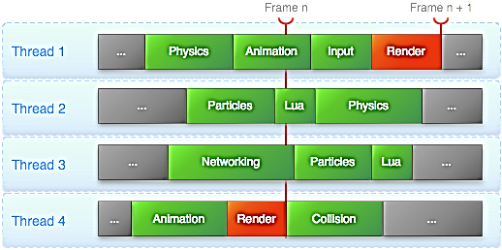

Figure : Threading Task Scheduling Diagrams

To further move the tasking system into the gaming environment, we added dependency ordering. This feature allows chaining of tasks through a dependency chain. For instance, this prevents the render task from running before other systems, such as physics or the particles. If the tasks did not have this feature, they would be unpredictable and the rendered output would not properly match the state of the system.

### Componentization

One of the core requirements for the *Singularity* engine was to allow quick development with an easy to build system. In order to accomplish such a task, we researched many different techniques. Each technique had its strengths and weaknesses; however, the component-based entity approach gave the engine the flexibility, testability, and compatibility to work within the multi-core threading model.

A component architecture is based on the separation of functionality into individual components. Instead of the traditional object hierarchy, an object is created as a collection of components – the sum of which represents all of the functional needs of the entity. Each component runs only within the scope of its functionality, thus removing much of the data dependency of hierarchical models.

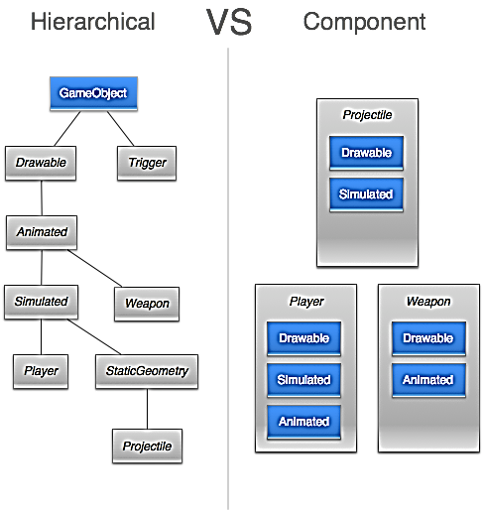

Figure : Hierarchal Architecture vs. Component-based Architecture

The advantages of the component architecture allow us to build independent component systems to handle the usual game functionality. Components help minimize the amount of overhead associated with multi-threaded systems. Due to their independent nature, components can minimize the use of data synchronization constructs. With very little data sharing between threads there are only a small number of cases that require any form of locking mechanism. Unlike most threading models that are only data or functionally separated, the threading model and component architecture integration allow *Singularity* to utilize a threading model based on data and functional division.

In *Singularity*, we create all game objects from a single type. However, unlike the hierarchical method, we do not derive from the class. Instead, we build up the class by adding components and behaviors. Components add functionality such as animation or model rendering; behaviors are scriptable and allow developers to extend the functionality of the game object.

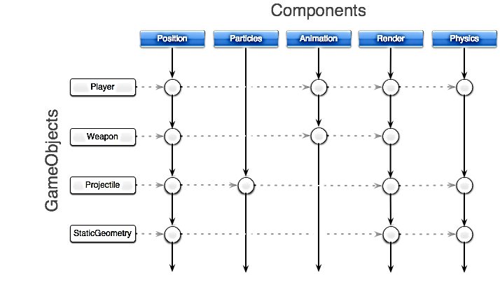

Figure : Object Composition Using Components

When components are executed, a centralized extension singleton control them. The purpose of this object is to split up the task into smaller more manageable tasks, each with a subset of the initial set of components. By running components in parallel instead of focusing on the game object, we can build a threading model where we need very few blocks to maintain stability. With a small number of locks, we can utilize the tasking system and the multi-core system to its fullest. What this means for the developer is more time to perform AI, physics, or other lengthy execution systems, without having to worry about frame rate.

## Tasking System

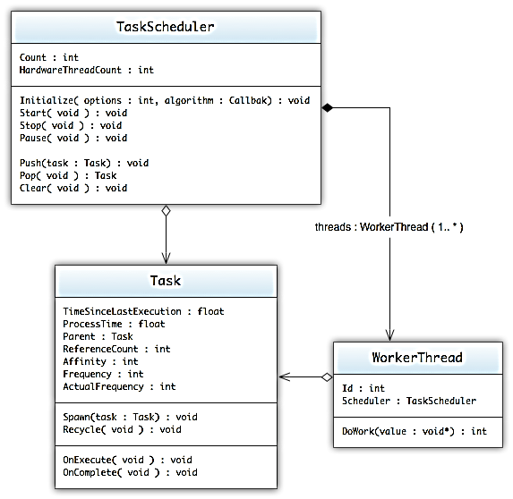

Figure : Task System UML Diagram

The tasking system is a hybrid of the two techniques used in the Intel Smoke demo [2] – both of which utilize the Intel Threaded Building Blocks library. To minimize the system’s size and execution overhead, the tasking system uses a custom developed systems architecture that closely mirrors the functionality of the Intel Threaded Building Block. Instead of managing tasks on each worker thread, the adjusted system architecture manages a centralized queue of tasks. And due to the system component based architecture, the standard game loop has been replaced with a dependency driven task execution pipeline.

### TaskScheduler

The task scheduler is the core of the tasking system. Its primary function is to manage the scheduling of tasks according to a weighting algorithm. The scheduler maintains an internal queue of the currently assigned tasks and is structured as a dequeue. When a task is requested, the scheduler returns the next task according to the weighting algorithm.

**Weighting Algorithm**

The rules used to determine the next executed task:

The task whose last child was completed by this thread.

The task whose frequency deadline has been reached or will fail if another task is executed.

The task with the highest affinity.

The task with the shortest process time.

* **Data**
  + Count : *int*
    - Number of *Tasks* currently on the scheduling queue.
  + HardwareThreadCount : *int*
    - Number of cores/processors available on the current system.
* **Operations**
  + Initialize(options : int, algorithm : WeightingAlgorithmCallback) : void
    - Initializes the task scheduler using the options. Allows the system to run in single or multi-threaded mode, as well as scheduling behaviors.
  + Start(*void* ) : *void*
    - Starts the scheduling system and spools up the appropriate *WorkerThread*
  + Stop(*void* ) : *void*
    - Stops the scheduling system and shuts down the *WorkerThreads*.
  + Pause(*void* ) : *void*
    - Pauses the scheduling system and puts all of the *WorkerThread* into sleep mode.
  + Push(task: *Task* ) : *void*
    - Pushes the task onto the scheduling queue.
  + Pop(*void* ) : *Task*
    - Pops the next task from the scheduling queue. Priority is determined by task frequency, last execution time, affinity, and process time. Ideally, tasks that have a frequency set will be moved to the start of the queue the closer they get to their deadline.
  + Clear( *void* ) : *void*
    - Removes all of the currently queued tasks from the scheduling queue.

### WorkerThread

The *WorkerThread* is the execution thread needed to process the queue tasks. Depending on the options specified in the initialization of the *TaskScheduler,* the number of *WorkerThreads* can range from one to the number of cores the system has.

* **Data**
  + Id : *int*
    - Identifier of the *WorkerThread* as assigned by the *TaskScheduler*
  + Scheduler : *TaskScheduler*
    - The scheduler which is currently handling the task management.
* **Operations**
  + DoWork(value : *void\**) : int
    - The main execution loop for the *WorkerThread*. This is where all of the *Task* Execution happens as well as the idling when no more tasks are present.

### Task

The task is the primary development concept of the tasking system. Tasks are the unitized functional calls that allow the threading model to execute dependent on the processor core, thus allowing multicore programming without having to maintain the overhead of thread management.

The task offers a set of functions that allow the developer to manage child and parent relationships.

* **Data**
  + TimeSinceLastExecution : *float*
    - Measurement, in seconds, of the elapsed time since the last execution of the task; if this is the initial run then the return value is 0.0.
  + ProcessTime : *float*
    - Measurement, in seconds, of the amount of time the task requires to complete. This value is averaged over the execution of the task.
  + Parent : *Task*
    - If the task was spawned from another task, this will be the value of the task's originator. Tasks that have not been spawned from a task will not have a parent assigned.
  + Scheduler : *TaskScheduler*
    - The scheduler which is currently handling the task management.
  + ReferenceCount : *int*
    - The number of tasks that have been spawned from this task. Before the task can complete every sub-task must complete, thus bringing the reference count to 0.
  + Affinity : *int*
    - The task's affinity within the current task scheduler. The lower the number the higher the priority in the scheduler and the task will run sooner.
  + Frequency : *float*
    - This defines, for the system, how often the task should be run. If no frequency is set, the system will treat the task as a filler when dealing with the scheduling algorithm.
  + ActualFrequency : *float*
    - Measurement of the tasks actual execution frequency. Due to the dynamic scheduling and process times associated with tasks, the actual execution frequency may not be the same as the defined frequency.
* **Operations**
  + Spawn(task : *Task*) : *void*
    - Spawns a child task associated with the current task. Completion of the parent task is dependent on the completion of all of the spawned child tasks. The reference count of the task will increase by one for each spawned task.
  + Recycle( *void* ) : *void*
    - Commands the task to push itself back onto the queue once it has finished execution and has been completed (all of its children have completed).
  + OnExecute( *void* ) : *void*
    - This function is called when the task has been assigned to a *Worker Thread* and is executed. When deriving from *Task*, the primary function that is adjusted to accommodate the functional needs.
  + OnComplete( *void* ) : *void*
    - This function is called when the task and all its children have completed and the task is finally pulled from the task queue. If the task has been recycled it will be reset and pushed back onto the scheduling queue.

## Scene System

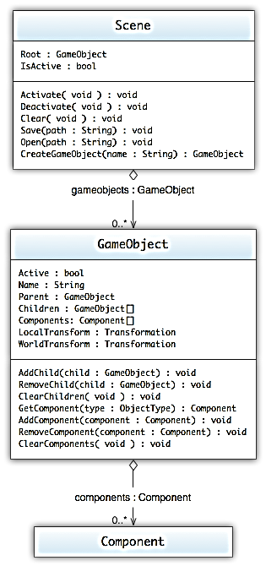

Figure : Scene System Diagram

The scene system is the core of the engine and manages all of the objects placed within *Trigger Happy*. Basic scene culling and object partitioning is handled within this system via the *SceneGraph* system. The system allows customization of the storage and partitioning of the GameObjects by the inclusion of user definable *SceneGraph* classes.

### GameObject

The *GameObject* are containers for all of the engine's components. All of the objects in *Trigger Happy* are compositions of other *GameObjects* and *Components*. *GameObjects* do not add any characteristics to the game by themselves; instead, they manage the attached *Components,* which implement the actual functionality.

* **Data**
  + Active : *Boolean*
    - Details whether the *GameObject* is active within the *SceneGraph.*
  + Name : *String*
    - The name of the object.
  + Parent : *GameObject*
    - The parent of the game object.
  + Children : *GameObject[]*
    - The children of the game object.
  + Components : *Component[]*
    - The list of all the attached components.
  + LocalTransform : *Transformation*
    - The local transformation of the *GameObject*, this transform describes the *GameObjects* position, rotation and scale relative to the parent *GameObject.*
  + WorldTransform : *Transformation*
    - The world transformation of the *GameObject*, this transform describes the *GameObjects* absolute position, rotation and scale in the world.
* **Operations**
  + AddChild(child : *GameObject*) : *void*
    - Adds a child *GameObject* to current *GameObject*; thus setting the child's parent to the current *GameObject.*
  + RemoveChild(child : *GameObject*) : *void*
    - Removes the child *GameObject* from the current *GameObject*; if the child is not found then nothing is removed.
  + ClearChildren( *void* ) : *void*
    - Removes all of the child *GameObjects* from the current *GameObject.*
  + GetComponent(type : *ObjectType*) : *Component*
    - Retrieves the first instance of a component that matches the *ObjectType.*
  + AddComponent(component : *Component*) : *void*
    - Adds a *Component* to the current *GameObject.*
  + RemoveComponent(component : *Component*) : *void*
    - Removes the component from the current *GameObject*; if the component is not found then nothing is removed.
  + ClearComponents( *void* ) : *void*
    - Removes all of the components from the current *GameObject.*

### Component

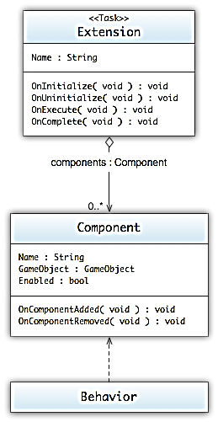

Figure : Component UML Diagram

*Components* represent all of the functional additions that developers may attach to *GameObjects*. Examples include rendering, collisions, physics, etc. See the Components section (section 6) for the current list of engine components that are available to the designers and game development.

* **Data**
  + Name : *String*
    - Contains the user-defined name of the *Component*
  + GameObject : *GameObject*
    - The GameObject that the *Component* is attached to
  + Enabled : *Boolean*
    - Describes whether or not the *Component* will be executed
* **Operations**
  + OnComponentAdded ( *void* ) : *void*
    - Called when the *Component* is added to a *GameObject*
  + OnComponentRemoved ( *void* ) : *void*
    - Called when the *Component* is removed from a *GameObject*

### Behavior

The *Behavior* class is nothing more than a simple distinction between functional *Components* and a completely callback based *Component.*

### Extension

*Extensions* are the managers of components and execute the overall behavior that the custom *Component* is meant to embody. *Extensions* are also *Tasks* and, as such, are able to take advantage of the multicore tasking system. By utilizing the multicore tasking system, *Extensions* are able to partition their *Components* and execute each subset in parallel – greatly increasing the execution throughput of the system.

* **Data**
  + Name : *String*
    - Contains the user-defined name assigned to the *Extension*
* **Operations**
  + OnInitialize( *void* ) : *void*
    - Called when the first *Extension* of this type is initially loaded into the scheduler
  + OnUninitialize ( *void* ) : *void*
    - Called when the last *Extension* of this type is unloaded from the scheduler
  + OnExecute( *void* ) : *void*
    - Inherited from Task
  + OnComplete ( *void* ) : *void*
    - Inherited from Task

### Scene

The Scene is the organizational construct that maintains and orders the *GameObjects*. Culling and other spacial operations are also performed using the power of the *SceneGraph*. Finally, the *SceneGraph* maintains the management of object locking to prevent systems from causing data collisions through the manipulation of the *GameObjects* within the *SceneGraph*.

* **Data**
  + Root : *GameObject*
    - Root *GameObject* that all other *GameObjects* are relative to. This is normally used as the base coordinate system for the game.
* **Operations**
  + BeginUpdate( *void* ) : *void*
    - Sets up a differed rebuild of the *SceneGraph* tree structure. This is used to prevent a large adjustment of *GameObjects* from propagating on every change; speeding up the system significantly.
  + EndUpdate(force : *Boolean*) : *void*
    - Finalizes the differed update of the *SceneGraph* tree structure. If *force* is enabled, then the tree will rebuild whether or not the tree needs it or not.
  + Update(force : *Boolean*) : *void*
    - Instantly rebuilds the *SceneGraph* tree structure. If *force* is enabled, then the tree will rebuild whether or not the tree needs it or not.

## Components

Up to this point, this document has emphasized the framework and subsystems needed to manage and execute the components. Components are the tools by which designers and developers can take the engine to create a game. As developers need new functionality, one may easily add new components that further extending the abilities of the engine.

Table : Summary of components

|  |  |
| --- | --- |
| Component | Description |
| Rendering | Component system used to render images to the graphics device or screen. Maintains all the information about the graphics hardware and builds in some core components for building scenes. |
| Input | Component system for tracking and recording input data. |
| Physics | Component system the enables physic based simulations on game objects. This system includes a collision system to allow general in-game physics simulations and wraps the external library Bullet Physics. |
| Animation | Component system that controls and updates the meshes to enable character or object animations. Gives the animator a set of functional tools for controlling animation sequences and transitions. |
| Networking | Component system that manages and synchronizes multiple game clients to enable multi-player action. |
| Lua | Component system that allows lua scripting to be executed and interact with game objects. |
| Particle | Component system for displaying and managing particle systems. |
| Audio | Component system for playing and managing audio. The audio components allow for 3D positional audio and dynamic audio content playback. |
| GUI | Component system that attaches to the camera component to draw 2D GUI components. |
| Content | Component tools for loading and building game objects based off of attribute encoded models. |
| In-Game | Components that are needed to extend the core engine components in order to fill gaps needed for the development of *Trigger Happy*. |

### Rendering Subsystem

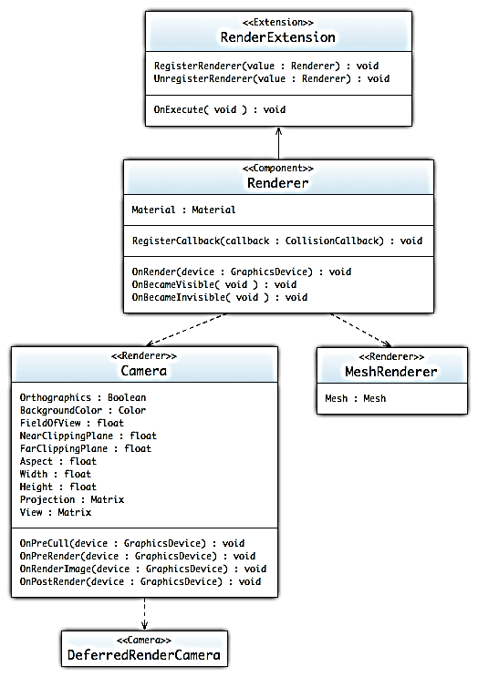

Figure : : Render UML Diagram

The graphics renderer is the component interface through which the system makes calls to the graphics hardware. It manages all aspects of the rendering and is the sole means through which one may request objects to be drawn to the screen. Since the *Singularity* engine is component based, the rendering pipeline is implemented as a collection of different components. Handling of all drawing calls is dealt with using both the Camera component and the MeshRenderer. Though both are Renderers, each component handles different aspects of the rendering pipeline. The Camera primarily handles the setup and processing of the viewport and resulted images from rendering. The MeshRenderer handles the object based rendering.

#### Mesh

Represents a collection of vertices and indices that represent a 3D/2D object.

* **Data**
  + BoundingVolume : *BoundingVolume*
    - A bounding object that contains all of the mesh's polygons.
  + Vertices : *VertexBuffer*
    - The mesh's *VertexBuffer*
  + Indices : *IndexBuffer*
    - The mesh's *IndexBuffers*
* **Operations**
  + Clear( *void* ) : *void*
    - Clears out the vertex and index buffers of the mesh resulting in an empty mesh.
  + RecalculateBounds( *void* ) : *void*
    - Recalculates the bounding volume of the mesh.
  + SetVertices(declaration : *VertexDeclaration*, data : *void[]*, length : *int*) : *void*
    - Creates or modifies the *VertexBuffer* with the provided data.
  + SetIndices(data : *int[]*, length : *int*) : *void*
    - Creates or modifies the *IndexBuffer* with the provided data.

#### Material

Materials are the core of the rending pipeline. Materials represent effects and as such control how objects are drawn and represented on the screen.

* **Data**
  + PassCount : *int*
    - The number of passes associated with this material.
* **Operations**
  + SetVariable(key : *String*, value : *Object*) : *void*
    - Sets the materials parameter named *key* with the value provided.

#### GraphicsDevice

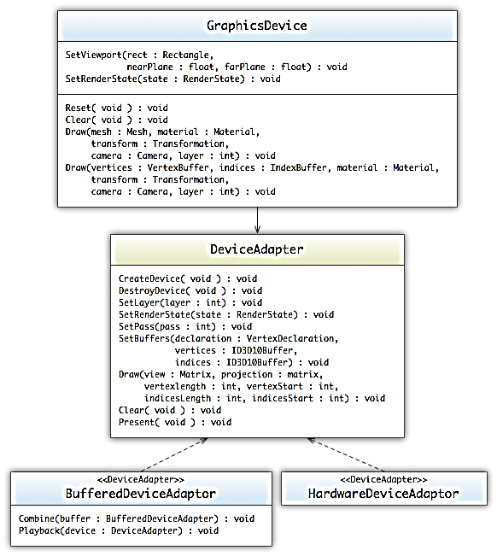

Figure : Graphics UML Diagram

The GraphicsDevice used in *Singularity* has a different structure than most graphic devices in other engines. Most engines spend approximately 50-80% of their time in the render state. Since the majority of our system’s execution time is used on rendering, it is in our best interest to spread this execution across the cores. However, due to the nature of the graphics hardware, we are unable make render calls across threads without locking each call. With *Singularity's* multi-core system, this slowdown would cause great hiccups in the execution process. To alleviate this issue, the graphics device has two primary modes. One mode is a direct line to the underlying hardware device, the other is a recording system that both optimizes the render calls and is thread safe. The recording system allows the render of all of the visible objects using the power of the multi-threaded system without having to block between render calls. Once the recording has been completed, the RenderExtension spools up the HardwareRendererExtension which will playback the recorded rendering calls.

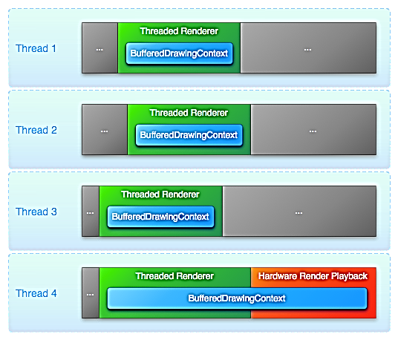

Figure : Threaded Rendering Example

#### DrawingContext

The DrawingContext is a base class for the graphics-rendering pipeline.  Its main purpose is to provide an interface layer between the objects and the device context.  The BufferedDrawingContext is a drawing call recorder whose main purpose is to allow the recording of draw calls for playback later.  By deferring the drawing until the end of the rendering cycle, the system is able to spread the drawing system across multiple cores while maintaining a single drawing call.

* Operations
  + Clone( void ) : DrawingContext
    - Clones an existing DrawingContext into a new context.
  + Clear(color : Color) : void
    - Clears the drawing buffer to the color specified.
  + Flush( void ) : void
    - Flushes the drawing calls to the current hardware context.
  + AddLight(light : Light) : void
    - Adds a light to the current context.
  + SetLayer(layer : int) : void
    - Sets the current drawing layer.
  + SetRenderState(renderstate : RenderState) : void
    - Sets the current render state for the context.
  + Draw(camera : Camera ,material : Material, world : Matrix, vertices : VertexBuffer, start : int, length : int) : void
    - Draws to the context the specified vertex buffer using the start and length to define the drawn vertices.
  + DrawIndexed(camera : Camera ,material : Material, world : Matrix, vertices : VertexBuffer, indices : IndexBuffer, start : int, length : int, vertexOffset : int) : void
    - Draws to the context the specified vertex buffer and index buffer using the start, length, and offset to define the drawn vertices.

#### BufferedDeviceContext

The *BufferedDeviceContext* is a recording class that takes all of the draw calls and stores them into a tree structure. Recording the draw calls allows us to enabled threaded rendering and provides the engine a means to organize and optimize the draw calls.

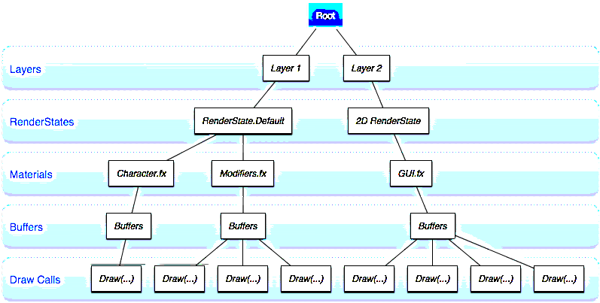

Figure : Recording Tree Structure used in BufferedDeviceContext Example

Each instance of the device manages its own copy of the tree structure.  When the final render task is completed, the trees are combined and played back using the graphics device.  This technique allows the other threads to start working on other tasks while the last instance of the BufferedDeviceContext builds a tree with an optimized render pipeline, speeding device rendering considerably.

* Operation
  + {replace}Playback(device : DeviceContext) : void
  + {with}Flush(void) : void

#### Renderer

The *Renderer* is the base *Component*, used to render images to the screen. Though the class itself is abstract, the *Renderer* is the only means through which *Component* give objects that must be drawn to the hardware device. At the current iteration, the only classes that implement *Renderer* are *Camera* and *MeshRenderer*. The system uses *Camera* to set up the viewport and manage both post-render and pre-render processes. It uses *MeshRenderer* to draw objects to the device.

* **Data**
  + Material : *Material*
    - The *Material* that will be used to render out objects*.*
* **Operations**
  + OnRender(device : *GraphicsDevice*) : *void*
    - Called when the *RenderExtension* is executed to render the screen and the object is not culled. The *GraphicsDevice* provided hides whether the rendering will be buffered or directly drawn to the screen.
  + OnBecameVisible( *void* ) : *void*
    - Called when the object was originally culled from rendering but has now been allowed to render.
  + OnBecameInvisible( *void* ) : *void*
    - Called when the object was originally rendered but has now been culled from rendering.

#### MeshRenderer

The *MeshRenderer* is the primary *Component* for rendering a Mesh to the screen.

* **Data**
  + Mesh: *Mesh*
    - The *Mesh* that will be used to render out objects*.*
* **Operations**
  + OnRender(device : *GraphicsDevice*) : *void*
    - Inherited from *Renderer; c*alled when the *RenderExtension* is executed to render the screen and the object is not culled.
  + OnBecameVisible( *void* ) : *void*
    - Inherited from *Renderer;* called when the object was originally culled from rendering but has now been allowed to render.
  + OnBecameInvisible( *void* ) : *void*
    - Inherited from *Renderer;* called when the object was originally rendered but has now been culled from rendering.

#### Camera

The *Camera* is a *Component* through which the player views the world. A screen space point is defined in pixels. The bottom-left of the screen is (0, 0); the right-top is (*Width*, *Height*). A viewport space point is normalized and relative to the camera. The bottom-left of the *Camera* is (0, 0); the top-right is (1, 1).

* **Data**
  + Orthographic: *Boolean*
    - Whether or not to use orthographic projection.
  + BackgroundColor : *Color*
    - The background color of the *Camera.*
  + FieldOfView : *float*
    - The field of view of the camera in degrees.
  + NearClippingPlane : *float*
    - The near clipping plane distance.
  + FarClippingPlane : *float*
    - The far clipping plane distance.
  + Aspect : *float*
    - The aspect ratio (width divided by height).
  + Width : *int*
    - The width of the camera in pixels
  + Height : *int*
    - The height of the camera in pixels
  + Projection : *Matrix*
    - Matrix that transforms from world space to camera space
  + View : *Matrix*
    - Matrix that transforms the model space to world space
* **Operations**
  + OnRender(device : *GraphicsDevice*) : *void*
    - Inherited from *Renderer; c*alled when the *RenderExtension* is executed.
  + OnPreCull(device : *GraphicsDevice*) : *void*
    - Called before a *Camera* culls the scene.
  + OnPreRender(device : *GraphicsDevice*) : *void*
    - Called before a *Camera* starts rendering the scene.
  + OnRenderImage(device : *GraphicsDevice*) : *void*
    - Called after all rendering is complete to render image
  + OnPostRender(device : *GraphicsDevice*) : *void*
    - Called after a *Camera* has finished rendering the scene.

#### RendererExtension

The RenderExtension is the primary task used to render Meshes to the render screen. This extension spawns a multitude of subtasks to render out the Meshes and Cameras, using the BufferedDeviceAdapter. Once tasks have completed, the BufferedDeviceAdapters are combined and played back using the HardwareDeviceAdapter.

*Note: Most tasks will register themselves as parent dependencies of the RendererExtension, which makes the render task move to the end of the scheduling process.*

* **Operations**
  + OnExecute( *void* ) : *void*
    - Inherited from *Task*; Spawns a multitude of sub-tasks to render the *Meshes* to the screen.

### Input Subsystem

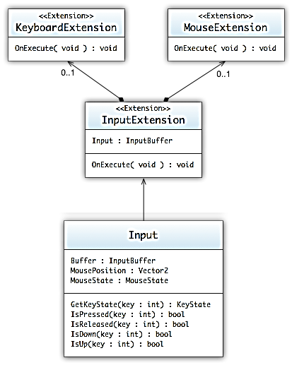

Figure : Input UML Diagram

The input system runs at approximately 30 Hz and gathers all of the inputs attached to the system. The system also provides intermediary calculations, to provide easy interfaces for interacting with both the keyboard and mouse devices.

*Note: Any tasks that require input from the user must register a dependency with the InputExtension.*

#### InputBuffer

Manages and stores all of the input state.

* **Data**
  + Buffer : *InputBuffer*
    - The current buffered state of the input devices.
  + KeyStates : *KeyState[]*
    - The current states of all of the keys.
  + MousePosition : *Vector2*
    - The Current position of the mouse relative to the windows client area.
  + MouseState : *MouseState*
    - The current state of all of the mouse buttons.

#### Input

*Input* is a static, thread-safe class that allows access to the device's state. The class is updated through the *InputExtension* and manages a double buffered system to prevent threading issues.

* **Data**
  + MousePosition : *Vector2*
    - Current position of the mouse relative to the window's client area.
  + MouseState : *MouseState*
    - Current state of the mouse; this constitutes which buttons are pressed, and where the scroll wheel is located
* **Operations**
  + GetKeyState(key : *int*) : *KeyState*
    - Gets the key's current state.
  + IsPressed(key : *int*) : *boolean*
    - Returns whether the key has been pressed; press constitutes an up event and then a subsequent down event.
  + IsReleased(key : *int*) : *boolean*
    - Returns whether the key has been released; release constitutes a down event and then a subsequent up event.
  + IsUp(key : *int*) : *boolean*
    - Returns whether the key is in the up state.
  + IsDown(key : *int*) : *boolean*
    - Returns whether the key is in the down state.
  + ResetMousePosition( *void* ) : *void*
    - Resets the mouse position to the center of the screen.

#### InputExtension

The InputExtension is the primary task used to gather the input state. This extension spawns both the MouseExtension and KeyboardExtension and manages the input state’s double buffer.

* **Data**
  + Input : *InputBuffer*
    - The current input state that has been gathered.
* **Operations**
  + OnExecute( *void* ) : *void*
    - Inherited from *Task*; Spawns the two other tasks, *KeyboardExtension* and *MouseExtension*, and swaps buffers.

#### KeyboardExtension

The *KeyboardExtension* handles all of the calls to *DirectInput* keyboard device and updates the input state.

* **Operations**
  + OnExecute( *void* ) : *void*
    - Inherited from *Task*; Queries and updates the input state.

#### MouseExtension

The *MouseExtension* handles all of the calls to DirectInput mouse device and updates the input state.

* **Operations**
  + OnExecute( *void* ) : *void*
    - Inherited from *Task*; Queries and updates the input state.

### Physics Subsystem

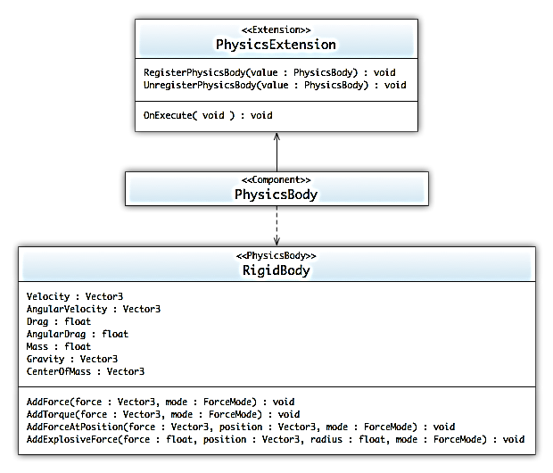

Figure : Physics UML Diagram

The physics system is a basic Newtonian physics simulator that utilizes the Bullet Physics Library to handle the underlying calculations.  In conjunction with the collision system, the physics system is able to manage all of the interactions between multiple collidable objects.  During the game, the system simulates any objects that have an attached PhysicsBody using the methods defined by the derived classes.  Since the physics system utilizes a 3rd party the tasking system only utilizes a single threaded task for the physics calculations.

Moreover, in the physics system is a collection of customizable Collision components that allow GameObjects to interact. Due to the inherent response that most physics systems have, Collision components are loosely tied to the physics subsystem's RigidBody component. Without the RigidBody attached, the Collider has no means of influencing the GameObject's position. In this case, the Collider acts as a trigger to a collision and has no interaction on the GameObject.

#### PhysicsBody

Base class for all physics components.

* **Operations**
  + RegisterCallback(callback : *PhysicsCallback*) : *void*
    - Registers a method callback that will be called when the *PhysicsBody* is executed

#### RigidBody

Controls the GameObjects position through basic physics simulations.

* **Data**
  + Velocity : *Vector3*
    - The velocity vector of the *RigidBody.*
  + AngularVelocity : *Vector3*
    - The angular velocity vector of the *RigidBody.*
  + Drag : *float*
    - The drag associated with the *RigidBody.*
  + AngularDrag : *float*
    - The angular drag associated with the *RigidBody.*
  + Mass : *float*
    - The mass of the *RigidBody.*
  + Gravity : *Vector3*
    - The gravity vector of the *RigidBody.* If no gravity is wanted then set to Vector3(0,0,0).
  + CenterOfMass : *Vector3*
    - The center of mass relative to the transform's origin.
* **Operations**
  + AddForce(force : *Vector3*, mode : *ForceMode*) : *void*
    - Adds a force to the *RigidBody.*
  + AddTorque(force: *Vector3*, mode : *ForceMode*) : *void*
    - Adds a torque force to the *RigidBody.*
  + AddForceAtPosition(force : *Vector3*, position : *Vector3*, mode : *ForceMode*) : *void*
    - Applies a force at the specified position; the force will invoke a torque force as well on the object.
  + AddExplosionForce(force : *float*, position : *Vector3*, radius : *float*, mode : *ForceMode*) : *void*
    - Applies a force to the *RigidBody* that simulates the explosive force.

#### Collider

A base class of all Colliders. Colliders are the means through which the system is able to manage and track the collisions between GameObjects.

*Note: In order for two or more objects to collide, they both must have some form of a Collider (box, sphere, etc.) attached to them.*

* **Data**
  + IsTrigger : *Boolean*
    - Whether or not the *Collider* is set to act as a trigger.
  + AttachedRigidBody : *RigidBody*
    - The *RigidBody* that the *Collider* is partnered with.
* **Operations**
  + RegisterCallback(callback : *ColliderCallback*) : *void*
    - Registers a callback that will be called when a collision is detected.
  + OnCollisionEnter(collision : *Collision*) : *void*
    - Called when a the collision between two *Colliders* has just started to happen and the *Colliders* have "Entered" each other’s bounding volume.
  + OnCollisionExit(collision : *Collision*) : *void*
    - Call when a collision between two *Colliders* has just ended and the *Colliders* have "Exited" each other’s bounding volume. This can only be called if a previous *OnCollisionEnter* has been called.
  + OnCollisionStay(collision : *Collision*) : *void*
    - Called when a collision between two *Colliders* is still occurring and the *Colliders* are occupying each other’s bounding volume. This can only be called if a previous *OnCollisionEnter* has been called.

#### BoxCollider

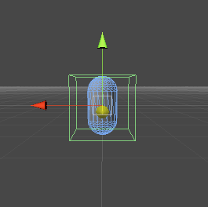

Figure : Box Collider Diagram

The BoxCollider is a simple axis aligned bounding box collision component.

* **Data**
  + Center : *Vector3*
    - The center of the box, measured in the *GameObject's* local space.
  + Size : *Vector3*
    - The size of the box, measured in the *GameObject's* local space.

#### SphereCollider

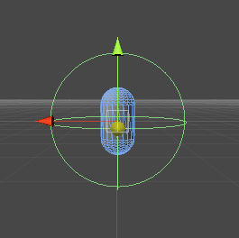

Figure : Sphere Collider Diagram

The Sphere Collider is a simple bounding sphere collision component.

* **Data**
  + Center : *Vector3*
    - The center of the sphere, measured in the *GameObject's* local space.
  + Radius : *float*
    - The radius of the sphere, measure in the *GameObject's* local space

#### PhysicsExtension

The PhysicsExtension is the primary task used to simulate the physics on RigidBody components. With the help of the Scene object, this extension spawns a number of subtasks to simulate the physics.

* **Operations**
  + OnExecute( *void* ) : *void*
    - Inherited from *Task*; Spawns a number of sub-tasks to simulate the physics.

#### CharacterController

The CharacterController is a custom class designed to give additional functionality to the character, such as jumping. It is a special type of collider that utilizes a capsule shape formed by two spheres.

* **Data**
  + Center : *Vector3*
    - The center of the capsule, measured in the *GameObject's* local space.
  + Radius : *float*
    - The radius of the capsule, measure in the *GameObject's* local space
  + Height : *float*
    - The height of the capsule, measure in the *GameObject's* local space
  + AttachedRigidBody : *RigidBody*
    - The *RigidBody* that the *CharacterController* is partnered with.
* **Operations**
  + Move(direction : *Vector3,* amount : *float*) : *void*
    - Moves the character controller in the provided direction a given number of units.
  + Jump(amount : *float*) : *void*
    - Applies a given amount of force in the opposite of the world’s gravity.
  + AddExplosiveForce(force : *float,* position : *Vector3*, radius : *float*) : *void*
    - Applies explosive force over a radius emitting from the provided position.

### Animation Subsystem

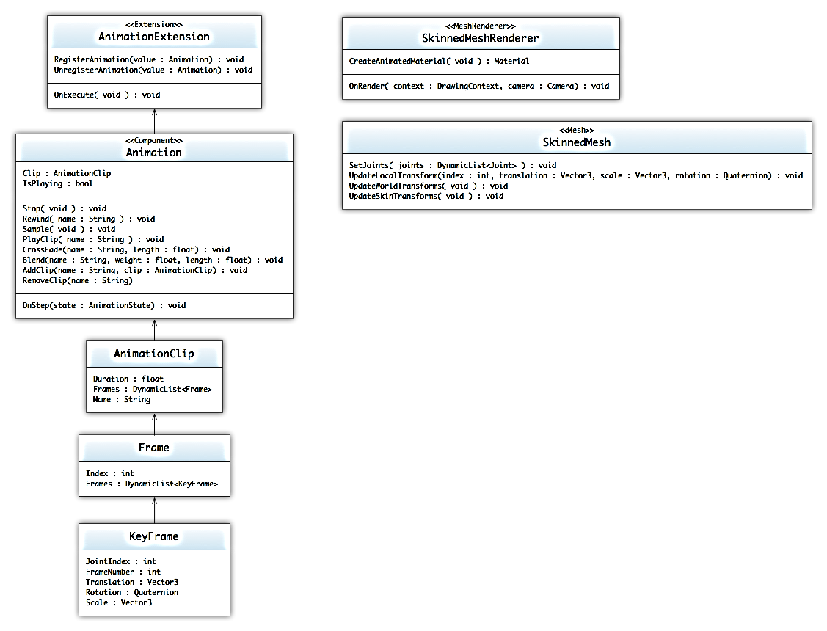

Figure : Animation UML Diagram

The animation subsystem is a composition of classes that utilize the built in animation formats, weighted keyframes, and the mesh data in the SMURF format. Although animation is primarily controlled via the loaded-in-approach via models, the Animation component allows users to attach a callback to calculate pre-processed or actually animate the GameObject. The core *Animation* component stores a series of *AnimationClips*. Only one *AnimationClip* can be active on an *Animation* component at a given time. The *AnimationClip* cycles through a list of *Frames*, which stores a list of *Keyframes* holding skeleton data for that particular time frame.

Along with the animation parsing system, *SkinnedMeshes* are loaded via the content importer that inherits *Mesh* properties. *SkinnedMeshes* have all the same properties as static *Meshes* but also have a list of *Joint* transform matrices. A *SkinnedMeshRenderer* inherits from *Renderer* and specifically handles the rendering of *SkinnedMeshes*. When *Animation* components are updated, the data pulled from therunning *AnimationClip* copies its data to the *SkinnedMesh’s* joint information.

*Note: Since most animation sequences are directly tied to the render system, the AnimationExtension registers itself as a parent dependency of the RenderExtension.*

#### Keyframe

Stores the transform information for one joint on one frame.

* **Data**
  + JointIndex: *int*
    - The joint’s index on the associated skeleton.
  + FrameNumber: *int*
    - The frame number of the keyframe’s data in association to its related animation clip.
  + Translation: *Vector3*
    - Translation data for the joint at that given time frame .
  + Rotation: *Quaternion*
    - Rotation data for the joint at that given time frame.
  + Scale: *Vector3*
    - Scale data for the joint at that given time frame.

#### Frame

*Frames* store keyframe data for a given time segment within the animation.

* **Data**
  + Keyframes: *DynamicList<Keyframe>*
    - List of keyframes that house skeleton transform data for the frame.
  + Index: *int*
    - Frame index in the animation clip.

#### AnimationClip

Stores the keyframes for the animation clip. The keyframes are loaded from the SMURF model definition.

* **Data**
  + Duration : *float*
    - Length of the animation clip in seconds.
  + Frames: *DynamicList<Frame>*
    - List of frames that house the new skeleton data.
  + Name: *String*
    - Name of the animation.

#### Animation

The *Animation* component is used to play back *AnimationClips*. The animation system is weight-based and supports animation blending, additive animations, animation mixing, and full control over all aspects of the animation playback.

* **Data**
  + Clip : *AnimationClip*
    - The default animation clip.
  + IsPlaying : *Boolean*
    - Whether or not an *AnimationClip* playing.
* **Operations**
  + Stop( *void* ) : *void*
    - Stops all playing animations that were started.
  + Rewind(name : *String*) : *void*
    - Rewinds the specified *AnimationClip*
  + Sample( *void* ) : *void*
    - Samples the animation at the current state.
  + PlayClip(name : *String*) : *void*
    - Plays the specified *Animation*, if no name is provided then the default animation is started.
  + CrossFade(name : *String*, length : *float*) : void
    - Fades the current animations with the specified *Animation* over a period of time.
  + Blend(name : *String*, weight : *float*, length : *float*) : *void*
    - Blends the specified *Animation* into the currently running animations.
  + AddClip(name : *String*, clip : *AnimationClip*) : *void*
    - Adds an *AnimationClip* to the *Animation.*
  + RemoveClip(name : *String*) : *void*
    - Removes an *AnimationClip* from the *Animation.*

#### AnimationExtension

The *AnimationExtension* is the primary task used to step the animations through the animation clips. Due to the independent nature of animations, the animation processing is instantly split into as many as ten separate running tasks to execute the animation sequences in parallel.

* **Operations**
  + OnExecute( *void* ) : *void*
    - Inherited from *Task*; Spawns the *n* number of animation tasks.

#### Joint

Segment of an overarching skeleton for a *SkinnedMesh.* Houses transformation matrix data for a given bone on the skeleton.

* **Data**
  + Index: *unsigned*
    - Index of the joint in the mesh’s skeleton
  + ParentIndex: *int*
    - Index of the parent joint (if any).
  + Translation: *Vector3*
    - Translation information of the joint based on the origin point of the mesh.
  + Rotation: *Quaternion*
    - Rotation information of the joint.
  + Scale: *Vector3*
    - Scale information of the joint.
  + Transform: *Matrix*
    - Transformation matrix of the joint which is comprised of the translation, rotation, and scale of the joint.
  + InvBindPose: *Matrix*
    - Inverse bind pose of the joint.

#### SkinnedMesh

*SkinnedMeshes* extend from *Mesh* and house animation data for an animated skeleton.

* **Data**
  + JointCount: *unsigned*
    - Number of joints in the mesh’s skeleton.
  + Joints: *Joint[]*
    - Array of joints for the skeleton associated with the mesh.
  + WorldTransforms: *Matrix[]*
    - Array of world transform matrices for the joints. This array is passed into the shader that parses vertex animation.
  + SkinTransforms: *Matrix[]*
    - Array of skin transform matrices calculated for each joint and passed into the animation shader effect.
  + BindPoses: *Matrix[]*
    - Array of bind pose matrices collected from the list of joints.
* **Operations**
  + UpdateLocalTransform(index: *unsigned,* translation: *Vector3*, scale: *Vector3*, rotation*:Quaternion*): *void*
    - Updates the local transforms of each joint.
  + UpdateWorldTransforms(*void*): *void*
    - Updates the world transform matrices of each joint to be passed into the animation shader.
  + UpdateSkinTransforms(*void)* : *void*
    - Updates the skin transform matrices that link each vertex in the mesh to a joint.

#### SkinnedMeshRenderer

The *SkinnedMeshRenderer* is the base animation renderer component. It is used to render animated meshes to the screen. The *SkinnedMeshRenderer* dervices from . At the current iteration, the only classes that implement *Renderer* are *Camera* and *MeshRenderer*. The system uses *Camera* to set up the viewport and manage both post-render and pre-render processes. It uses *MeshRenderer* to draw objects to the device.

* **Data**
  + Material : *Material*
    - The *Material* that will be used to render out objects*.*
* **Operations**
  + OnRender(device : *GraphicsDevice*) : *void*
    - Called when the *RenderExtension* is executed to render the screen and the object is not culled. The *GraphicsDevice* provided hides whether the rendering will be buffered or directly drawn to the screen.

### Networking Subsystem

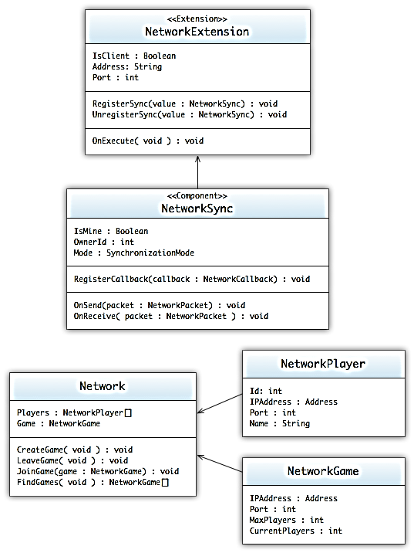

Figure : Networking UML Diagram

The networking system runs on multiple multicast networks to distribute and maintain synchronization among all of the connected clients. When the engine starts, it attaches to the "game" network. This network used to publish open games and other higher-level commands between clients. The information provided on this network is what is used in the game lobby, so that users can choose which games they would like to join. Once joined, or if the player creates a game, a secondary multicast network is created to manage only information pertinent to that instance of a game. The *NetworkSync* works on this game dependent network and utilizes the small-multicast network to synchronize objects between all of the clients. If a player leaves, the update is register back on the "game" network and updated. If the last player leaves, then the game is registered as destroyed and the network shutdown and unregistered from the list of available games.

#### Network

The *Network* class is an interface to the networking communication system. The class provides information and methods to allow the player to join, leave, and create games.

* **Data**
  + Players : *NetworkPlayer[]*
    - The current players in currently running game; if no game has been joined, then the list is empty
  + Game : *NetworkGame*
    - The currently running game; if no game has been joined, then return NULL.
* **Operations**
  + CreateGame( *void* ) : *void*
    - Creates a new game and publishes it to the game network.
  + LeaveGame( *void* ) : *void*
    - Leaves the joined game.
  + JoinGame(game : *NetworkGame*) : *void*
    - Joins a game; updating the number of players and initializing the in-game network.
  + FindGames( void ) : *NetworkGame[]*
    - Finds currently open games on the game network.

#### NetworkPlayer

The *NetworkPlayer* encapsulates the information needed to identify and track a networked player.

* **Data**
  + IPAddress : *Address*
    - The IP address of the networked player.
  + Port : *int*
    - The port of the networked player.
  + Name : *String*
    - Friendly name or username of the player.

#### NetworkGame

The NetworkGame encapsulates the information needed to identify and track a running networked game.

* **Data**
  + IPAddress : *Address*
    - The IP address of the network game.
  + Port : *int*
    - The port of the networked game.
  + MaxPlayers : *int*
    - The max number of players allowed in the game.
  + CurrentPlayers : *int*
    - The current number of players joined in the game

#### NetworkSync

The *NetworkSync* is a component which, when attached to a *GameObject,* will synchronize the information from other components and transform information to other clients of the game. There are two modes of synchronization, Reliable (TCP) and Unreliable (UDP). Depending on what mode selected, it will determine the protocol that is used to transfer the information between clients.

* **Data**
  + IsMine : *Boolean*
    - Whether the object being synchronized is the responsibility of the current client.
  + OwnerId : *int*
    - The ID of the *NetworkPlayer* who has responsibility of the object.
  + Mode : *SynchronizationMode*
    - This sets which protocol(UDP/TCP) the network uses to synchronize the information between clients.
* **Operations**
  + RegisterCallback(callback : *NetworkCallback*) : *void*
    - Registers a callback that is called whenever a synchronization happens between the client and host.
  + OnSend(packet : *NetworkPacket*) : *void*
    - Called when a synchronization packet is sent out.
  + OnReceive(packet : *NetworkPacket*) : *void*
    - Called when a synchronization packet is received.

#### NetworkExtension

The *NetworkExtension* manages the connection between both the "Game" network and the game instance networks. When run, the extension will spawn off packet builder tasks. Each packet builder task will collect the synchronization information needed to be sent to other clients. Once the packet data is collected, the system will bundle that up and send it out to the other game clients.

* **Operations**
  + OnExecute( *void* ) : *void*
    - Inherited from *Task*; Collects the synchronization data and then packages it up and sends it out to game clients.

### Lua Scripting

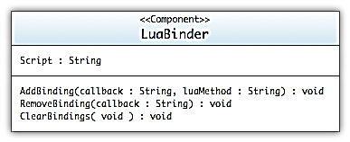

Figure : Lua UML Diagram

The Lua script interpreter is one of the main ways for designers/developers to modify object behaviors. Instead of building off the *Extension/Component* architecture of most subsystems, the lua subsystem uses a single *Component*, the *LuaBinder*. The main purpose of the *LuaBinder* is to manage the bindings between *Component* callbacks and the Lua script methods.

#### LuaBinder

The *LuaBinder* is a *Component* used to bind Lua snippets to the *GameObject* and *Component* Method callbacks. Execution of the Lua script is run immediately and is given access to the objects scope. Management of the *LuaState* is held through global variables and management across all *LuaBinders*.

* **Data**
  + Script : *String*
    - Lua Script file to reference.
* **Operations**
  + AddBinding(callback : *String*, luaMethod : *String*) : *void*
    - Adds the callback binding to the *LuaBinder*; when the callback is called, the method will be redirected to the lua scripted method.
  + RemoveBindings(callback : *String*) : *void*
    - Removes the callback binding
  + ClearBindings( *void* ) : *void*
    - Clears all of the callback bindings.

### Particles Subsystem

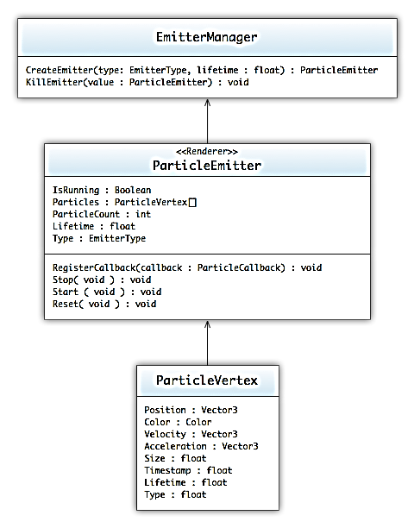

Figure : Particle UML Diagram

The particle subsystem is a composition of *ParticleEmitters* that render particle effects to the screen. *ParticleEmitters* derive from *Render* components, which are therefore managed by the graphics system. *ParticleEmitters* are attached to *GameObjects* and then handle the rendering of particles. The emitters store *ParticleVertexs*, *EmitterType, and lifetime* variables to that govern how the emitter behaves over time. The *ParticleEmitter* can be one of nine unique types. Each of these *EmitterTypes* defines the behavior for the particles associated with the emitter. This type variable is passed to its associated particles where the shaders perform the calculations based on that type identifier.

*ParticleEmitters* are stored in the *EmitterManager*, which is responsible for creating and killing emitters when their lifetimes have been reached. It is inside the *EmitterManager* where new emitters are created and attached to *GameObjects*. The *EmitterManager* keeps a list of dead emitters and live emitters. These two lists allow for *GameObjects* to reuse already created emitters instead of creating new emitters. When an emitter is killed off, it is stored in the dead emitters list to be reused again.

#### EmitterType

* **Explosion**
  + A spherical emitter where particles start from a center point and translate outward in a random direction.
* **Directional**
  + An emitter that can specify a direction in which to randomize its velocity. Similar to explosion emitter type where particles start at a central point and project outward.
* **Linear**
  + Particles move in one defined direction until their lifetime has been reached.
* **Fountain**
  + Particles project upward and outward from a central point and as their age increases, they begin to fall.
* **Orbital**
  + Particles move along an orbit around a central point.
* **Spiral**
  + Particles move along a specified axis in a spiral that starts small and its radius increases over time.
* **Sphere**
  + Particles are stationary in a spherical formation around a central point.
* **Radial**
  + Particles are generated along a radius around a central point and translate upward.
* **QuadStretch**
  + A single textured particle that grows over time.

#### ParticleVertex

The *ParticleVertex* will hold all the possible data that a particle will need to render. This data is passed into the *VertexBuffer* and to the *GraphicsDevice*. Shaders take the data in from the vertices and render them out to the screen.

* **Data**
  + Position : *Vector3*
    - The starting position of the vector
  + Color : *Color*
    - Color of the vertex
  + Velocity : *Vector3*
    - The velocity that alters the position of vertex over time.
  + Acceleration: *Vector3*
    - The acceleration that alters the velocity and position of the vertex over time
  + Size: *float*
    - The size of the particle across a quad.
  + Timestamp: *float*
    - The start time of the particle. Used to calculate the particle’s age.
  + Lifetime: *float*
    - The lifetime of the particle.
  + Type: *float*
    - The type of the emitter that is defined by the user. The type allows for different calculations to be performed on the particle to achieve the different emitter types.

#### ParticleEmitter

The *ParticleEmitter* is used to render particle effects*.* The emitter keeps track of a vertex buffer, which houses all of the *ParticleVertexes* to be rendered. Emitters attach themselves to *GameObjects* as components so that they can be recognized and rendered by the renderer. Emitters keep track of their overall lifetime and translate that information to the particles.

* **Data**
  + IsRunning : *Boolean*
    - Whether or not the *ParticleEmitter* is currently running.
  + Particles : *ParticleVertex*[]
    - Array of particle vertices that will be passed into the vertex buffer
  + ParticleCount : *int*
    - The max number of particles the emitter can hold
  + Lifetime: *float*
    - The lifetime of the emitter
  + Type: *EmitterType*
    - The type of emitter that defines the particle’s behavior before being rendered
* **Operations**
  + RegisterCallback(callback : *ParticleCallback*) : *void*
    - Registers a callback event whenever the particle emitter component needs to be rendered.
  + Stop( *void* ) : *void*
    - Stops the *ParticleEmitter* from moving to the next display state.
  + Start( *void* ) : *void*
    - Starts the *ParticleEmitter*.
  + Reset( *void* ) : *void*
    - Resets the *ParticleEmitter* to its initial state.

#### EmitterManager

* **Data**
  + DeadEmitters: DynamicList<ParticleEmitter\*>
    - List of dead emitters.
  + LiveEmitters: DynamicList<ParticleEmitter\*>
    - List of live emitters.
* **Operations**
  + CreateEmitter(type:EmitterType, lifetime:float): ParticleEmitter\*
    - Based on the type passed in, either creates a new emitter or retrieves an already used emitter from the DeadEmitters list. Lifetime is reset upon return.
  + KillEmitter(emitter: *ParticleEmitter\**): void
    - Moves the passed in *ParticleEmitter\** to the DeadEmitters list. No longer updates until retrieved again.

### Audio Subsystem

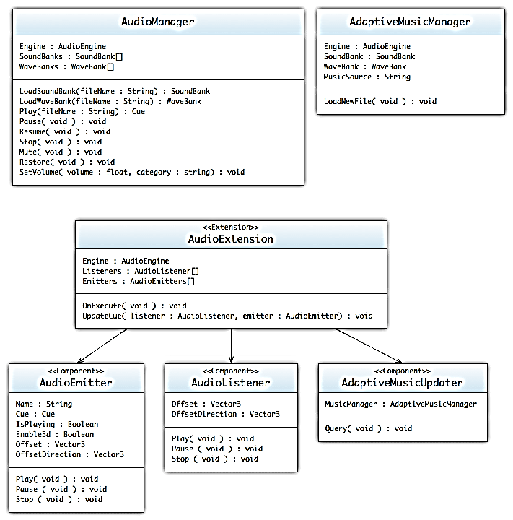

Figure : Audio UML Diagram

The audio subsystem allows access to the audio device and allows audio assets to be played. The audio subsystem is hardware-agnostic and utilizes XACT as a wrapper to XAudio2. The AudioManager class is the primary interface used to play a sound. The AudioManager contains a pointer to the XACT audio engine. Assets are managed with external software and loaded into the system using the Soundbanks and Wavebanks, which wrap XACT's implementations. The system is designed to abstract away the complexities of XACT and allow other programmers to interface simply and easily with audio by playing sound through emitters. Finally, a cue is used to manage each instance of a sound. Specialized AudioEmitter and AudioListener components are placed onto specific GameObjects in order to update 3d positional information.

Attached to the audio subsystem is a unique music management system for adaptive audio. The *AdaptiveMusicManager* requires up-to-date information, which is provided by the *AdaptiveMusicUpdater.* Developers need only interact with the *AdaptiveMusicManager* directly if another set of music should be changed (e.g., if a new level is being loaded).

#### AudioManager

The *AudioManager* is the main point of access for anything related to sound. It maintains a collection of *SoundBanks* and *WaveBanks*, as well as a pointer to the *AudioEngine*. This class allows access to playback features such as pause and volume controls. The *AudioManager* can also directly play an audio file without associating it with a cue.

* **Data**
  + Engine : *AudioEngine*
    - The *AudioEngine* used by the system.
  + SoundBanks : *SoundBank[]*
    - The list of SoundBanks in the system.
  + WaveBanks : *WaveBank[]*
    - The list of WaveBanks in the system.
* **Operations**
  + LoadSoundBank(fileName : *String*) : *SoundBank*
    - Loads a SoundBank into the system. Expects a .xsb extension on the filename.
  + LoadWaveBank(fileName : *String*) : *WaveBank*
    - Loads a WaveBank into the system. Expects a .xwb extension on the filename.
  + Play(fileName : *String*) : *Cue*
    - Prepares and plays a particular file. Returns a cue associated with that instance.
  + Pause (*void*) : *void*
    - Pauses or unpauses all playback on the audio engine. This affects all cues.
  + Stop (*void*) : *void*
    - Stops all cues currently being played in the audio engine. They cannot be restarted without being re-prepared.
  + Mute(*void*) : *void*
    - Mutes the audio engine without pausing it. This affects all cues.
  + Restore(*void*) : *void*
    - Unmutes the audio engine without pausing it. This affects all cues.
  + SetVolume(volume : *float,* category : *String*) : *void*
    - Sets the volume for an XACT category defined in the asset management tool.

#### AudioEmitter

The *AudioEmitter* is a *GameObject* component that contains a *Cue.* The *AudioEmitter* updates the positional data in the *Cue* and identifies when to fire off a cue. Each *AudioEmitter* represents a single instance of a single cue.

* **Data**
  + Name : *String*
    - A name for the cue being emitted.
  + Cues : *Cue[]*
    - The *Cues* that emit from this *AudioEmitter.*
  + IsPlaying : *boolean*
    - Whether or not the cue is currently active.
  + Enable3d : *boolean*
    - Whether or not the cue is positioned in 3d.
  + Offset : *Vector3*
    - A positional offset of the component from the *GameObject*.
  + OffsetDirection : *Vector3*
    - The direction to offset.
* **Operations**
  + Play(index : *int*) : *void*
    - Begins to play the cue. Unpauses if paused.
  + Pause(*void*) : *void*
    - Pauses or unpauses the cue.
  + Stop (*void*) : *void*
    - Stops playing the cue and reprepares it.
  + AddCue(cue : *Cue*) : *void*
    - Adds the provided cue onto the list of cues to be played.

#### AudioListener

The *AudioListener* is a *GameObject* component that attaches to a *GameObject* and utilizes its position for 3D audio calculations.

* **Data**
  + Offset : *Vector3*
    - A positional offset of the component from the *GameObject*.
  + OffsetDirection : *Vector3*
    - The direction to offset.

#### AdaptiveMusicUpdater

The *AdaptiveMusicUpdater* is a *GameObject* component that attaches to a *GameObject* and can update the *AdaptiveMusicManager* with game state information.

* **Data**
  + MusicManager : *AdaptiveMusicManager*
    - The adaptive music manager this component will update.
* **Operations**
  + Query(*void*) : *void*
    - Queries the *GameObject* it is attached to and updates the *AdaptiveMusicManager*.

#### AdaptiveMusicManager

The *AdaptiveMusicManager* is a special class designed to control the background music of the game. While linear audio is played through the traditional *AudioManager*, the *AdaptiveMusicManager* takes a collection of "slices" of audio and sews them together. The *AdaptiveMusicExtension* updates the *AdaptiveMusicManager* when necessary.

* **Data**
  + SoundBank : *SoundBank*
    - The soundbank associated with the adaptive music.
  + WaveBank : *WaveBank*
    - The wavebank associated with the adaptive music.
  + Engine : *AudioEngine*
    - The audio engine associated with the adaptive music.
  + MusicSource : *String*
    - The path to an XML file in which the music information is located.
* **Operations**
  + LoadNewFile(*void*) : void
    - Reads in adaptive audio information based upon the source XML file in question.
  + SetVariable(name : *string*, value : *float*)
    - Sets adaptive variable information for the system to interpret.

#### AudioExtension

The *AudioExtension* updates all of the audio information in the game world. It is comprised of three types of subtasks: one to update all of the positional audio information, one to update the audio engine once per frame, and one to query the game world and update the *AdaptiveAudioManager*. Ten subtasks are spawned to manage the *AudioListener*/*AudioEmitter* calculations, and a single subtask is provided to each of the other two types.

* **Data**
  + Engine : *AudioEngine*
    - The audio engine. Used to update the 3d cue information.
  + Listeners : *AudioListener[]*
    - The components that represent audio listeners.
  + Emitters : *AudioEmitter[]*
    - The components that represent audio emitters.
* **Operations**
  + OnExecute(*void*) : *void*
    - Inherited from *Task*. Spawns a collections of subtasks to update all of the information required for the audio engine, 3d position audio, and the adaptive audio system.
  + UpdateCue(listener *: AudioListener,* emitter : *AudioEmitter*) : *void*
    - Updates the DSP information for the cue in the audio engine. Calculates and applies all positional data.

### GUI Subsystem

The GUI subsystem is used to create any type of 2D interface for the user. Examples include title screen, match lobbies, and HUDs. Each screen is attached to a camera and enabled or disabled depending on what parts are allowed to render to the screen. Like all of the other components, this system has a background extension that changes the devices render state to allow 2D rendering with alpha blending of the background. Due to the blending, GUIs are usually placed on the last layer of the rendering sequence, in order to prevent transparency artifacts.

The GUI is made up of a system of movable windows and controls that are added onto the windows, inspired by the component system of the engine.

#### GUIScreen

The GUIScreen is the main render point for generating a GUI for the camera. All of the controls are added to this screen and positioned. If a GUIScreen is enabled, it will be drawn as a 2D orthogonal plane overtop all of the rest of the scene.

* **Data**
  + Camera : *Camera*
    - The *Camera* the *GUIScreen* is attached to for rendering
  + Controls : *Control[]*
    - The list of *Controls* added to the *GUIScreen*.
* **Operations**
  + AddControl(control : *Control*) : *void*
    - Adds a control to the *GUIScreen* and causes the control to render when the camera screen is rendered.
  + RemoveControl(control : *Control*) : *void*
    - Removes a control from the list of added controls; no longer rendering it on the camera screen.
  + Clear( *void* ) : *void*
    - Clears all of the controls from the *GUIScreen.*

#### NinePatch

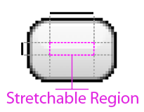

Figure : 9-Patch Diagram

The GUI system supports a stretchable bitmap image, called a 9-Patch graphic. This is a PNG image whereby one defines a stretchable section that the GUI system will automatically resize so that it appears appropriately. .

* **Data**
  + StretchableRegion : *Rectangle*
    - Defines the left, top, right, and bottom of the stretchable region of the texture.
  + Size : *Size*
    - The size of the texture.

#### Font

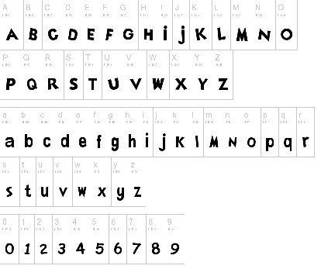

Figure : Font Map

The *Font* object takes font map textures that defines the character layout and sizing of a specific font. All controls take a font object when displaying any form of text.

* **Data**
  + FontMap : *Texture*
    - The font map *Texture* of the *Font.*

#### Control

Represents the base class for user interface (UI) elements that use *Texture* and *Fonts* to define their appearance.

* **Data**
  + Font : *Font*
    - The font object to use when printing out the specified text.
  + Text: *String*
    - The text to display; the means of display changes depending on the type of *Control.*

#### Panel

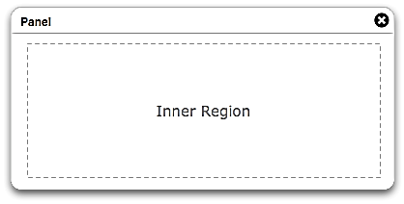

Figure : Panel Control Diagram

A *Panel* is a control that contains other controls. You can use a *Panel*to group collections of controls such as a group of Labels or Button controls. The *Panel*control is displayed by default without any texture or output rendering. You can provide a *NinePatch* texture to enable border and background rendering.

* **Data**
  + Texture : *NinePatch*
    - The *NinePatch* texture to apply to the background of the *Panel.*
  + Padding: *Rectangle*
    - Defines the amount of spacing around the border that is given left empty when drawing inner controls.
  + Controls : *Control[]*
    - The list of *Controls* added to the *Panel*.
* **Operations**
  + AddControl(control : *Control*) : *void*
    - Adds a control to the *GUIScreen* and causes the control to render when the camera screen is rendered.
  + RemoveControl(control : *Control*) : *void*
    - Removes a control from the list of added controls; no longer rendering it on the camera screen.
  + Clear( *void* ) : *void*
    - Clears all of the controls from the *GUIScreen*

#### Label



Figure : Label Control Diagram

Represents the text label for a control, the control has no interactions – only display properties.

#### Button



Figure : Button Control Diagram

A *Button* is a control that allows user interaction through the mouse/keyboard interface. The *Button* control is displayed by default with a basic texture. You can provide a *NinePatch* texture to change the border and background rendering.

The following example shows three buttons that respond to clicks in three different ways.

* Hover: the first button changes colors when the user hovers with the mouse over the button.
* Press: the second button requires that the mouse be pressed while the mouse pointer is over the button.
* Release: the third does not reset the background color of the buttons until the mouse is pressed and released on the button.
* **Data**
  + Texture : *NinePatch*
    - The *NinePatch* texture to apply to the background of the *Panel.*
  + Padding: *Rectangle*
    - Defines the amount of spacing around the border that is left empty when drawing the text.
  + Callback : *ButtonCallback*
    - Sets the function callback that is called when a user presses the button.

#### Textbox



Figure : Textbox Control Diagram

A *Textbox* is a control that allows user interaction through the keyboard interface. The *Textbox* control is displayed by default with a basic texture. You can provide a *NinePatch* texture to change the border and background rendering.

* **Data**
  + Texture : *NinePatch*
    - The *NinePatch* texture to apply to the background of the *Panel.*
  + Padding: *Rectangle*
    - Defines the amount of spacing around the border that is given left empty when drawing the text.
  + Callback : *TextboxCallback*
    - Sets the function callback that is called when a user presses a key within in the *Textbox*.

#### GuiExtension

The *GuiExtension* is the primary task used to render GUI controls to the camera screen. This extension spawns a multitude of subtasks to render out the *Controls* using the *BufferedDeviceAdapter*; once the tasks have completed, the *BufferedDeviceAdapters* are combined and played back using the *HardwareDeviceAdapter*.

* **Operations**
  + OnExecute( *void* ) : *void*
    - Inherited from *Task*; Spawns a multitude of sub-tasks to render the *Controls* to the camera screen.

#### Content Subsystem

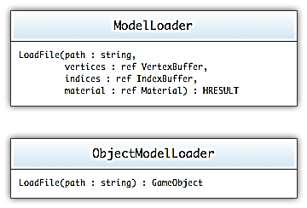

Figure : Content Loader UML Diagram

The component subsystem is a set of static tools used to load models and game objects into the game. These tools make use of a custom SMURF format to load the vertices, indices, materials and textures needed to draw the objects. The extended *SmurfModelLoader* uses a system of attributes embedded within the SMURF to enable the loader to create the *GameObject* and attach the needed components and properties.

#### ModelLoader

Static content tool used to load model files and return the imported graphics components. If the system is unable to load aspects of the model, certain buffer types are returned as NULL.

* **Operations**
  + LoadFile(path : *String*, vertices : *ref VertexBuffer,* indices : *ref IndexBuffer*, material : *ref Material) : HRESULT*
    - Used to load the file and return the imported *VertexBuffer*, *IndexBuffer*, and *Material.*

# Game

## Components

These components are specific to the *Trigger Happy* game and are not initially part of the *Singularity* Engine's *Component* set. More detail can be found in the *Trigger Happy* Development Document, where lua-based systems are expanded upon. General forms are provided below.

## Game Objects

With the component-based architecture, all of the usual game objects are replaced by an aggregation of components attached to a *GameObject*. Because of this, the development of the core objects for the game will be less programming and more design. By adding the LuaBinder to the objects, designers and developers can augment the behaviors of the *GameObject*s with nothing more than lua scripts.

## References

[1] Intel Threading Building Blocks 3.0 for Open Source 2010, <http://www.threadingbuildingblocks.org/>

[2] Intel Smoke – Game Technology Demo 2010,

<http://software.intel.com/en-us/articles/smoke-game-technology-demo/>

Game Production Document

# Summary

In order to maintain a sense of order in many facets of our development, we have established a system for organizing files, assets, and even code. We have written this production guide to help maintain this order and allow for a more cohesive development experience for the development team. By maintaining the coding standards established in this document, we can ensure that team members stay up to speed on other team members’ work. We can also ensure that, should we need to fill gaps in development, we maintain an understanding of where team members currently are in their development timelines.

# Document Scope

In this document, we have detailed the various aspects of production organization. This includes naming conventions and folder organizations for all files pertaining to *Trigger Happy,* and organizational styles for writing code and comments. We have organized this document into tables that detail these specific tasks and describe how the convention works.

# File Naming Convention

Table : Summary of file naming conventions table

|  |  |  |
| --- | --- | --- |
| Type | Standard/Convention | Example |
| Texture | PascalCase naming with .png or .tga extension. Lowercase prefix documenting the context of use. | Room\_Box.png |
| Model | PascalCase naming with .fbx extension. Lowercase prefix documenting the context of use. | Room\_Box.fbx |
| Effects | PascalCase naming with .fx extension | BasicEffect.fx |
| Lua Scripts | PascalCase naming with .lua extension | MainFunction.lua |
| Raw Audio Resources | Lowercase prefix followed by an underscore followed by a PascalCase name. See Audio Design Document for list of prefixes. Contains a .wav extension. | menu\_CursorMove.wav |
| XACT Settings | PascalCase name with .xgs extension. | TriggerHappy.xgs |
| SoundBank | PascalCase name with .xsb extension. | MenuEffects.xsb |
| WaveBank | PascalCase name with .xwb extension. | MenuEffects.xwb |
| Cue Names | Lowercase prefix followed by an underscore followed by a PascalCase name. See Audio Design Document for list of prefixes. No extension. | menu\_CursorMove |

# Document Structure

Table : Project file and storage structure

|  |  |
| --- | --- |
| Path | Description |
| .\ |  |
| assets\ | Asset files used in the development of the game |
| audio\ | XACT audio files (\*.xgs, \*.xsb, \*.xwb) |
| effects\ | Effect files(\*.fx) |
| models\ | Model files(\*.fbx) |
| <maya structure> | The Maya texture and model hierarchy |
| textures\ | Texture files(\*.png, \*.jpg) |
| materials\ | General uncustomized surfaces |
| <room>\ | Customized, room specific textures |
| reference\ | Reference images |
| scripts\ | Script files(\*.lua) |
| code\ | Engine\Component source code files |
| include\ | Header files(\*.h\\*.inc) |
| src\ | Source files(\*.cpp) |
| lib\ | Library files(\*.lib) |
| scripts\ | Project files(\*.vcproj) |
| tools\ | External tools or projects |
| documentation\ | Documentation files |

# Coding Standards

## Naming Conventions

Table : Code naming conventions table

|  |  |  |
| --- | --- | --- |
| Type | Standard\Convention | Example |
| Namespaces | Pascal Case, no underscores. Use Singularity.{ComponentType} as root. | Singularity::Graphics  Singularity::Physics |
| Classes and Structs | Pascal Case, no underscores or leading "C" or "cls". Classes may begin with an "I" only if the letter following the I is not capitalized; otherwise it looks like an Interface. Classes should not have the same name as the namespace in which they reside. Any acronyms of three or more letters should be pascal case, not all caps. Try to avoid abbreviations, and try to always use nouns. | GraphicsDevice  XmlLoader  AnimationState |
| Exception Classes | Follow class naming conventions, but add Exception to the end of the name | InvalidInputException |
| Interfaces | Follow class naming conventions, but start the name with "I" and capitalize the letter following the "I" | IGraphicsDevice |
| Enumerations | Follow class naming conventions. Do not add "Enum" to the end of the enumeration name. If the enumeration represents a set of bitwise flags, end the name with a plural. | SchedulingOptions |
| Functions | Pascal Case, no underscores, try to avoid abbreviations. | void DoSomething(...) |
| Properties | Follow Function naming conventions. Accessors should start with "Get\_" and modifiers with "Set\_" | int Get\_Something()  void Set\_Something(int value) |
| Parameters | Camel Case. Try to avoid abbreviations. | int deviceType |
| Procedure-Level Variables | Camel Case. Try to avoid abbreviations. | unsigned indexType |
| Class-Level Private and Protected Variables | Camel Case with Leading "m\_". Use standard type naming notation (i for ints, f for floats, etc.).  Do not use single character variable names like i, j or k, unless that name is the commonly accepted mathematical notation. | unsigned m\_iIndex |
| Class-Level Global Variables | Follow Class-Level naming convention. Leading "g\_" instead of the standard "m\_" | void\* g\_pInstances |

## Comments

* All files should start with a file comment in the style:

/\*

\* File.h

\*

\* Overview of what is in this file, why it exists and how it fits

\* into "The Big Picture".

\*

\* Author: Your Name

\*

\* Date: <Date of Origination>

\*/

## Class Syntax

class Class\_One: public Class\_Parent

{

private:

#pragma region Variables

// variables

#pragma endregion

Properties:

#pragma region Methods

// methods

#pragma endregion

public:

#pragma region Properties

// accessors and mutators

#pragma endregion

#pragma region Constructors and Finalizers

// constructors and deconstructors

#pragma endregion

};

## File format

* Only one class (and any associated typedefs, constants, etc.) should be declared in each .h/.cpp pair.
* Files should be named for the (singular) class that they contain, i.e. Class\_Name.h/Class\_Name.cpp

Development Timelines

# Overall Timeline

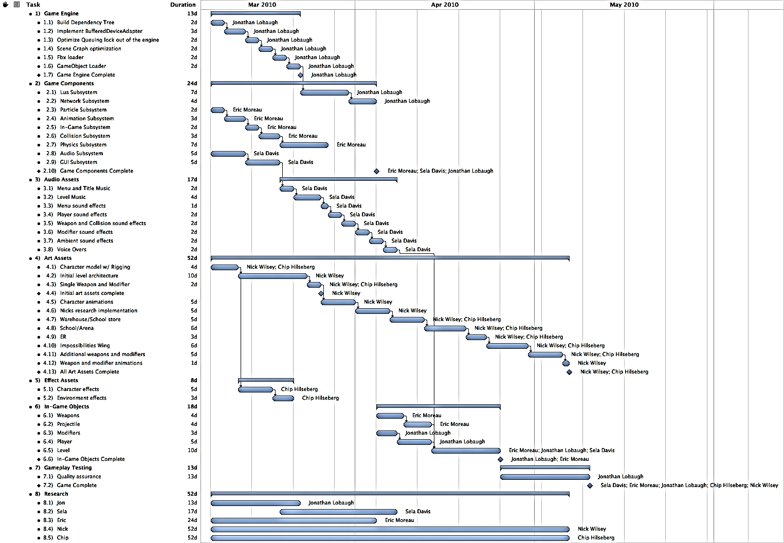

# Game Engine Timeline

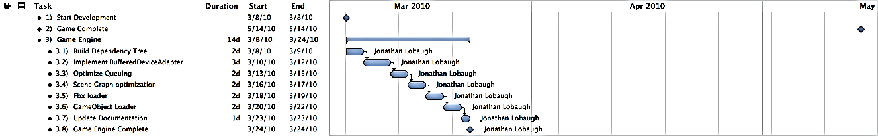

# Game Components Timeline

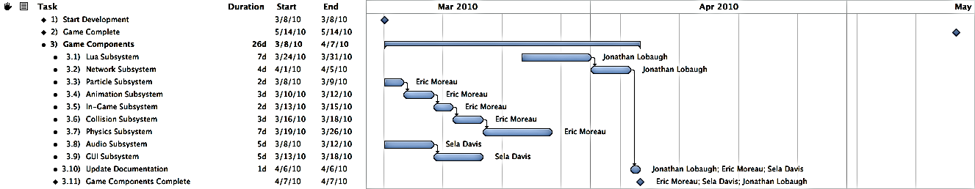

# Audio Assets Timeline

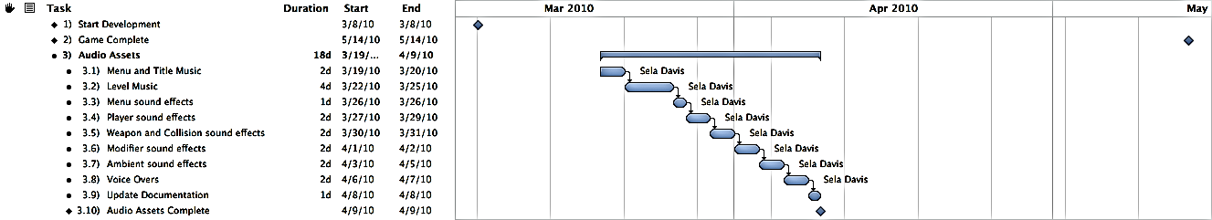

# Art Assets Timeline

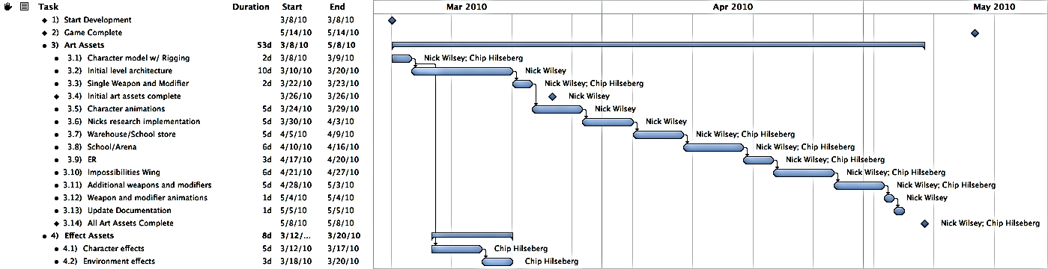

# In-Game Objects Timeline

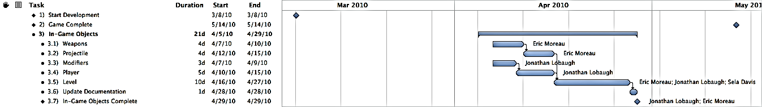

*This page intentionally left blank.*

A Heuristic-Based Model for Adaptive, Non-Linear Music Generation in Games

Capstone Research by Sela Davis

# Quick Bio

## Short Summary

Audio engine programmer, nonlinear composer for games ('audio manipulator'), metalsmith. MS Game Design & Development at RIT. Co-coordinator of IGDA Rochester.

## Further Detail

Sela Davis is currently pursuing an M.S. in Game Design & Development at the Rochester Institute of Technology. She is an experience multidisciplinary worker, and thrives in such cultures. Her particular interests lie in artistic media -- particularly game audio, her specialty, and in metal, with which she is formally trained. She also enjoys writing for interactive media (such as ARGs!) and teaching others.

Sela is a published poet in Rochester, NY (under a pseudonym), a shown artist in San Francisco, CA, and has co-hosted three years’ worth of BarCampRochester. She is currently the co-coordinator and co-founder of IGDA Rochester along with Alex Lifschitz. She made her first appearance at San Francisco's GDC in 2009 flaunting hand-made etched copper business cards and a drive strong enough to melt steel. Sela will act as a Conference Associate at the upcoming GDC 2010 and as a member of the steering committee of a yet-unannounced new game industry conference.

# Problem and Solution

## Overview

Music in long-play games such as first person shooters can become monotonous over time. Players have a tendency to turn off the music and/or all of the game’s audio, which poses a particular problem for the game design and the audio content developers. One solution, as seen in games such as Team Fortress 2, is to avoid playing music entirely. This is not an optimal solution. An adaptive audio system is proposed for two reasons: to give more information to players about the state of the game world and to keep the music from becoming repetitive and monotonous.

There are a few major types of repetitive music. Linear music provides one: music becomes monotonous because it is not affected by the state of the world in any way. This type of music does not adapt to a game’s situation and can often break immersion by syncing improperly to the player’s emotions. This is analogous to playing the “Raider’s March” over the Star Wars scene depicting Luke’s family’s corpses. Moreover, this music is typically a loop that plays over and over without variation. Instead of this technique, many games use a set of triggers to change the music based upon the mood the player should be feeling. The flaw with this technique is the lack of blending from track to track (if the player can make a choice that changes the music, it jerks rather than flows) and the fact that the music typically has a set start point. This is a better solution, but still not an ideal one. There may be variation from area to area, but not from track to track. Again, once in these areas a track will loop constantly. The player may hear more tracks than in the previous style, but each is ultimately a piece of linear music that does not change over time.

The proposed solution takes this and expands it further. By using small pieces of music and generating combinations on the fly, nonlinear music can be used to provide a non-looping, non-repeating background track. Moreover, these tracks can be easily switched from one set of pieces to another based upon the state of the game world without a stop or a fade. The extra benefit of this system is the fact that it provides extra game state information to the player. Over time, the player should be able to understand subconscious what certain musical cues are. For instance, an increase in the tempo of the music may imply that a fight is beginning to break out in the game. Dynamically piecing together this information allows audio to move past individual linear music cues for determining the emotion of the player.

## Relevance to Game

### Problem to Game

*Trigger Happy* is a deathmatch-based First Person Shooter, or FPS. This style of game typically invites a long-term investment of time, during which traditional linear music often becomes boring to the player. Thousands of hours of linear music could, of course, be generated, but the resources necessary are costly and the required storage and memory space become quite large. Traditionally, FPSes and similar multiplayer games tend to avoid the use of music entirely, but there is so much more that can be done. FPSes in particular lend themselves well to adaptive audio, as there is often enough occurring in the world that most players have a difficult time determining their situation and danger level.

When players turn off their speakers, they lose important data. Hearing is one of the three (as of now) senses players use when they interact with games, and significant information can be lost if that sense is removed. This does not mean that the game is unplayable without sound; however, a significant amount of the atmosphere is lost without it. Even the loss of either music or sound effects is noticeable: music helps to create mood and emotion, and sound effects often provide world data.

### Game to Problem

*Trigger Happy* is the perfect place to attempt an implementation for an adaptive audio system. This type of system helps to avoid the repetition found in long-term multiplayer games such as FPSes and MMOs, and has been implemented in games such as Spore and Slipgate Ironworks’ unannounced MMO. By doing this, players are less likely to turn off the audio – the most significant problem game audio faces today – and are more likely to stay immersed in the game.

Moreover, a game like *Trigger Happy* has enough happening in the world that some players may find it difficult to understand exactly what is going on. While 3d positional audio provides many of these clues – and clues to events happening outside the player’s point of view – players who turn off the audio miss all of this. As a team-based game, *Trigger Happy* requires players to know what is happening as much as possible. An adaptive music system like the one proposed allows players to identify the general state of the game world through the use of various themes and motifs. Such a system can also help to immerse players by accurately fitting the mood of the music to the mood of the scenario.

# Literature Search and Previous Work

## A Generative, Adaptive Music System for MMO games

Hedges, Jim, Kurt Larson, and Chris Mayer. “A Generative, Adaptive Music System for MMO games.” GDC Austin 2008. Sept. 2008. MP3 file.

This is Slipgate Ironworks’ talk on “GAMS” or more recently “AGMS” – an ambient-based MMO solution that does not translate to FPSes. The system stands for “Generative, Adaptive Music System” and allows for the creation of zones. This talk provides the most inspiration for this particular inspiration, even though the developers specifically state that it works best for ambient music and ”if you want to create “Ride of the Valkyries”, this isn’t the right tool to use. The solution for *Trigger Happy* suits a different need for the audio soundscape and will hopefully serve a different audience with the same goal.

## Procedural Music in *Spore*

Jolly, Kent, and Aaron McLeran. “Procedural Music in Spore.” GDC 2008. Feb. 2008. MP3 file.

In *Spore*, a system for procedural music is provided for the game’s menus and creature creators. These areas are the ones that the player will spend the most time on, and therefore the ones most likely to become repetitive. The developers implemented a system that generates ambient melodies on the fly, partially using player input as a way to nudge the music in a particular direction. As in this system, the music is non-repeating, but the style of music does little to enhance mood.

## Dead Space Sound Design: In Space No One Can Hear Interns Scream. They Are Dead.

Veca, Don. Interview. *Original Sound Version*. Web. 24 Feb. 2010. <http://www.originalsoundversion.com/‌?p=693>.

This interview discusses the role of music and sound design in Dead Space. Much like the Left 4 Dead solution provided below, the Dead Space developers went with a system for cueing audio tracks when necessary to add to the soundscape and create an appropriate feel of horror. They also discuss an audio scripting language used for the game, a set of 3d samples played to make the player feel fear, and “fear emitters” that act much like the audio emitter used in the *Singularity* audio engine. This is an opportunity to get an in-depth look into non-traditional use of composition.

## *Left 4 Dead* Audio Commentary

Valve. Audio commentary for Left 4 Dead. In-Game Audio Commentary.

In their Left 4 Dead commentary, Valve employees discuss some elements of the audio of the game. One of the most interesting bits of commentary is about the adaptive audio in the game. In addition to the AI Director is the Audio Director, which allows the game to cue small pieces of music based upon the game state. While this is not as ambitious a system as proposed here, this is an excellent way to use cueing music based upon the world and adapting it to the game world. Transcript is available at <http://left4dead.wikia.com/wiki/Developer_Commentary_(Left_4_Dead)>.

## Computer models of musical creativity programs

Cope, David. Computer models of musical creativity programs. Web. 24 Feb. 2010. <http://artsites.ucsc.edu/‌faculty/‌cope/‌cmmc.html>.

In this section of his website, composer and programmer David Cope, the creator of Emily Howell, an AI composer, offers a selection of tools developed to create creative music through software. Cope helps to show how composition is simply mathematical rules – especially when listeners are very pleased with Emily Howell’s music until informed that she is actually an artificial intelligence. While Cope does not work in games with adaptive music, some of his research is critical to software-driven audio creation and shows how far we have come in time.

# Implementation and Deliverables

## Plan of Action and Fallbacks

### Attempt 1: “Slices” of Audio

The problem will be solved through the implementation of an adaptive music subsystem in the game. The AdaptiveMusicManager will be interface with the *Singularity* engine’s AudioManager and tasking system. This AdaptiveMusicManager will be built on top of XACT for its implementation. It will have a significant number of individual “slices” of music, which are single-instrument measure-long clips designed to be ordered and played non-linearly. Content developers will need to think in a different fashion in order to develop these “slices”, and the development of this audio will result in a set of “best practices” for future content and heuristic developers. In this type of system, content developers will often be required to develop the playback heuristics for the game in conjunction with the game developers and designers.

The adaptive music subsystem will accept in game data modifications through the use of an updater component, which will query the necessary GameObjects in the engine to collect a set of numbers. These numbers will each correspond to a variable defined in the Adaptive Audio Playback Tool, or AAPT. The AAPT allows content developers to nonlinearly compose their tracks by defining what variables the game world should be paying attention to (in correspondence with the developers) and what individual “slices” of music are allowed to play with others. The update component will run in a separate subtask in the *Singularity* engine and update once every few frames.

The AdaptiveMusicManager will then thread the various different tracks together based upon the data it is given. A major aspect of the implementation is the determination of what will and will not be “successful” for stitching together a track that is enjoyable and non-looping.

### Attempt 2:

The primary fallback for the system involves using a MIDI renderer to generate the music on the fly without pregenerated tracks. Because music composition is often mathematical, heuristics can still be used to piece music together. However, it will much more difficult to set the mood in this fashion. This system also will require more memory usage in order to generate the notes, and may potentially generate measure-by-measure rather than track-by-track.

### Fallback

On the off chance that both of these systems are unsuccessful, linear audio tracks will be delivered at the end of the content delivery phase. These tracks will be loops that replace the adaptive music.

## Deliverables

There are three major deliverables for this project. Each is described in light detail below.

### Adaptive Audio Playback Tool (AAPT)

The AAPT is a tool used for testing the adaptive audio slices and determining their properties and heuristics. Variables can be defined to output to XML, and will create a tag with the variable’s name. The implementation in the AdaptiveMusicManager will have to recognize and read in these names. Some sort of content metadata will be associated with each of these variables. (For instance, if the “health” variable is within a certain range, the likelihood of playing a specific slice may increase.) The AAPT is crucial for defining the heuristics for playing musical slices, and these heuristics will be determined as needed.

The first version of the AAPT should be implemented and available around week 3 of development quarter.

### AdaptiveMusicManager

The AdaptiveMusicManager is the subsystem within the game architecture that will identify the game state and determine the pieces of data used to determine which music slices should be played. It will load in an XML file created in the AAPT to determine what each heuristic modifies, and play back audio appropriately according to the defined ruleset.

The AdaptiveMusicManager should be implemented and integrated around week 5 of development quarter.

### Content

The content to be delivered is made up of the musical “slices”, which are short, measure-long instrument-specific pieces of music that can be sewn together with the system. Development of these pieces will be crucial, and the various instruments will need to work in harmony with each other. Various rhythms can be used, but some tracks will need to be marked not to play with one another.

These slices will be delivered within weeks 6-9 of development quarter, allowing time for adjustment and polish.

## Requirements of Solution

### Adaptive Audio Playback Tool (AAPT)

* The AAPT must output into XML or some other filetype readable by the *Singularity* engine and the *AdaptiveMusicManager*.
* The AAPT must allow variables to be changed by the content designer.
* The AAPT must be developed with C# and Windows Forms for convenience of the programmer and the content developer.
* The AAPT must allow content designers to select soundbanks/wavebanks and choose settings for tracks.
* A specific structure for file output must be developed for the AAPT.

### AdaptiveMusicManager

* The *AdaptiveMusicManager* must accept world data from a subtask.
* The *AdaptiveMusicManager* must be able to read in data from XML or some other defined filetype.
* The *AdaptiveMusicManager* must determine which slices to play based upon the data given and an elimination algorithm.
* The *AdaptiveMusicManager* must have its content dynamically loaded – each piece has some sort of metadata associated from the AAPT.
* If the *AdaptiveMusicManager* has a choice of multiple slices to player, they should be randomly chosen based upon a weight provided by the data.
* Slices must be queued to play in sets of measures so the music does not sound incohesive. At the same time, the system should be able to prioritize new slices if the data changes quickly and significantly enough.
* The *AdaptiveMusicManager* should use XACT. As a fallback, Wwise and FMOD will also be considered if XACT proves impossible to work with.

### Content Generation

* Slices must flow seamlessly into one another and combine well.
* Slices must be developed measure-by-measure, instrument-by-instrument.
* Slices should be developed in Apple Logic using MIDI for rhythmic consistency.
* Slices should be developed with particular rhythms in mind. These rhythms can and will help to define which instrument slices can layer on top of each other.
* Slices must be developed at a constant tempo and in a constant key. This can be revisited later if time allows.

## Final Goals for Solution

There are a few overarching goals for this solution. First, the music system must use “slices” of audio in some fashion. This is significant, as it allows for more dynamic and mood-generating audio than an ambient solution. Next, the music system must be theoretically non-repeating for a significant length of time. This type of system cannot guarantee that the same selection of slices will be blended together at any given time, but the design of the system and the limitations of content development mean that it will at some point occur.

This music must also be appealing and mood-assisting. The development of the individual slices will allow the content creators to easily create moods and define rules to blend them together. Moreover, the inclusion and exclusion of individual slices in a particular variable allows a strong individual focus on mood-appealing elements. A “happy” set and an “angry” set could be defined that are exclusive, and a variable to switch or blend between them can be defined.

Finally, there should be a few separate non-development bits of information that comes out of this: a set of heuristics for *Trigger Happy* and an understanding of what types of information make good rulesets for the system. More importantly, an understanding of why this world is important and can help to field future work in the area. Finally, a set of best practices for non-linear audio content in such a system would be a fantastic thing to provide to those doing future work in the area.

Dynamic Difficulty Adjustment and Storytelling in Multiplayer Competitive Environments

Capstone Research Topic by Chip Hilseberg

# The Problem

There are two specific problems that I am attempting to tackle with this research project. They may at first seem to be unrelated, but they actually share a deep link that makes them well suited for a joint solution.

The first problem comes from the conflict between storytelling and interactive environments. On the one hand, designers want to communicate a powerful sense of world, character, and plot in their games. On the other hand, they want the player to feel in control of their actions and not sit idle waiting for cut scenes to finish. Gains in one area often come at a cost in the other area. Anyone who has played Metal Gear Solid can tell you that games can sometimes feel more like a movie when constructed in certain ways. The pace of a first person shooter (as *Trigger Happy* is) makes this problem even more difficult, amplifying any breaks in the action to the point where they quickly annoy the player.

This does not mean that story telling is impossible in an FPS however. Half Life and Half Life 2 showed that in-game machinama can be used to tell a cut scene story in a less intrusive way. Halo and Max Payne featured solid enough stories to interest Hollywood moviemakers. However, all of these successes share one thing: their stories are told in a scripted, single player mode. What about multiplayer competitive modes? Can a designer convey the game's world without disrupting a Capture the Flag match? Can they do it with no scripted battles, no dialog, and little if any control at all? I wish to attack this open problem, and push past the halfhearted attempts of games like Unreal Tournament with nothing more than weak back-stories for the death match competitions.

The second problem is found in all games, but is particularly interesting in a multiplayer competitive context. It is known as dynamic difficulty adjustment or adaptive difficulty[[7]](#footnote-8), and deals with the fact that players of infinitely different skill levels play the same game content. In single player games, the problem is often dealt with by offering a couple distinct difficulty levels that the player can choose from. However, some single player games go beyond that point by attempting to measure and dynamically adjust the challenges that a player faces.

A good example of this approach is Max Payne, which adjusts enemy HP and player-aiming precision to keep the player constantly and precisely challenged based on their changing success rate[[8]](#footnote-9). Other solid examples include Left 4 Dead, which dynamically manages zombie spawn amounts and Half Life 2, which controls pickup quality based on player HP. However, not all approaches are successful. Racing games are notorious for the “rubber banding” algorithm which allows the AI cars to cheat and sometimes even teleport to the player's location in the name of creating challenge[[9]](#footnote-10). However, all it really does is anger the player who is not presented with a fair competition.

In multiplayer games the problem is even harder to solve because the designer has little control over the “difficulty” of the other players. There have been some systems implemented to approach this problem, but they each have their flaws. One approach is rating-based matchmaking, which tries to evaluate player skill in the form of a rating and tailor rewards to match the balance of ratings in a match. A game that does this is World of Warcraft, which rates its 2v2, 3v3 and 5v5 PvP “Arena” competitions based on a team's success against other rated teams. WoW attempts to ensure interesting competition by choosing similarly rated teams for battle, but if a match is not available, it settles for not penalizing the worse team very much when they are slaughtered. This is ultimately fair, but it does nothing for ensuring a fun match between players of different skill levels.

Another approach is handicapping the better player or allowing the worse player to gain an advantage. An example of this is Quake III, which has an option in its multiplayer mode that allows players to assign a handicap to themselves. This handicap modifies the amount of damage received, allowing a weaker player to sustain more hits. The problem with this approach is that it can easily feel like the weaker player is cheating (because in a sense, they are). All it takes is one good player rating themselves low to throw off an entire match.

Finding a way to allow for balanced competition between players of many skill levels without crippling the better players’ experience or cheapening the weaker player's experience is an open problem.

The link between these two problems is that their solutions take the same form. Both of them seek to bend the multiplayer game experience in subtle ways to convey the designer’s will. For the first problem, the designer is conveying a certain style or theme, while in the second, they are conveying a certain difficulty level. Subtle methods of game play control could be equally applied to both problems.

# Why is this Problem Important?

These problems are important for their own reasons. The first is important because modern multiplayer FPS games have very little of the emotional power of story driven games. They may be set in an environment from a well-crafted single player campaign, but rarely do they convey or even maintain the power of the context. I can set my avatar as Master Chief and play a map set in a Covenant Base, but in an online Capture the Flag match, all of the context drops away. The player’s actions are not shaped by the world design, only by the polygons that they collide with. Why can’t a player compete with other players while also taking something from the world and feeling a part of it? Some MMOs succeed in doing this, such as the rivalry between the Horde and the Alliance in World of Warcraft. Blizzard’s division of languages and races was an active design choice that contextualized and enhanced their PvP combat. Analogous tactics that mesh with the FPS game world could have similar benefits.

The second problem is important because multiplayer games suffer quite a lot from experience imbalances. Whether its new players being stomped by veterans, random groups getting stomped by coordinated groups, or rating differences preventing friends from playing together, there are many opportunities for frustration and/or boredom. None of these situations are acceptable in single player games, revealing a distinct flaw in their multiplayer counterparts. An even partially successful solution to this problem would do a lot to increase the number of fun, epic matches and reduce the number of ones that leave players feeling like they do not want to play another.

# Goals

This research project has two main goals to be realized through one unified feature:

* Communicate the world of *Trigger Happy* in a way fitting for a multiplayer, competitive first person shooter. Specifically, communicate the style of the four organizations and of the combat entertainment industry.
* Create a mechanism for balancing player difficulty that meets the following criteria:
  + Allows players of different skills to play in the same game.
  + Encourages new players to improve, and assists them in the meantime.
  + Reduces the relative bonuses to better players in a way that doesn’t cripple them.
  + Allows better players to show off in ways that compensate for this reduction.

# The Approach

The mechanic that I'm proposing to explore for this project is similar to the achievement system popular in many console games. In an achievement system, the designer sets out certain scenarios or challenges that are additional to, but synergistic with the existing game play. Examples can range from the banal (“Kill 50 people”) to the odd (“Get a kill with every weapon in one match”). Once the achievement is gained, it is gained forever and usually displayed on the player's profile.

My mechanic would take the achievement concept and change it in three main ways. First, I would make them repeatable and only last for a single multiplayer match. The point of this change is to reward players that meet the challenge with a match specific benefit that helps them succeed. It is not about nailing the achievement once so much as performing in a way that reliably collects them (and showing some style in doing it).

The second change would be to vary challenge difficulty based on how well the player is performing in the match. Existing achievement systems have challenges that vary in difficulty from ones that can be done without even knowing that they exist to ones that require careful setup. I wish to use this diversity to act as a difficulty adjustment technique, which gives player that are significantly outpacing the average exponentially harder challenges for linearly better rewards.

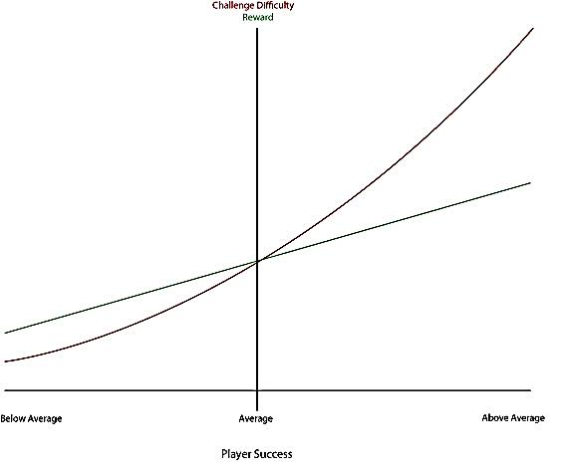

Figure : Graph of player difficulty

By using the challenges in this manner, I offer below average player’s easier access to beneficial buffs without just giving them away. At the same time, better players have access to better buffs, but at exponentially higher difficulties. As a player trends toward above average, the reward to challenge ratio decreases more and more, meaning that they are given less and less assistance without giving them nothing to shoot for. At the same time, success at these difficult challenges is announced to the match players, compensating for the decreasing game benefits with “fame.”

The third change would be to tie the challenges in to the story. Achievements generally come with some flare and style that gives them their own personality. For example, in World of Warcraft, there is an achievement for using the hug emote on every type of small animal in the game. I hope to use this characteristic to apply the “flavor” of the three organizations in the game (The ACF, The Society for Historical Beatdowns, and Impossible Possibilities) to the challenge requirements. For example, Impossible Possibilities has a mad scientist feel, so their associated challenges would focus on odd combinations and ways to kill people. I can also use it to flesh out some of the “entertainment industry” TV shows by sponsoring challenges for players to complete. For example, a historical reenactment show could sponsor “The Spartan – Use a wall to stop three incoming projectiles” as a sort of advertisement.

# Research Literature

* <http://www.gamasutra.com/blogs/EnriqueDryere/20091229/3959/Difficulty_Setting_in_Multiplayer_Games_Can_it_be_done.php>
* <http://www.gameontology.org/index.php/Dynamic_Difficulty_Adjustment>
* <http://www.destructoid.com/good-idea-bad-idea-dynamic-difficulty-adjustment-70591.phtml>
* <https://www.aaai.org/Papers/Workshops/2004/WS-04-04/WS04-04-019.pdf>
* <http://portal.acm.org/citation.cfm?id=1178573>
* <http://www.gamasutra.com/view/news/18376/Feature_The_Designers_Notebook_Difficulty_Modes_and_Dynamic_Difficulty_Adjustment.php>

# Deliverables and Integration

* A game mechanic or set of game mechanics that achieve the previous goals.
* A user evaluation of the game to determine if it achieves those goals. This will be done by play testing the game with a sample of users and recording their answers to questions about balance and style.

# When is it Complete?

This research will be complete when:

* A game feature has been created.
* It has been integrated in the game.
* It has been play tested by non-members of the team and evaluated.
* It has been improved based on that feedback (time allowing).

Design and Implementation of a Componentized Multi-Core Game Engine

Capstone Research Topic by Jonathan Lobaugh

# The Problem

The specific problem I am addressing in this research project is the integration of multi-core processor architecture and game engine design. I hope to integrate two different technologies to build an engine that is both easy to use and optimized for multi-core processors.

The key development construct for most game engines is the game loop. The game loop construct has been at the core of most of the commercial engines and has worked well for single processor systems. However, with the advent of multi-core processors, game engines have been unable to adapt the game loop to fully utilize multi-core processors. With the current market share of multi-core processors reaching over 50%, the need for game engines to adapt and embrace the multi-core processor is becoming a huge motivation for a shift in game architecture.

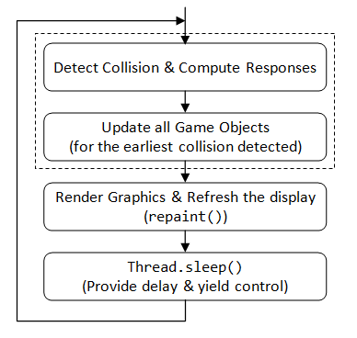

Figure : Game Loop Control Diagram

Since multi-core processors were introduced developers have been attempting to move the game loop from a single-core process to a multi-core process. The shift produced engine architectures that were built around forms of data synchronization constructs such as critical sections, reader/writer locks, or barriers and context switching mechanisms. Data synchronization constructs (aka locking constructs) provide a means for developers to re-synchronize the data across the multiple cores; without such synchronization, data would become unreliable. Context switching mechanisms are a means by which multiple threads are able to run on a single processor.

However, as a cost to the synchronization and thread management, both locking constructs and context switching take valuable time and memory to execute. Many times the locking constructs can cause large slots of execution time to be lost. Each time a thread must synchronize, the thread must stop its execution, which causes a context switch. These two actions are a huge loss of processing time when dealing with game engines.

The job of an engine designer is to understand these locking issues and design a means for developers to minimize their use. However, many times it is difficult to minimize locking constructs without building the engine specific to the development of the game. To further complicate the system, many times design of the game makes it impossible to eliminate the locks from the engine.

To take full use of the multi-core processors, the time used to synchronize data and switch threads among cores needs to be minimized, or eliminated if possible. Intel’s Threaded Building Blocks (TBB) library attempts to minimize the time lost to thread management by eliminating the need to switch threads. By utilizing small tasks the library is able to minimize the amount of time lost to context switching. Data synchronization is still an underlying issue, one that the TBB library does not fully address.

To fully utilize multi-core processors and architecture needs to be designed that minimizes the usage of context switches as well as forms of data synchronization locks. If an engine architecture is able to minimize these two slowdowns while maintaining an easy to use system, then game engines will finally move into the realm of multi-core applications.

# Why is this Problem Important?

As game development as matured over the years, the need for more processing time has become a huge limiter of what features have been implemented in games. Processes such as Artificial intelligence and physics have been limited in order to manage the frame rate of games. The hardware industry has answered back with multi-core processors, expanding the amount of computational time available to developers. However, the game loop was never intended to exist as a threaded process and most implementation that attempt to amend the game loop end up with very little benefit compared to the amount of overhead.

In order to embrace the technological improvements of multi-core processors, engine design is going to have to explore another architectural model. Models that are able to abstract the process of multi-core development while minimizing the overhead of the multi-core development. When engines adopt this approach, then more process time can be opened for extended running processes.

# Goals

This research project has two main goals:

* Create an engine framework that can integrate a task-based threading model and component-based entity architecture.
* Create a mechanism for allowing threaded rendering with a constant time optimization of draw calls.

# The Approach

The architecture I am proposing is a combination of techniques. As describe above, the issue with game engine design and its subsequent move towards multi-core processors has been the steadfast use of the single threaded game loop. Techniques and libraries have been emerging on the forefront that has taken the threading models from the single processor to a higher abstraction in the form of tasks. The core utilization is quite high and allows for quick unitized tasks to be completed in parallel. Intel’s Threaded Building Blocks have built this model into the library. The technique make use of every core of the processor while minimizing the context switching that is usually necessary when running threaded systems.

This threading approach integrated with a component-based entity architecture will be the direction I feel will provide the most processor utilization. Whereas the tasking system allows functional separation, the component-based entity architecture allows data separation. When combined properly the two models allow threading with both functional and data separation, completely individuating each task. What this means for the engine, is a threading model with little to no data synchronization locks. The ability for an engine to manage and execute game logic across multiple threads with no data synchronization or context locks is a means of utilizing multi-core processors to their fullest.

# Research Literature

* "Designing the Framework of a Parallel Game Engine - Intel." Intel Software Network communities - Intel. Web. 24 Feb. 2010. <http://software.intel.com/en-us/articles/designing-the-framework-of-a-parallel-game-engine/>.
* Gabb, Henry, and Adam Lake. "Gamasutra - Feature - "Threading 3D Game Engine Basics"" Gamasutra - The Art & Business of Making Games. 17 Nov. 2005. Web. 23 Feb. 2010. <http://www.gamasutra.com/features/20051117/gabb\_01.shtml>.
* Gasior, Geoff. "Valve's Source engine goes multi-core - The Tech Report - Page 1." The Tech Report - PC Hardware Explored. 13 Nov. 2006. Web. 24 Feb. 2010. <http://techreport.com/articles.x/11237>.
* Lorenzon, Jorge A., and Esteban Walter Gonzalez Clua. "A Novel Multithreaded Rendering System based on a Deferred Approach." SBGames 09. Print.
* Mönkkönen, Ville. "Gamasutra - Feature - "Multithreaded Game Engine Architectures"" Gamasutra - The Art & Business of Making Games. Gamasutra, 06 Sept. 2006. Web. 24 Feb. 2010. <http://www.gamasutra.com/features/20060906/monkkonen\_01.shtml>.
* Slade, Matthew, Ken MacGregor, and Edwin Blake. The Development of a Multi-threaded Game Engine. The Development of a Multi-threaded Game Engine. 2008. Web. 23 Feb. 2010. <http://shenzi.cs.uct.ac.za/~honsproj/cgi-bin/view/2008/packham\_slade.zip/packham\_slade/downloads/report\_matthew.pdf>.
* Tagliasacchi, Andrea, Ryan Dickie, Alex Couture-Beil, Micah J. Best, Alexandra Fedorova, and Andrew Brownsword. "Cascade: A Parallel Programming Framework for Video Game Engines." Print.
* Zamith, Marcelo, Mark Joselli, Luis Valente, Esteban Clua, Anselmo Montenegro, Regina Celia P. Leal-Toledo, and Bruno Feijo. "A Game Loop Architecture with Automatic Distribution of Tasks and Load Balancing between Processors." Brazilian Symposium on Games and Digital Entertainment 8 (2009): 5-9. Print.

# Deliverables and Integration

* The game engine framework source code
* The game engine framework one-sheet
* Small Demo of the Game engine
* Performance measurements and comparison data.

# When is it Complete?

This research will be complete when:

* A game engine framework has been developed.
* It has been integrated into the game.
* The performance has been measured against other multi-core solutions.

Variable Style Deferred Rendering

Capstone Research Topic by Eric Moreau

# The Problem

The topic of my research for our capstone project is the ability to create multiple art styles through a deferred renderer. The reason I am pursuing this topic is because of the art style that *Trigger Happy* utilizes multiple art styles to set up its environment. The characters and the environment each have a distinct look to them that is beyond the reach of a standard deferred renderer. A standard deferred renderer use a two-pass system. The first pass takes a snapshot of what is being rendered on the screen and applies shading model effects. This snapshot is often known as the G-Buffer. The G-Buffer holds all the data that is going to be sent through the renderer. The results from these effects are then output to render targets and fed into the second pass. The second pass renders out the final scene using the textures created from the render targets in the first pass. Since the whole scene is looped into one lighting model post-process, it makes it hard for multiple art styles.

Common deferred renderers render out to at least three render targets in order to achieve basic results. These render targets create textures for original pixel color, normal maps, and specular maps. Other maps have been known to implement a second pass before the final render pass to achieve higher detail in their scenes. The Leadwerks Engine utilizes a second pass that includes a diffuse lighting and specular reflection render targets added to the scene.

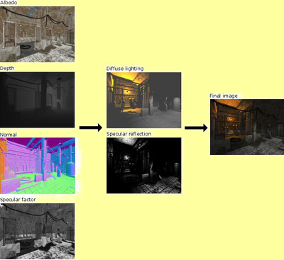

Figure : Deferred Renderer Implemented in Leadworks Engine 2.0

# Why is this Problem Important?

Handling multiple art styles is usually handled using a forward rendering process as it can handle more object specific post-process techniques. Deferred Rendering excels in performance over forward rendering in the sense that it is only doing one draw call per frame. Forward rendering takes multiple draw calls per frame. Because of this single draw call, deferred rendering also scales nicely when more lights are added to the system. This scaling factor comes into play most notably in enclosed environments where more lights are required to light the area. Deferred rendering does not work so well in outdoor environments since it generally setup by one large point light that represents the sun.

There has been a long debate as to which style of rendering is better. As of right now there is no definite answer since each system has its own strengths and weaknesses. The correct answer at this time is it is really system and game dependent. There are limitations to deferred rendering outside of the post-process limitations. Deferred rendering does not handle transparencies in scenes that well. This is due to snapshot approach to the scene. From there it is hard to determine draw order of objects in the scene. Another issue is hardware anti-aliasing in deferred rendering. Many hardware architectures are incapable of applying standard hardware MSAA anti-aliasing to scenes. There are ways around the anti-aliasing issue but engines are forced to take performance hits in order to achieve the upscaling and downsampling required to perform the techniques.

While the exploration of the transparency and anti-aliasing is outside of the scope of my research, they are both worth noting as limitations of the deferred rendering pipeline. On the highest concept level, adding the ability to vary art styles inside a deferred renderer moves away from the standard deferred rendering pipeline model and more into a forward renderer model, though not entirely.

# The Approach

My development plan can be broken down into two steps. These steps are to ensure that if there is a point in my research where I feel that my desired results cannot be achieved, I can assess the situation early and often without delaying development or break already existing portions of our engine development.

## Implement Basic Deferred Renderer

The first step to achieving my end-goal is to implement a deferred renderer. Without a basic renderer to draw from, it will be difficult to understand where and how to break up the G-Buffer. Already implemented in the *Singularity* Engine that *Trigger Happy* is to be running on is a forward renderer system. When the deferred renderer is complete I will do a performance assessment of both rendering systems. Comparing the performance difference between the two system will give me an understanding of which system is faster for the Singularity Engine as well as give me an indication of how much of a performance hit a final solution would take from the engine.

## Compartmentalize the Renderer

The second and more challenging of the two steps will be the compartmentalizing functionality of the renderer. Users working with the system will need to be able to identify what types of art style they want their objects to render as. From there each style will need to identify what textures they will need to achieve the desired effect. I will be taking a page from the Leadwerks Engine approach by using a second pass to render textures that apply to all styles; such as specular reflection and diffuse lighting. Below is a flowchart for the system in its final stage.

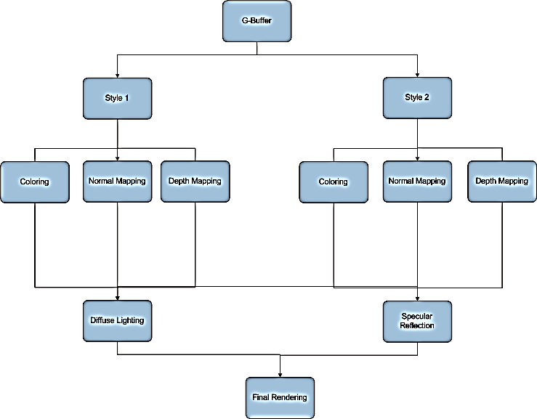

Figure : Deferred Rendering Flowchart Proposition

# Goals

* Implement a deferred rendering system
* Be able to compartmentalize objects in the scene to apply separate post-process techniques.
* Be able to apply separate post-process techniques to separate compartments.
* Bring all compartments back together for a second pass

# Deliverables and Integration

The deliverables for this system will be a fully integratable rendering system that allows for varied post-process techniques using a deferred rendering core. Integration with the game and the engine will be fairly simple due to the engine’s component system. The component system allows for base game objects to add modular components to achieve various levels of functionality. The game objects this research will focus on objects drawn on the screen that require a rendering component. As of the time of the writing of this proposal, the *Singularity* Engine is capable of handling the forward rendering system and is capable of sustaining a deferred rendering component to replace the forward renderer.

One of the larger differences in the system will be how effects are handled in relation to the deferred system. In order for the deferred rendering system to work, objects will need to render to various render targets that will create the desired look and feel for *Trigger Happy*.

The fallback plan for this system will be to use the forward rendering system that already exists in our engine.

# When is it Complete?

* Deferred Rendering framework has been developed
* The rendering system has been fully integrated into the *Singularity* Engine
* The rendering system is capable of compartmentalizing objects into style groups to render different post-process effects
* The compartments can be combined into one scene to render common post-process maps and rendered to a final scene
* Performance has been measured against the forward rendering system already in place in the *Singularity* Engine

# Research Literature

Much of my research has come in the form of community discussion on various websites with various papers on Deferred Rendering thrown into the mix. These discussions offer reasonable warnings and point/counterpoint comments on the deferred rendering process. I will use these discussions, papers, demonstrations, and any other future findings towards my research.

# Bibliography

Game Creator's Newsletter July 2008.

[C#][HLSL] Mixing Deferred Rendering and Forward Rendering. n.d. January 2010 <http://www.gamedev.net/community/forums/topic.asp?topic\_id=559161>.

Deering, Michael. Proposed Deferred Rending Technique in 1988. n.d. January 2010 <http://en.wikipedia.org/wiki/Michael\_Deering>.

"Deferred Particle Shading." n.d. January 2010 <http://download.unity3d.com/blogs/nf/files/page0\_blog\_entry73\_1.pdf>.

Deferred Rendering Implementation Example. n.d. January 2010 <http://www.catalinzima.com/?page\_id=41>.

Deferred Rendering in Frameranger. n.d. January 2010 <http://directtovideo.wordpress.com/2009/11/13/deferred-rendering-in-frameranger/>.

"Deferred Rendering in Killzone 2." n.d. January 2010 <http://www.guerrilla-games.com/publications/dr\_kz2\_rsx\_dev07.pdf>.

"Deferred Rendering in Leadworks Engine." n.d. January 2010 <http://www.leadwerks.com/files/Deferred\_Rendering\_in\_Leadwerks\_Engine.pdf>.

Deferred Rendering Sample. n.d. January 2010 <http://www.codesampler.com/usersrc/usersrc\_7.htm>.

Deferred Shading Implementation. n.d. January 2010 <http://www.gamedev.net/community/forums/topic.asp?topic\_id=463293>.

Deferred Shading Shines, Deferred Lighting? Not So Much. n.d. January 2010 <http://gameangst.com/?p=141>.

Forward vs. Deferred Rendering. n.d. January 2010 <http://www.gamedev.net/community/forums/topic.asp?topic\_id=424979>.

GPU Gems 2: Chapter 9 -- Deferred Shading in S.T.A.L.K.E.R. n.d. January 2010 <http://http.developer.nvidia.com/GPUGems2/gpugems2\_chapter09.html>.

"Inferred Lighting: Fast Dynamic Lighting and Shadows for Opaque and Translucent Objects." n.d. January 2010 <http://graphics.cs.uiuc.edu/~kircher/inferred/inferred\_lighting\_paper.pdf>.

"Light Indexed Deferred Lighting." n.d. January 2010 <http://lightindexed-deferredrender.googlecode.com/files/LightIndexedDeferredLighting1.1.pdf>.

Lighting in Deferred Shading. n.d. January 2010 <http://www.gamedev.net/community/forums/topic.asp?topic\_id=482654>.

Lighting Rendering Architecture Doubt -- Discussion on Multipass and Singlepass Lighting Architecture. n.d. January 2010 <http://www.gamedev.net/community/forums/topic.asp?topic\_id=424468>.

Maya-based Creation and Assignment of Component Attributes for a Component-based Game Entity Architecture

Capstone Research Proposal – Nicholas Wilsey

# Background

Traditionally, game programmers have represented game entities through an object-oriented, hierarchical tree-based structure. This structure has been used to produce generations of games, but by using it, programmers have always been required to deal with its inherent issues. Most obvious of those issues is the fact that often times, programmers cannot describe every set of game entity relationships through a directed acyclic graph. And when they try to add functionality to the nodes (entities) in such a situation, they end up having to reorganize the graph each time they do it. That reorganization, fortunately, is relatively easy. Maintaining an acyclic graph after doing so, however, is generally not.

To deal with such a hurdle, programmers often try to avoid it all together by moving data and functionality up and down the graph (rather than reorganizing it). Sometimes these moves are sound, but often times they go against the key object-oriented principles that they hoped to follow when they chose a hierarchical structure. For instance, when one moves data up the graph, the "highest" nodes often begin to misrepresent what they truly are and become very bloated. When data is moved down the graph, it is often done by duplicating code, and sprinkling it around to the classes that need it. In the end, all functionality has its place, but given the data structure, one would not always find it where s/he might logically expect it to be.

To avoid these sorts of issues (and there are others), some game programmers have stopped using a purely inheritance-based architecture to represent their game entities. Instead, they have begun taking a composition-based approach. Programmers often refer to this method as a component-based architecture, and it represents a fundamental shift in game entity representation.

Component-based models flatten the typical hierarchical structure, almost making the concept of child/parent nodes and what that represents (in terms of function) irrelevant. In this approach, instead of adding functionality to an object through a long hierarchy, programmers compose objects of “behaviors” and “attributes”. Behaviors define functionality, and attributes act as the inputs and outputs to those behaviors. There are a few more details involved, but ignoring those for now, behaviors and attributes combine to compose “components”. These components are what we attach to individual game entities, and they are, essentially, what define a particular game entity. For the development of *Trigger Happy*, we have adopted such an approach.

# Problem

To use a component-based system, there must be a way to define component attributes and behaviors, assign them to unique game entities, and then edit their individual values. This method should be simple to follow and easily achievable by any member of the team, regardless of which team one is on (i.e., the asset creation, engine development, or gameplay programming team). Moreover, when the game engine reads in and composes game entities at runtime, that process should be relatively fast and require as little overhead as possible. If the engine reads entities from a file, for instance, that file should contain the entity definition as well as assigned attributes and behaviors; reading any of that data from additional files would be considered unneeded overhead.

Defining a list of editable component attributes and behaviors is rather simple – one could do it in a simple text file. And one would not generally consider assigning components to unique game entities much harder either, especially if s/he uses an XML-type file schema and is able to edit those files. However, a text-based editing system is not necessarily the most intuitive way to go about things. Programmers may easily parse XML, but it is a cumbersome task to do so. Moreover, the mere fact of looking at code (or anything that resembles code) may simple be too daunting a task for an artist to easily handle. We need a system that can work for everyone, and is not needlessly cumbrous from tedious text file editing. There is no readily available system for us to use, so we will have to implement our own.

# Claim

We already plan to use Autodesk’s Maya software to define our game environment and the world position of its entities. I think that we could use Maya to help assign our components as well. The Maya API completely unlocks all of its features to C++ and Python programmers, giving them low-level access to all data required to make plug-ins. Wielding that power, I think that I could write a plug-in that would meet all of our needs.

# Goal

My goal is to build a Maya plug-in that will allow us to easily and quickly define, assign, and change component attributes for our component-based game architecture. As stated previously, this system should give users the ability to easily define and edit component attributes, and then assign them to individual game entities. Moreover, it should help make the loading and construction of entities at runtime as fast and simple as possible. Finally, it should do these things in an intuitive way, with a very flat learning curve.

# Method

There are two ways to extend Maya functionality. The first is Maya’s C++ API. This API provides access to every element within Maya, including all scene data, dependency graph information, shaders, file translators, etc. The second way is with MEL (or Python) script. MEL is the internal Maya scripting language, and is typically used to design user interface elements. One may also embed it within C++ code, and it will execute within Maya as if one had directly input its commands into Maya’s internal command shell.

Using these two features, I would design and implement a C++-based plug-in that would be loaded and run within Maya. MEL script would allow me to create a user interface that is not only fully integrated into Maya, but also intuitive to use and easily extendable. In addition, I would use the C++ API to build the entity-defining components we would like to have (granting easy access to their behaviors and attributes in the process), and a simple way to assign them to any node within a scene.

With access to the dependency graph, particular components could be dragged-and-dropped directly onto the objects they would compose. Likewise, with a custom made GUI, editing those component attributes values would be as easy as changing a few values within a GUI field element. I would seamlessly integrate all component information into the data that Maya already assigns to its meshes, and export it all from a file type that we would easily parse with our game engine.

# Conclusion

Maya will help give us the power to easily make a component-based game-entity-architecture a reality. Instead of designing and building an interface from scratch – even trying to use what could be a very tedious and cumbersome XML-based file approach – we could use everything what Maya already provides. Instead of editing text files, we could simply drag and drop components (thereby assigning them) directly onto individual objects within the scene. Those connections would be visually apparent to everyone, and easily changed through our custom-made GUI elements. Moreover, with full access to all data and file translators, we could easily define a custom file layout and optimize it for our game loading needs.

Switching to a component-based architecture, especially from a hierarchical approach, is not necessarily a simple task. If we can do anything to make our development process easier and ourselves more productive, we all think we might as well do it. And by using the power of Maya as we have outlined here, I think that we can certainly do that.

# Bibliography

Autodesk. "Autodesk Maya Online Help." n.d. 22 February 2010 <http://download.autodesk.com/us/maya/2009help/index.html>.

Gould, David A. D. Complete Maya Programming. 1st. Vol. I. Morgan Kaufmann, 2003. II vols.

—. Complete Maya Programming. 1st. Vol. II. Morgan Kaufmann, 2005. II vols.

*This page intentionally left blank.*

Development Document

This Development Document details the technical development of *Trigger Happy*. It begins by outlining and describing the systems and components we created during the development of Trigger Happy, and then goes on to explain the thought process had throughout development, and why we made some particular choices. It concludes with a game-initialization walkthrough, followed by a post-mortem that explains what we thought went well, what could have gone better, significant setbacks, future work, and how well we followed our initial development timeline.

# Lua-based System HLA Diagram and Discussion

## Game Systems

We coded the game systems entirely in Lua. [1] They bind to the C++ engine infrastructure through auto-generated binding functions creating using tolua++. [2] While Lua does not have a class structure per-se, these systems can be thought of as containing static/dynamic data and operations split between clients and remote players. Static data such as weapon attributes are stored in single tables while dynamic data like ammo counts are built into new tables for each “instance.” Instead of hierarchical class structures, our game systems use a “mixin” approach to build objects from several tables of component parts.

### *Player*

*Player* handles the networking of most player data, player camera and movement, along with weapon swapping.

* **Static Data**
  + *Mesh* – Player.
  + *Material* – Player.
* **Static Operations**
  + *CreateClient* – Creates a client (local) player with a camera, input binding, rigid body physics, and weapon cache. Stores the player in the game player table.
  + *Create* – Creates a remote player with a collider, mesh, and weapon cache.
  + *InitGeneral* – Sets shared player data including audio cues, ID, Name, etc.
  + *WeaponStates* – State machine responsible for allowing the client to swap weapons.
  + *Camera Update* – Moves the client's camera based on mouse movement. Handles player movement and jumping.
  + *Camera Inver*t – Flips the camera over.
  + *Enable* – Allows this system to update.
  + *Disable* – Prevents this system from updating.
  + *Update* – Calls other game system updates and handles movement and health and ammo regen.
* **Shared Data**
  + *WalkRate*
  + *Kills*
  + *Deaths*
  + *State* – Alive, Dead.
  + *HP*
  + *Energy*
  + *CurrentWeaponIndex*
* **Client-Only Operations**
  + *AddBuff* – Adds a buff to the player's list.
  + *CanAddBuff* – Returns true if the player can handle another buff (doesn't have more than max).
  + *RemoveBuff* – Removes a buff from the player's list.
  + *HasBuffType* – Returns true if the player has a buff matching the passed in type.
  + *CountModifierBuffs* – Returns the number of modifier buffs that player has on them.
  + *TakeDamage* – Reduces the player's health and handles network notification of death.
  + *Restore* – Restores the player's health, energy, state, and weapons from being dead.
  + *AddWeapon* – Adds a weapon to the player's active list from the weapon cache.
  + *RemoveAllWeapons* – Deactivates all the player's weapons to be reinitialized.
* **Remote-Only Operations**
  + *SetWeapons* – Sets player's current weapons from network data.
  + *SetModifiers* – Sets player's current modifiers from network data. Creates and destroys modifiers as necessary.
* **Shared Operations**
  + *CurrentWeapon* – Returns player's current selected weapon.
  + *GetWeaponByType* – Returns the player's weapon of the passed in type or nil if they don't have that type.
  + *SelectWeapon* – Changes the player's current weapon. Handles toggling of models and enforces a cooldown.
  + *AddModifier* – Adds a modifier to the player's list.
  + *RemoveModifier* – Removes a modifier from the player's list.
  + *GetModifierByID* – Returns a player's modifier matching the passed in ID or nil.
* **Network Messages**
  + *SlowInfo* (1s) – All player info except for weapons and modifiers.
  + *FastInfo* (0.03s) – Position, Orientation, State, and Current Weapon.
  + *WeaponInfo* (1s) – Active weapon set with ammo, clip ammo, and type.
  + *ModifierInfo* (0.5s) – Active modifier set with ID, type, position, orientation, and owner.
  + *Death* – Sent when a player dies. ID and attacker ID.

### *Weapon*

Manages the client's weapon firing behavior and represents a remote player's weapon.

* **Static Data**
  + *Weapon Attributes* – One for each weapon type. Includes some of the following:
    - Damage
    - Type
    - Nick name
    - Fire Cooldown
    - Clip Reload Cooldown
    - Max Ammo
    - Max Clip
    - Regen Period – Seconds between ammo regen ticks.
    - My Scale – Scale of the weapon on the client.
    - Their Scale – Scale of the weapon on remote players.
    - Mesh
    - Material
    - Audio Cues – Fire, Switch, Empty, Reload.
    - Projectile – Fired projectile in applicable.
    - Hit Particles – Particle system displayed at collision point.
    - Custom Attributes – Specific to each weapon. Examples include pistol charge time and grenade release angle.
* **Static Operations**
  + *CreateAllWeapons* – Creates a cache of weapons and returns it.
  + *Create* – Makes a remote weapon with a mesh, ammo, type, and clip.
  + *CreateClient* – Makes a client weapon with a mesh, ammo, type and clip.
  + *InitGeneral* – Adds mesh and audio cues to weapon.
  + *GetWeaponTypeByProjectileType* – Returns the weapon type of a projectile.
  + *GotoIdleOrNoAmmo* – Swaps current weapon state after firing completes.
  + *HandleNoAmmo* – General behavior when a weapon has no ammo.
  + *WeaponBehavior* – State machines that operate each weapon type. Contain weapon state data (timers, etc) and custom state functions. Each state function receives the elapsed time and a boolean indicating if the machine just entered this state. Common states include:
    - Idle – The weapon is ready to fire.
    - Fire – The weapon is firing. Call appropriate projectile method to shoot.
    - Between Shot Delay – Weapon is cooling down between shots.
  + *Enable* – Allows this system to update.
  + *Disable* – Prevents this system from updating.
  + *Update* – Runs the current weapon and trigger laser state machines.
* **Shared Data**
  + *Type* – Weapon name.
  + *Ammo* – Current ammo.
  + *Clip* – Remaining ammo in the clip.
* **Client-Only Operations**
  + *AddAmmo* – Adds ammo to the weapon, capped at the max.
  + *Reset* – Gives the weapon full clip and ammo.
* **Shared Operations**
  + *GetAmmo* – Returns current ammo or nil if weapon doesn't have ammo.

### *Projectile*

Projectile handles both the weapon firing operations and the applying of effects, such as damage, to other systems. It implements a number of firing styles including projectile, single ray, multi-ray, and modifier behaviors, and it networks these firing behaviors. It also includes a particle pool for management of GameObjects and decluttering the game world.

* **Static Operations**
  + *MakeAoEProjectileType* – Creates a projectile prototype storing type, damage, AoE range, speed, if it's affected by gravity, collision particles, radius, mesh, material, scale, and a function for making a callback closure.
  + *MakeSingleProjectileType* - Creates a projectile prototype storing type, damage, speed, if it's affected by gravity, collision particles, radius, mesh, material, scale, and a function for making a callback closure.
  + *DoRayQuery* – Returns a collider, target position and depth along a directed ray.
  + *DoInstantSingle* – Attempts to hit a player with an instant, single target shot. Sends network notification of where the shot hit and the target if any.
  + *DoShotgun* – Attempts to hit players with a 25 ray, square shaped spread shot. Damage dealt based on distance from the firing player. Sends network notification of targets hit.
  + *DoTrigger* – First attempts to trigger a modifier the player owns. Failing that, it tries to damage an enemy player's modifier. Implemented as a ray query.
  + *DoSpawnModifier* – Casts a ray and spawns a modifier at the intersection point if it doesn't intersect with a player.
  + *DoDestroyModifier* – Casts a ray and destroys the player's modifier at that position (if any).
  + *HandleRayHitEffect* – Handles when a ray weapon hits anything. Creates particles at the collision point. Called by the network.
  + *HandleRayFireEffect* – Handles when a ray weapon is fired. Plays audio at the shooter's position. Called by the network.
  + *Enable* – Allows this system to update.
  + *Disable* – Prevents this system from updating.
  + *Update* – Removes projectiles that have existed longer than 5s from the game.
* **Shared Data**
  + *Projectile Attributes* – Stored in a projectile type. These include:
    - Type – A String name for the projectile type.
    - Damage
    - AoE Range – Radius of the target determining sphere.
    - Speed
    - Gravity – Boolean indicating if this projectile is affected by gravity.
    - Particles – The particle system activated on collision.
    - Radius – The radius of the particle's spherical collider.
    - Mesh
    - Material
    - Scale
    - *MakeClosure* – Function that can create a unique collision closure for this particle.
* **Client-Only Operations**
  + *SpawnClient* – Spawns a projectile using InitGeneral and notifies other players of its firing.
  + *MakeAoEClosure* – Returns a function that handles the collision of an AoE particle.
  + *MakeSingleClosure* - Returns a function that handles the collision of a single target particle.
  + *FindDeadProjectile* – Identifies a projectile that is no longer alive for reuse.
  + *InitializeProjectiles* – Initializes all projectiles in the pool.
  + *KillProjectile* – Removes the projectile from the active list and deactivates its game components.
* **Remote-Only Operations**
  + *Spawn* – Spawns a projectile. Called from the network.
* **Shared Operations**
  + *InitGeneral* – Creates a new instance of the projectile type at the specified position moving in the specified direction. Projectile type settings can also be overridden.
* **Network Messages**
  + *FireInfo* – Sent when a player shoots a projectile weapon. Projectile owner, type, position, and direction.
  + *HitInfo* – Sent when a player is struck by any weapon. Attacker ID, target ID, damage, and weapon type.
  + *RayHitInfo* – Sent when a ray weapon hits anything. Weapon and hit location.
  + *ModifierHitInfo* – Sent when a modifier is struck by a trigger laser. Owner and damage taken.
  + *RayFireInfo* – Sent when any ray weapon is fired. Weapon type and owner.

### *Modifier*

Handles the spawning and destruction of client and remote modifiers. Also handles networking and application of modifier effects.

* **Static Data**
  + *Modifier Attributes*
    - NickName
    - Audio Cues – Proximity, Trigger, Shot, Destroyed.
    - Cost – Energy cost to deploy.
    - Meshes and Materials for effects.
  + *Tween* – Tweens and tween functions responsible for animating the modifier effects.
  + *Trigger Behavior* – A set of functions responsible for building a modifier target list and spawning the effects.
  + *HandleModifierHitMe* – Called from the network or locally when a modifier hits the player.
  + *HandleModifierHitOther* – Called from the network when a remote player has been hit by an modifier effect.
  + *AlertHitMe* – Alerts others that I was successfully targeted by a modifier.
  + *AlertHitOther* – Alerts others that they've been targeted by a modifier.
  + *AlertRemovedFromMe* – Alerts others that an effect on me has been eliminated prematurely.
  + *Modifier Behavior* – A set of functions and data that implement the application and removal of modifier effects. Standard functions for each modifier include:
    - *Activate* – Called once to apply the effect. If the player is a client, it first evaluates if it’s a valid target and then notifies others of the application.
    - *ApplyEffect* – Applies the client or remote graphical effects and game object effects. Applies a buff to the client.
    - *Process* – Called continuously to update the effect.
    - *Deactivate* – Called once to remove the effect. Removes the buff from the client. Maybe be invoked after the duration elapses or sooner.
  + *AddActiveEffect* – Adds an effect to the active processing list.
  + *RemoveActiveEffect* – Removes an effect from the active processing list.
  + *Search Functions* – Functions responsible for finding active effects by type, ID, etc.
  + *Enable* – Allows this system to update.
  + *Disable* – Prevents this system from updating.
  + *Update* – Updates active effects and modifier cooldowns.
* **Static Operations**
  + *Create* – Uses InitGeneral.
  + *CreateClient* – Assigns a modifier ID, cooldown monitor, and reset its attributes.
  + *InitGeneral* – Creates and animates the modifier marker. Adds audio cues.
  + *Destroy* – Destroys the modifier and restores the player's energy.
  + *MakeCooldownBehavior* – Returns a table capable of measuring the modifiers cooldown and indicating its ready state.
* **Shared Data**
  + *Type* – Modifier type.
* **Client-Only Operations**
  + *TakeDamage* – Deals damage to the modifier and handles destruction condition.
* **Network Messages**
  + *ModifierTarget* – Sent when a player is targeted by a modifier. Type, ModifierID, OwnerID.
  + *ModifierHit* – Sent when a player is hit by a modifier. Handles other players getting hit by modifiers. OwnerID, TargetID, type, effectID.
  + *ModifierRemove* – Sent when a modifier effect is removed prematurely. TargetID, EffectID.

### *Tween*

Responsible for smoothly varying values over a time frame.

* **Tween**
  + *MakeLinearTween* – Makes a tween that changes at a constant rate.
  + *MakeCosTween* – Makes a tween that changes at a cosine rate.
  + *MakeSinTween* – Makes a tween that changes at a sine rate.
  + *Evaluator Functions* – Calculate the next value of the tweened variable.
* **TweenSet**
  + *Bind* – Adds a tween bound to a specific property with a duration to the set.
  + *SetTarget* – Sets the object on which this tween set acts.
  + *SetLoopCount* – Sets how many times the tween set runs.
* **Tweener**
  + *Play* – Begins playing the tween.
  + *Pause* – Pauses the tween's execution.
  + *Resume* – Resumes a paused tween.
  + *Stop* – Stops a playing tween.
  + *Update* – Advances all active tweens, updating the tween set targets with new values.

### *Network*

Encapsulates network functionality allowing callbacks on packet delivery and reliable packet delivery.

* *Serialize* – Converts a Lua table into a string for networking.
* *Deserialize* – Converts a string into a Lua table.
* *Register* – Registers a callback function that is executed when a chosen message type is received.
* *Unregister* – Unregisters a callback function and stops responding to that message.
* *Send* – Sends a message with no guarantee that it will arrive.
* *SendReliable* – Sends a message and resends up to three time if it is lost.
* *Receive* – Called by C++ to report a new packet. Invokes callbacks waiting on the packet and handles acknowledgments and duplicates.
* *Update* – Does resending of packets if necessary.

### *Achievement*

Monitors the game to reward the client when they complete goals.

* *Goals* – A table with the state and processing functions for each achievement system goal.
* *Rewards* – A table with functions to apply and remove rewards of varying strength.
* *ApplyReward* – Applies the selected reward to the player.
* *ProcessEffects* – Updates and disables active rewards.
* *SelectGoal* – Chooses the player's next goal and reward based on their relative success to the other team. The better the player is doing, the harder the goal.
* *Update* – Selects a new goal if the player has completed their previous goal.
* *Enable* – Allows this system to update.
* *Disable* – Prevents this system from updating.

# SMURF Format Maya Exporter

The SMURF file format is a custom model format. It contains all model information, including vertex data, an index buffer, material data (i.e., primary color, ambient color, diffuse color, eccentricity, and texture file path), joint, key frame, and frame data (if applicable), and collision volume data. Autodesk Maya exports to it in either ASCII or binary format; however, the *Singularity* engine only parses those in binary format.

To export from Maya into the SMURF format, users must load the SMURF exporter’s .mll plug-in file (from within Maya). They must also *source* an associated .mel import/export script file. This script file allows one to choose the SMURF’s exported data format (ASCII or binary) at time-of-export, as well as whether to include animation data (if applicable).

# Development Process

## Engine Development

Engine development began as part of one member’s research in the winter quarter. The first step was to design and stub out core features of the engine and build out from that base. Once the system was layed out, work began on the components and tasking system that would drive the engine. When the spring quarter began, two other team members joined the engine development, bringing the number of developers up to three. The engine was a primary task for a significant portion of the development time. Late in the quarter, two developers moved to game logic, leaving one on engine maintenance. This allowed any changes to the engine to be made quickly, while allowing the developers to focus most of their time on the game logic near the end of the spring quarter.

The multithreaded core of the engine had many advantages and disadvantages. On one hand, it significantly improved the speed of the game and allowed the engine to utilize all of the cores of the CPU as best as possible. The engine elegantly scales up and down depending on the number of cores in the player’s system. It also allows certain tasks to run effortlessly in the background. On the other hand, multithreading made debugging the system much trickier, and introduced many errors due to timing and non-thread-safe code. An example of this can be found with the disconnect between the player’s currently selected weapon and the camera. Because *Trigger* Happy utilized a first-person camera system, it would utilize the player’s world transform to determine position and orientation. This was the same for the player’s weapon. At times, while the player would move around the world, the currently selected weapon would jitter around the screen. This was due to the camera pulling from world transform data that had gone through the update cycle but not the draw cycle yet due to them being on separate threads. A solution was created in the form of the camera storing the previous world transform after it had been drawn and using that to update the associated render objects attached to the player game object; in this case, the weapon or modifier that the player had equipped at the time. These issues ranged from the occasional visual glitch to problems with core functionality which were ultimately addressed.

## Engine Component Development

The engine itself was broken down into a number of different subsystems, allowing development to proceed in a parallelized fashion. These subsystems were split off into individual projects within Visual Studio, allowing shorter compilation times if a given project didn’t rely on code that had been changed. This also meant that developers could feel a sense of ownership over certain subsystems, as well as allowing people to utilize their domain knowledge effectively.

Each of these subsystems had a particular focus: for instance, the animation subsystem focused solely on topics related to animation. Each subsystem was functional as a standalone unit, as well as able to interact with other subsystems when necessary. For instance, the GUI subsystem did not need the animation subsystem to function, but utilized the graphics subsystem in order to draw its vertices.

As mentioned above, multithreading these components created some issues. While subsystem components could easily access data of their parent game objects, the tasks that were scheduled and updated on a regular basis occasionally had thread-safe issues. Trying to track down some of these issues was made especially difficult by our integration of lua, as we could not step through code that passed through lua (our game logic) or see how this code interacted with the rest of our systems.

## Asset Creation

The asset creation portion of the development process took place mainly over the first seven weeks of the quarter. During that time, two team members were allocated to the asset creation tasks. Chip was responsible for creating textures, while Nick focused on making models. The process began with creating the level, taking each room in order. Nick has spent the last two weeks of Winter quarter building the first room which gave us a one room buffer between the modeling and texturing tasks. After completing the ACF wing and the arena at the fifth week, we made the decision to cut one of the wings and to simplify the other two. We were slightly behind our schedule and the map was already becoming too large for a four-on-four battle. We cut the IP wing, which was the least developed and decided to only do the geometry in the classrooms.

After the map was complete to our standards, we created seven of the eight weapons. We rejected the heat ray because of the complexity of the model, the fact that it was not an essential weapon, and because it would have required custom beam effects that no other weapon needed. Simultaneously, Chip created modifier visual effects (particles, effect textures) while Nick built a Maya exporter because FBX wasn't fast enough. This took up several weeks, which were thankfully saved by finding outside help to do our character model and animations. Finally, we created the level collision volumes and Chip took on GUI graphics while transitioning to programming. Even though we had scheduled for doing art the whole 11 weeks, the programming side was falling behind and we stepped in to help speed the process.

In the end, we completed 9 of 14 rooms, 7 of 8 weapons, full collision volumes, full GUI graphics, full effect textures, and an unplanned custom file format. We did not complete character and environmental shaders, and weapon animations. We felt the impact of the reduction in these areas of asset creation did not hinder the overall gameplay of *Trigger Happy* to a large extent. The choice to remove the heat ray was a decision made early due to the complexity of implementation on both the asset side and development side. The reduction in room creation did not affect gameplay whatsoever as it meant that players simply had a smaller environment to perform the same tasks. However, by not completing weapon and character animations, the player’s overall immersion of the game is ultimately lost as it seems static character models sliding across the screen.

## Game Development

The development of the actual game logic started late in the development process. Due to our team task allocation, problems getting the engine running, and the fact that we were waiting on Lua to do the game logic, we did not begin game logic until the eighth week. Even then, we only had a single person on game logic and a single person on GUIs until the ninth week. However, despite the late start we made rather remarkable progress. Within a week and a half, most of the menus were mocked up and all core gameplay systems were implemented including weapons, modifier, projectiles, a tweening system, and other support systems. Thanks to our component model and the ease of building objects in Lua, it was very quick to create game objects.

Unfortunately, by the tenth week, the game development had caught up to the engine and was starved for functionality. Callbacks had to be rewritten to support Lua parameters, bugs began to appear in core rendering functionality, and some other systems just hadn't been hooked up to Lua yet. For some of these, we were able build quick mock ups that simulated missing functionality. For example, the network class called its own receive function to simulate packet arrival so packet parsing code could be tested. These mock ups were very successful for the most part, allowing us to debug 80% of the net code in a single day when engine support had been added.

Most of the debugging in the game logic derived from one of two sources. The first was the Lua environment and bindings. We spent several days contending with access violations that resulted from *tolua++* inappropriately freeing C++ memory that was either still in use or an invalid target for the free call. The solution to this problem was an ugly hack that ended up creating a large memory leak down the line. The Lua garbage collector also created performance issues that we eventually solved by running the collector frequently, but only on a small chunk of the garbage. The second came from component integration. Especially towards the end where multiple were working on shared files, the build would often break every single day. From the point of view of the person committing the code everything works, but it invariably had a negative impact on what others were doing. At least an hour was spent each day trying to get code back to the point where it was working. Other sources of problems included threads being swapped out while Lua logic was executing (creating graphical flickers and pops) and not designing core systems for networking the first time around.

At the end of eleven weeks we had integrated the following functionality into the game: choosing and firing all weapons, dealing damage with non-projectile weapons, player movement, all modifiers, the King of the Hill format, and networking for moving and attacking. What we did not succeed in integrating was particle effects for modifiers and weapons, character animations and networked modifiers. Most of the things that weren't integrated were hung up on engine functionality. The solution to this problem probably would have been to remove either Chip or Nick from art, reduce the art scope, and add them to the programming team.

The team took ten more weeks to improve the game and do their best to solve the issues remaining in *Trigger Happy*. While not entirely successful, many issues were fixed in the engine, Deathmatch and Assault were added, and the animation and collision systems were fixed. Spawn points and capture points were identified and integrated for the level, and problems generated by the switch from 32-bit to 64-bit and from loading in the entire world were identified and solved one by one.

# Implementation Choices

## Lua

We decided to use the Lua scripting language to write the majority of game logic. We were able to do this by auto-generating bindings to our C++ engine using the *tolua++* package. The main reason we chose to take this route was speed of development. With a large amount of content to create and a technically challenging engine to implement we needed to produce game logic as quickly as possible. Thanks to Lua's simple scripting syntax, automatic memory management, and rapid compilation we were able to do just that. Core gameplay systems including the weapons, projectiles, and modifiers were created in their initial versions in just two weeks’ time. While full compile times for the engine ran into the ten minute range, our scripts built in less than ten seconds. Lua also simplified our data loading and networking because there is little separation between code and data. Loading stats for weapons was as simple as compiling a syntactically simple key-value table.

There were two main downsides to using Lua. The first was that memory management of C++ objects was nearly impossible given how we had defined our interfaces and how *tolua++* passed C++ objects to Lua. For any given Lua version of a C++ object it was impossible to know if the C++ system still maintained a reference to it. For this reason, it was impossible to know whether the object should be freed (if it was an object generated by the bindings) or left for C++ to free (objects made in C++ such as transforms for a game object). This forced us to never free memory that was generated by the bindings which created a (manageable) memory leak. The second problem with Lua was debugging. Because the lua runtime was embedded within our engine we didn't have the luxury of breakpoints or memory inspection. Sometimes we didn't even have the luxury of error messages generated on compilation. However, Lua errors can usually be ferreted out quickly using print statements and don't take the cryptic form that C++ errors can sometimes take (such as linker errors).

All told, Lua was a great asset to this project, allowing us to code quickly and adapt quickly without paying a large performance penalty.

## Serialized Networking

We used Lua's table data structure to handle all of our networking. This was a risky decision given the network performance intensive nature of a first person shooter. By sending strings across the network we inflated the size of each packet and forced the system to compile the packet data before it could be processed. However, we gained the ability to send complicated data sets of any hierarchical depth without having to write a single line of serialization code. We also didn't have to write custom structs to represent each of the nearly twenty packet types. Luckily trusting in Lua's fast compilation paid off as we were able to use our existing tables as messages and easily test our netcode (being Lua native tables), without seeing any evidence of network lag.

## SMURF Format

The SMURF format was more or a necessity than a choice. Lacking the XNA content pipeline we were forced to use the FBX SDK to do our own import. Unfortunately, the FBX format is so bloated that import of even basic models was taking in the range of seconds, when it should have been milliseconds. Given that our level was over 100k triangles with a variety of textures, it would have taken in the tens of minutes to load up everything – which was unacceptable. Consequently, Nick wrote a Maya exporter script that only contained the mesh, material, and (sometimes) animation data that we required. The SMURF format allowed all of our assets to load in less than five seconds. Unfortunately, it took a considerable amount of unbudgeted time to develop. However, short of using C# with XNA, this was a required bit of development.

## Maya as Level Editor

Instead of building a custom level editor for our game, we decided to use Autodesk Maya. We made this decision because a first person shooter map is heavy in custom geometry and textures, and light in game objects. There are of course spawn points and capture points, but the majority of the design work is concerned with editing geometry, which is something that Maya is able to do much better than any solution that we could have generated.

The main benefit of using Maya was exactly what we had expected. It was a very powerful and reasonably easy to use tool for generating our map. Combined with Photoshop, we were able to generate hundreds of assets and organize them into our level layouts. The game objects gave us no real problems because we were able to identify locations for them within Maya and then enter the coordinates into Lua manually. The only real problem we had with Maya (beyond exporting issues) was assigning collision volumes. In a high quality game editor like UnrealEd, collision volumes for the floors and walls can be auto-generated using BSP geometry. But in Maya, we were forced to hand create all of the boxes. This ended up totaling over 1000 boxes and took approximately five days to do. We created a basic tool for creating them, but it could only generate axis-aligned boxes, which were too inaccurate to use without rescaling and orienting first. We could have mitigated some of the work by creating simpler geometry (less curves and concave objects), but an algorithmic solution was out of our reach.

# Bullet Physics

We integrated Bullet Physics into the game midway through the development cycle. It helped offset the expensive time cost of developing a new physics system, while simultaneously solving a couple issues in the collision system. In addition, integrating Bullet Physics provided some neat extra functionality to *Trigger Happy*, such as force and weight built into each rigid body.

We integrated rigid bodies and colliders into the *Singularity* Engine by providing a component wrapper for each class deemed necessary. These components were attachable to any GameObject in the world, instantly providing them with gravity, weight, and other useful abilities. The physics and collision system was developed into a task managed by the core engine, and collision callbacks were added so developers can respond to collision events from within Lua scripts.

Unfortunately, Bullet Physics does not yet include a collision system that is seamless, so we had to take special care to make sure that players and projectiles did not pass through the world. With more time, the team would have modified the source of Bullet Physics to “look ahead” and make sure that collision events were not missed.

# Removal of Weapons

Over the course of the development process, three weapons were cut from the final version of the game; the Damage Over Time Weapon, the Nullifier Gun, and the Grenade. The Damage Over Time Weapon never made it beyond the conceptualization stage. This was done for two reasons. The first was that it would require the developers to either augment heavily or refactor the bullet collision system that had already been successfully tested and implemented. The second reason was that of all the weapons, it was the most complex model to create because it also required a special particle system attached to it in order to realistically display the spray effect that it would require.

The Grenade was the second weapon to be cut from the final version. While the asset for the grenade was already created, from the development side of things, the Grenade posed a large time investment to the developers that, as the due date drew closer, the investment became less and less feasible. In order to have Grenades in the final version, the animation system would have needed to be completed, which at the time it was not. Along with the animation system, the Grenade required a unique solution to be fired. Instead of a ray cast or line of sight targetting system like all other weapons had implemented, the grenade required a throwing system that would allow the Grenade to arch through the air and eventually hit the ground. Once it became apparent that these systems would not be able to be finished in time, the Grenade was cut.

The Nullifier Gun was the last weapon to be cut from the final version. Again, the asset for the Nullifier Gun was created on time but time restrictions on the development team prohibited them from having the time to create the systems necessary for the Nullifier Gun to be in *Trigger Happy.* From a development standpoint, the Nullifier Gun required augmentation of the Player system to recognize that the player was in effect of the Nullifier Gun. Along with the gameplay additions, a unique particle system that strayed away from the initial *Particle Emitter*’s design would have to be created. This would require a drastic restructuring of the system and even at the time, the system was not fully in place so to have the developers refactor a non-working system in the late stages of development was not a cost effective move. Finally, the Nullifier Gun also required the *Network* system to be augmented to handle the Nullifier Gun’s recognition which, while a smaller time investment than the particle system, would also take the team’s time that they did not have at that point in development. Based upon those reasons, the Nullifier Gun was cut from the final version.

# Game Walkthrough

*Game Start* – The game loads its core functionality and then displays a series of screens giving credit to various parties. The game then loads into the main menu.

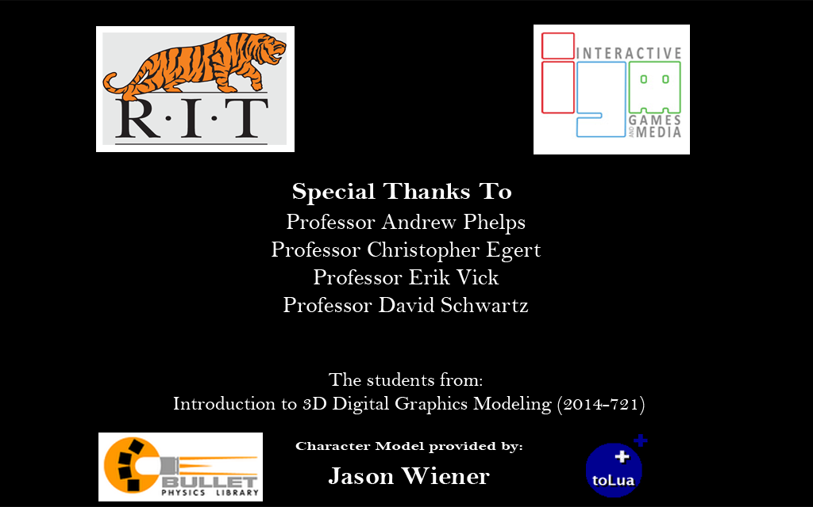

Figure : Intro logo screen - Special credits final render

*Main Menu* – The main menu displays several options. Players can edit game options or quit the game. They can also create a network match or join a network match.

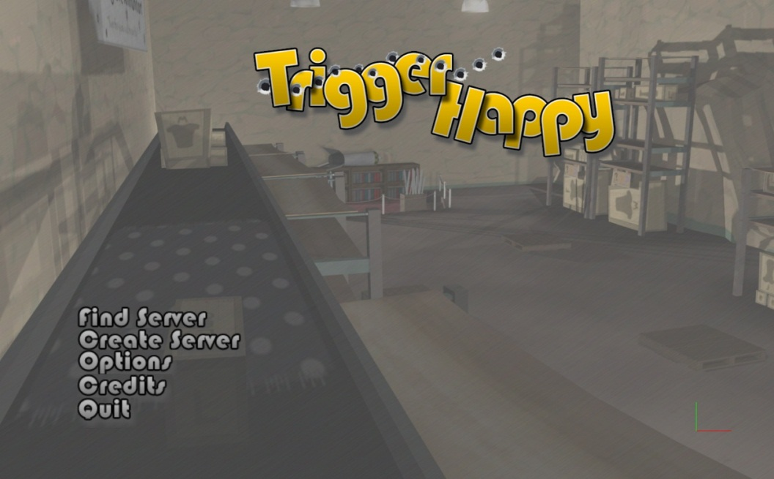

Figure : Main Menu screen final render

*Create Network Match* – The player is presented with several basic options to configure their match.

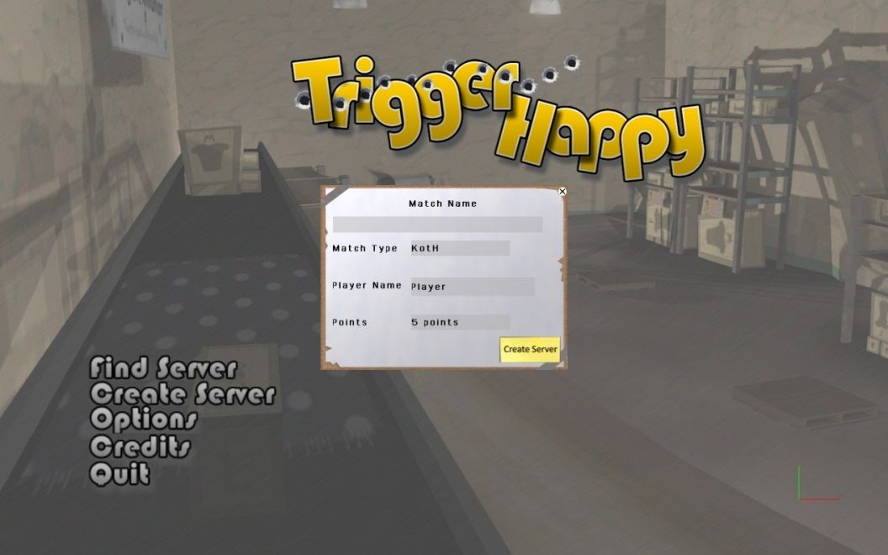

Figure : Create match screen final render

*Join Network Match* – The player can select a hosted match from a list of choices found on the network.

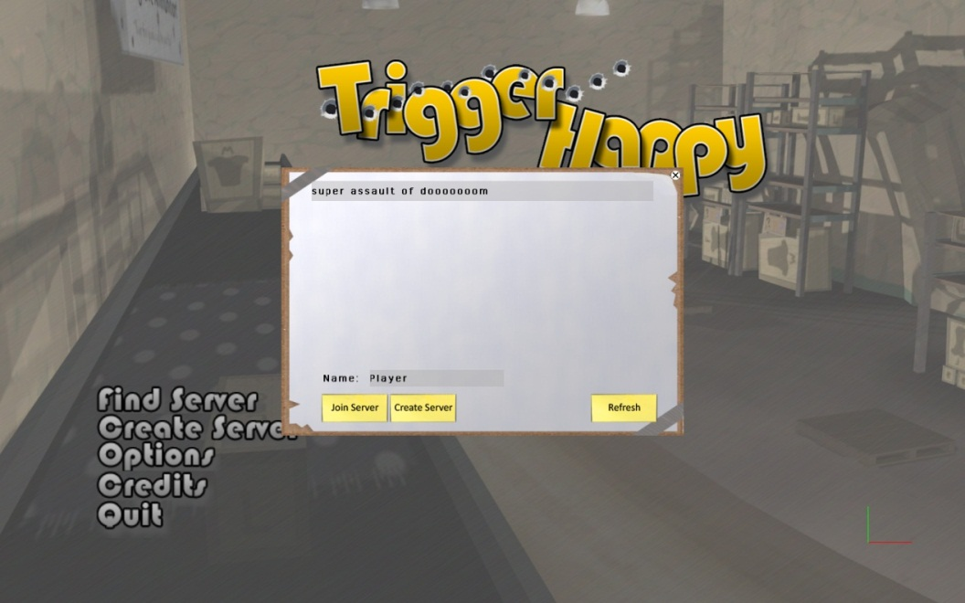

Figure : Find Server screen final render

*Waiting Room Screen* – The player can see the match setting and team layouts, join a team, and let the host know when they are ready to start. When all players are ready, the game begins.

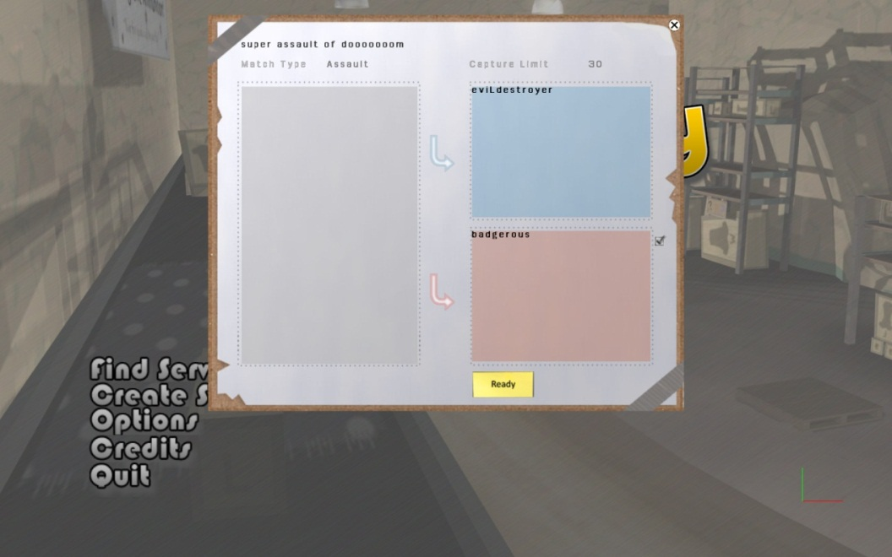

Figure : Waiting Room screen final render

*Weapon/Modifier Selection Screen* – Here the player can select their loadout of modifiers and weapons. They may spend a total of three “points” on weapons and select a total of three modifiers. After all players have chosen, the game begins. Players may return to this screen whenever they die.

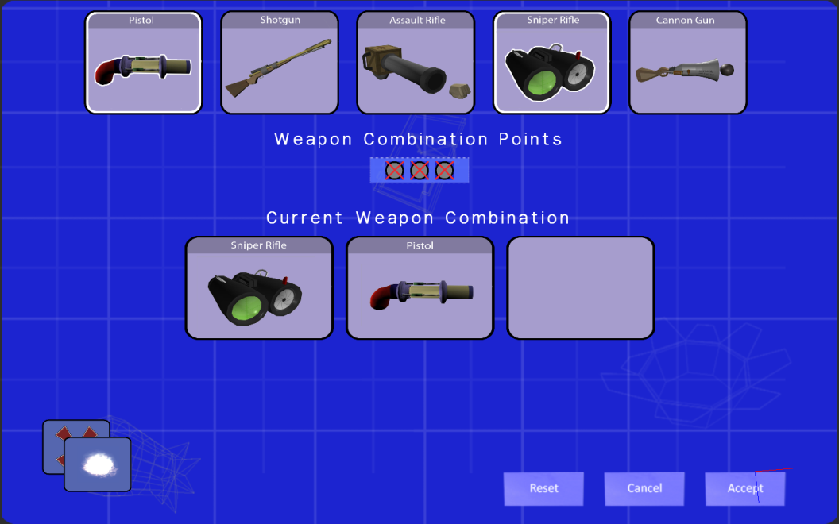

Figure : Weapon Selection screen final render

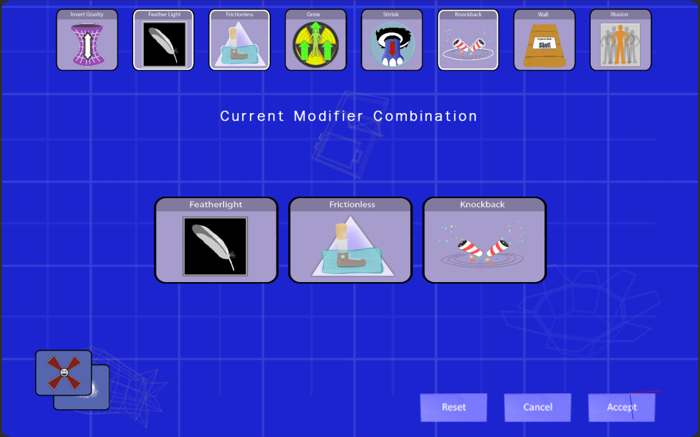

Figure : Modifier Selection screen final render

Game: King of the Kill – This game mode is played by two teams. To win, the players’ team must capture the specified number of control points before the other does. Control points are captured by securing their area such that only members of your team occupy it for 25 seconds. If at any time a member of another team enters the control point they will stop the timer (if a member of your team is occupying the control point) or assume control (if not). When a control point is captured, the next control point location is randomly selected from a list.



Figure : King of the Hill In-Game final render

The control point location is indicated by an icon located on its center point. The player will also receive the control point buff when standing in the control point.

*Game Statistics* – The player can check the current game statistic by bringing up the scoreboard using “Tab.”

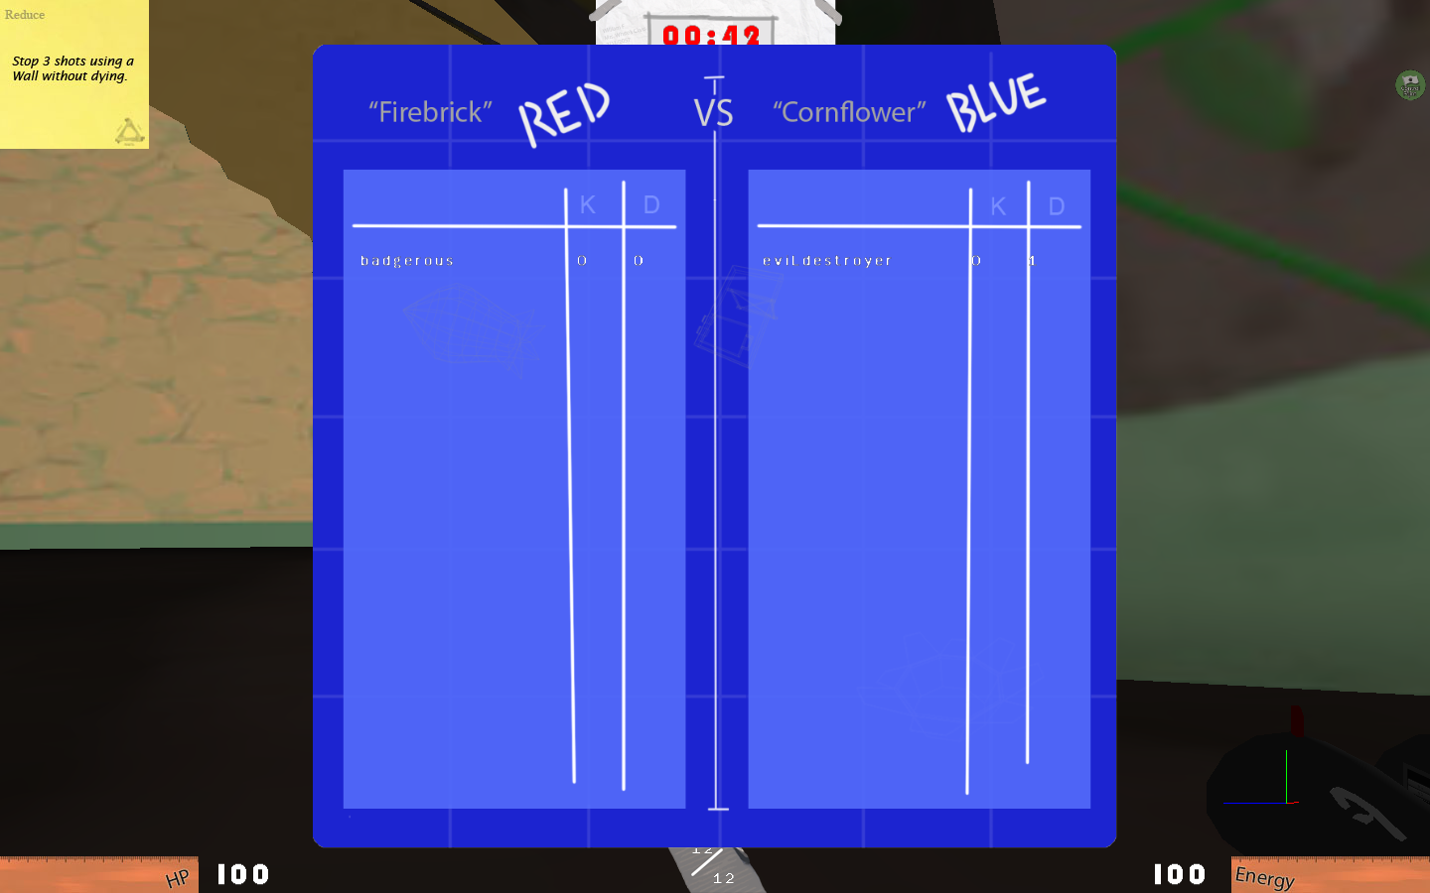

Figure : Team score final render

Game End – When the game is complete, the final result is displayed.

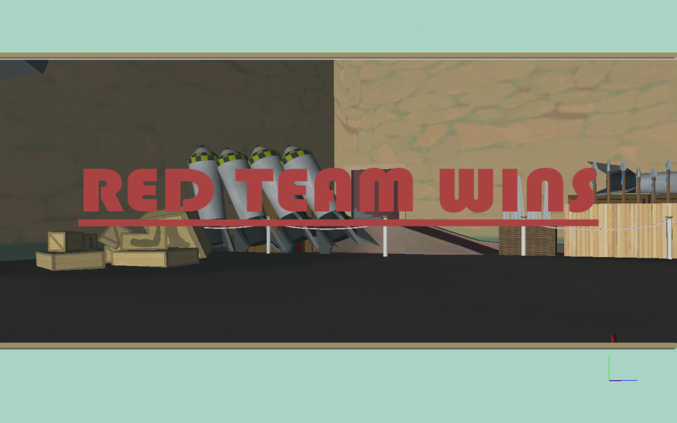

Figure : Win screen final render - Red Team

# Post Mortems

## What Went Well

* ***Lua*** – As discussed in detail in the implementation choices section, Lua was a very successful choice. Once we discovered a binding auto-generation library that worked for us, we were able to reap benefits in both development speed and compilation speed.
* ***Art Execution*** *–* For not having a single art minded person on the team, art execution was very successful. Nick was able to keep pace with all of the modeling for the most part while Chip was able to do the same for textures. The final result captured the essence of the look and feel, which was supposed to be cartoonish and slapped together. While it may not have been at AAA quality level, the map was varied and expansive, the weapons were interesting and visually attractive, and the GUI was professional looking.
* ***Documentation*** – Despite getting a late start in the documentation process, the final documents that we generated were very similar to the game we created. The components and engine design were a perfect match, the art style was consistent, and the game features were very close as well. The major changes that we made to the game came largely because of cutting features or swapping simpler implementations for more complicated ones. We removed some of the map, simplified HP and Ammo regen, removed weapon animations, etc. And while these changes did matter, we never diverged from the core message of the documents. The only “major” changes were writing our own model file format and replacing one of the modifiers (Increase Gravity) with one more appropriate for our map (Featherlight).
* ***Component Model*** – The component based approach that we took instead of a standard hierarchical one was very successful for a number of reasons. First, it allowed a separation in development that made it easy for each component to be developed in a vacuum with little reliance on other systems. However, this didn't keep the game objects that used them from exhibiting composite behaviors. Quite the opposite, as we had great flexibility in how we mixed and matched the pieces. Creating a bullet required nothing more than adding a rigid body, a collider, and a mesh renderer to a game object. This style also worked very well with Lua which favors a composition model based on joining tables.

## What Could Have Gone Better

* ***Art Scope*** *–* The scope of the art should have been less ambitious. While we were on the hook for weapons and characters regardless of our art direction, the map could have been simplified. The variation between the rooms meant that the map was interesting to explore, but it also meant that we needed new texture materials for each room. The map was expansive, but that meant more modeling work, and ultimately the map was too big for the number of players that we were aiming at. While we did cut significantly (and appropriately) to control this problem, it didn't become apparent until five weeks in, at which point we had already lost significant programming time.
* ***Multi-threading and System Integration***- We experienced a number of bugs as a result of our integration of different systems and different threads. Sometimes it was threads destroying game objects while other threads were trying to draw them. Sometimes it was tolua++ deleting C++ memory that was still in use because Lua had garbage collected its representation of that memory. Sometimes it was C++ drawing in the middle of a Lua function that manipulated the position of objects causing flickering and popping. We could have used more accurate debugging info to find these problems. We could have also used a set policy on how Lua and the engine were going to cooperate in terms of execution schedule and memory sharing. There are many options involving passing only copies of objects, passing only identifiers, or tagging objects, but all of them needed to be implemented early on.
* ***Allocation of People*** – This goes back to the art scoping issue. In allowing ourselves to over budget on art we also underestimated the amount of programming work to be done. The engine and C++ components were flexible and powerful, but slower to develop than a C# solution or a less robust engine. The multi-threaded debugging load was also larger than what it would have been for single-threaded. Additionally, we needed a fairly rigorous physics solution which proved difficult to produce. From the beginning we could have used another person full time on programming. We had hopes of finding art support to allow this to happen, but reducing art scope would have helped as well.

## Significant Setbacks

* ***Access Violation Errors*** – As mentioned above, multithreading our engine caused many problems while providing us with many speedups. Most of these issues came in the form of access violations, which occurred when threads had strange timing issues. These would immediately crash the game, and usually had some sort of bad piece of memory associated with them. The team slowly worked through these issues by identifying each root cause, but the multithreading made it difficult to identify where something was happening due to an inability to trace through.
* ***PIX*** – PIX, Microsoft’s tool for inspecting DirectX calls, refused to work properly with *Trigger Happy*. While it would allow inspection of call for the main menus, once it began to load in more data PIX and *Trigger Happy* would immediately crash. Unfortunately, we were not able to localize the problem and this meant that we were not able to use one of our very important tools, causing us issues down the line. PIX refused to work on any machine with *Trigger Happy* running Windows Vista or Windows 7, and was tested with multiple versions of DirectX. An alternate, NVPerfMon, was discovered for NVidia graphics cards, but required special integration into the game engine that the team never got around to.
* ***Rendering Optimization*** – At the time of this writing and submission, significant rendering optimization had not taken place yet. When running on brand-new high-powered machines, the game ran somewhere between 10 to 20 frames per second. Optimization could easier be performed given more time, but the entire world’s objects were not loaded in until the last minute, causing problems. In addition, most of the game’s textures had to be scaled down in size just so the rendering subsystem could load in all of the data without crashing. This is also due to the fact that resources were not shared between files, meaning that a texture would be loaded in once for each model it was associated with.
* ***Custom File Format*** – Due to the speed of FBX, we were forced to develop a custom file format for our models that included their meshes, materials, collision boxes, and other pieces of information. While this meant that an entire piece of the level could be loaded in with one file, it took a significant amount of time to develop the file format and the importer/exporter system. As time passed, we slowly realized that some necessary information (such as the rotations on collision boxes) were not being passed along from Maya due to the way Maya stores and resets information. Unfortunately, it took much longer than it should have to put this together through no fault of the team’s.
* ***Animation*** – The animation subsystem took a long time to finally pull together. Most of it can be understood through the custom file format issues, but animation had its own set of peculiarities. These issues ultimately required a rewrite of much of the exporter as well as some of the *Trigger Happy* animation subsystem. The animation issue may not have taken anywhere near as much time if we had been able to use PIX, as it would have allowed the animation developer to look at and understand the information being passed into the shader and the positions of the vertices.

## Future Work

Given additional time we could have expanded on:

* ***Weapon Animations*** – These were initially drawn up in the Art Bible, but were cut due to lack of a solid, non-bone based animating system and their relative unimportance to game play. However, they would be a relatively painless way to improve the look and feel of the game while also communicating the improvised nature of the weapons.
* ***Visual Effects*** – The modifiers and weapons were given baseline visual effects to communicate important information about their types, who they affected, and where they were targeting; however, there was a lot more we could have done to make the effects more entertaining. You can see shades of this with the Shrink modifier which was the first one implemented. Examples include animations for grow and shrink, smoothing out gravity invert, and making the illusion more active.
* ***More Game Modes*** – A game based on physical modifiers such as ours lends itself to a number of variations. We could have explored solo vs. team, different objectives, different modifier deployment schemes, global modifiers, etc. Each of these modes would be rather simple to code up in Lua and would do a lot for getting the most out of our game idea.
* ***Map Customization*** – We would have liked to have spent more time designing the map to provide lots of opportunities for using modifiers. For example, entrances only accessible on the ceiling, pits to jump over, small doorways to trap people using grow, etc. Some areas of the map are made with this is mind, but we never got the time to make a real editing pass over the map before setting it in stone.

## Timeline Discussion

Despite laying out the timelines rigorously as we did, the team was unable to meet these milestones and fell behind weekly. Many systems fell behind due to the R&D required for the component and multithreading system as well as the issues that the multithreaded engine provided. The artists also found that they needed more time than originally estimated in order to complete all of their tasks. Ultimately, every task of *Trigger Happy* took longer than estimated to complete, making the project an interesting case study in project management.

The team did everything possible in order to try to get back on schedule. Each member cut significant portions of his or her assigned tasks from the project, and the team met often to determine what could be done to speed up development. When it still appeared that there would not be enough time, team members voluntarily entered a month-long crunch period, working 14-16 hours in a single day during the depths of the crunch without a day off. Even then, *Trigger Happy* did not end on time for a variety of reasons explored in the Development Document.

There were, however, many things complete at the end of the expected development time. All game subsystems were functional, and the engine ran very smoothly. All art assets were complete, and rough audio assets were implemented in the game. Basic game logic had been implemented, and systems were tested and worked across the network in the RIT Game Design & Development Lab. On the other hand, animation was not yet functional, some Bullet Physics issues existed in the realm of collision, and more complicated game logic was incomplete. Furthermore, many odd bugs began to pop up, which the team had just patched over before.

Much of the following three months were spent fixing issues in the game engine and completing the game logic. Many particular problems are explored in depth in the Development Document, but a few large issues stood in the way of full completion early on. For example, the renderer was unable to handle the large game world, as it had not been optimized. The team was also divided, as three members remained in Rochester while the others went off to other cities. *Trigger Happy* also was not anybody’s primary project during this time, as all of the team members were working full-time jobs (three at RIT and two elsewhere) and team members needed to focus on other incomplete projects during this time. Despite all this, the game came together into a functional state at the end of the second three-month development cycle.

## References

[1] Lua 2010, <http://www.lua.org/>

[2] ToLua++ 2009, <http://www.codenix.com/~tolua/>

*This page intentionally left blank.*

Appendix

|  |  |
| --- | --- |
| Content | Date Added |
| Capstone Defense Slides | September 20th, 2010 |
| <Sela’s Research Topic Title> |  |
| <Chip’s Research Topic Title> |  |
| <Jon’s Research Topic Title> |  |
| Eric’s Research – Variable Style Deferred Rendering in a Component Based Engine | February 18th, 2011 |
| <Nicholas’ Research Topic Title> |  |

Capstone Defense Slides

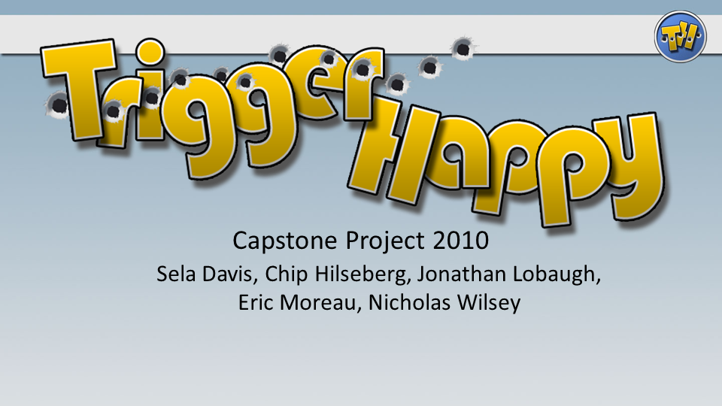

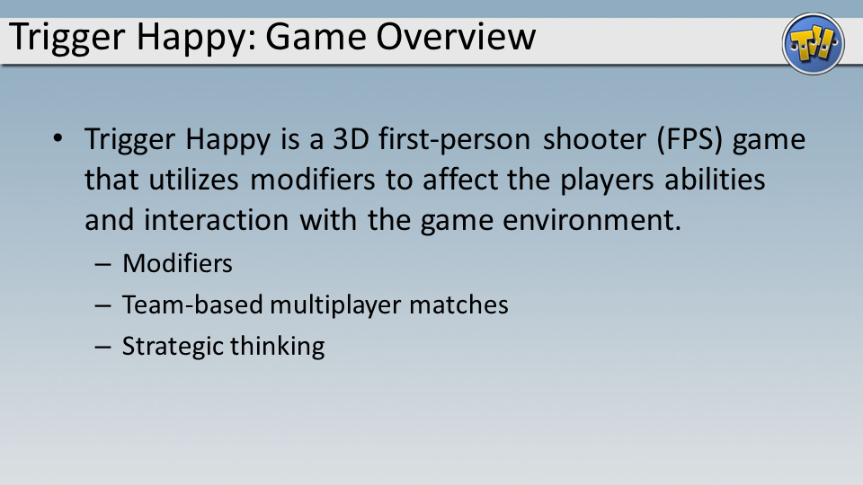

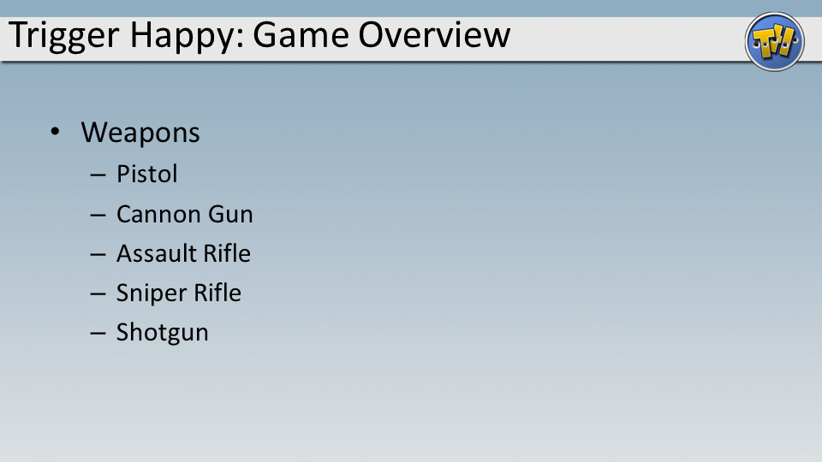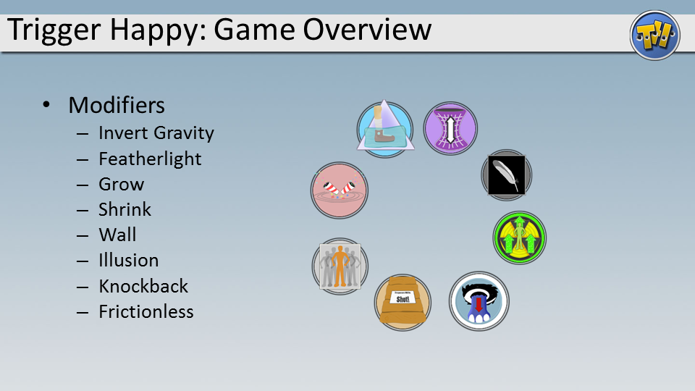

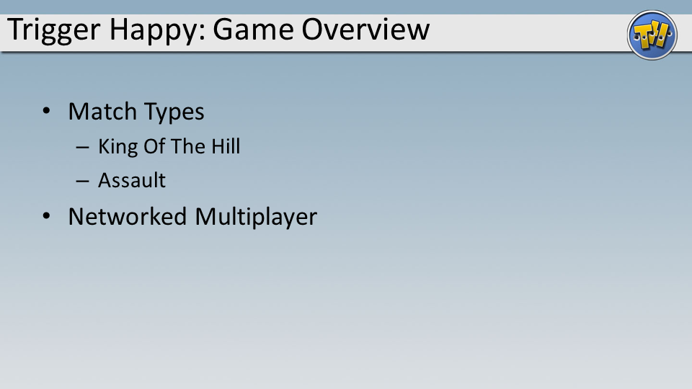

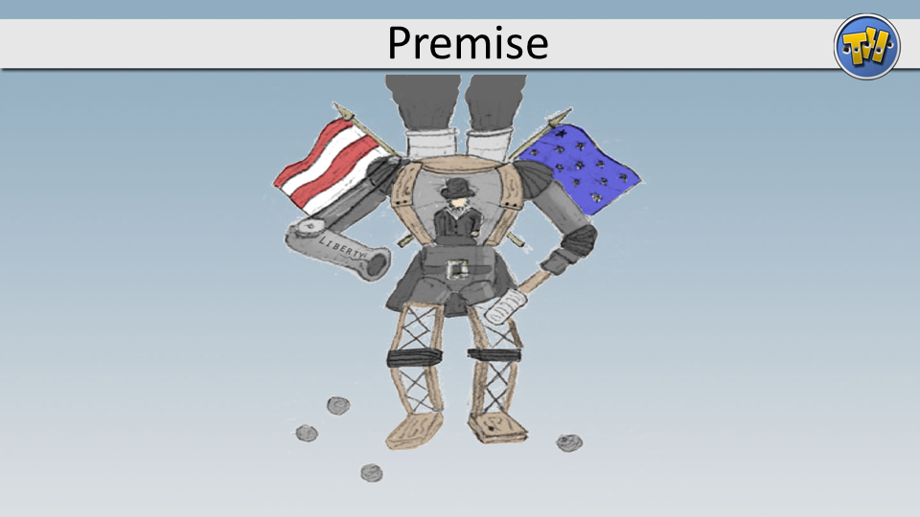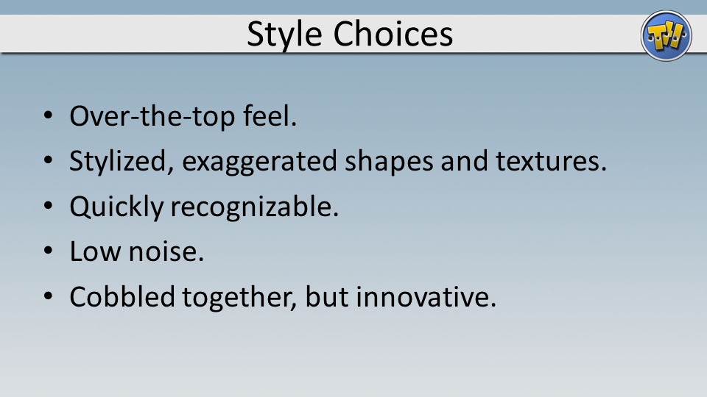

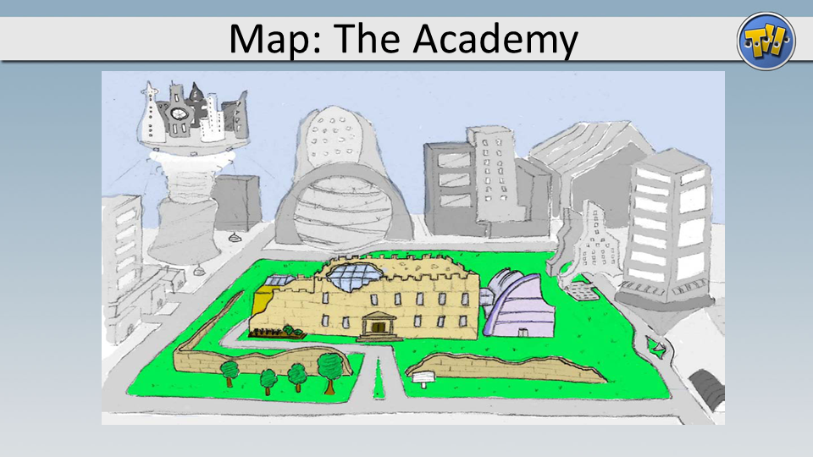

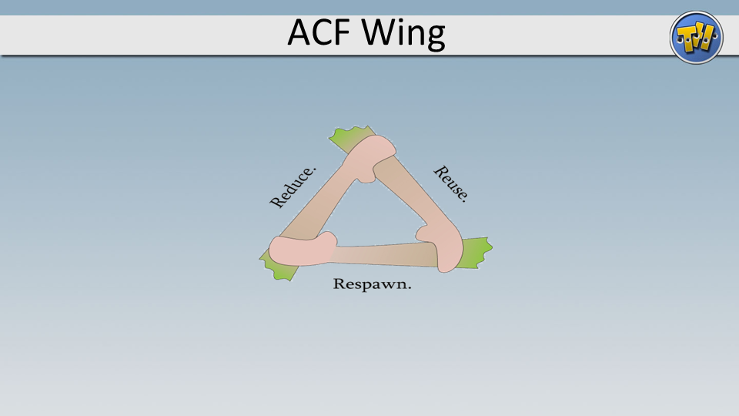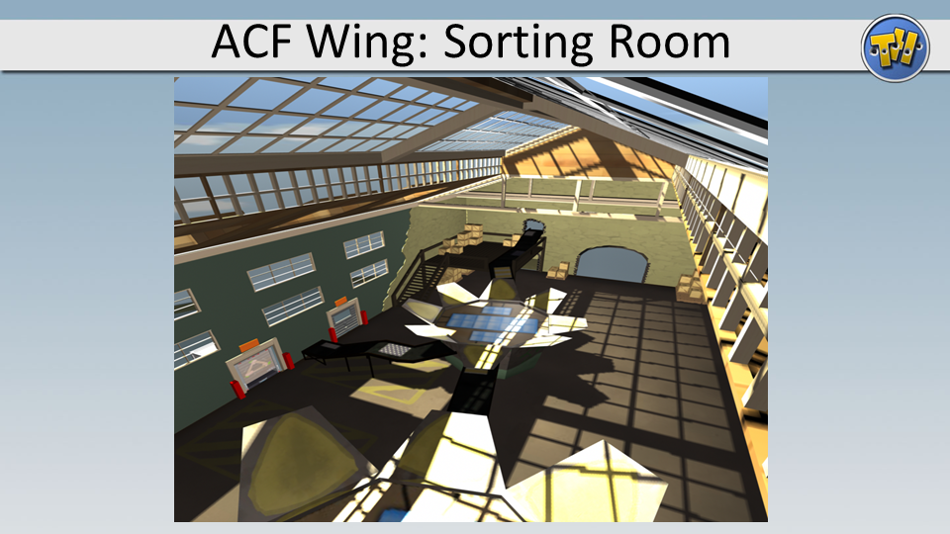

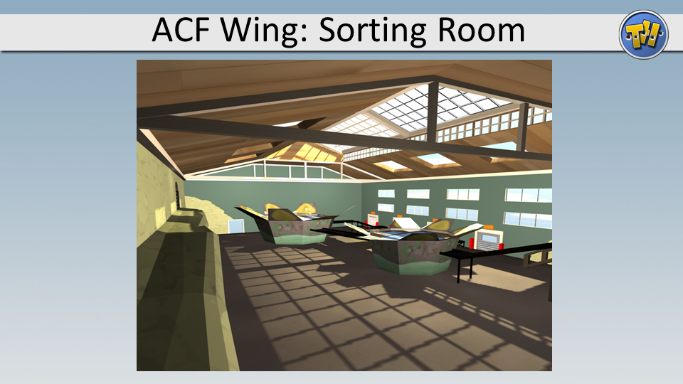

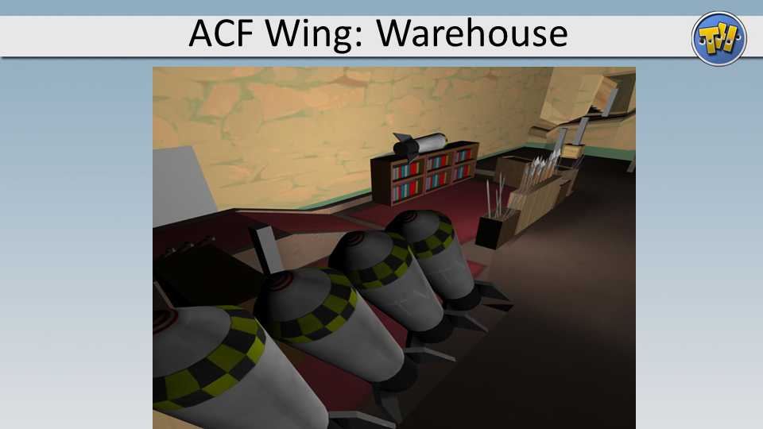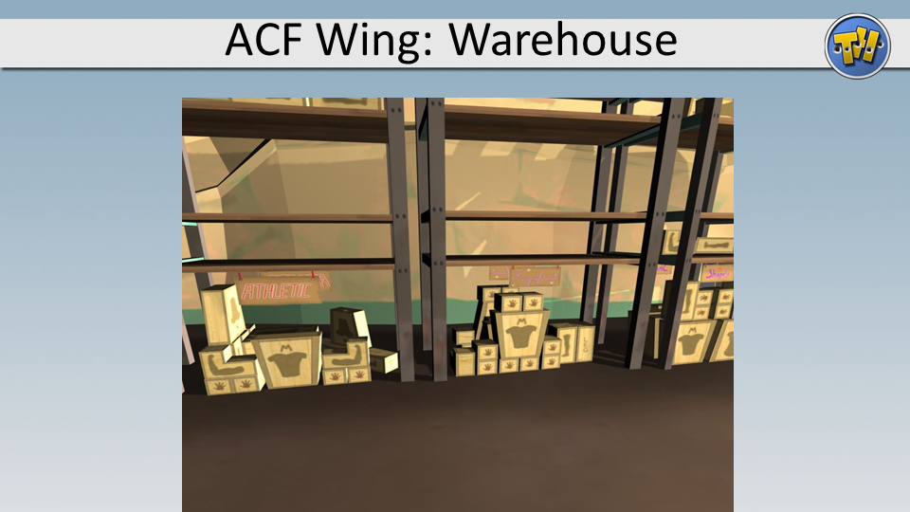

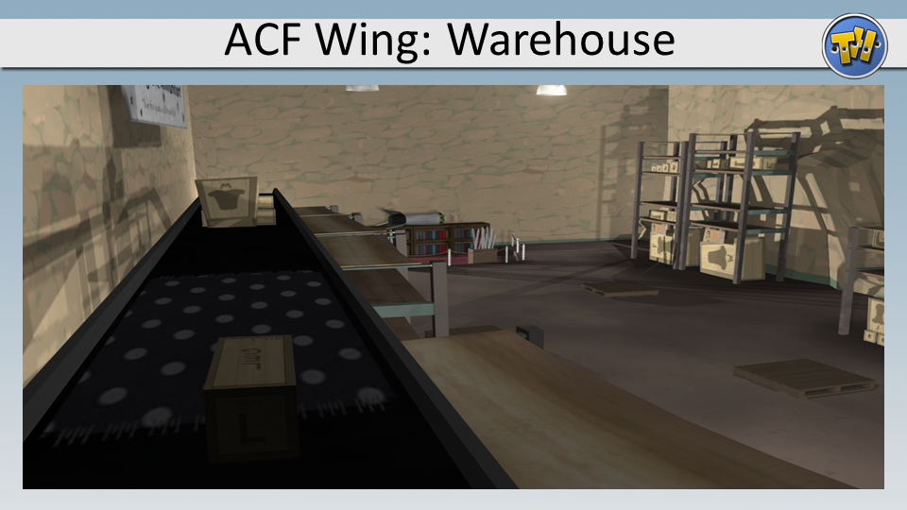

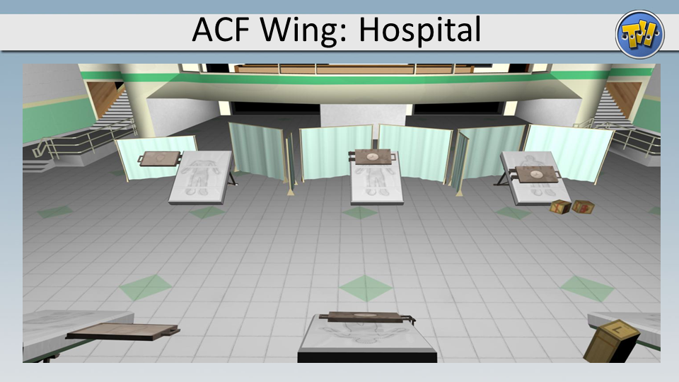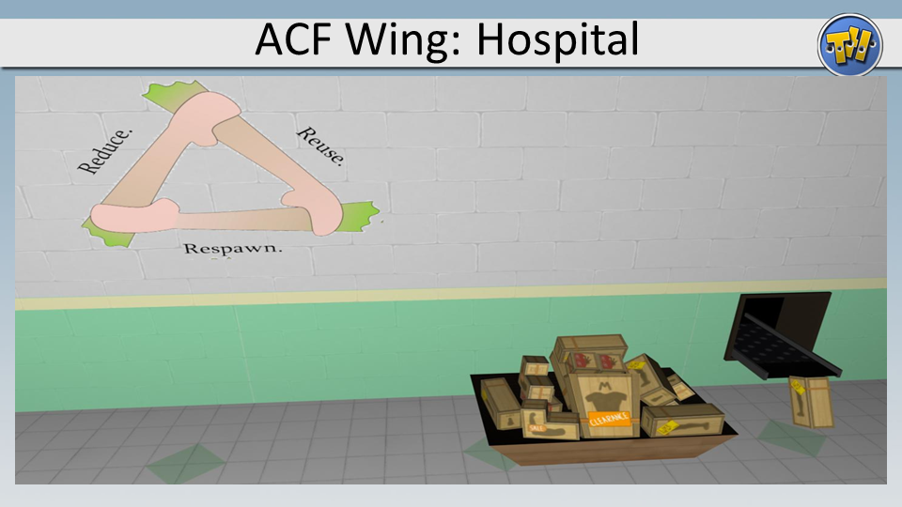

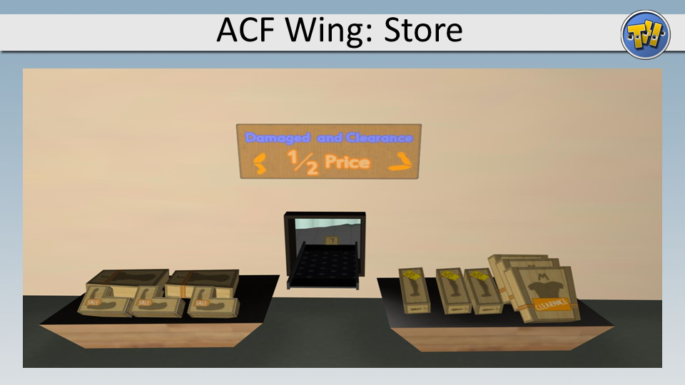

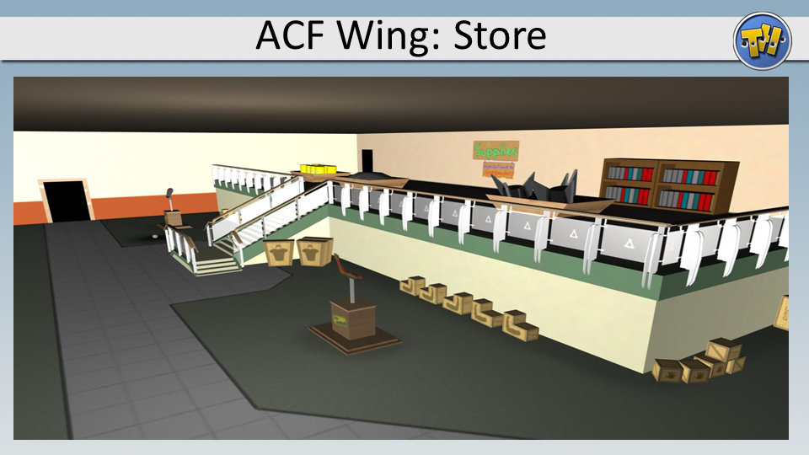

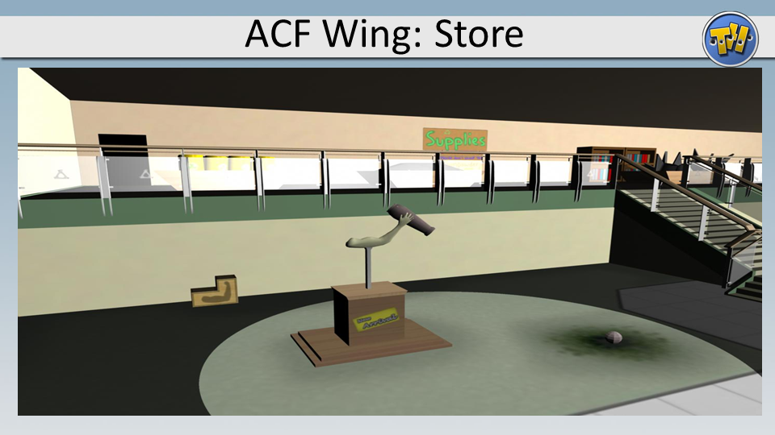

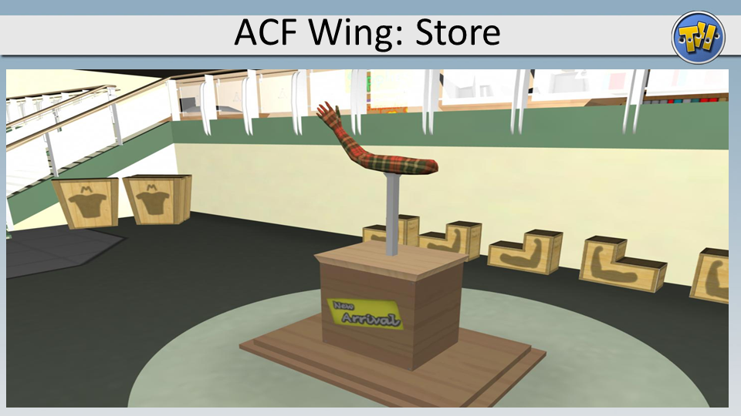

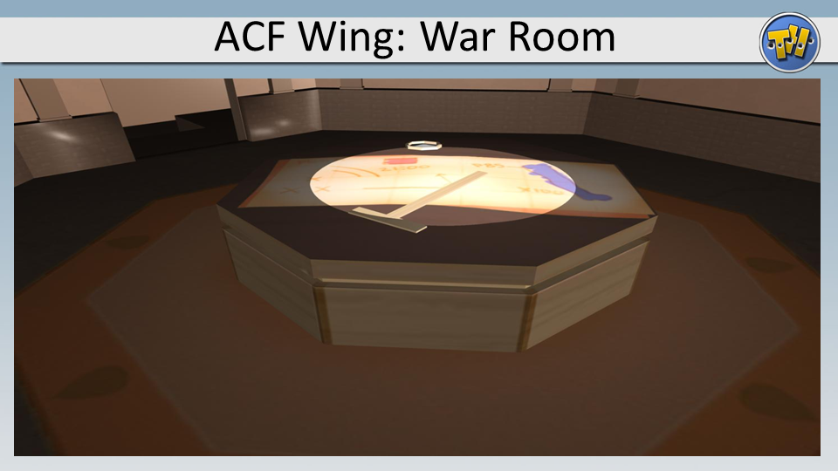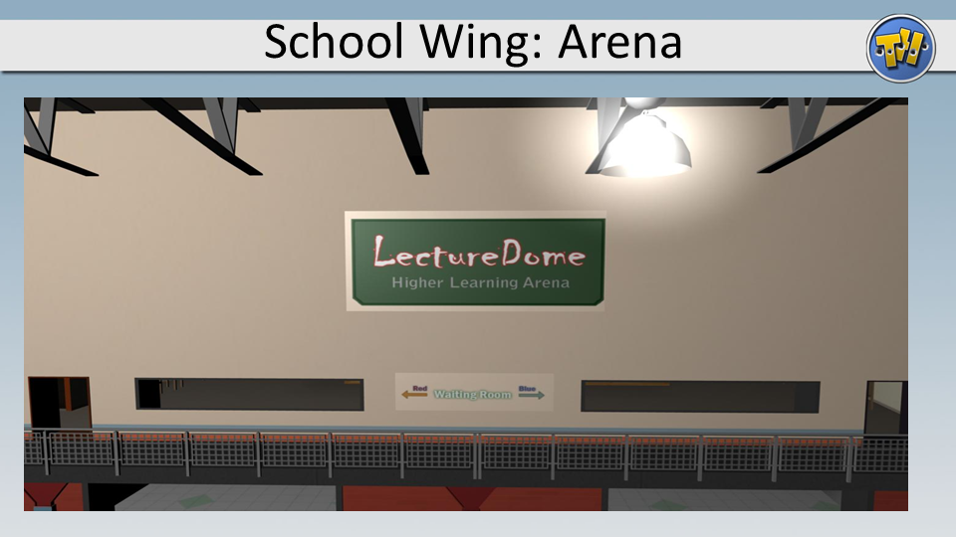

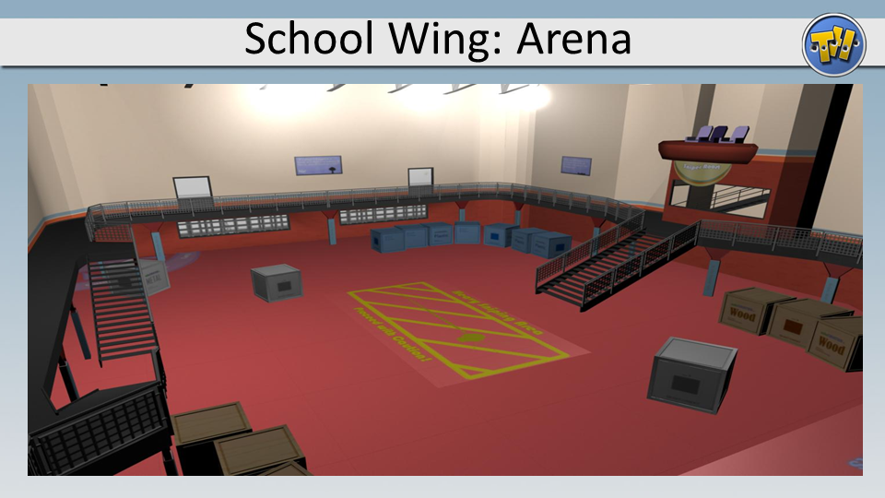

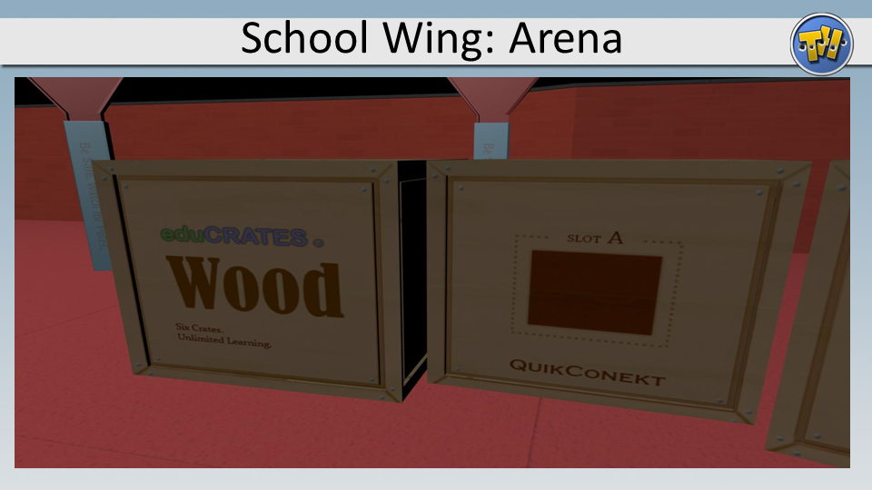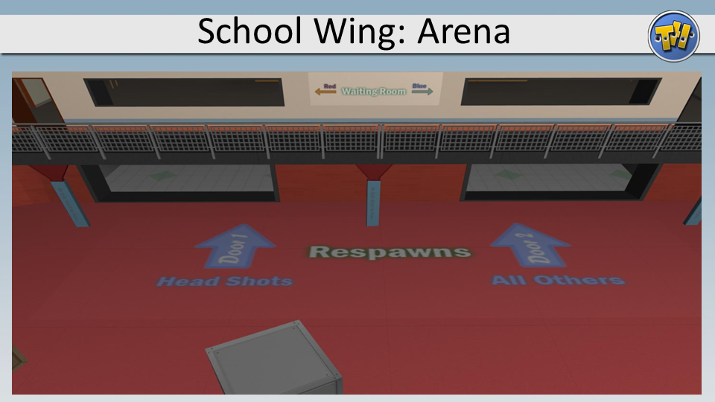

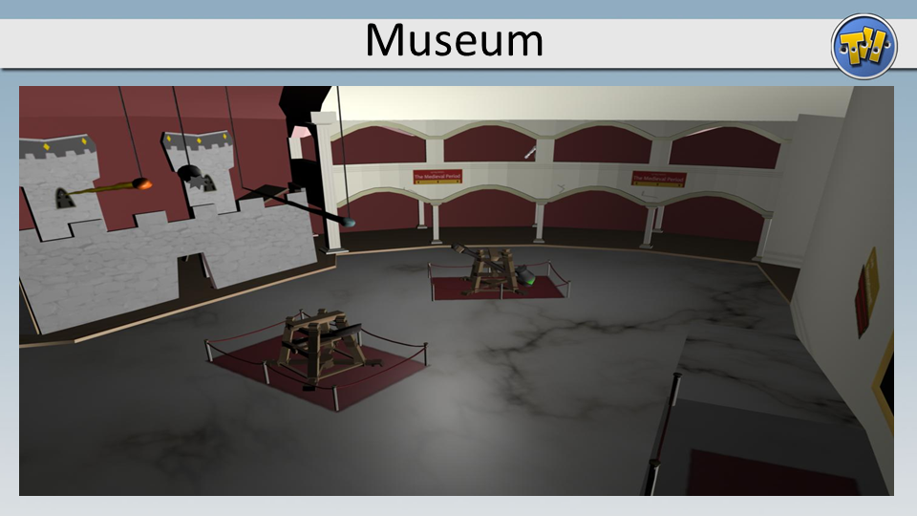

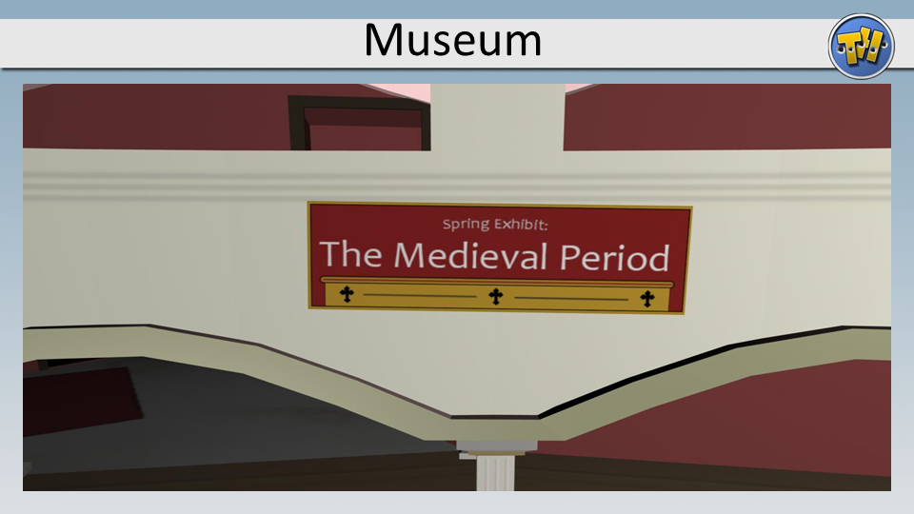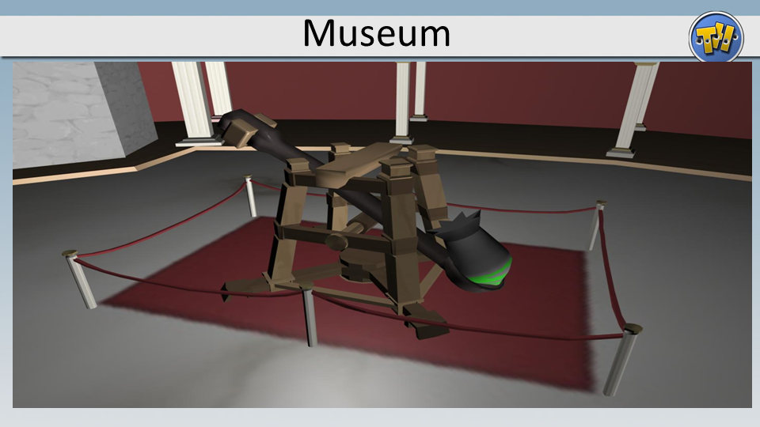

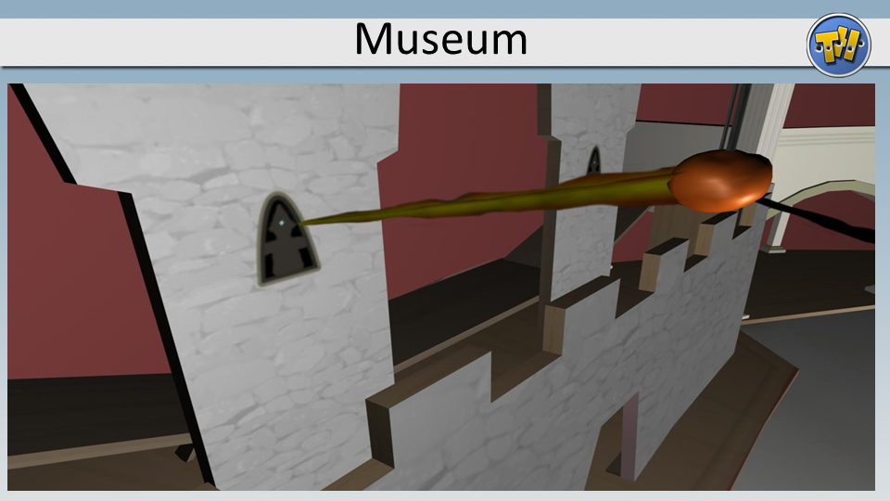

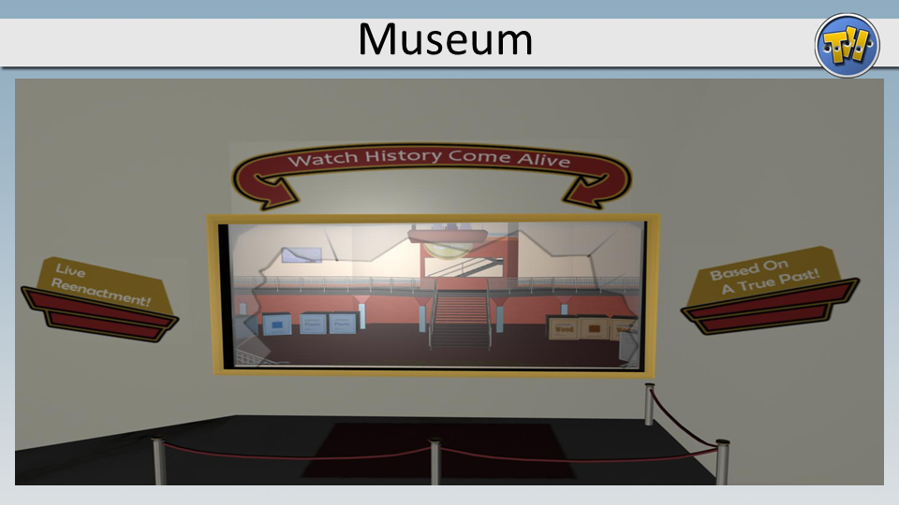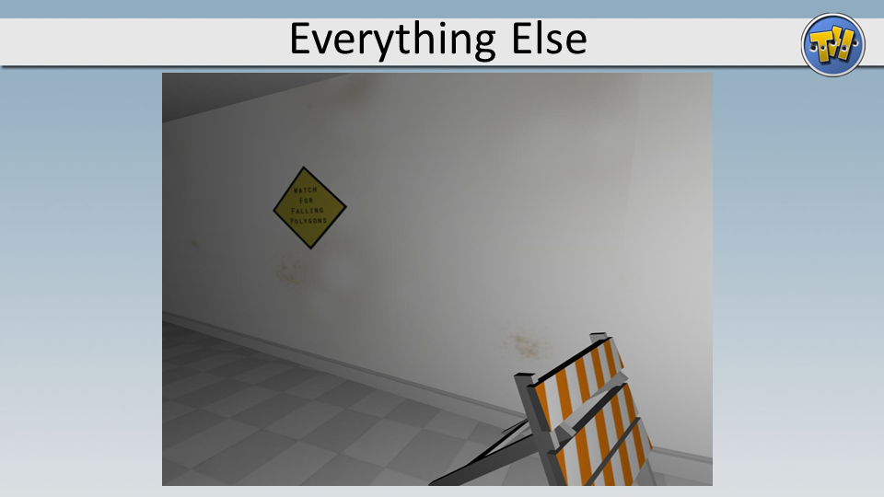

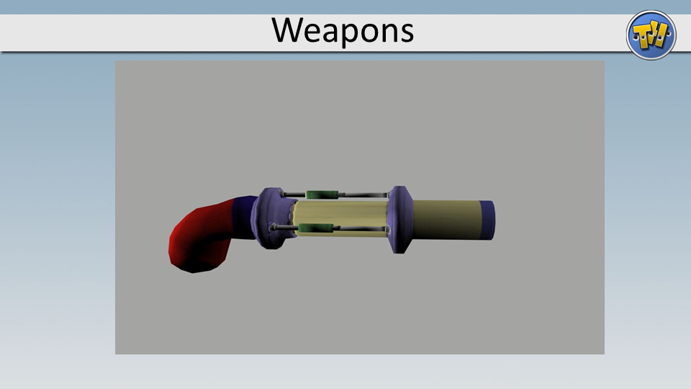

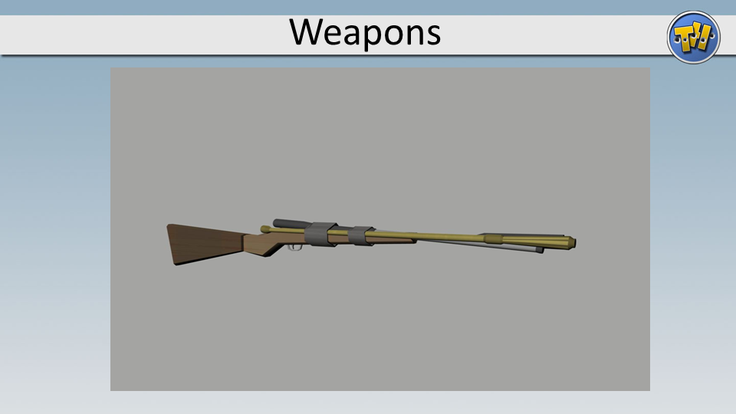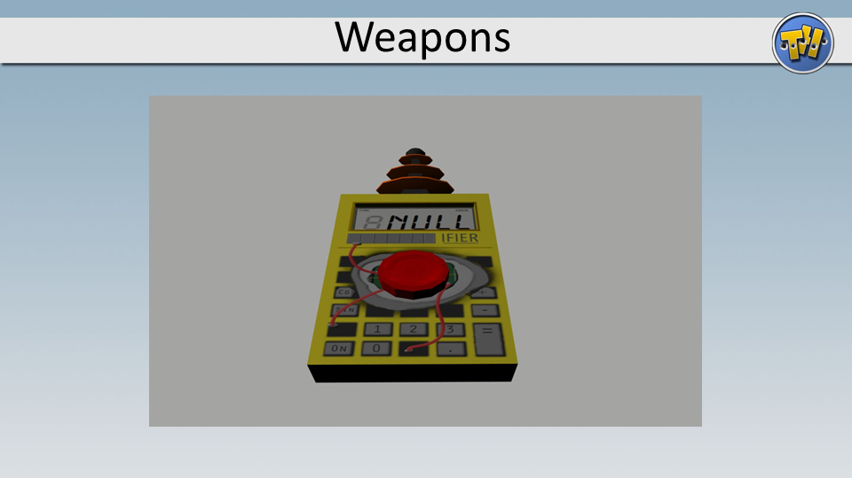

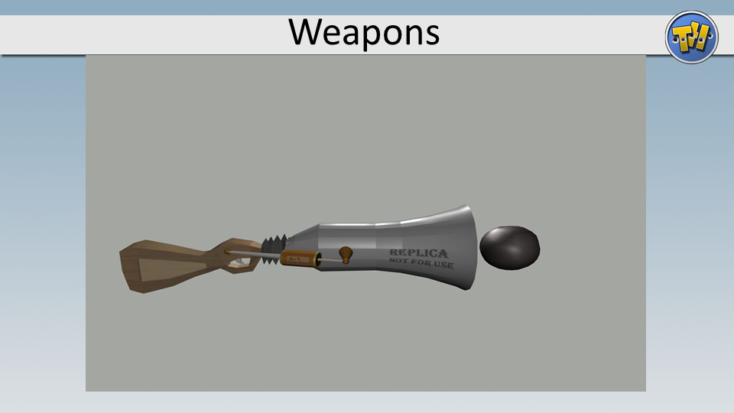

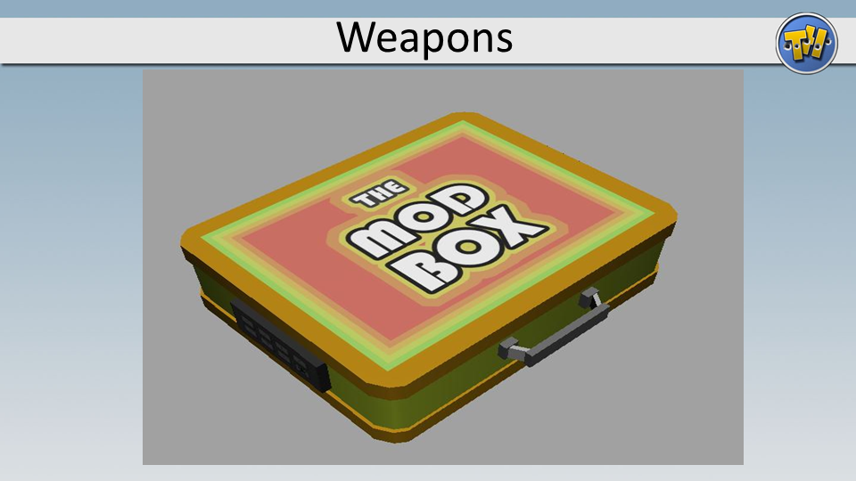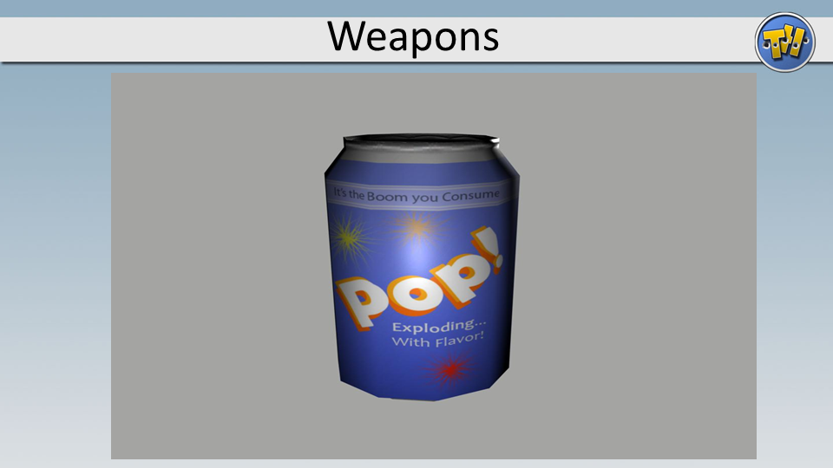

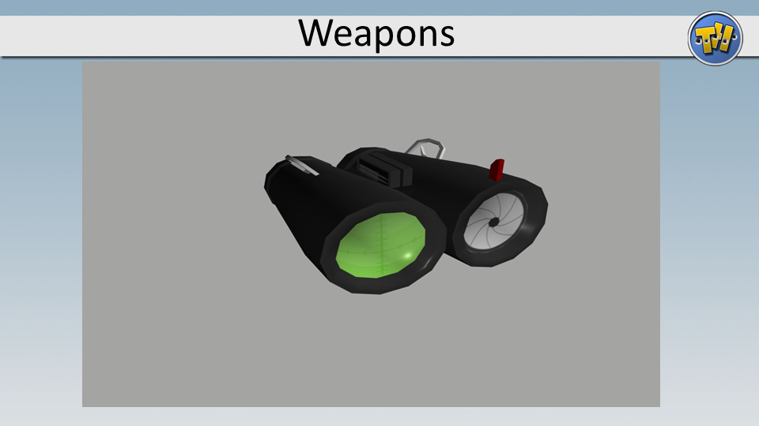

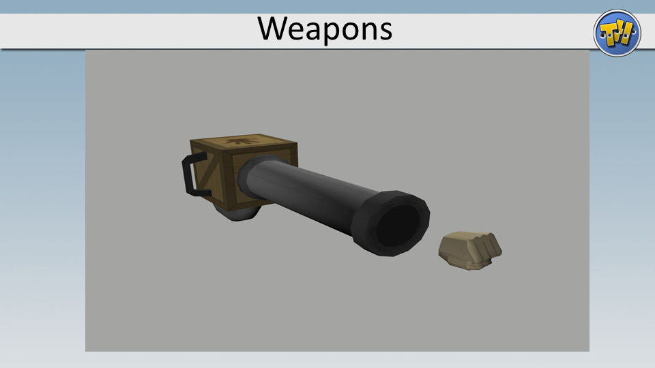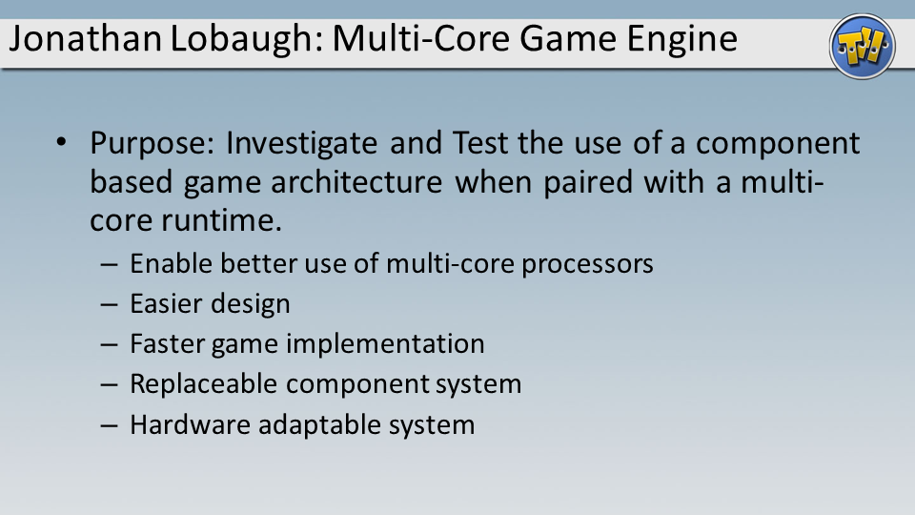

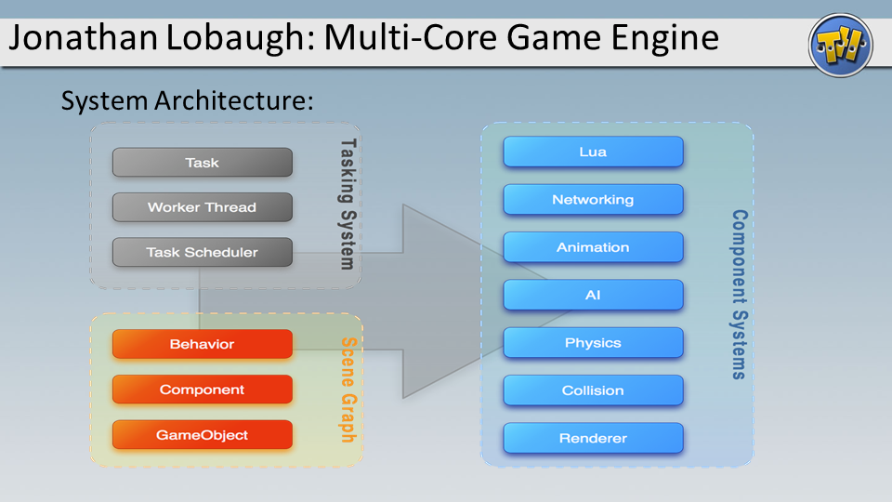

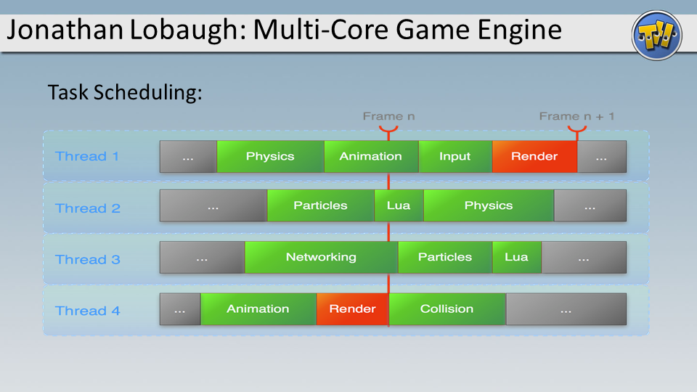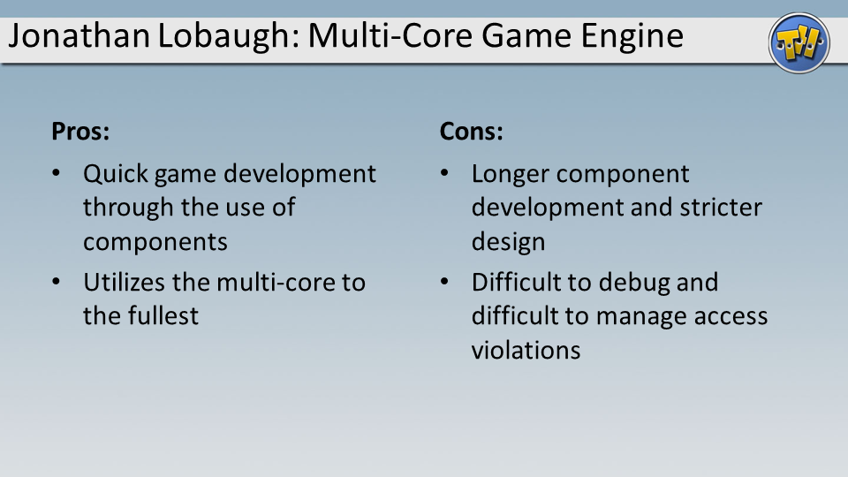

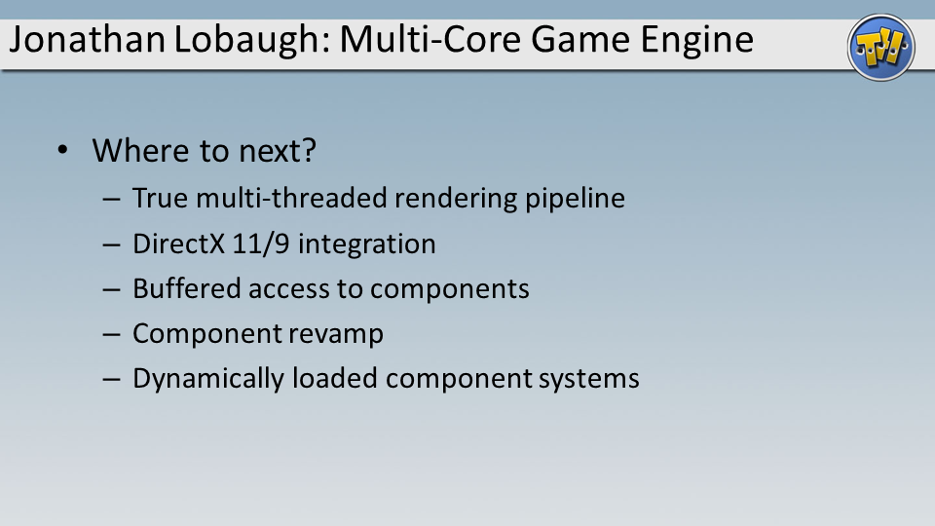

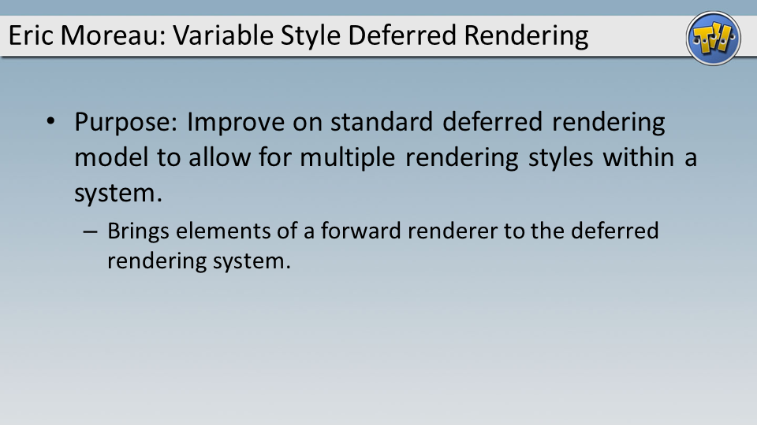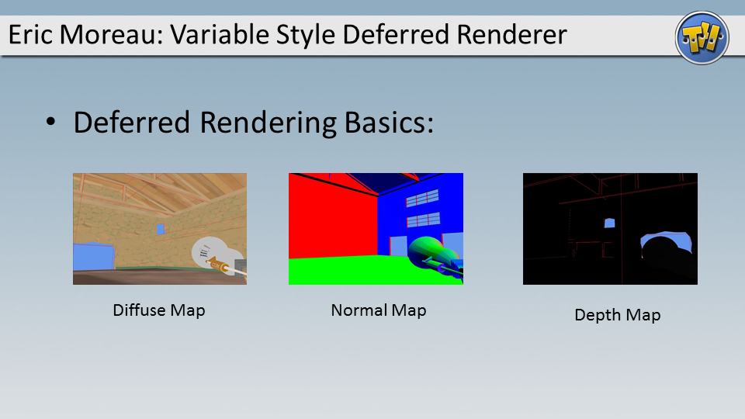

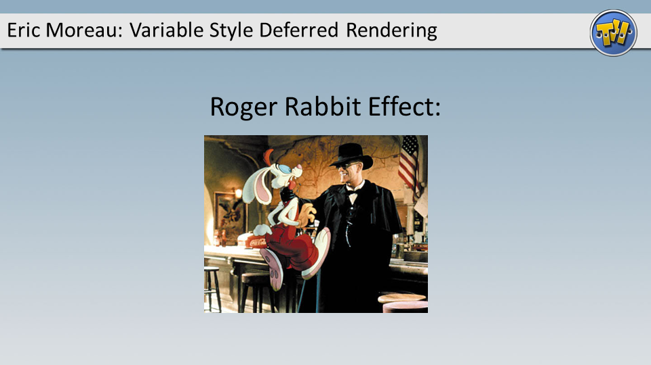

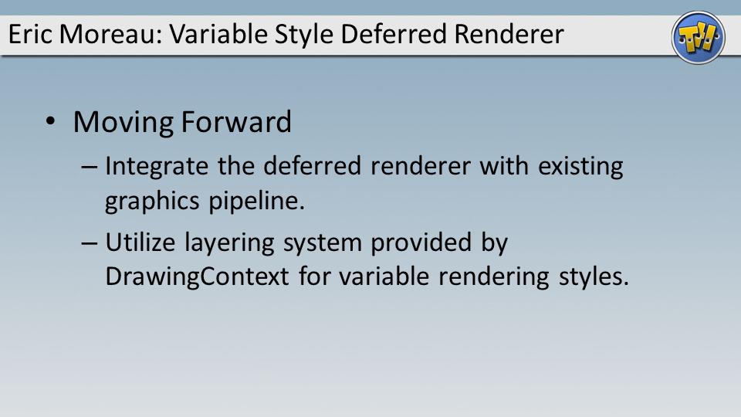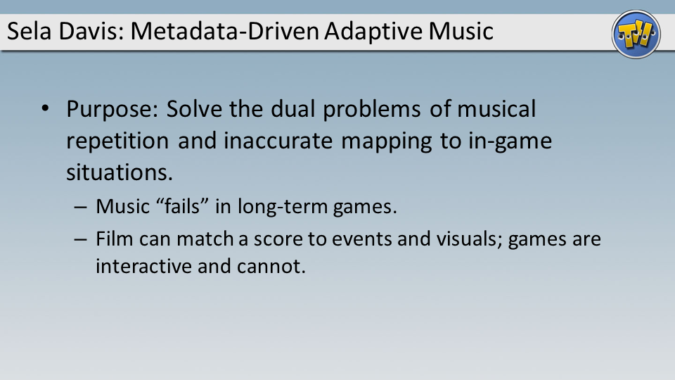

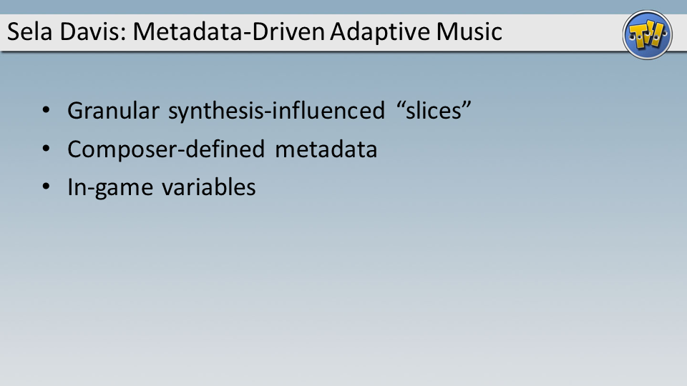

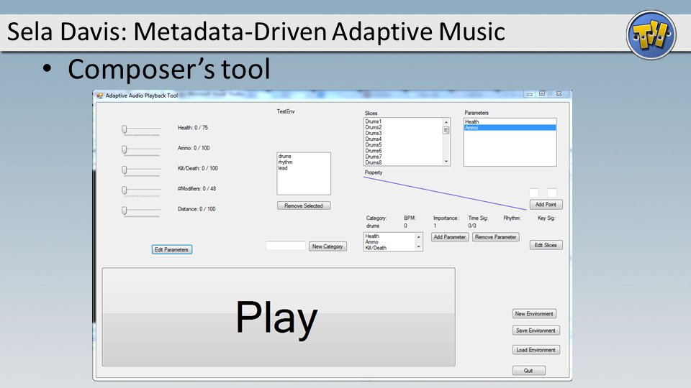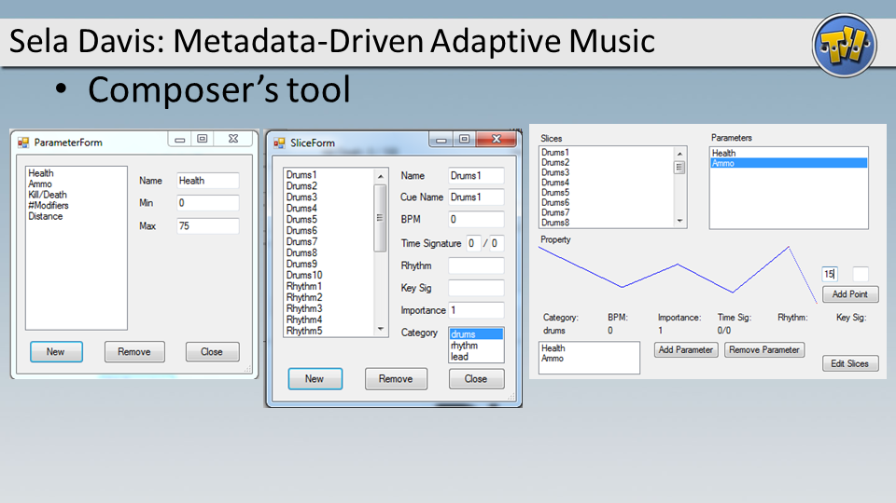

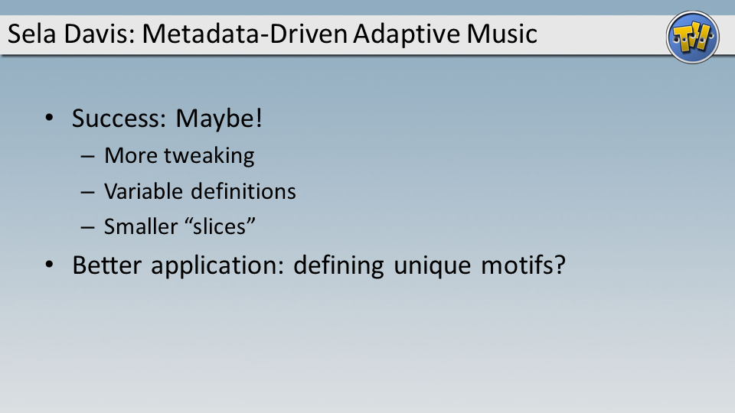

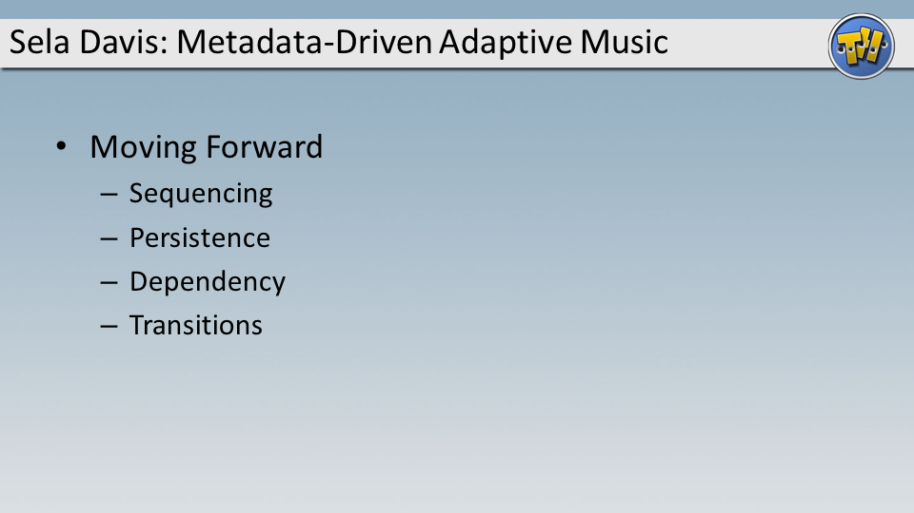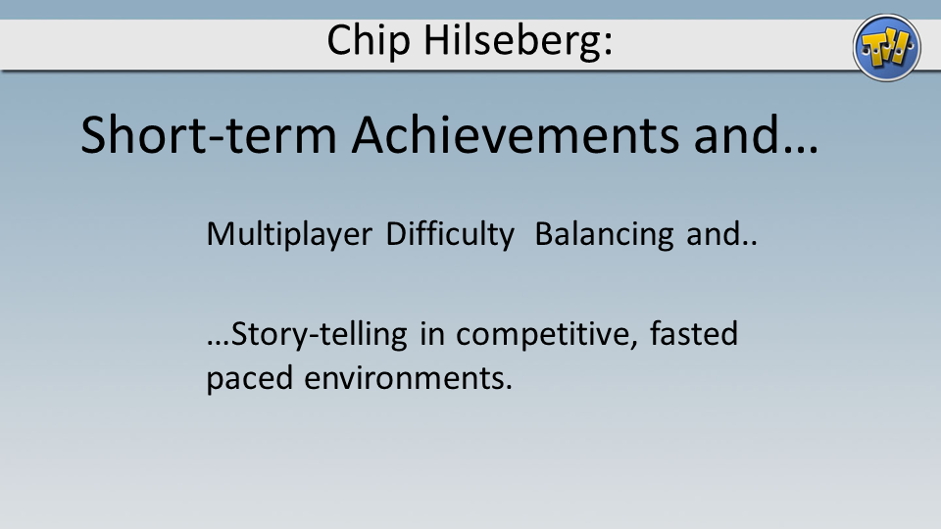

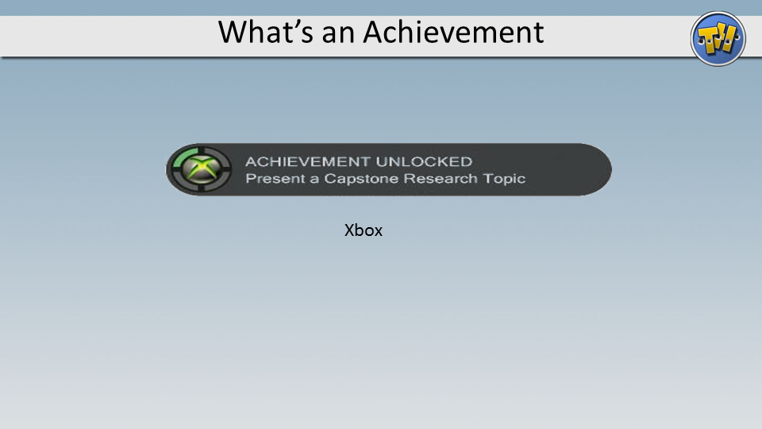

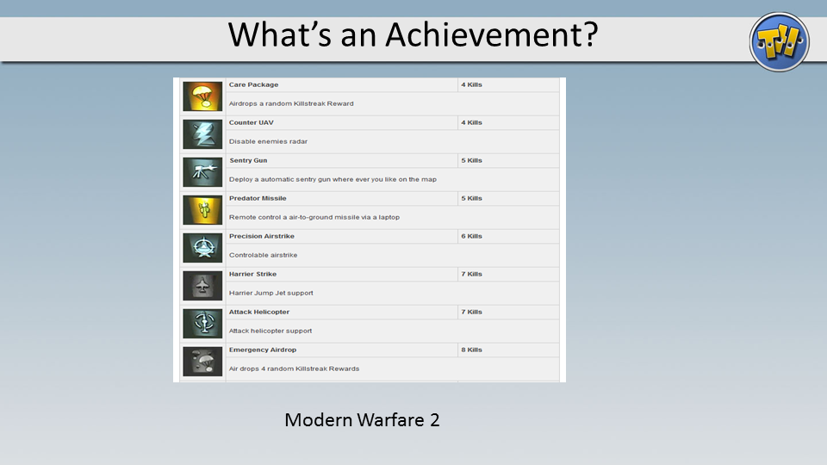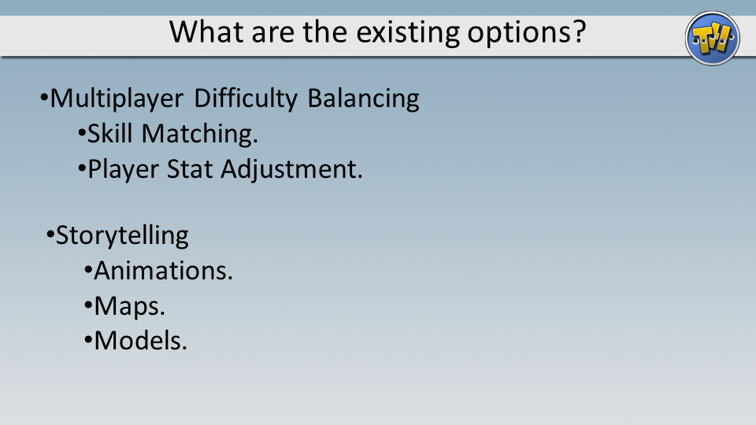

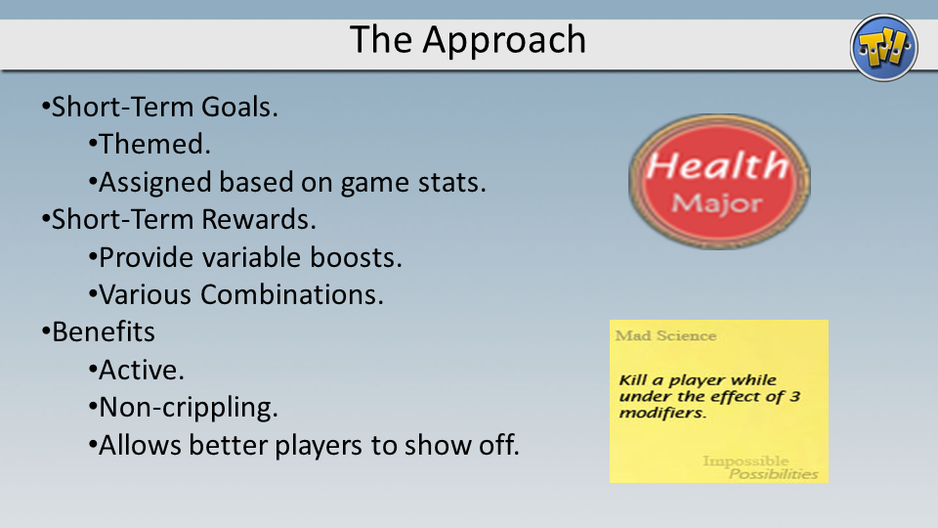

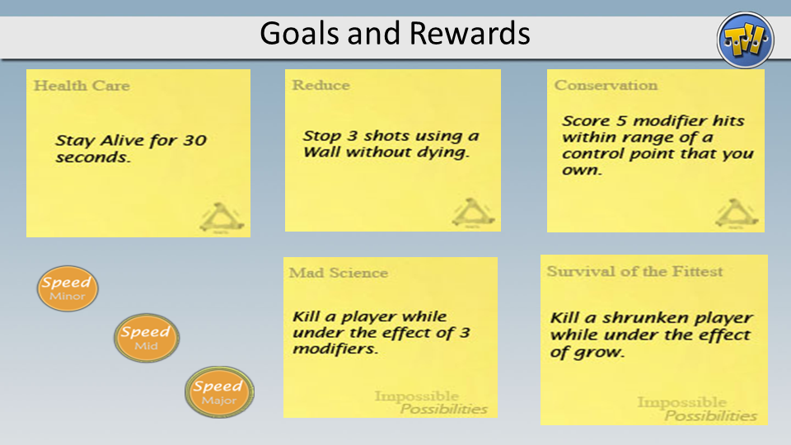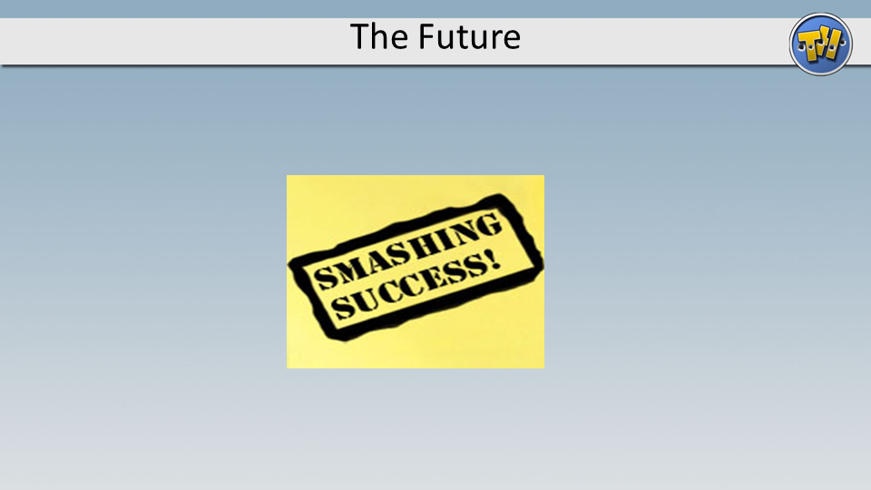

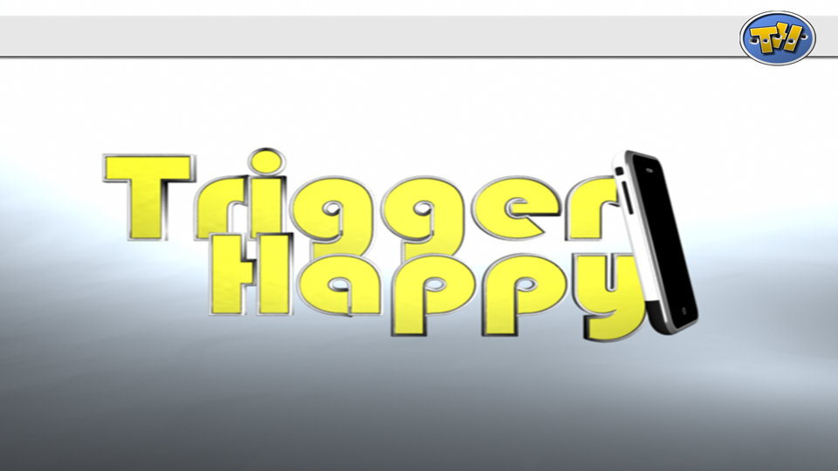

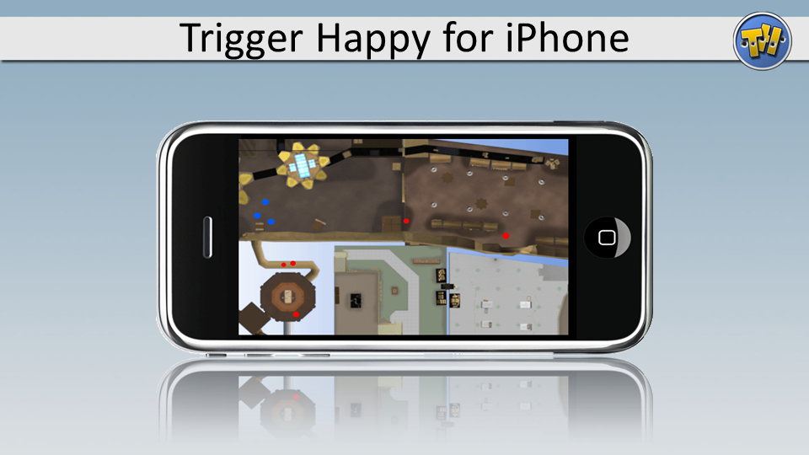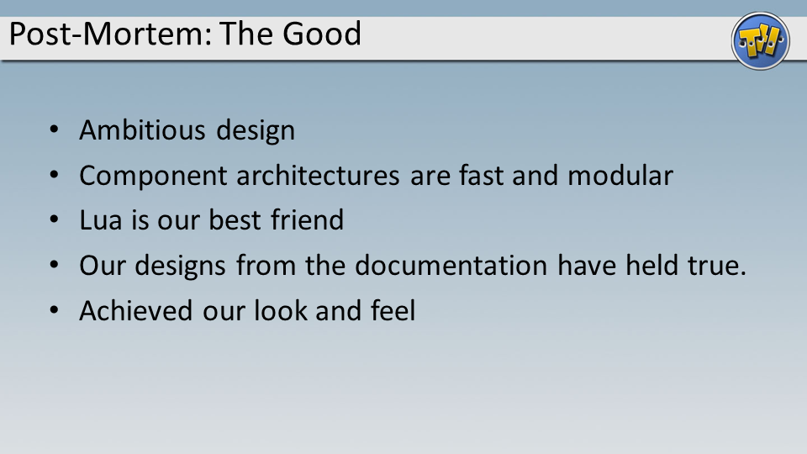

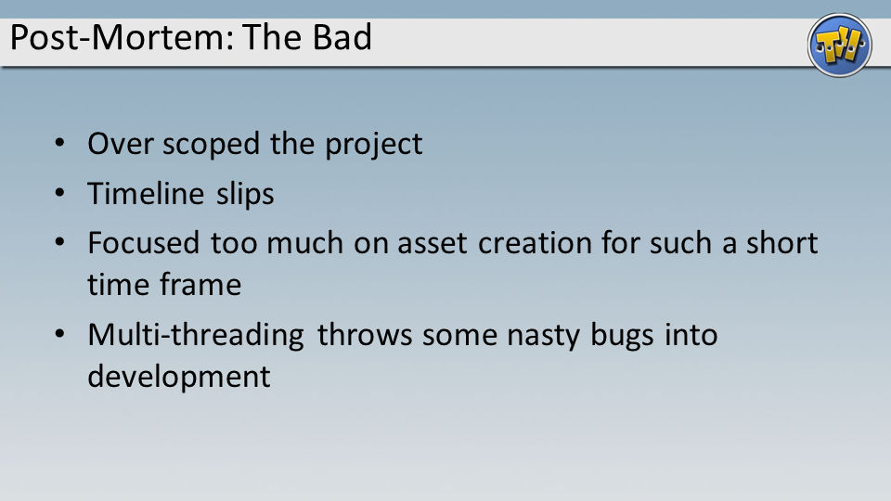

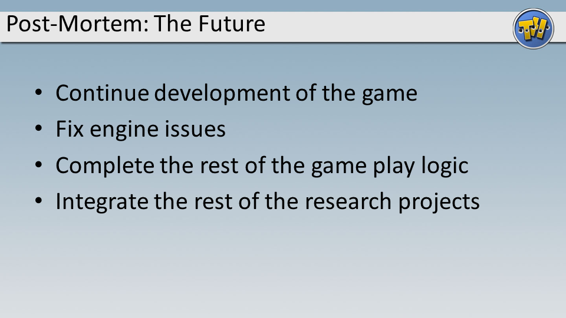

1. <http://www.metacritic.com/games/platforms/pc/unrealtournament2004> [↑](#footnote-ref-2)
2. Thus, unlike some other FPS games, where players may not bludgeon others to death with their weapons. [↑](#footnote-ref-3)
3. Note: One may “charge” the Pistol weapon type and cause more damage on players hit by its “charged” rounds. See the Pistol weapon explanation for more details. [↑](#footnote-ref-4)
4. A particularly gruesome show that used hidden cameras to film public reactions to clones being killed in various staged ways. Almost resulted in the banning of all clone programming. [↑](#footnote-ref-5)
5. Not to be confused with the Alien Conservation Fund, which collects money to fight for alien rights in the case that we ever find any [↑](#footnote-ref-6)
6. In the past, they hacked a designer cloning machine to create a batch of hands that would extend a certain finger on random occasions. [↑](#footnote-ref-7)
7. <http://www.gameontology.org/index.php/Dynamic_Difficulty_Adjustment> [↑](#footnote-ref-8)
8. <http://www.destructoid.com/good-idea-bad-idea-dynamic-difficulty-adjustment-70591.phtml> [↑](#footnote-ref-9)
9. Ibid. [↑](#footnote-ref-10)